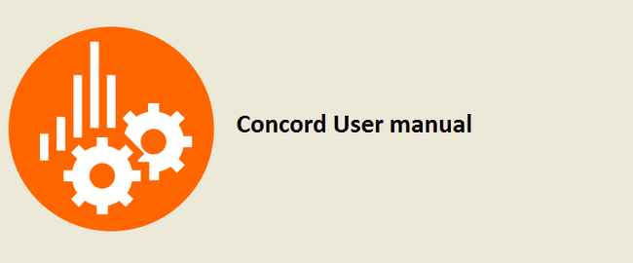

Concord Installation & User Manual

V3.12SP0000

Contents

1. Overview 1

1.1. Hardware Details 1

1.2. Software Details 1

1.3. Additional Requisites 1

2. Installation 2

2.1. Installation related files and its uses. 2

2.2. Installation using ConcordInstaller.exe 2

2.3. Version Upgrade using ConcordInstaller.exe 7

2.4. UnInstallation using ConcordInstaller.exe 10

2.5. Log files 12

2.6. Invoke the Tool 12

2.7. How to create New Project 14

2.8. How to invoke Test Script Generator Plugin 14

3. Workflow for creating test steps 18

3.1. Create an Object Repository 18

3.2. Add the selected object to the Repository 19

3.3. Add a screenshot of the selected object 21

3.4. Add the selected object to the Repository（Timer） 22

3.5. Add a screenshot of the selected object（Timer） 22

3.6. Save the Repository 22

3.7. Object Properties (with real time values) 26

3.8. Highlighter 28

3.9. Close the Spy Tool 32

3.10. Associate “Test Step” and “Action” 32

3.11. Click on Play Button 32

3.12. Track Element – Manual 33

4. IDE Actions 35

4.1. Enable/Disable the Steps 35

4.2. Delete Repository Item/Node from IDE 36

4.3. Unlinked Repository items/nodes Bulk Deletion 38

4.4. Expand /Collapse All 39

4.5. User group feature for repositories 39

4.6. Update Image of screenshot 40

4.7. Mouse Image action (Force Threshold to pass) 41

4.8. Continuous screenshot (IDE) 42

4.9. Operations on IDE 42

5. Keyword Actions 44

5.1. Mouse Operations 44

5.1.1. Mouse 45

5.1.2. Mouse Wheel 47

5.2. Key Sequence 49

5.3. Get Value 53

5.3.1. Object Information 53

5.3.2. System Information 54

5.3.3. Process Information 57

5.4. Set Value 58

5.5. Application 60

5.5.1. Run Application 60

5.5.2. Close Application 61

5.5.3. Invoke Application 62

5.6. Checkpoint 62

5.6.1. General Checkpoints 65

5.6.2. Object Checkpoint 66

5.6.3. Image Checkpoint 68

5.6.4. Variable Compare 83

5.6.5. System Information 84

5.6.6. File/Folder property 87

5.6.7. Localization 89

5.7. Runtime Checkpoints 102

5.7.1. Image Checkpoint 102

5.7.2. Object Checkpoint 104

5.7.3. Region Checkpoint 105

5.8. Quick Checkpoint 106

5.8.1. Addition of Quick Checkpoint 107

5.8.2. Check Other Properties 109

5.8.3. Enable and Disable Quick Checkpoint 113

5.9. Delay 116

5.10. Wait For 116

5.11. OSD 117

5.11.1. Run OSD 117

5.11.2. Close OSD 121

5.12. Custom Log 122

5.12.1. User Message 123

5.12.2. Capture Screenshot 123

5.13. File Operations 127

5.13.1. File Write 127

5.13.2. File Read 129

5.14. Decision Making Statements 130

5.14.1. IF Statement 130

5.15. Branching Statement 130

5.15.1. RETURN Statement 130

5.15.2. LABEL Statement 131

5.15.3. GOTO Statement 131

5.15.4. CONTINUE Statement 131

5.15.5. BREAK Statement 132

5.16. Looping Statements 132

5.16.1. For Loop 132

5.16.2. While Loop 132

5.16.3. Do-While Loop 133

5.17. User Code 133

5.18. Transaction Action 144

5.18.1. Configure Transaction 144

5.18.2. Summarize transaction 147

5.18.3. Adding Transaction during recording 148

6. Configure the UWSC executable path in Concord 151

7. Running and Editing the UWSC or MOTT Script 152

8. Data binding 154

8.1. Add the User Variables as necessary and Save 154

8.2. Add data sources from Header menu 155

8.3. Data binding 158

8.4. Configure Data Source 159

8.4.1. Selecting data source from available data sources 159

8.4.2. Data bind – Map the column headers to Variables 163

8.4.3. Showing Range value on testsuite after adding data source in dataconnector 164

8.5. Global variable parameter binding 165

8.5.1. Add new test suite level variable 165

8.5.2. Binding Test Suite level variable in test cases 166

8.5.3. Add new test case level variable 167

8.5.4. Binding of test case level variable 168

8.5.5. Points to remember 168

9. Recording Modes 169

9.1. Object based Recording 170

9.2. Image based Recording 171

9.2.1. Custom image based Drag and Drop 173

9.3. Co –ordinate based Recording 177

9.3.1. Mouse Move (MMV) 178

9.3.2. Active Control Window (ACW) 180

10. Play screen 182

11. Pause Script Execution 184

12. User manual 186

13. Test Suite 187

13.1. Open Test Suite 187

13.2. Add New Test case 187

13.3. Add New Recording/Test case 188

13.4. Recording /Test case Reordering 188

13.5. Open Recording 189

13.6. Play Recording 189

13.7. Run Button 190

13.8. Cut “Recording” and “Testcase” 190

13.9. Copy “Recording” and “Testcase” 190

13.10. Paste “Recording” and “Testcase” 190

13.11. Delete “Recording” and “Testcase” 191

13.12. Paste New Copy (Recording) 191

13.13. Rename Recording (Project Explorer/ Test Suite) 191

13.14. Delete Recording (Project Explorer) 192

13.15. Rename Test case (Test Suite) 192

13.16. Rename Solution (Project Explorer) 193

13.17. Test suite Replay Repeat Count 195

13.18. Test suite Turbo mode 195

13.19. Test suite erroneous recordings 195

13.20. Exclusive feature for user mouse control 196

13.21. Requirement ticket number and test ID 197

14. Scheduler 198

14.1. Create Task 199

14.2. Enable task 199

14.3. Delete Task 200

15. Test Run Configuration 201

15.1. Add Configuration 201

15.2. Delete Configuration 201

15.3. Copy Configuration 202

15.4. Paste Configuration 203

15.5. Rename Configuration 203

16. Save/Save All 204

17. Settings 205

17.1. Project Settings 205

17.2. Global Settings 210

17.2.1. Shortcuts 210

17.2.2. External Settings (UWSC\MOTT) 211

17.2.3. Advanced Settings 213

17.2.4. Repository Defaults 214

17.2.5. Recorder Defaults 215

17.3. Local Settings 220

17.3.1. Current Recording 220

17.4. Import /Export of Settings 221

18. CSV Report 222

19. Command Line Execution 223

20. Backward Compatibility Module 225

21. Solution Upgrade Tool 227

21.1. GUI Application 227

21.2. Console Application 236

22. Export Test Project 240

22.1. How to use Export Test Project 240

22.1.1. Executing scenarios 241

22.1.2. Executing Test Project exe using exported folder/zip 242

22.1.3. Known Issues: 243

23. Drag and Drop 244

23.1. Steps drag and drop 244

23.2. Repository item drag and drop 244

23.3. In-Repository view drag and drop of Repository items 244

24. Performance Monitoring 245

24.1. How to create a performance profile. 245

24.2. Global and Local settings related to Performance Monitor. 246

24.3. Performance Monitor report. 247

24.4. Performance Monitor Graph. 248

25. Recovery Scenario 250

25.1. How to use recovery scenario in concord. 250

25.2. Create a scenario in Recovery suite. 250

25.3. Linking the Scenario with Recording. 251

25.4. Recovery Configuration Manager 251

25.5. Decide Post Action 253

26. Macro 255

26.1. Macros in the project tree 255

26.2. Macro edit screen 256

26.2.1. Add Macro Variable 256

26.2.2. About changing macro variables 257

26.3. Using macros in recordings/scenarios 257

26.3.1. Adding a RunMacro Action 257

26.3.2. Macro file settings 258

26.4. Variables setting 259

26.4.1. Macro Variables screen 259

26.5. Continue on Fail 260

27. Configuration management using Git 261

27.1. Git options 261

27.2. Specific scenarios 264

28. Concord Reporting 268

28.1. System operations 268

28.2. Dashboard view 268

28.3. Details view 269

28.4. Export HTML report 274

28.5. Image stitching 275

28.5.1. Image based action/ Select repository 275

28.5.2. Checkpoint actions/Get coordinate 278

28.5.3. Difference in Image 279

28.6. Reporting -Ignore Fail Case: 280

28.7. Batch setting/canceling about image saving settings 283

28.8. Replace Image 287

28.8.1. Replace All 287

28.8.2. Replace Selected 288

28.8.3. Replace Image on step 289

29. Smart Path Object Identification (Profiles & Path Editor) 291

29.1. Profile settings 291

29.1.1. Optimization to Smartpath: 303

29.2. Path Editor 304

29.2.1. Path editor through SPY: 304

29.2.2. Path editor through IDE (Inline Path Editor) 305

29.2.3. Support Regular Expression (Regex) in Path Editor: 309

29.2.4. Regular expression Evaluator: 311

29.3. Using Smart Path Variables 316

29.3.1. Add/Remove Repository Variables 316

29.3.2. Use variables in coding 317

29.4. Inherit the changes of smart path to descendant controls 319

30. Import/Export Recording and Recovery 320

30.1. Export Recording and Recovery 321

30.2. Import Recording and Recovery 328

30.3. Import/Export with Recording Wise Repository 332

31. Import/Export Macro 337

31.1. Export Macro 337

31.2. Import Macro 339

32. Helper Utility 341

33. Copy Repository 343

34. Recording wise Repository 346

35. Multiple Import/Export in sequence order 347

35.1. Export Recording and Recovery 347

35.2. Import Recording and Recovery 350

36. Self Healing Summary 356

37. Concord Chromium 361

37.1. What are chromium applications? 361

37.2. Working environment 361

37.2.1. Test Suite View 361

37.2.2. Recording View 363

37.2.3. Report View 367

37.3. How to create new Project 377

37.4. How to create Test case 378

37.5. Rename Solution 378

37.6. How to create Recording 381

37.6.1. Instant Recording 381

37.6.2. Executing Recording [Play] 382

37.6.3. Copy / Paste Recording 384

37.6.4. Copy / Paste Scenario 385

37.6.5. Import / Export Recording 386

37.6.6. Import / Export Macro 392

37.6.7. Repository & Spy 392

37.6.8. Play/Pause Script Execution 421

37.6.9. Manual Step Creation 423

37.6.10. Commenting feature in IDE 510

37.6.11. Mouse Image Action (Force Threshold to pass) 512

37.6.12. Enable/Disable steps 514

37.6.13. Changing repository item 516

37.7. Settings 518

37.7.1. Project Settings 519

37.7.6. Global Settings 532

37.7.7. Local Settings 542

37.7.8. Import/Export of settings 543

37.8. Save/Save All 544

37.9. Data Binding 545

37.10. Regular Expression 545

37.10.1. How to set regular expression in Concord Chromium? 546

37.11. Google Chrome and Microsoft Edge Support 553

37.11.1. Steps to create shortcut 553

37.11.2. Browser shortcut creation utility 554

37.11.3. Limitations 554

38. Good practices while creating or maintaining the Concord Suites 555

Appendix 558

History 559

# Overview

## Hardware Details

|  |  |
| --- | --- |
| CPU: | 2.33 Gigahertz (GHz) or faster 32-bit (x86) or 64-bit (x64) processor |
| Memory: | 2 Gigabyte (GB) RAM (32-bit) or 2 GB RAM (64-bit) |
| HDD: | 16 GB available hard disk space (32-bit) or 20 GB (64-bit) |

## Software Details

| Subject Name | Item explanation |
| --- | --- |
| Operating System | Microsoft Windows 10 (64 Bit). |
| Net Framework | 4.6.2or later |

**Note**: Concord compiler uses “C# 5.0” which doesn’t support “CJK compatibility ideographs.” The latest C# compiler determines a default language version based on the project's target framework or frameworks, for .Net framework 4.0 “C#7.3” is used by default, which supports “CJK compatibility ideographs”. In this case, there are chances that if a variable name contains some non-English characters, then Concord will produce a compilation error. The following link has some details about the same.

<https://docs.microsoft.com/en-us/dotnet/csharp/language-reference/configure-language-version>

## Additional Requisites

Scale and layout setting should be 100%

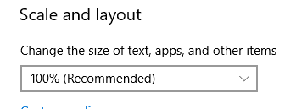

Concord Automation Tool requires "Admin Privileges" for few operations, so please ensure you run Concord as "Run as Admin" always.

# Installation

## Installation related files and its uses.

Concord Build comes as a zip file. Unzip the zip file and you will get the build folder along with exe for installing concord as below.

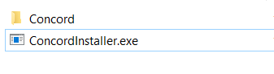

Using ConcordInstaller.exe user can do Install, Version Upgrade and UnInstall of Concord application.

## Installation using ConcordInstaller.exe

Execute ConcordInstaller.exe file with admin rights. Ensure that no instance of previously installed Concord application is open during setup.

**NOTE** : Admin rights are required for installation of the Concord Application.

If Concord is not installed previously on the system, the installer will start up with the window for selecting the installation mode.

The concord version that we are about to install will be displayed on top left of installation window along with the title.

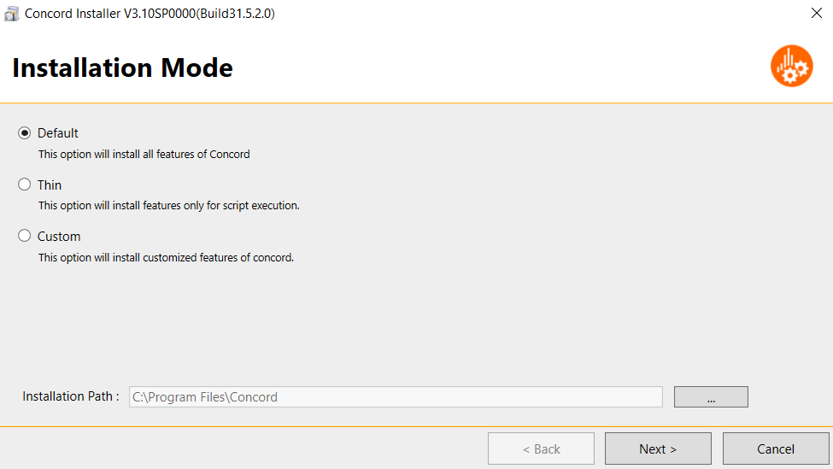

Here user can choose the mode of installation and installation path. The default installation mode selected will be “Default”. User can choose from the available options (Default, Thin or Custom).

The installation path selection area will display the default installation path as ”C:\Program Files\Concord”. Use the browse button to change the installation path and select the installation folder if required. Now click the “Next“ button to proceed further. The settings window displayed after this will depend on the installation mode selected.

**NOTE** **:** With “Default” and “Custom” options, the IDE is included in the installation. If you do not want to include the IDE and only want to install the runtime environment, select “Thin” installation mode.

* **Default**

If we select the “default” installation mode it will install all features of Concord. User can choose this option to install Concord with default settings. On clicking “Next” button, the consolidated “Summary” window will be displayed as below.

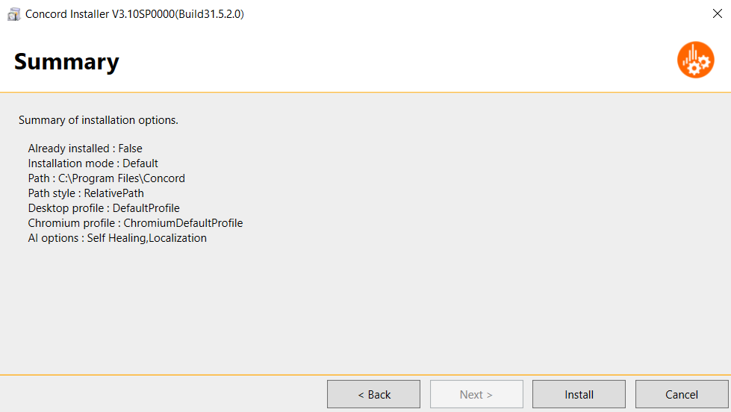

The default settings that will use during installation will be displayed in this summary window. For “Default” mode all AI options will be enabled. User can confirm the settings before proceeding for Installation.

* **Thin**

This option will install only the necessary features required for script execution. After selecting the installation path, click the “Next” button to move to “AI Features” selection page.

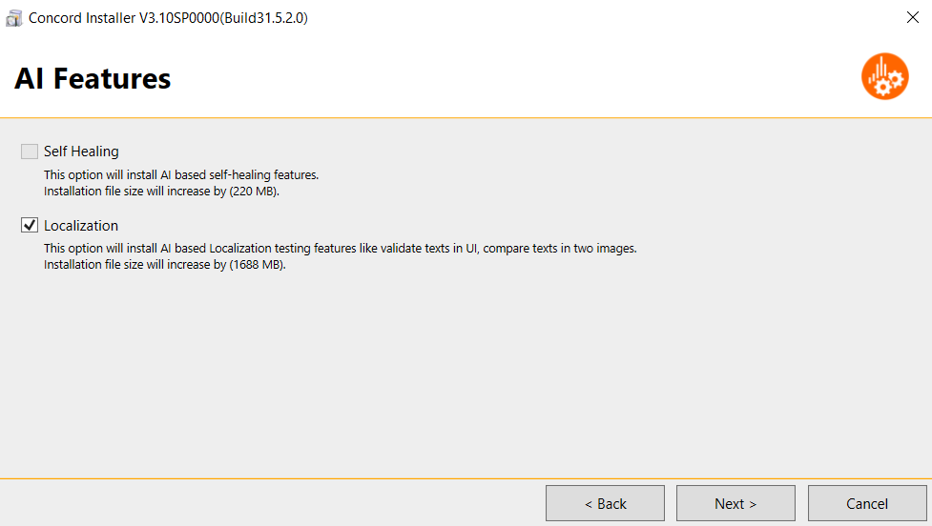

This window lists all the AI options supported by Concord namely Self Healing and Localization. For “Thin” installation only Localization AI option can be used. Check this option to install AI based Localization testing features. The installation file size for this feature will be displayed along with the description as (xxxxMB).

Click the “Next” button to view the summary details as below.

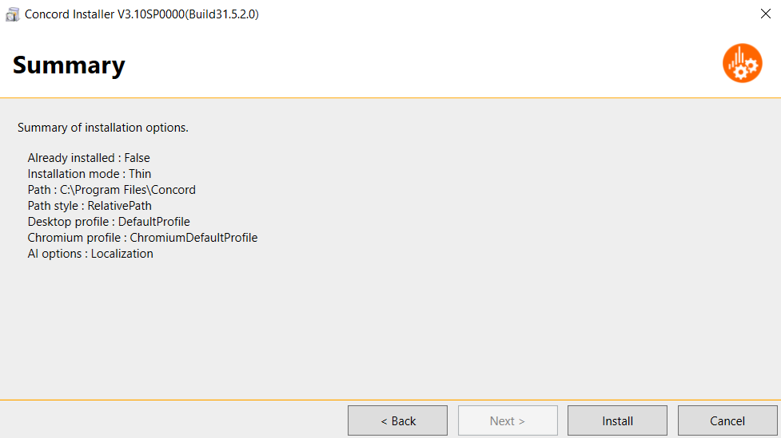

Confirm the installation options before proceeding for Installation.

* **Custom**

If user wants to proceed with custom installation enable this installation mode. After selecting this option user can perform customized selection of all installation options.

Click the “Next” button to navigate to the “Profile Selection” window.

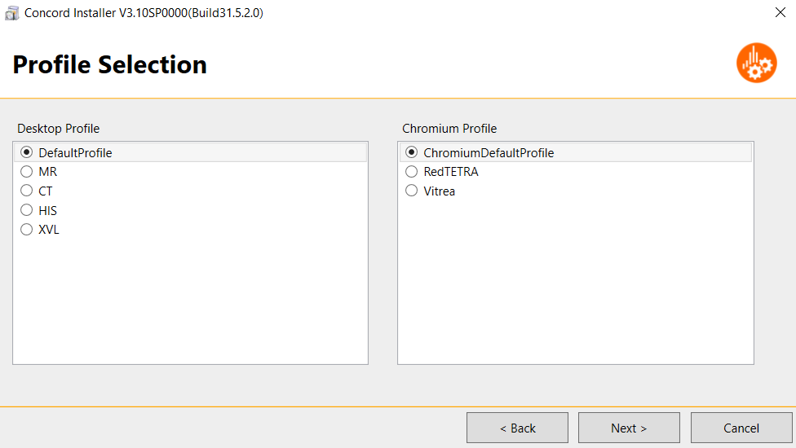

Profile selection area will list all available desktop and chromium profile options. By default, DefaultProfile and ChromiumDefaultProfile will be selected. User can change the options as required.

On clicking the “Next” button “Path Style Settings” will be displayed. Below screen will be shown to select the path style for solutions.

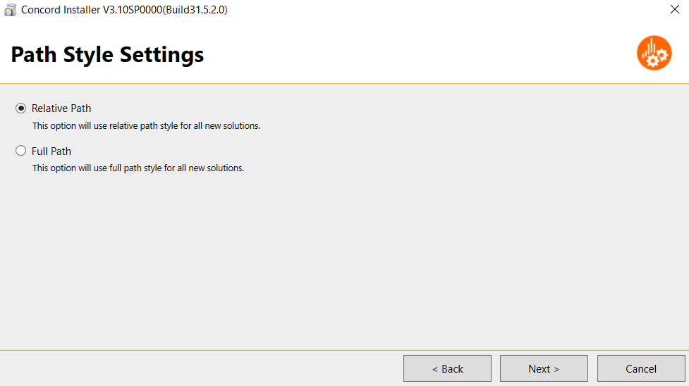

Select from the below path style options before proceeding.

* Relative Path – To use relative path style for all new solutions.
* Full Path – To use full path style for all new solutions.

This setting will be applicable for all new solutions created in the build. For the older solutions, settings already done on that solution will be applicable. User can change this setting later from Global Settings-> Advanced tab (Refer 16.2.3 Section).

Click on “Next” to move to “AI features” selection window.

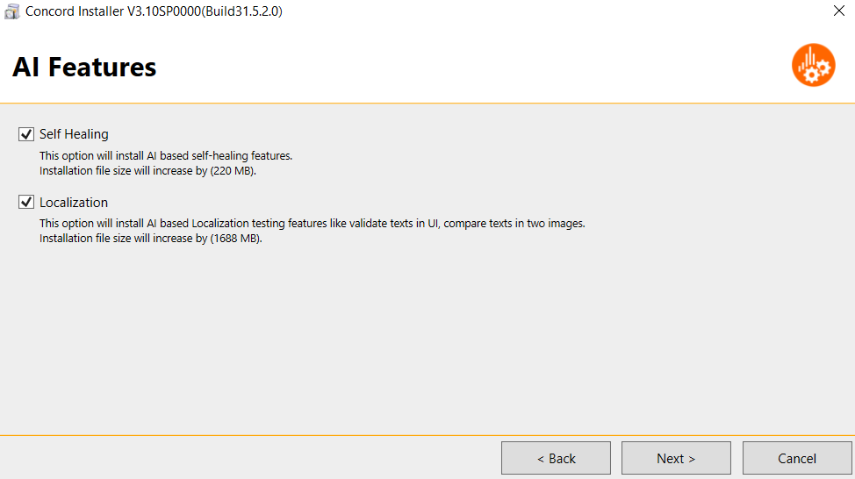

Currently Concord supports the following AI features

* Self Healing – By checking this option the installer will install all AI based self healing features. The installation file size for this feature will be displayed as (xxxxMB).
* Localization – Check this option to install all AI based localization features like validating texts in UI, compare texts in two images. The installation file size for localization will be displayed as (xxxxMB).

Once “Next” button is clicked the summary for custom installation will be consolidated as shown below.

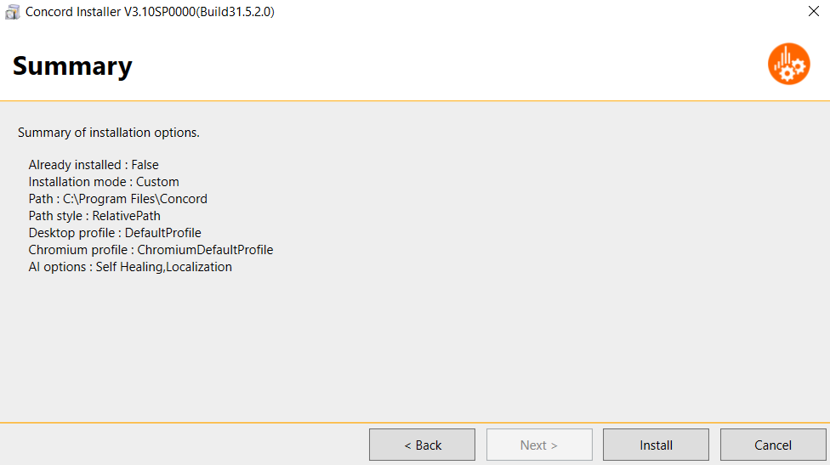

At any point of installation if the user wants to change the installation options, click the “Back” and “Next” button to move back and forth between windows. In order to quit the installation wizard, click the “Cancel” button. If the user is ready to go with the settings click “Next”.

After selecting any of the above-mentioned installation mode and then clicking the “Install” button, the progress of installation can be seen on “Installation In Progress” window.

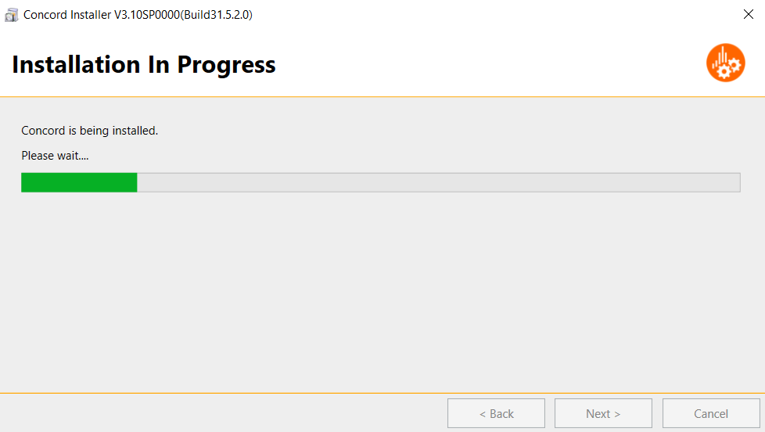

If any error occurs during installation the “installation Error” page will be displayed as below.

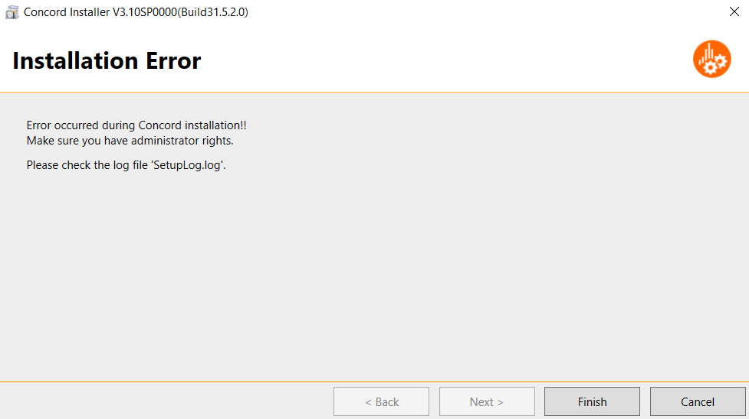

Error details can be viewed in “SetupLog.log” located at installer exe path. If the installation is successfully completed it will automatically prompt to the “Installation Completed” page.

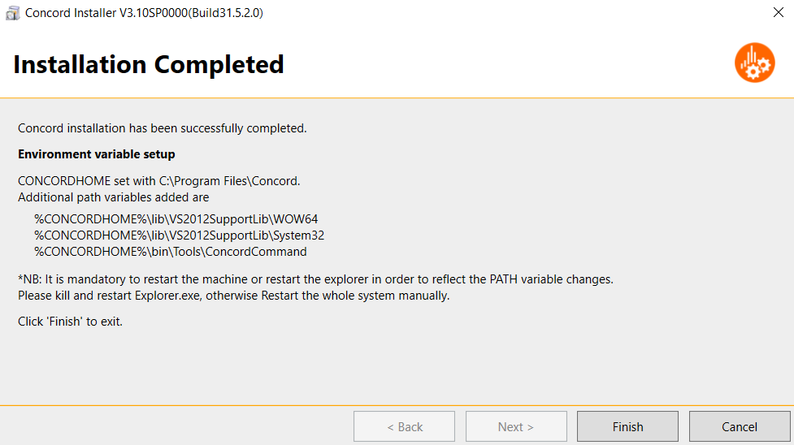

Here we can see the Environment variables setup details ie. CONCORDHOME path and additional path variables.

Finally click the “Finish” button to exit the installation wizard.

**Note:** It is recommended to restart the machine or explorer for reflecting the changes.

## Version Upgrade using ConcordInstaller.exe

If Concord is already installed in the system and user execute ConcordInstaller.exe with admin privilege, the installer “Setup” window will display as follows.

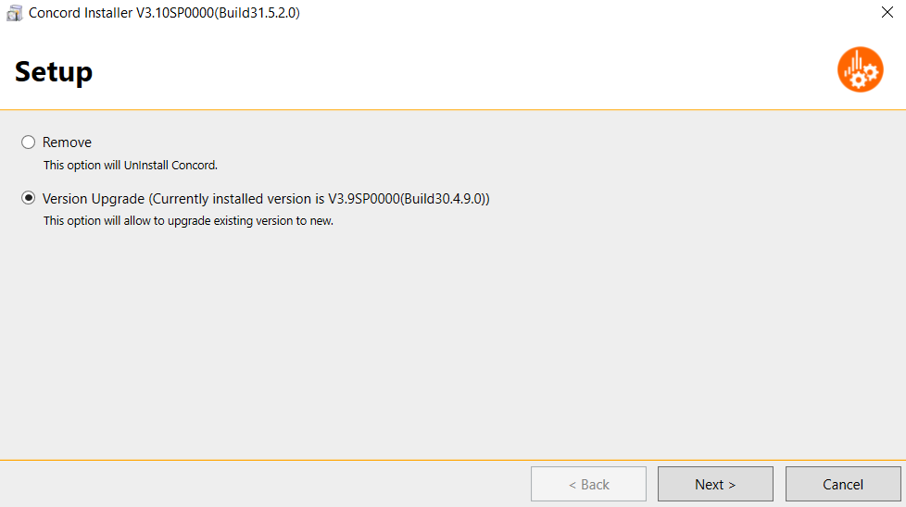

Choose the “Version Upgrade” option. The currently installed Concord version will be displayed along with version upgrade option as above. Click the “Next” button to view the “Installation Mode” window for version upgrade.

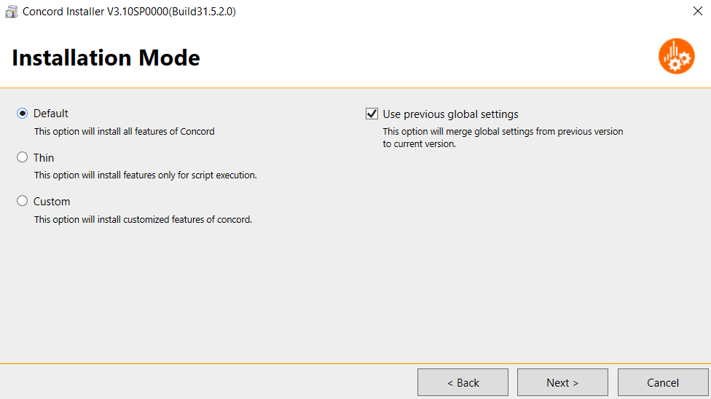

In order to use global settings from previous build, check the “Use previous global settings” option. This will merge global settings from previous version to current. By default, this option will be checked.

The version upgrade path will be same as the already installed concord path. A backup for installed concord version will be kept at the same path. Choose any installation mode from above options and proceed as mentioned in 2.2.

For version upgrade the summary will be displayed as follows.

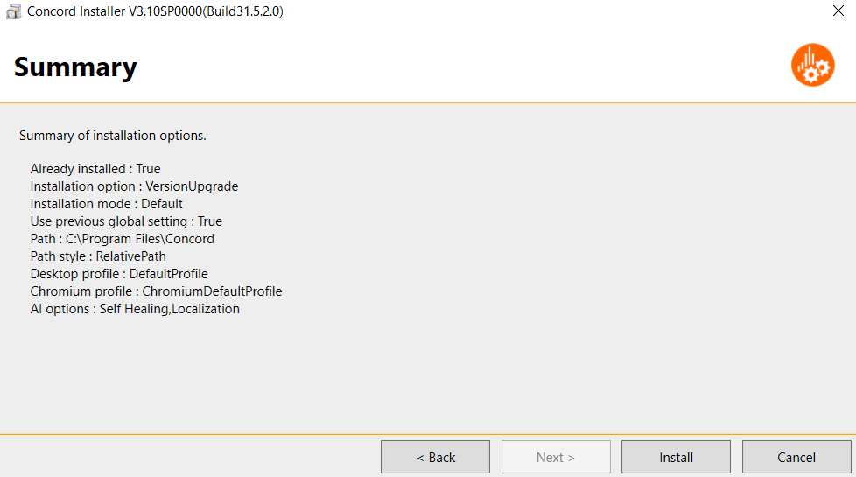

Verify the settings and click “Install”. User can view the progress of installation in “Installation In Progress” window.

Once the installation is finished the “Installation Completed” page will be displayed.

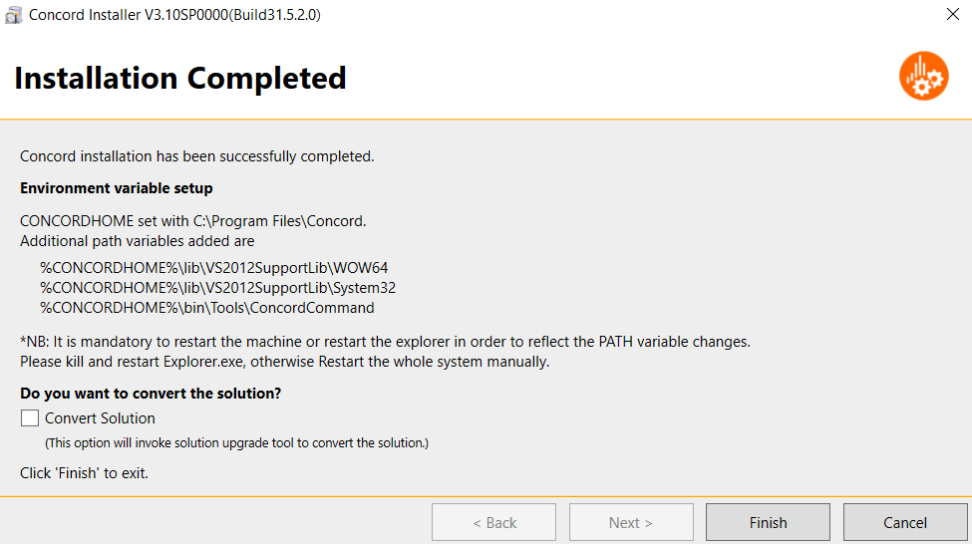

Here we can see the Environment variables setup details ie. CONCORDHOME path and additional path variables.

Once the installation is completed and user wish to convert the solutions, check the “Convert Solution” option. This will invoke the Solution Upgrade Tool to perform solution conversion.

Finally click the “Finish” button to exit the installation wizard. If “Convert Solution” option is checked, Solution Upgrade Tool will be displayed.

**Note:** It is recommended to restart the machine or explorer for reflecting the changes.

## UnInstallation using ConcordInstaller.exe

If concord is already installed, run ConcordInstaller.exe with admin rights to uninstall concord. Choose “Remove” option from the window displayed as below.

**NOTE** : All instances of Concord should be closed before starting with the uninstallation process.

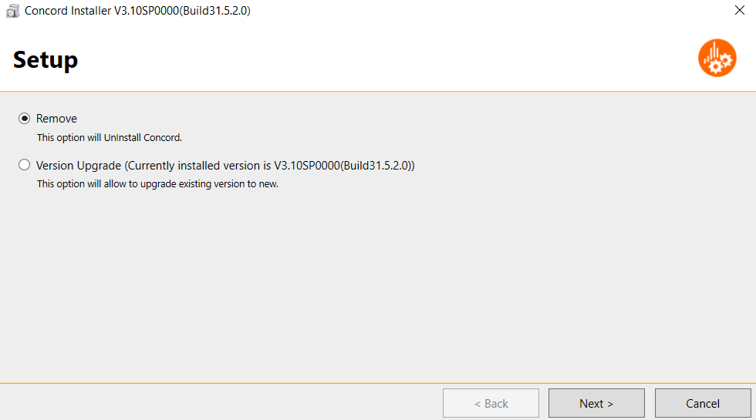

Click “Next” button to display the “Confirm UnInstallation” window.

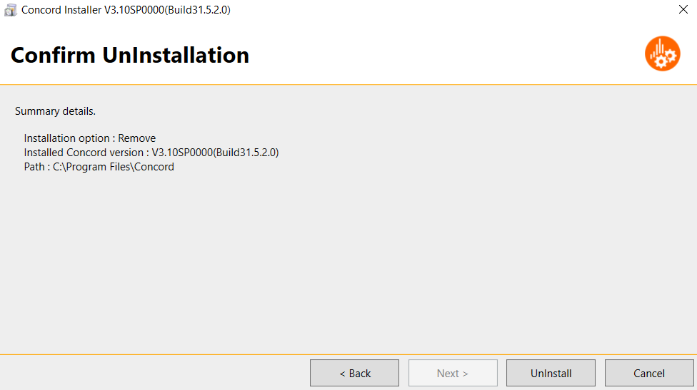

Installed concord version and path details will be displayed in the confirmation window. Click “UnInstall” to proceed for uninstallation.

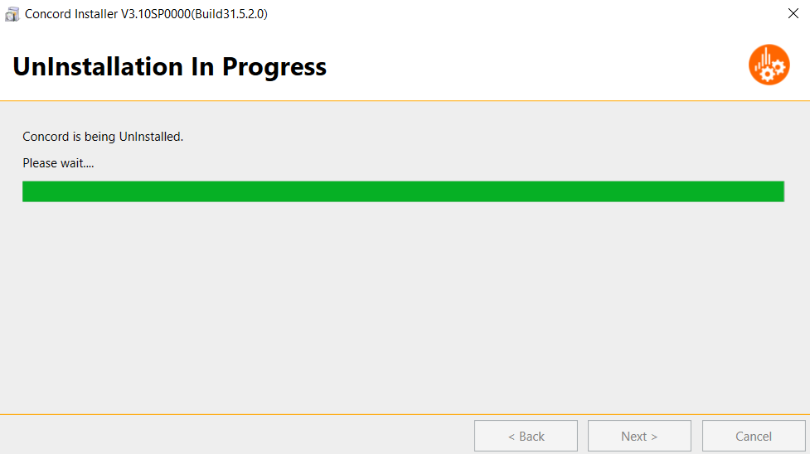

If any error occurs during uninstallation then “UnInstallation Error” window will be displayed.

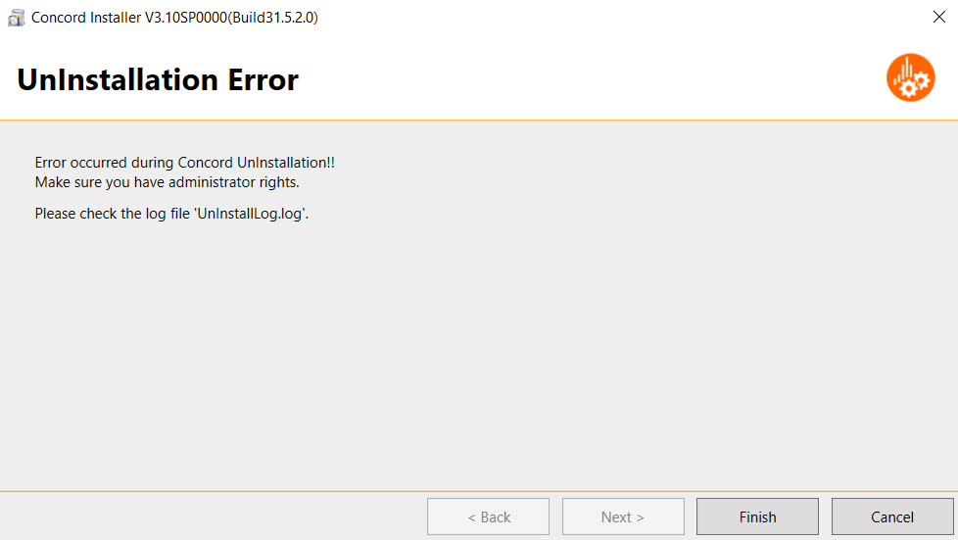

Once the uninstallation is completed successfully, the “UnInstallation Completed” window will be shown. The details of uninstallation or any uninstallation error details will be displayed in “UnInstallLog.log” file located at installer exe path.

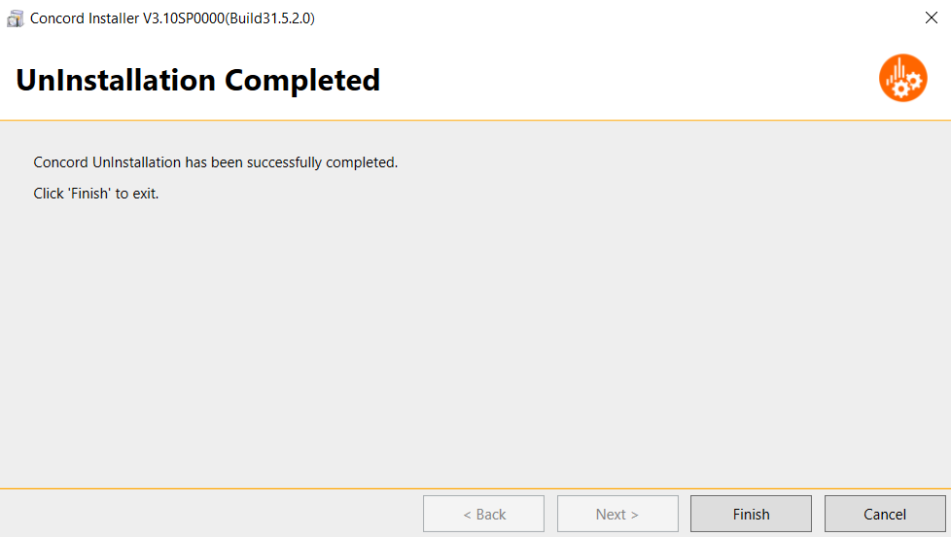

Click “Finish” to exit the uninstallation wizard.

## Log files

For any kind of Installation, Version Upgrade or Uninstallation log files will be generated which will have the details of installation/uninstallation process.

For Installation or Version Upgrade the installation details or error log details will be created in SetupLog.log. For uninstallation the log file created will be “UnInstallLog.log”. The log files can be found in the same path where ConcordInstaller.exe is present.

After installation completed successfully, these logs will be taken backup to <%CONCORDHOME%\Log\setuplog\> folder.

## Invoke the Tool

Once Concord is installed successfully and Environment variables are set, executable file will be available in the bin folder at the location the build is installed.

E.g. For default path, exe will be available at below location:

*C:\Program Files\Concord\bin\SharpDevelop.exe*

While invocation of Concord user will be asked to enter a valid license provided by ****, See the figure shown below.

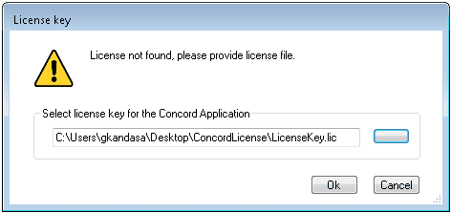

In the above dialog please browse for file and select “LicenseKey.lic” and click OK.

Note: Please note the below for licensing

* Without a valid license we cannot invoke Concord.
* Validity of license will be expired in 1 year after that **** will provide a new license.
* Validity of license is also specific to the version installed, for a different versions different license will be provided.

Once valid license is entered window will invoke automatically, See the figure shown below..

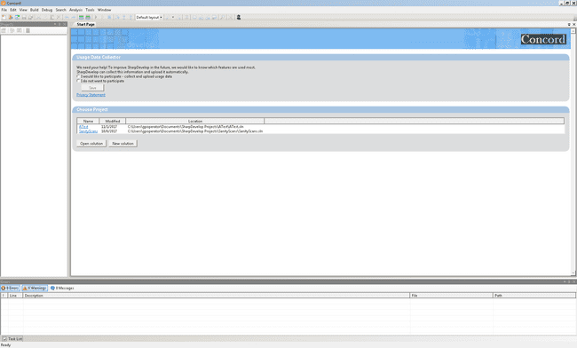

## How to create New Project

Click on **“New Solution”** to create New Project. To create a new Test Project select **“Concord Test Suite Module”** and click **“Create” ,** see the figure shown below.

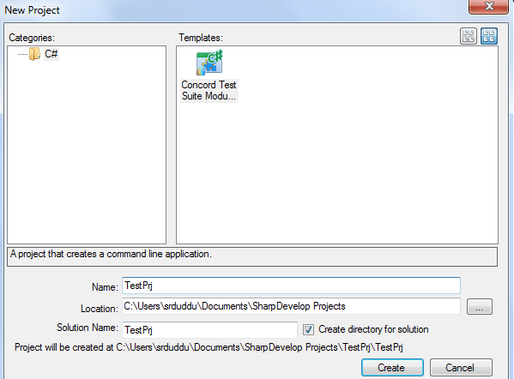

## How to invoke Test Script Generator Plugin

Script generator window can be launched by double clicking on the Recording icon see the figure shown below:

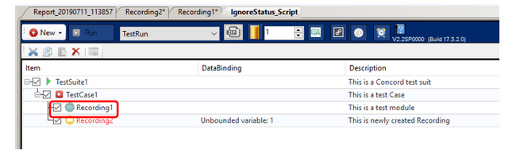

Test steps can be created by selecting the actions from below lists

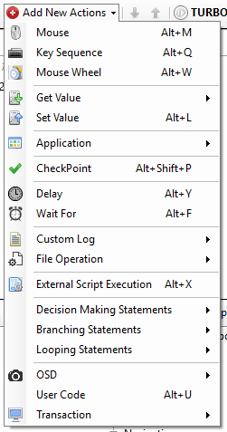

Actions can also be added through context menu that is displayed on right click on any added step in the steps grid see the figure shown below:

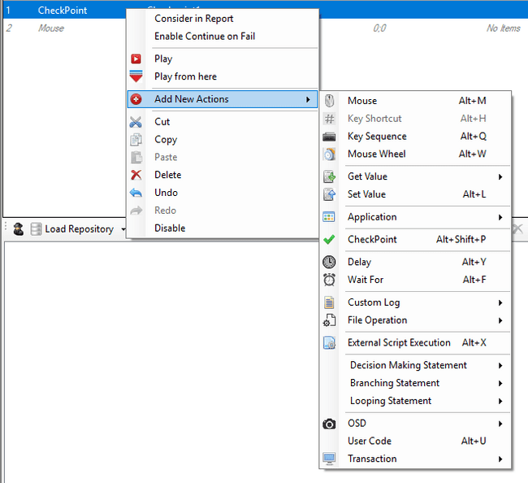

The context menu contains edit options like Cut, Copy, Paste, Delete, Undo, Redo etc. see the figure shown below.

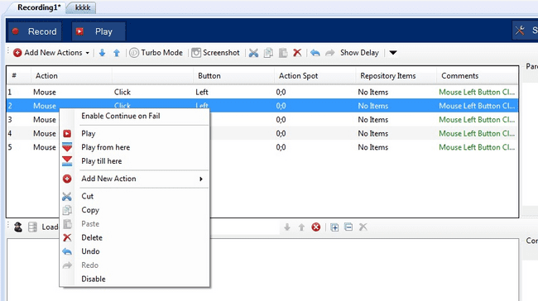

**Play**  
Select one or more steps of a recording and click on “Play” in the context menu.  
It will execute only selected rows.

**Play till here**  
This will execute the steps from step no. 1 till the currently selected step on which right click was done.

**Play from here**  
This will execute the steps from currently selected step on which the right click was performed till the last step.

Please note:

1. “Play till here” and “Play from here” context menu options will be not available on selecting more than one steps.
2. “Play from here” context menu will be not available on right click for last step.
3. “Play till here” context menu will be not available on right click for first step.
4. “Play”, “Play till here” and “Play from here” context menu will be not available for disabled steps.

# Workflow for creating test steps

## Create an Object Repository

An Object Repository of Test objects/controls can be created by using “Object Spy”. This object repository can be used to perform test operations on the added objects/controls when steps are added manually.

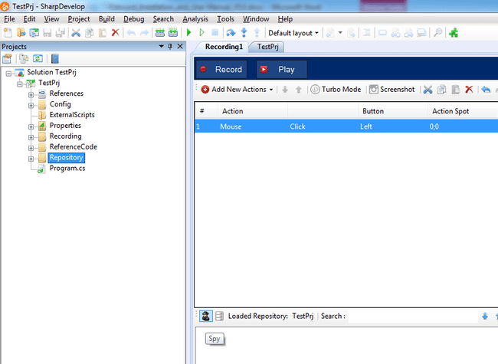

Below is the snapshot of Spy Tool along with sample application. The tree also shows controls with IsControlElement=False.

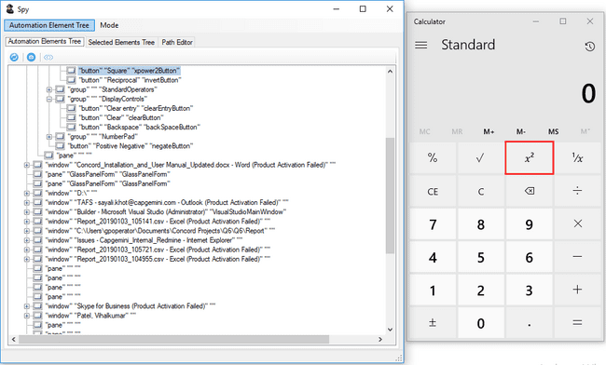

## Add the selected object to the Repository

To add an object to the repository, select and right click on the object. Below two options can be seen:

* Add to Repository – This adds only the selected object with its Parent node to repository.
* Add to Repository ( include Children) – This adds the selected object with its parent hierarchy and its child controls.

**Note**: Ensure the Focus is on the Application Under Test (AUT) that is to be automated, so that Spy & AUT are only active windows see the figure shown below.

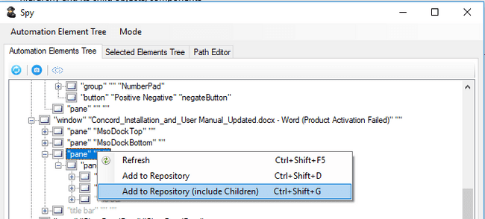

When you switch to the "Selected Elements Tree" tab, the repository items you added are highlighted to blue. The highlights are retained until you save the repository even if you rename added repository items.

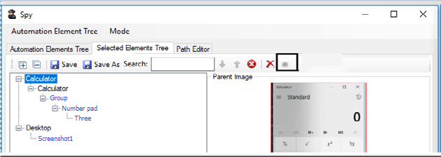

In case if same element is present in repository then user will have option to add duplicate element in repository.

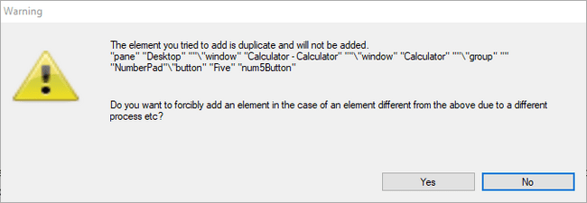

In case of Include children, checkbox will be provided to skeep further confirmations.

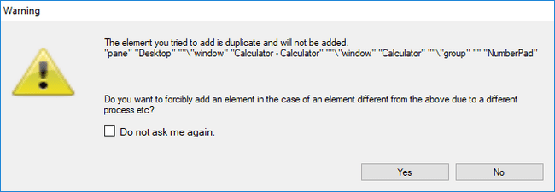

Also using Hover Mode, the individual elements to be added to the repository can be identified in the Spy Tool, see the figure shown below.

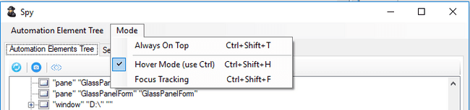

## Add a screenshot of the selected object

To add an object to the repository, select and right click on the object. Below two options can be seen:

* Add to Screenshot – Add a screenshot of the selected object.

**Note**: Ensure the Focus is on the Application Under Test (AUT) that is to be automated, so that Spy & AUT are only active windows see the figure shown below.

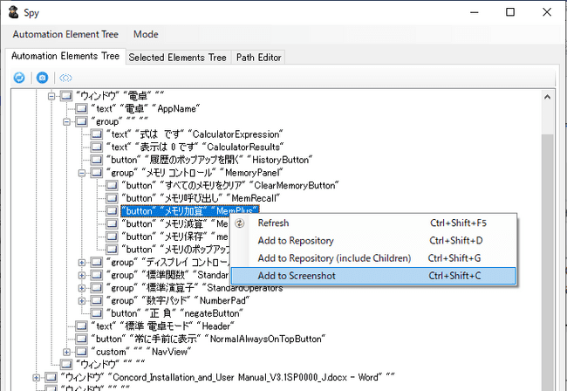

When you switch to the "Selected Elements Tree" tab, the repository items you added are highlighted to blue. The highlights are retained until you save the repository even if you rename added repository items.

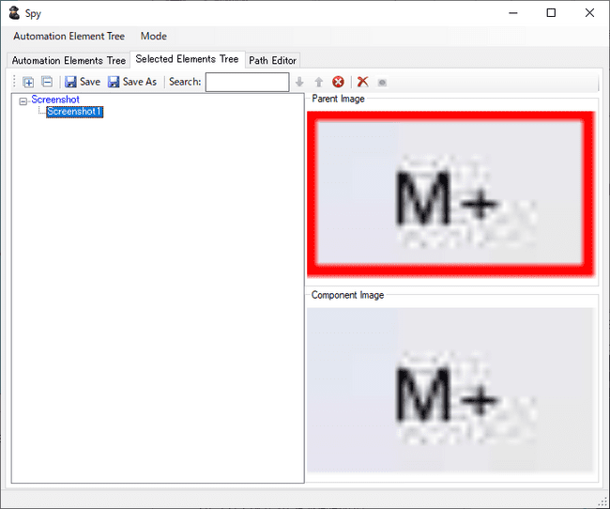

The screenshot name is automatically created as Screenshot + number.

## Add the selected object to the Repository（Timer）

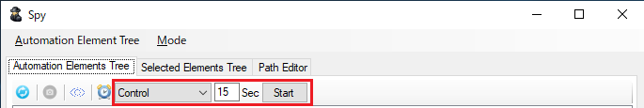

You can automatically add selected objects to the repository using the following method.

1. Select the [Automation Elements Tree] tab and select [Control] from the registration type.
2. Set the timer time. (Settable time: 1 to 999Sec)
3. Press the Start button. When pressed, the timer time countdown starts.
4. Place the cursor on the object you want to register and wait until the countdown reaches 0.
5. When the countdown reaches 0, the object under the cursor is automatically added.
6. The added object will be displayed in a red frame (*), and the corresponding node will be highlighted in the Tree.

*Since the corresponding object will be displayed in a red frame after the additional processing is completed, there will be a delay from countdown 0 until the red frame is displayed.

## Add a screenshot of the selected object（Timer）

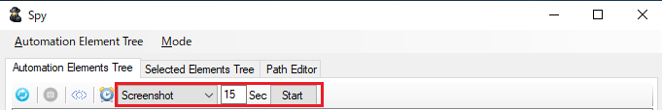

You can automatically add the selected object (Screenshot) to the repository using the following method.

1. Select the Automation Elements Tree tab and select Screenshot from the registration type.
2. Set the timer time. (Settable time: 1 to 999Sec)
3. Press the Start button. When pressed, the timer time countdown starts.
4. Place the cursor on the object you want to register and wait until the countdown reaches 0.
5. When the countdown reaches 0, a screenshot of the object under the cursor will be automatically added.
6. The added object will be displayed in a red frame (*), and the corresponding node will be highlighted in the Tree.

*Since the corresponding object will be displayed in a red frame after the additional processing is completed, there will be a delay from countdown 0 until the red frame is displayed.

## Save the Repository

The repository can be saved in one of the two ways:

1. **Save**: Click on save will save the project using the name of the current project by default.
2. **Save As**: This option is used to save the repository in a different path or using a different file name.

The highlights (blue) of the added repository itemss will return to black when saving repository is completed.

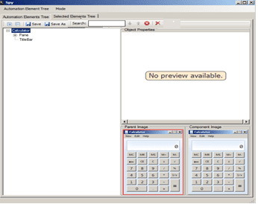

XVL profile selection changes on Repository saving from Spy:

1. User selects the XVL profile as default profile from Project setting tab as shown in below fig:

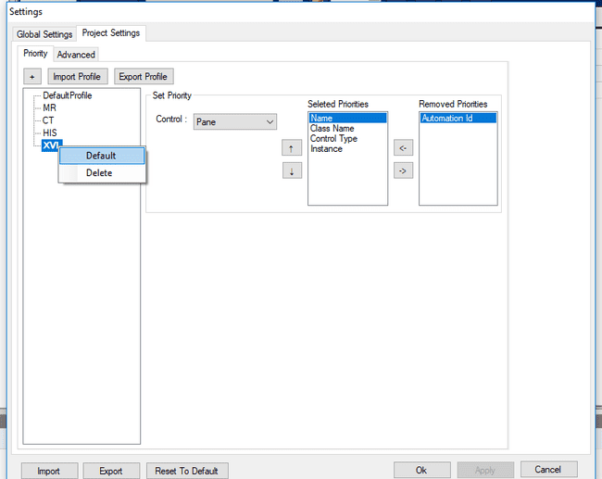

1. In case of XVL profile, the spy saving option will be disabled.

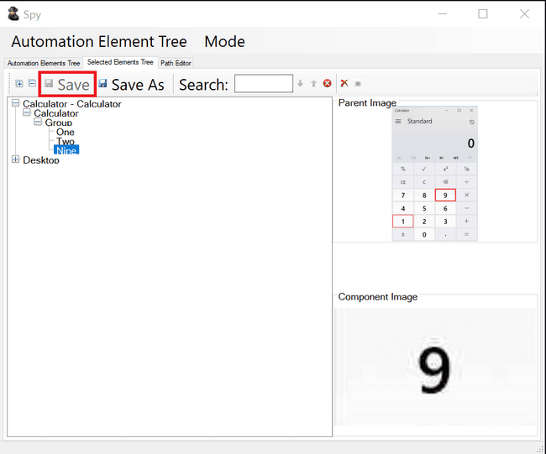

1. If user performs any action using spy then user needs to directly close the spy in order to update the changes in Repository of IDE. On closing of spy user will not be prompted with the message to save the changes.
2. Any changes done from Spy including Add to repository, Add to repository including children, Rename element, Delete element, Path Editor changes Apply, etc. all these changes will be updated in the repository without clicking on Save Button. User needs to just change and close the spy.

**Note**:   
If SPY is opening from



It is only for editing current repository items which are loaded in IDE.  
User should not be allowed to load the other repository using IDE same is the behavior in other automation tools.

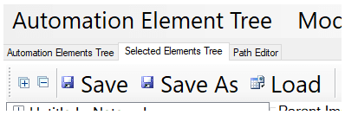

If user wants to load or merge repository then he can use IDE load repository.  
Load option should be available if SPY is global SPY.

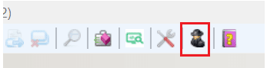

If SPY is opened for a local solution then it is to edit the present repository and to load other repository users should use load repository option from IDE.  
As user can see a linked object in steps, also the same behavior is matching with other tools.  
So load repo is hidden if SPY is opened for local repo and it will be available if SPY is opened from global SPY.

## Object Properties (with real time values)

1. When saving repository we are storing properties and same could be shown in object properties window. These will be selectable, and used for Custom Identification improvements see the figure shown below.
   * 1. 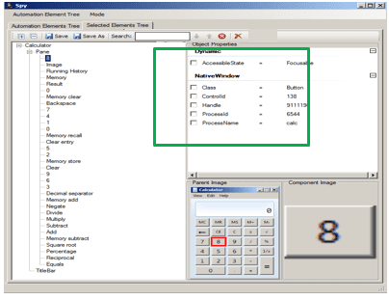
2. While adding items in repository if any item doesn’t have properties then spy will display “No preview available” See the figure shown below.

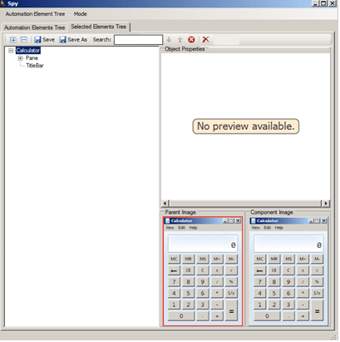

1. E.g. Window’s run time properties as follows-:

Control State, Exists and Visible, see the figure shown below

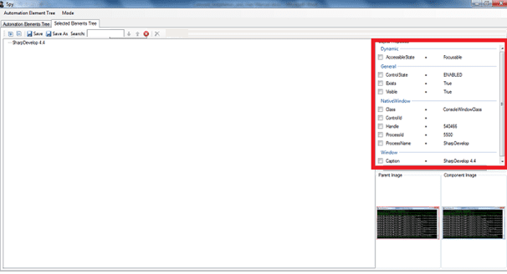

## Highlighter

User can highlight saved repository item whose smart path has been created successfully, See the figure shown below:

Enable Highlighter option either from “Selected Element Tree” or from “Path Editor”.

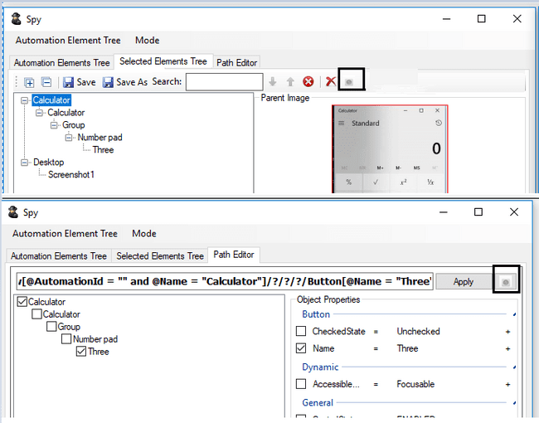

* + 1. Now select the repository item which needs to be highlighted. While Spy search for repository item below highlighted see the figure shown below:

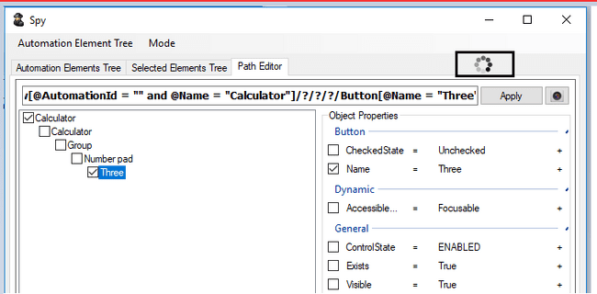

* + 1. User can add/modified property of selected element from object properties window. If element is found it will be highlighted on screen with blue rectangle and if element is not found spy will show below message “Timeout. Not able to find control”. Please check below figures for examples. *You will also get “Timeout. Not able to find control“ message if element is actually not present on screens.*

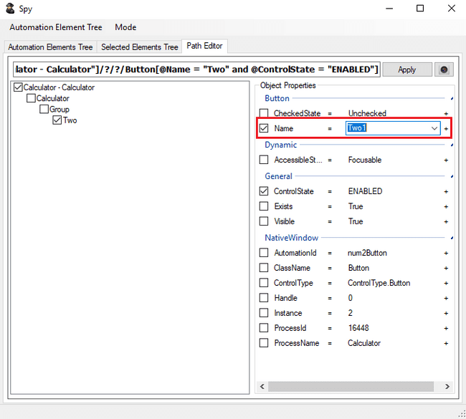

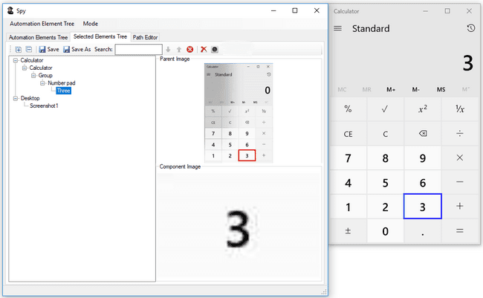

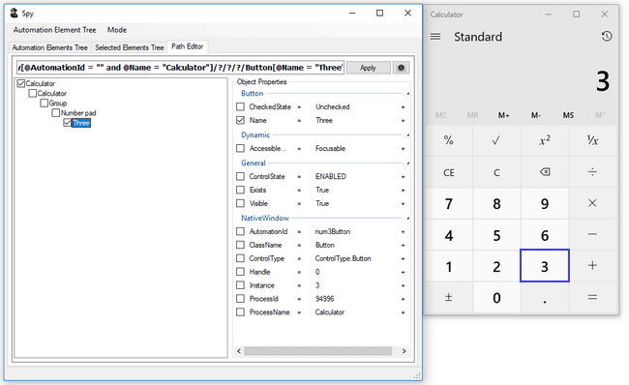

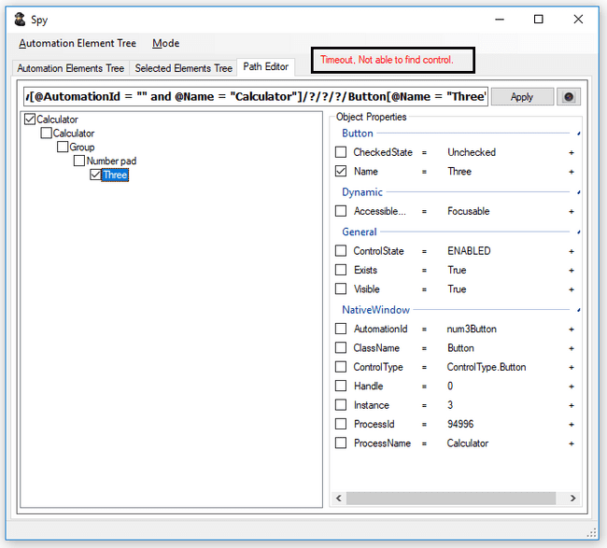

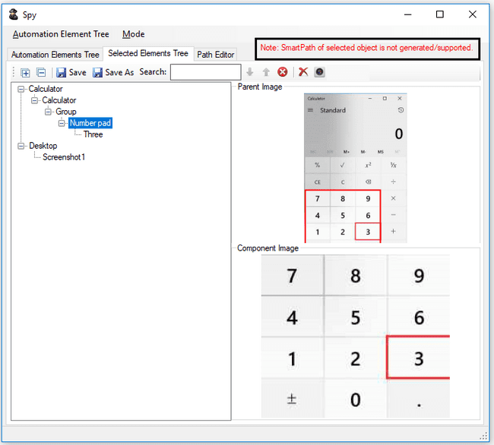

## Close the Spy Tool

The saved Repository is now loaded into the IDE Repository pane, and can also be invoked in Step Action (if applicable) see the figure shown below.

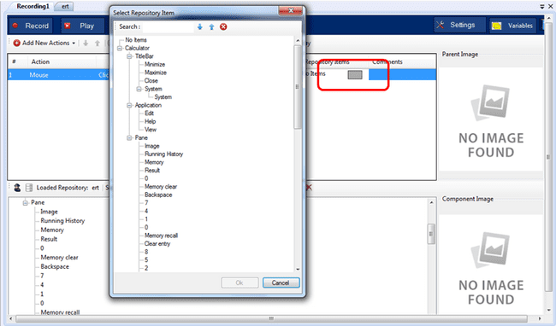

## Associate “Test Step” and “Action”

Associate any Action with the Test object. Repeat the process for other steps.

## Click on Play Button

This would Build Project & Run the script

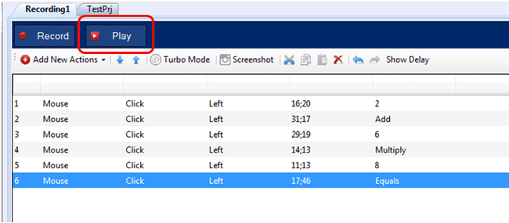

After the Test case is executed, Report is displayed in new tab.

## Track Element – Manual

Track element is another way of adding elements in the repository. In this the user need not search for the element in spy tool. User can click the Track Element button on IDE which will set the tracking mode to ON. The cursor should be then pointed to the element that should be added to the repository. A green box, similar to the red one displayed in spy, can be seen bordering the selected element. User can then click the allotted button (F2 by default) to add the element in repository. User can exit from the track mode by pressing the button (F3 by default) allotted for exiting the tracking mode. Once the tracking mode is set to OFF, the green border will stop appearing around the selected element.

The buttons for adding the elements in repository and exiting the tracking mode can be configured in global settings. Please refer the Global Settings section for more details on how to configure the keys.

Below are the steps to track an element:

1. Check the keys for adding the element in repository and stopping the tracking. This can be done in one of the below two ways:
   1. Go to Global Settings and see the keys configured for tracking under the Repository Defaults tab.
   2. See the tooltip for the Track Element button.



1. Click on Track Element button to start tracking.
2. Hover on the item to be added to the repository. A green border will be seen.



1. Press the key set for addition of element in the repository (F2 in this case).
2. Repeat steps 3 and 4 for all the items that should be added in the repository.
3. After the required elements are added, click on the key set to stop tracking (F3 in this case).
4. The IDE will appear with the added elements.



**Note:** Some AUT’s implementation may be different resulting in the object display hierarchy wrongly. For e.g: in case of MR/XR application there are some tab controls under which same list will be displayed, resulting in display of tab control & the list control under same parent instead of displaying the list control under tab control in the SPY. In this case play back of the list control may result in failure so user need to take necessary workarounds like changing the smart path or image base recording.

# IDE Actions

## Enable/Disable the Steps

Test steps can be enabled/disabled using the Enable/Disable option that appears on the right click of the test steps see the figure shown below. By default step is enabled. When enabled, only disable option appears in the context menu on right click. If step is disabled, only enable option appears in the context menu on right click.

Right click on the enabled step in order to get the option to disable the step:

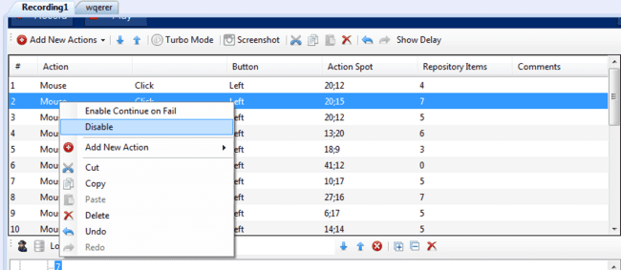

When disabled, Step changes the font to italics and gets greyed out as shown below:

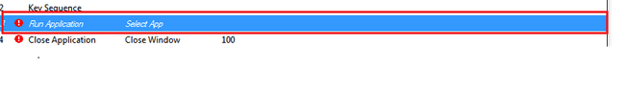

Right click on the disabled step in order to get the option to enable the step as shown below:

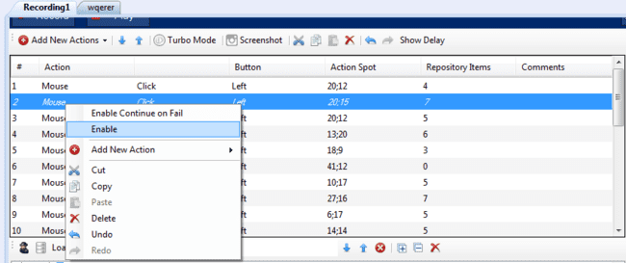

On clicking on the enable action the step becomes enabled and changes its font to normal.

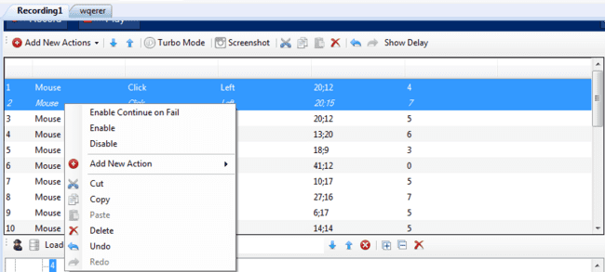

When a mix of Enabled/Disabled steps is selected, user gets the option to Enable /Disable in the context menu on right click. Enable will enable the disabled steps and Disable will disable the enabled steps.

Undo and Redo can also be performed on the enabling and disabling steps.

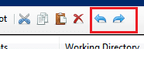

## Delete Repository Item/Node from IDE

Delete node functionality deletes the selected node(s) from repository in IDE.

Node from tree can be deleted by following ways

1. Select node from tree to be deleted and click on delete button

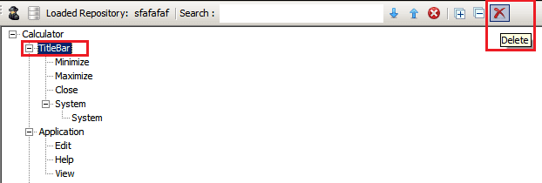

1. Right click on node to be deleted. A context menu appears with the Delete option.

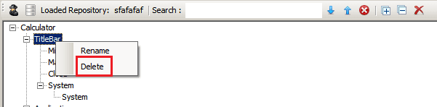

1. Select node to be deleted and click on Delete.
2. Check if the delete node is linked to any step, display link information list dialog.

**The case linked to any step:**

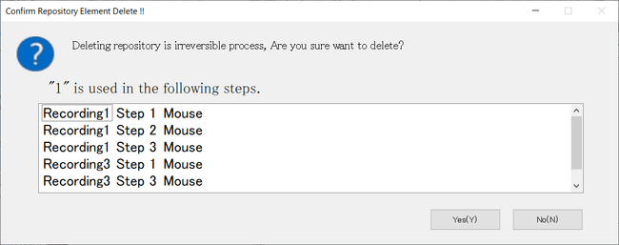

**The case no link:**

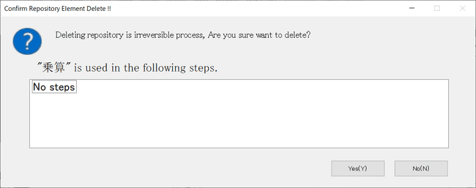

1. In the dialog displayed, if user clicks [YES]button, repository items/nodes are deleted.

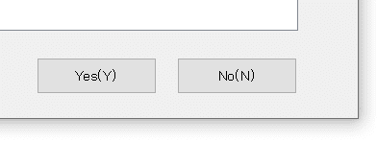

1. In the dialog displayed, if user clicks [NO]button, delete operation is canceled.



When user deletes node, if that node is linked with any step, then it gets unlinked. “No Item” will be displayed in place of deleted node in step.

## Unlinked Repository items/nodes Bulk Deletion

User can delete unlinkd repository items/nodes at once by clicking ths button shown in the figure below.  
Here is how to delete repository items/nodes from the tree structure.

1. Click the [Delete unused items]button.



1. Display a list of unlinked repository items/ nodes in a dialog.

**a list of unlinked repository items/ nodes:**

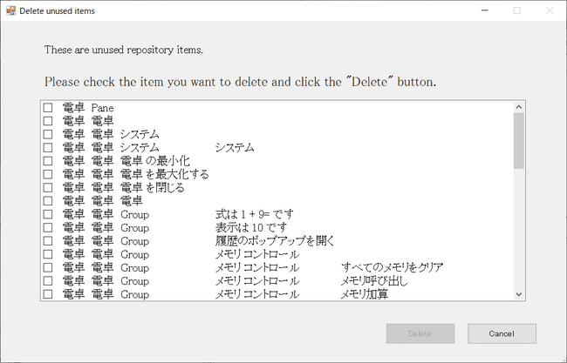

1. Check and select the checkbox of the repository items / nodes user want to delete.

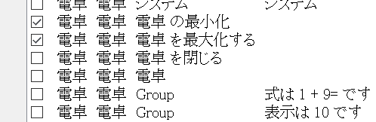

1. Click the [Delete] button in the displayed dialog to delete all selected repository items / nodes.

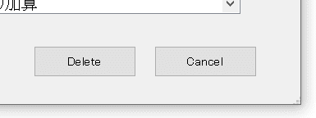

1. Click the [Cancel] button in the displayed dialog to cancel the batch deletion.



## Expand /Collapse All

On click of Expand All button the entire tree structure is expanded.



On click of Collapse All button all the tree nodes are collapsed.



## User group feature for repositories

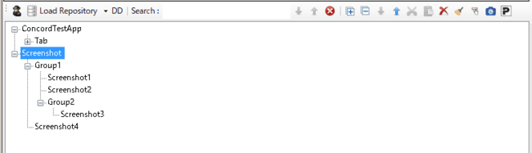

For screenshot items only, users can create arbitrary groups in the tree hierarchy created by default and move screenshot items into the created groups.

Screenshot items can be moved using the context menu or drag and drop, and within a screenshot you can move screenshot items and group hierarchies.

## Update Image of screenshot

In image based automation when AUT images change then user can update images using this functionality.

User can update image without unlinking from steps which was captured in image based recording. Update option is present on context menu for image element see the figure shown below.

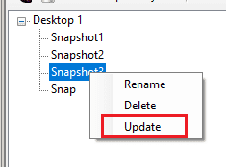

On clicking the update option from the right click context menu, Edit Click Location dialog will get invoked. User can do either of the following:

1. use the already loaded image or
2. by selecting any image from the disk or
3. Can capture a new image.

Region button is present at top of Edit Click Location dialog, clicking on that button will start the screen capture mode which will help to capture region see the figure shown below.

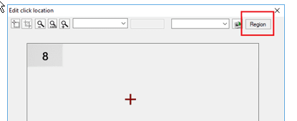

Note: While updating image, if new image is a single color image then user will get a following warning message. As single color image may give wrong result.

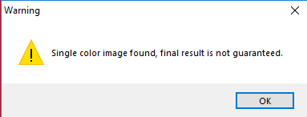

## Mouse Image action (Force Threshold to pass)

User can capture coordinate and check linked image is exist in given coordinate. On failed steps user can pass action by applying Force Threshold to Pass.

1. On adding new mouse action click on Repository Item column two options will display Add Image and Select Repository , see the figure shown below.

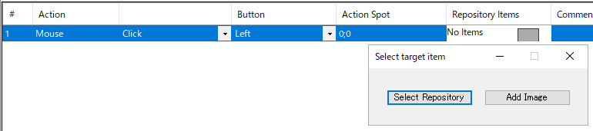

1. **Select Repository** => User can select existing repository and link to mouse action
2. **Add Image** => On click of Add Image button Screen Capture mode open user can select required area to capture, After capturing, the area is saved as an image in repository as Screenshot and then, Edit click location window with editable Image percentage opens as shown in below figure.

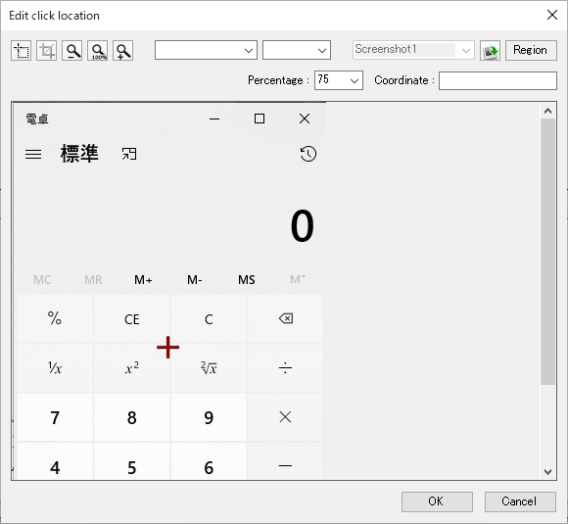

On click of OK button captured screenshot get added in selected step, on cancel operation screenshot will not add in step.

Runtime it will check screenshot exist in captured coordinate, user can update screenshot.

When an external image is added to the given step, the coordinates will be removed.

1. Default percentage will show to all image based actions where user can update matching percentage.
2. After linking screenshot to given step and after Play/Run action is performed; if image is not matched with user given percentage, the step fails. User can pass same step by applying “Force Threshold to Pass” as shown in below dialog.
3. Right click on failed step, “Force Threshold to Pass” option appears in context menu, on click of Force threshold to pass User percentage value will swap with actual threshold. So that step will passed. See the figure shown below.

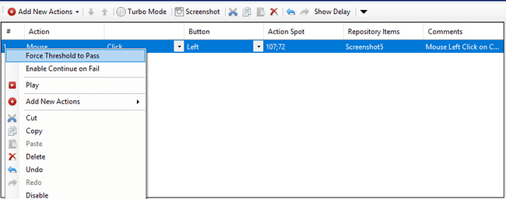

## Continuous screenshot (IDE)

User can take continuous screenshots for image actions. After taking screenshots user can link to step action.

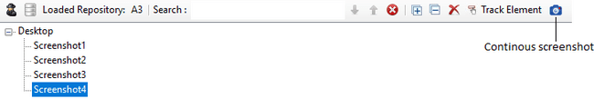

## Operations on IDE

These are the following operations that can be executed in IDE:

* + - 1. **Move Up and Move Down**: This operation allows user to move the selected action up or down in the recording.



* + - 1. **Cut:** This operation allows user to cut the action and paste it in recording.



* + - 1. **Copy:** This operation allows user to copy the action and paste in recording.



* + - 1. **Paste:** This operation allows user to paste the action which has been cut or copied in recording.

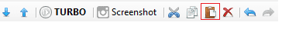

* + - 1. **Undo and Redo:** This operation allows user to undo the last user action performed on the recording and once undo is done, it allows user to redo it again in recording.



# Keyword Actions

There are predefined Actions for easy creation of steps. See the figure shown below.

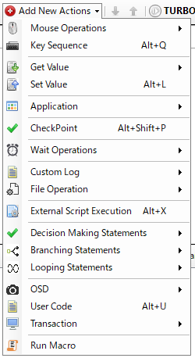

## Mouse Operations

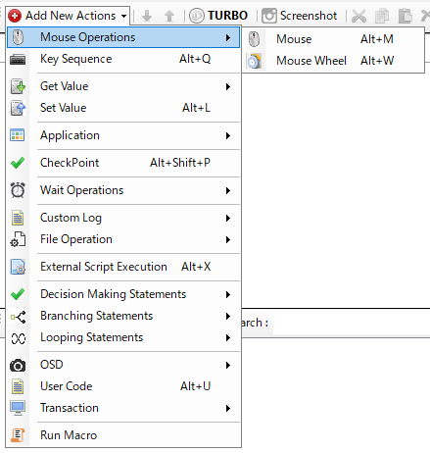

### Mouse

Users can automate left, right, and center mouse button clicks, double-clicks, moves, and up/down operations.



Mouse operation can be set from Up/Down/Click/Double Click/Move (see figure below).

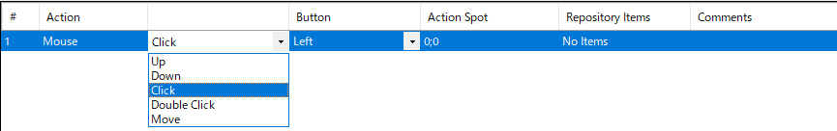

Button allows you to specify a mouse button (see figure below).

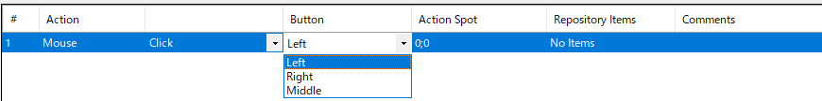

The Action Spot allows you to specify the mouse operation position.You can enter the coordinate position directly or select “Center” or a variable from the combo box.

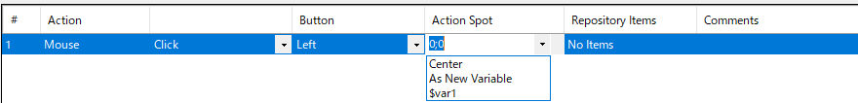

Repository Items allows you to associate repository items (controls) with actions. During the execution of this step, the specified mouse action is executed on the associated repository item (control).



Select Repository: Allows the user to select an existing repository and link to mouse actions.

Add Image: Opens Screen Capture mode. The user can select the area that needs to be captured. After capturing, the selected area will be saved in the repository as a screenshot. The Edit click location window will then open.



The Edit click location window allows you to specify the mouse operation position.You can enter the coordinate location directly or select a variable from the combo box.

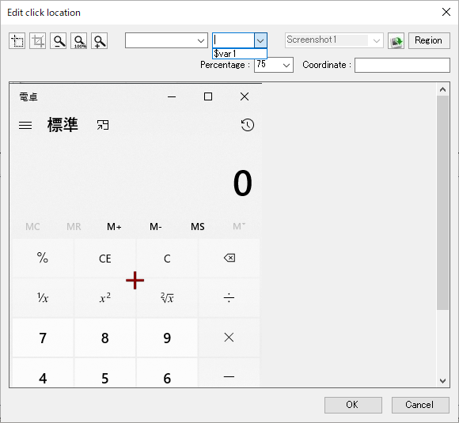

Clicking the OK button causes the Action Spot to reflect the mouse operation position specified in the Edit click location window.



**Note**: *In case of an object is overlapped by the topmost window, then still Concord will perform an operation and will show the result as pass.*

*So if the user has such a scenario then s\he should take care while the time of script creation by adding some checks.*

### Mouse Wheel

The MouseWheel action is used perform mouse wheel related actions like scrolling Horizontal/Vertical up/down, Zoom in/out with selected object. In IDE, “Add New Action” contains “Mouse Wheel” action by using user can add in IDE see the figure shown below.

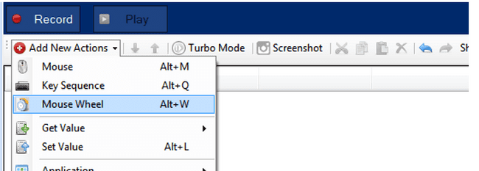

Mouse wheel action contains 4 fields in which “Orientation” and “delta” are mandatory fields and others are optional. Orientation having two types “Horizontal” which is for horizontal scroll and “Vertical” for vertical scroll see the figure shown below.

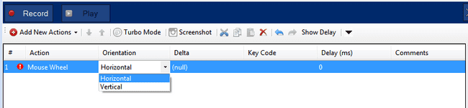

User has to put delta Value. Here delta value means count of single (minimum) scroll of mouse. User can also select variable which contains delta value see the figure shown below.

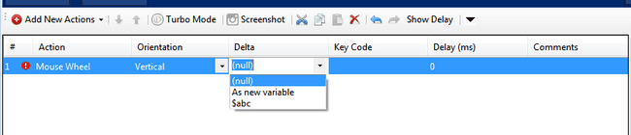

Next input is “keycode” which having a Key values in dropdown list. Selected key values will be pressed while scrolling see the figure shown below.

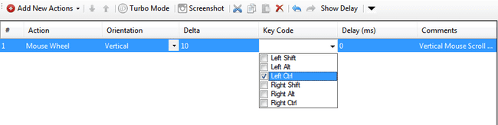

Also add delay which will show scrolling speed. Its default value will be 0.User can also select variable for this input see the figure shown below.

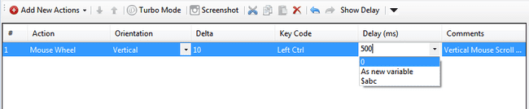

## Key Sequence

This action makes it possible to execute or to simulate key sequence. This action is typically recorded in a form filling scenario (e.g. username field in login process). For this action a repository item assignment is not required.

Adds a new key sequence action item, see the figure shown below (e.g. 'How are you').

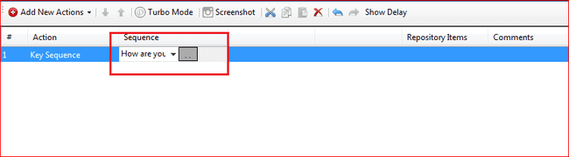

Key sequence action only stores the keystrokes made during a recording.

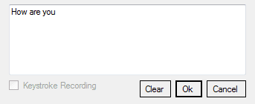

It can also add short-cut key combination (e.g. Ctrl+A, Ctrl+Shift+A).

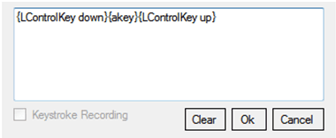

To make the input of the title variable, open the combo box as shown below and select 'As new Variable' to create a new variable.

Concord will switch off Num Lock, Caps Lock and Scroll Lock keys before start recording and playing.

KeyStroke Recording: Checkbox “KeyStroke Recording” enables the feature to record the special key character, hot keys in the form of key codes.

|  |  |
| --- | --- |
| **Keys** | **Representation in Concord Key Sequence action** |
| Enter Key | {Return} |
| Esc | {Escape} |
| PrtScn | {PrintScreen} |
| Backspace | {Back} |
| Windows key | {L/Rwin} |
| Control Key | {L/RControlKey} |
| Shift Key | {L/RShiftKey} |
| Alt Key | {L/RMenu} |
| Window/Shift with any key | {Window/Shift down}key{Window/Shift up} |
| Alt/Control with digit | {Alt/Control key down}{Ddigit}{Alt/Control key up} |
| Alt/Control with alphabets | {Alt/Control key down}{Alphabetkey}{Alt/Control key up} |
| Numpad key when numlock is on | {NumPaddigit} for example NumPad7 for 7 |

For example, to record the KeyCombination of Alt+F4 , simulate such key combinations by entering them manually. Just check the “KeyStroke Recording” and enter the keys manually.

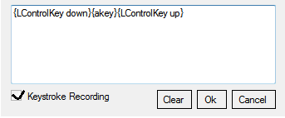

AutoSave: As soon as focus changes from the KeyStroke user interface if “KeyStroke Recording” is checked, contents of the text area will get saved.

**Clear**: Cleans the text input area.  
**Ok**: Saves the text.  
**Cancel**: Ignore the current text inputs in the text area.

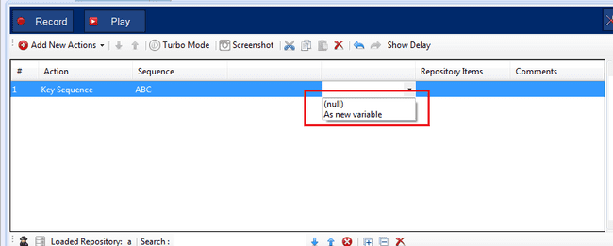

Initial window of “Add Variable”

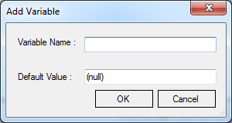

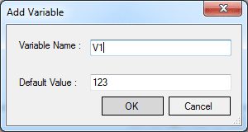

Specify the variable name and the default value which is automatically set to the same value as it was recorded initially. To alter the name or the default values, simply open the variables dialog as described in the ‘Add the User Variables as necessary and Save’ section.

**Note**: Please do not use variable names which are already in use by a recording or code module.

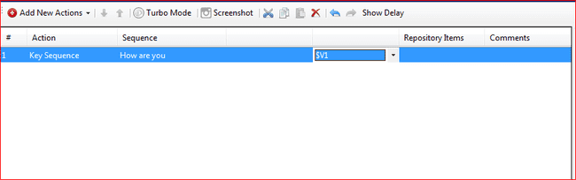

Merge Selected Keyboard Items:

This option will appear on Right click menu of Key Sequence action only when 2 or more Key Sequence actions are selected on IDE which are present one after the other. Merge Selected Keyboard action merges the Key Sequence of 2 actions and make it as 1 action.

This is mainly used in the following scenario,

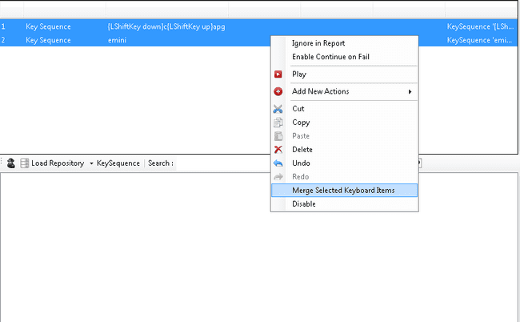

During recording if user gives some delay while doing key strokes the actions get splitted e:g: "Capgemini" if user gives delay after g then "Capg" will be recorded in a one action & "emini" will be recorded in the next action. In this case to reduce the no of lines of code got generated we can use this merge selected keyboard from IDE after recorder stopped.

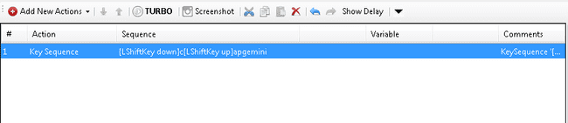

## Get Value

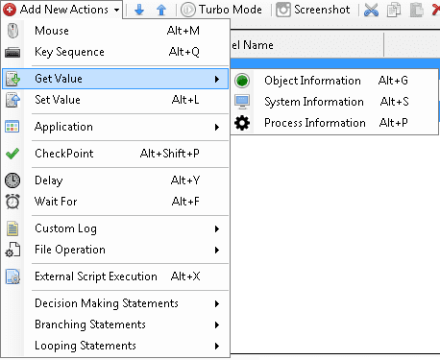

### Object Information

As the action name indicates, this option can be used to get values from repository items i.e. object. Depending on the assigned repository item, the available attributes can be different. The value obtained can be assigned to a module variable. This module variable can be used for ‘Set Value’ action, i.e. user can set the obtained value to another repository item.

Following are the controls where user can get value:-

1. **Buttons:**For this control following attribute options are available: ‘AccessibleState’, ‘Class’, ‘ControlId’, ‘Handle’, ‘ProcessId’, ‘ProcessName’, ‘ControlState’, ‘Caption’, ‘Visible’, ‘Exists’ and ‘CheckedState’.  
   CheckedState is for getting the checked state of Checkbox and Radio Buttons who have control type as Button. Depending on whether the checkbox or radio button is checked or unchecked, the value will be returned by Get Value. For all other buttons the value will be unchecked.
2. **Edit box**For Edit box there is only ‘Text’ attribute option is available in the dropdown in Name column.
3. **Combo box**For this control there are three attribute options available ‘GetSelectedItemIndex’, ’GetSelectedItemText’ and ‘TotalCount’.
4. **Radio buttons**For Radio Buttons there are three attribute options available ‘Checked’,’ Caption’ and ‘ControlState’
5. **Check Box**For this control there are three attribute options available ‘Checked’,’ Caption’ and ‘ControlState’
6. **List Control**For this control there are three options are available ‘SelectedItemIndex’,’SelectedItemText’,’GetText’ ‘Columncount’ and ‘TotalCount’.  
   Other than specified properties for each control some common properties are also available for Controls.Below common properties are available for controls: Button, Edit, Checkbox, List, Combo Box, Radio Button, Slider and Tab.  
   Mandatory parameters for actions as below:

a) SelectedItemText => Column index



b) GetText => Row Index and Column index

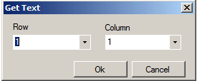

Common Properties:  
AccessibleState, Class, ControlId, Handle, ProcessId, ProcessName

### System Information

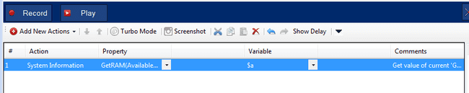

This option is used for getting system information such as:

🡪 CPU Usage  
🡪 Get RAM (Available Mbytes)  
🡪 Date Time  
🡪 Mouse Cursor  
🡪 Cursor Position  
🡪CursorOnDisplay

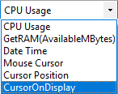

This information can be stored in variables also which can later be used for other purposes.

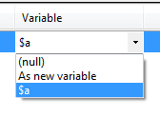

The Red Error Mark shows if the step is Invalid. The tooltip shows what needs to selected to make it a valid step as shown in below figure:

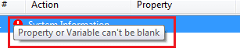

If the step is valid, the test can be run. The report will be generated as shown in below figure:

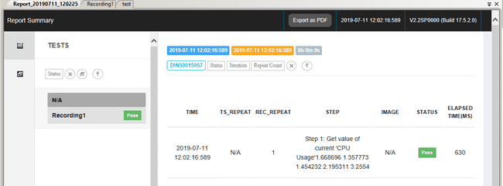

* **If the step is valid in mouse cursor. The report will be generated as shown in below figure.**

If the cursor matches, then step will pass and it will show below cursor name along with cursor handle.

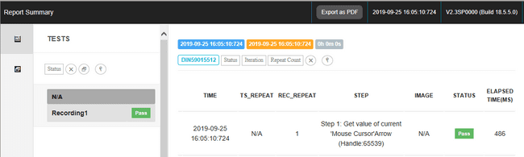

* **If the step is invalid in mouse cursor. The report will be generated as shown in below figure.**

If cursor value does not match then step will be fail and then user can add that mouse type in mouse cursor utility. Follow the link for mouse cursor utility steps for adding cursor type.

Refer section 32 for info on mouse cursor utility steps, for adding cursor type.

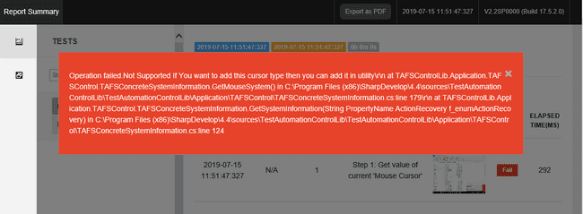

### Process Information

This action is used for getting information of the process which is currently running in background.

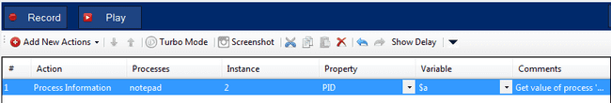

1. **Processes:** This contains the name of the process for which information is to be obtained. This process should be a running.
2. **Instance:** This contains the number of instances present for a particular selected process. The instance of the process whose information is to be obtained can be selected.
3. **Property:** This contains different properties of process whose information can be obtained. Below is the list of properties:

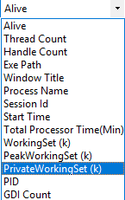

1. **Variable:** This contains the variable to which values can be bind. This can be used further to get information.

The Red error mark shows that the step is Invalid. The tooltip shows what needs to be selected to make it a valid step as shown in below figure:

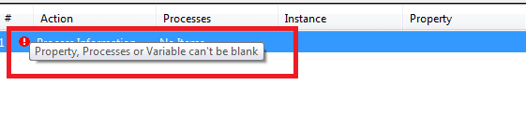

**Note**: User can also select application by providing its path. If path is provided from same directory where script is create, it will display relative path else full path will be display. User can also use environment variable to select path. If environment is selected then path will be displayed in term of environment path. Below figure shows path selected from different location:

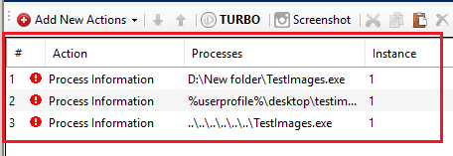

If the step is valid and run, the report will be generated as shown in below figure:

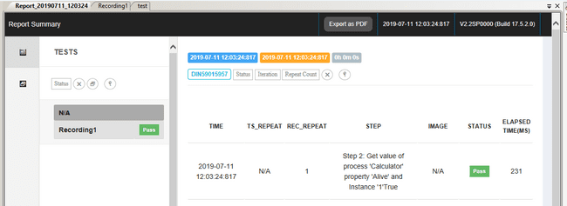

Below report is of Private working Set Action which gives user the Memory used by particular process; user can select any process which will run in the background.

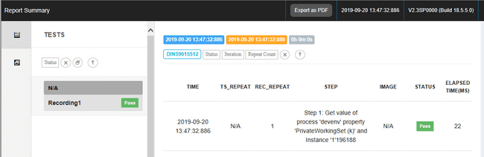

## Set Value

This method can be used for setting values to attributes of repository items. Depending on the assigned repository item, the available attributes can be different. The value obtained using Get Value in a module variable can be used to set another repository item for selected control.

Following are the controls where user can get value: -

1. **Button**For Button, Check and Uncheck options will be available. This is basically provided for checkboxes and radiobuttons which have controltype as button. For such controls, the checkbox or radio button will get checked or unchecked based on the selection. For other buttons, though the step will pass, no change will appear on the screen.
2. **Edit box**For Edit box there is only one attribute option ‘SetText’.User can set any text using either variable or manually to edit box using Set Value.
3. **Combo box**For this control three attribute options are available DropDownVisible’,’ SelectIndex’, and ‘SelectText’
4. **Check Box**For this control two attribute options are available ‘Check’ and ‘UnCheck’. User can change state of check (check or uncheck) box using setvalue.
5. **Tree View Control**For this control two attribute options are available ‘SelectTreeItem’ and ‘SelectedItemBySequence'. User can give $ separation for selecting Menu Item.

SetValue will take Tree as repo and using above mentioned attributes, Tree Item selection can be done.

Suppose user wants to set value at Tree Item Child1 using above two attributes

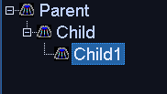

E.g. Parent$Child$Child1 (for SelectTreeItem)

E.g. 1$1$1 (for SelectTreeItemBySequence)

Note: Set value can be used only for tree, not for tree item in repo

1. **Tab**For this control the only one attribute option is available ‘Select’. SetValue will select the tab item which is present at repository item, i.e., which is linked to action.
2. **List Control**For this control two attribute options are available ‘SelectedItemIndex’ and ‘SelectedItemText’. Set Value will select list item name which is mentioned. User can select list item either by using variable or directly by giving item name.
3. **Slider**For this control five attribute options are available ‘Value’, ‘Min’, ‘Max’, ‘Increase’ and ‘Decrease’.
4. **Menu**For this control two attribute options are available ‘SelectMenuItem’ and ‘SelectMenuItembySequence’. User can give $ separation for selecting Menu Item.

E.g. Menu$SubMenu$SubMenu1 (for SelectMenuItem)

E.g. 0$1$1 (for SelectMenuItembySequence)

**Limitation**: If list contains multiple item with same name (Eg. A, B, C, D, A), so it always select first item (A, B, C, D, A), it doesn’t select item as per instance. In this case user needs to use index property.

## Application

### Run Application

Add a Run application action from Application->Run application see the figure shown below.

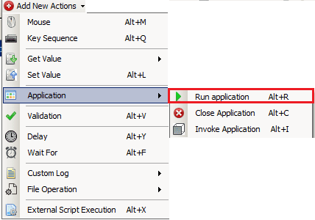

Using run application, the path of application to be run can be browsed using the browse button in File Name column, see the figure shown below.

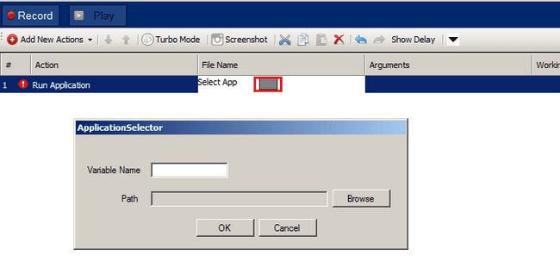

Provide the variable name and path. For e.g.

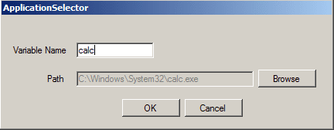

“Calc” application will be added in steps. Click OK to go back to IDE.

Executing this step will open a new instance of Calculator application.

**Note**: User can also select application by providing its path. If path is provided from same directory where script is create, it will display relative path else full path will be display. User can also use environment variable to select path. If environment is selected then path will be displayed in term of environment path. Below figure shows path selected from different location:

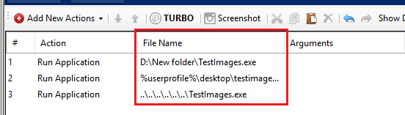

### Close Application

Add a Close application action from Application->Close application see the figure shown below.

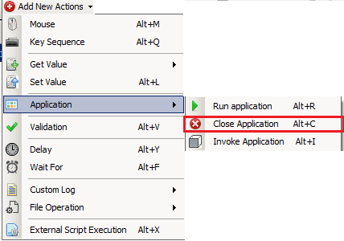

Close Application have three options as shown in below figure ,

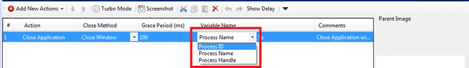

If “Process Handle” is selected, then all variables which are available in Run application are displayed. That means we can close application which are opened using Run application. At least one “Run application” action should be present before “Close application” to select “Process Handle”.

If “Process ID”/”Process Name” is selected, then user will see variable list other than Run application variables. User can close process with selected variable’s default value having process name/id (if it is open). For example, if variable ABC having value as 15239, then process having process ID 15239 will get closed. If variables value is “calc”, then all instances of calculator get closed.

### Invoke Application

Add an Invoke application action from Application->Invoke application see the figure shown below.

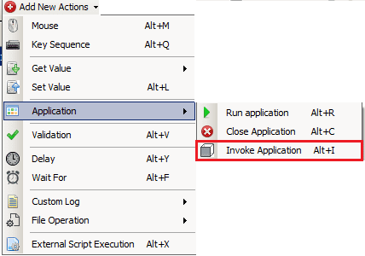

Invoke application will simply invoke the app to the front whose PID is provided.



## Checkpoint

Checkpoint opens the Expression Generator window. Expressions can be created in “Expression Generator” window. User can create the Expressions using various actions like Exists/Not Exists, Property, Compare Image, Compare ImageFile, Contain Image Variable Compare. Expression Generator window also provides options for creating AND/OR expressions based on action’s values.

Click on Checkpoint to open Expression Generator window see the figure shown below.

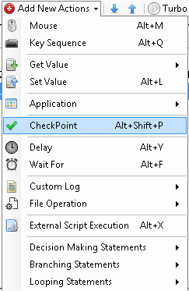

The Expression Generator window shown in below window.

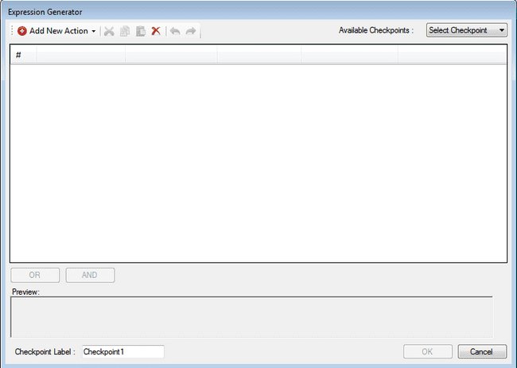

In this Expression Generator form, “Add new action” menu contains Sub action using which user can create expressions see the figure shown below.

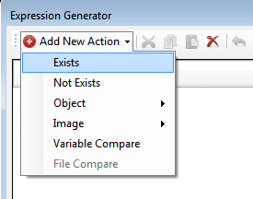 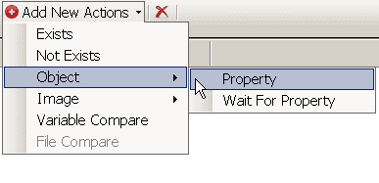 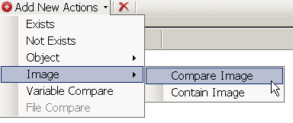

User can see already created checkpoints in Available checkpoints combo box which is top-right side. User can check and also re-write checkpoint label which is bottom-left. User can create expressions using “OR and “AND button. It will work as per their truth table. Using this user can create conditions of multiple expressions.

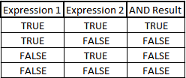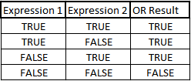

After creating condition Expression generator* will be shown in below figure.

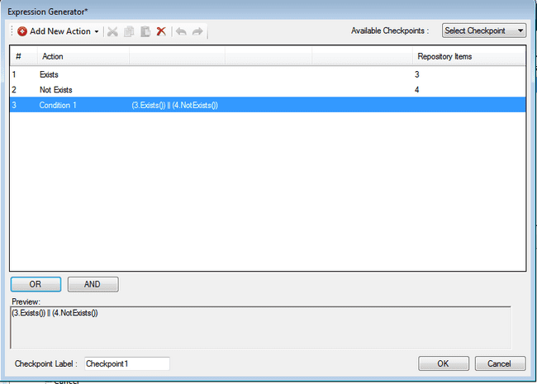

Final condition user can use for checkpoint in Main IDE. After clicking OK button user can see Checkpoint label in main IDE column. If user wants to change expression then he can modify again by clicking same button which is used to open Expression Generation window see the figure shown below.

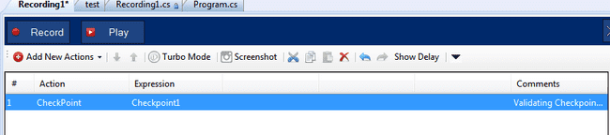

### General Checkpoints

#### Exists

The sub action checks for the existence of the repository item and expects an existing item.

Example:

A user can validate whether a button exists with a resulting success if the button actually exists.

Time out field decides the time out for searching the item. If the selected repository item is not found in the time allotted in this field, the step fails. If the item is found, based on the condition/action in the step, the step may pass.

User has option to give image comparison percentage. Image percentage is mandatory field for image repository.

Repository Item is compulsory filed for Exists. After selecting item window will be shown as follows

E.g. Exists Object

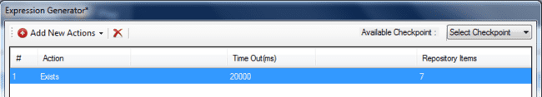

E.g. Exists Image

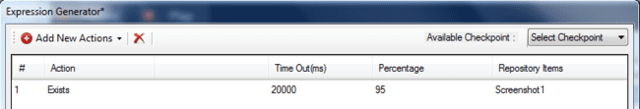

#### Not Exists

The validation checks for the existence of the repository item and expects the item not to exist.

Example:

A user can validate whether an error dialog does not exist with a resulting success if the dialog does not exist.

Time out field decides the time out for searching the item. If the selected repository item is found in the time allotted in this field, the step fails. If the item is not found, based on the condition/action in the step, the step may pass.

User has option to give image comparison percentage. Image percentage is mandatory field for image repository.

Repository Item is compulsory filed for not-Exists. After selecting item window will be shown as follows

E.g. Not Exists Object

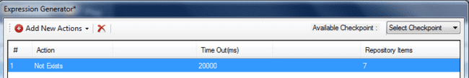

E.g. Not Exists Image

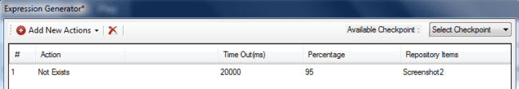

**Note:**

In Time Out(ms) field:

1. When user add zero value then it resets to default value i.e. 1500.

2. When user add value between 1 to 1499 then it shows error mark.

3. The value greater than 9999999 is not allowed/accepted.

### Object Checkpoint

#### Object Property

User can find property under object Action. This validation checks whether a specified repository item is equal to a specific property value. Property will be displayed according to item selected in repository. It is depends on item’s ControlType.

Example:

 A user can validate a button name by selecting its property “caption”.

On selecting Property following row will be added

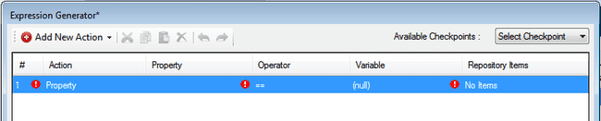

Repository items, Property, operator, variable these all fields are compulsory for property validation. Property field will populate after selecting repository items. Operator used for compare property and variable values. Operator fields contains following operators.

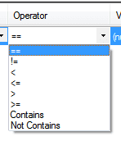

Variable field contains Available variables, default values of selected property and also user can add variable using “As new variable” option see the figure shown below.

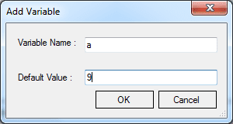

#### Wait For Property

User can find property under object Action. This validation will wait till the allotted time for an object to get the specified property. Property will be displayed according to item selected in repository. It is depends on item’s ControlType.

Example:

A user can validate a button name by selecting its property “Visible”.

On selecting Property following row will be added.

Time out field decides the time out for searching the item property value and matching with variable value. If the selected repository item property value is not found in the time allotted in this field, the step fails. If the item property value is found, based on the condition/action in the step, the step may pass.

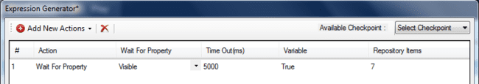

Repository items, Property, time out, variable these all fields are compulsory for Wait for property validation. Property field will populate after selecting repository items. Variable field contains Available variables, default values of selected property and also user can add variable using “As new variable” option see the figure shown below.



### Image Checkpoint

Image checkpoint provides log of the similarity as well as the difference in two compared images and text verification on image. Mostly it is useful to compare the image obtained from the object with the reference/parent image and to verify the text on image with the value provided. Two types of comparison can be carried out using Image Validation: Contain /Compare/ Compare ImageFile along with text verification: Get Text, as shown in below figure.

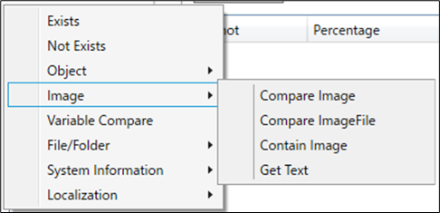

#### Contains Image

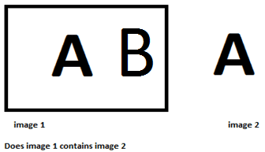

This validation checks whether the repository item’s image contains a specified screenshot. This screenshot can be edited easily with the ‘Edit Click Dialog Box’ which can be accessed via a button in the 'Screenshot' column. This can be useful for tweaking the similarity of the corresponding image validation action.

Example:

It's possible to validate whether the user-defined list of icons contains a specific icon. This can be done using image-based validation. The repository item would therefore hold the list of icons and the screenshot would be a picture of the specified icon. The validation would lead to a result if the list contains the specified icon.

#### Compare Image

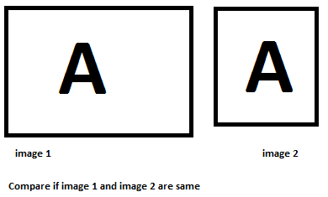

This validation checks whether a specified repository image is equal to a specific screenshot. This screenshot can be easily edited within the ‘Edit Click Location Dialog Box’ which can be accessed via a button in the 'Screenshot' column. This will report a difference mask showing the differing pixels as well as the differential. This can be useful for tweaking the similarity of the corresponding image validation action.

Example:

To validate whether the toolbar of the application contains the intended icons you can compare the repository item with a screenshot of the toolbar in its initial state.

In case if the object is not identifiable then user can use the screen co-ordinates. While executing the script, Concord will take the image under the given screen co-ordinates to compare\contain.

**How to perform Compare/Contain image validations**

1. Choose action Compare/Contain Image. This will add new row into the Expression Generator window. Please note the default values for current row’s cells would be as same as shown below in the image.
2. Click on the button present in the Repository Items cell. This will open up the Select Target Item. This dialog let’s user choose between “Select Repository” and “Add Image”.  
     
   **Select Repository**: This will open up another dialog to select any one available repository out of available repositories list.  
     
   **Add Image** : This will open up the screen capture mode. User can crop a co-ordinates using mouse. This will generate a co-ordinate’s value.

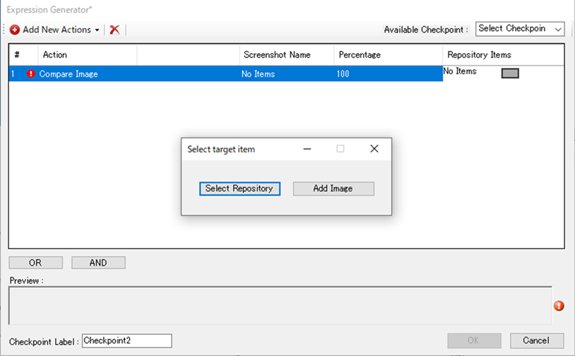

1. Choose action Contain Image. This will add new row into the Expression Generator window.  
     
   If user select Add Image user will not get image in screen shot column name. User needs to select image by clicking on ‘No Items’ see the figure shown below.

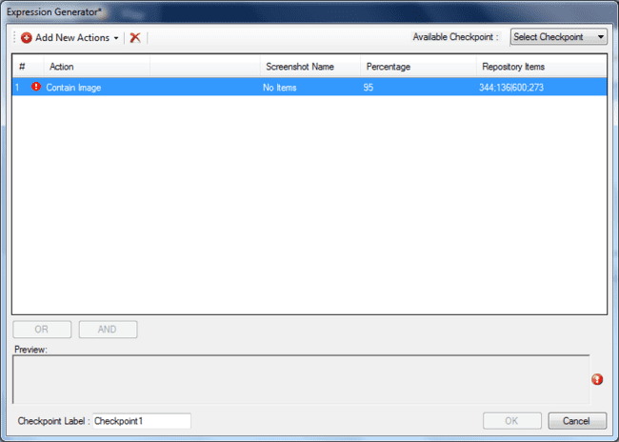

1. User can choose anyone option provided on the Select Target Item window. On the selection of Select Repository, Repository Selection Window will be open. Shown in the below figure. User gets option to search any repository, Expand/Collapse the tree view and Move Up/Move Down the selections.

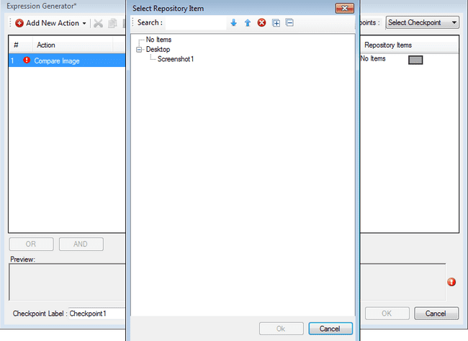

1. User can choose anyone option provided on the Select Target Item window. On the selection of Add Image, screen capture mode will be open up. Complete screen will be blur. User needs to move the mouse to get the co-ordinates. On the movement of the mouse, a rectangle will be form. As mouse is released, the co-ordinates value of the rectangle will get assign as the Repository Item cell value see the figure shown below.

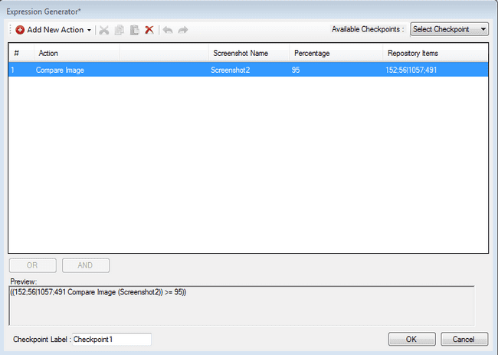

1. User can click on the button present into the column “Screenshot Name”. This will open up the “Edit Click Location” Window. On this Window, User can change the current selected image with the help of the Drop down. See the figure shown below. User can also use the file open dialog to select another image.

User can also change the Compare/Contain validation percentage. Please note, user can input the value between 10 to 100. Any attempt of entering values apart of the suggested range will result into row validation error. Row validation error will be shown as exclamation mark near the row’s serial number .

When comparing images with "Pixel by Pixel", the Percentage column is not displayed.

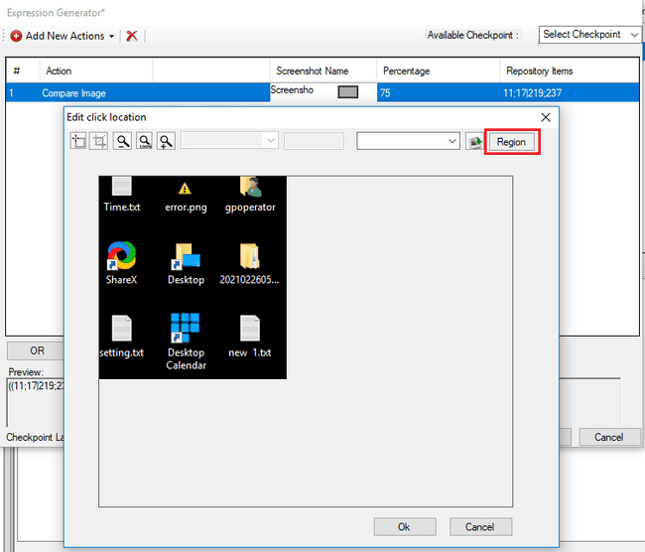

When comparing images with Pixel by Pixel in Compare Image , you can specify the area to exclude the comparison. The exclusion area is set in Excluded area . The Excluded area is only visible when comparing on Pixel by Pixel.

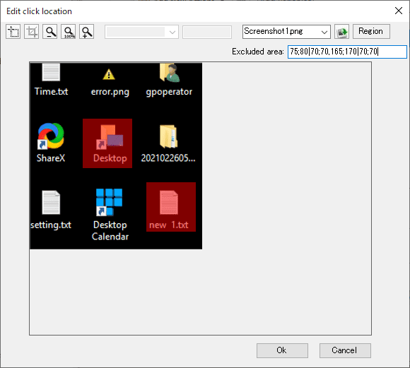

The exclusion area specifies the x, y coordinates in the comparison image and the width and height from those coordinates in the following format.

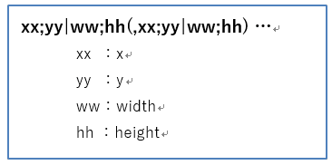The specified exclusion area is displayed as a translucent red rectangle in the image.

1. Once user is done with adding the actions using proper valid values. User can create AND/OR options as shown below. Making such expressions, will add new row as a Condition [Number]. If user has created proper valid actions, Ok button gets enable see the figure shown below.

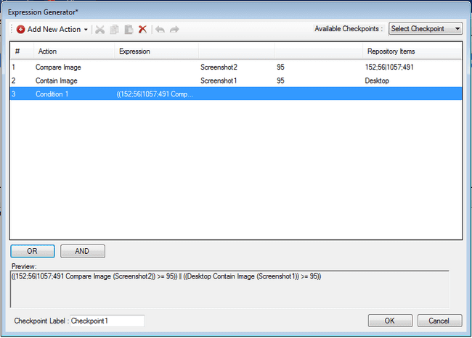

**Force Threshold to Pass:** After first time successful execution a new option will appear in the context menu - ‘Force Threshold to Pass’. With the help of this latest validation percentage updates in Scale column. This percentage helps in validation of image with current percentage see the figure shown below.

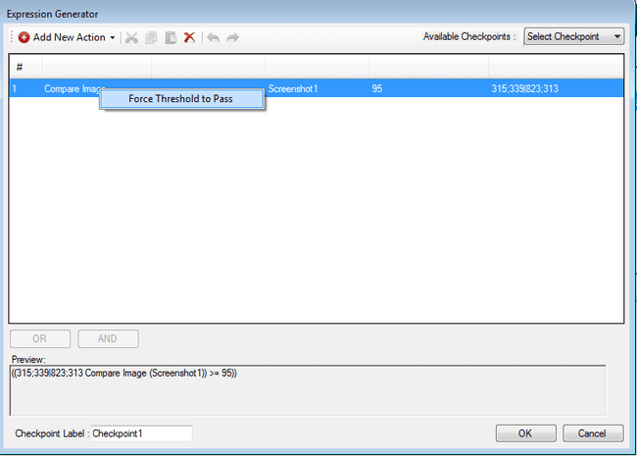

#### Compare ImageFile

This validation checks whether the specified repository image is equal to the image displayed during the test run. The image displayed during test execution is the image captured by the Capture Screenshot action described later, and is used for comparison using a variable whose value is the image file path. This function has the following features.

Example:

・Because it is captured during test execution, it is not affected by images that change from test to test.

・There is no need to prepare an expected image.

・Images outside of Concord can be used as expected images.

**How to perform Compare ImageFile validations**

1. Choose action Compare ImageFile. This will add new row into the Expression Generator window. The initial values of cells in the current column are the same as in the image below.
2. Clicking the button in the Repository Items cell opens the Select target item dialog box. Using this dialog box, you can choose to either Select Repository or Coordinate (see image below).

**Select Repository**: Another dialog will open allowing you to select one repository from the list of available repositories.

**Coordinate**: Another dialog will open where you can set the region values. You can also crop coordinates using the mouse on the screen to generate coordinate values.

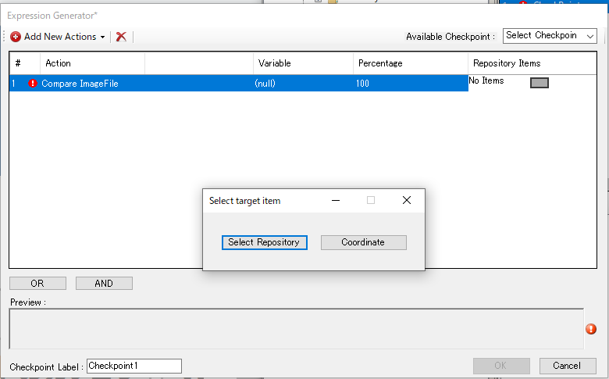

1. In the Select target item dialog, select "Select Repository" or "Coordinate".

[Case : Select Repository]

1. Select Select Repository in the Select target item dialog box to open the Select Repository Item dialog (see the figure below). Users have the option to search the repository, expand/collapse the tree view, and move selected items up or down.

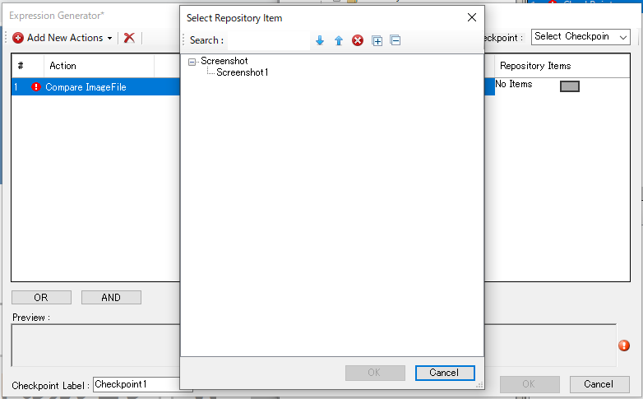

[Case : Coordinate]

1. Select Coordinate in the Select target item dialog box to open the Select Area dialog (see the figure below). Users can enter values in the X, Y, W, and H fields, or press the Capture button and specify a range by dragging and dropping.

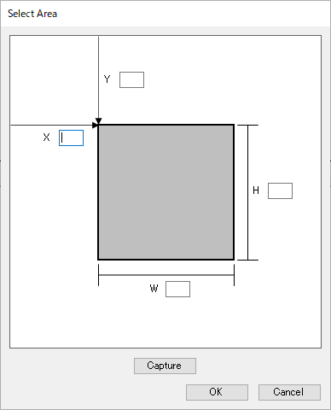

1. If you press the Capture button, a screen like the one shown below will appear, so specify the range by dragging and dropping.

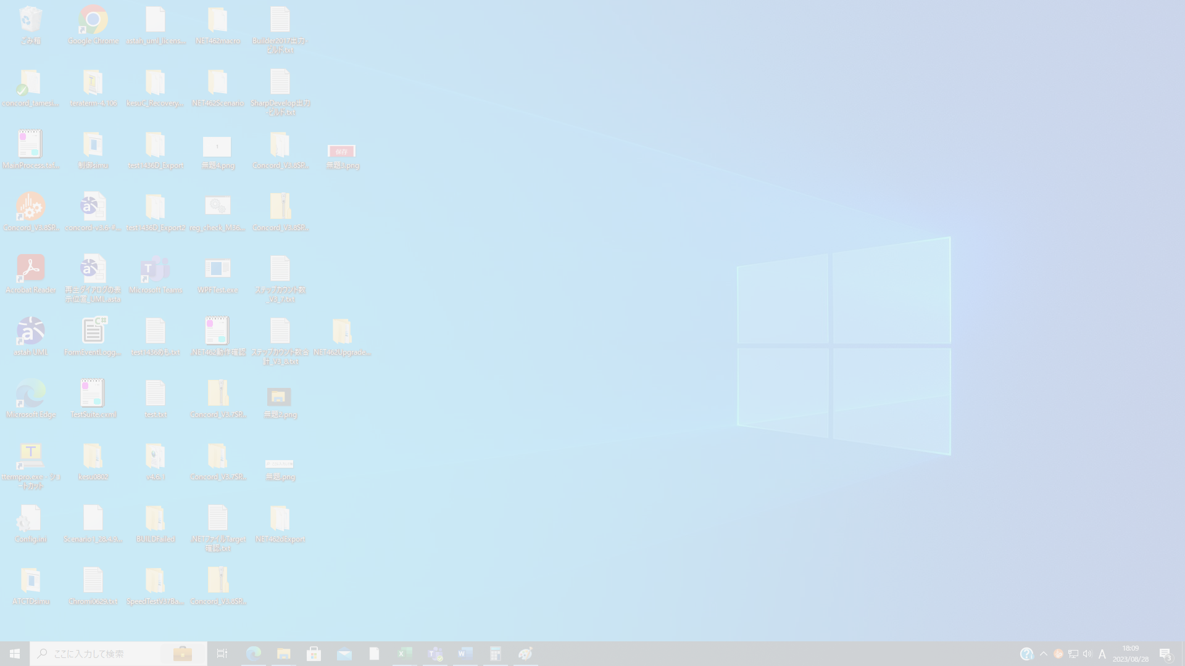

1. After selecting a repository or area, open the repository selection dialog again and a new option "Exclude Areas" will appear.

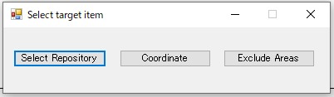

**Exclude Areas**: The Exclude dialog allows you to exclude multiple unwanted areas of an image and save the corresponding excluded image. This is useful for filtering out dynamically changing text like dates and times.

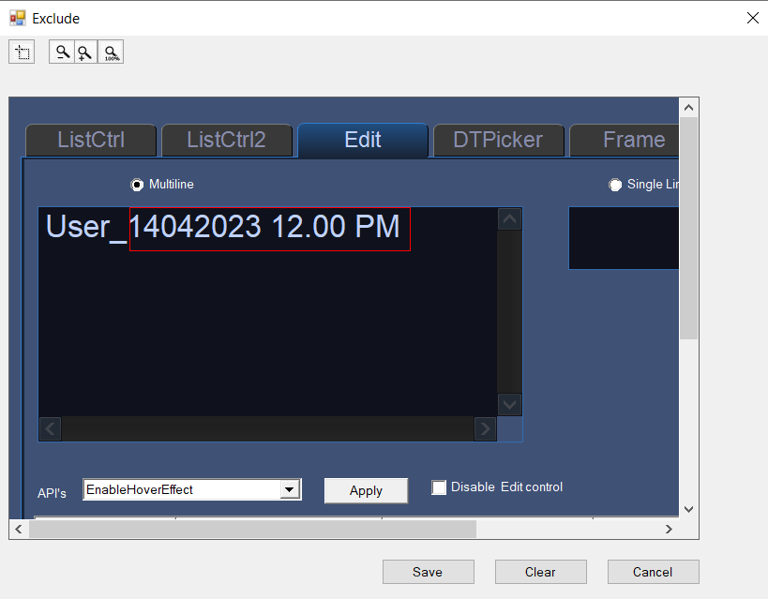

*If you have set the area value, a white background corresponding to the area size will be displayed.

1. In order to set the comparison target with the repository/area set in the Repository Items field, select a variable whose value is the image file path in the "Variable" field. Users can select a saved variable or create a new variable using the "As New Variable" option.

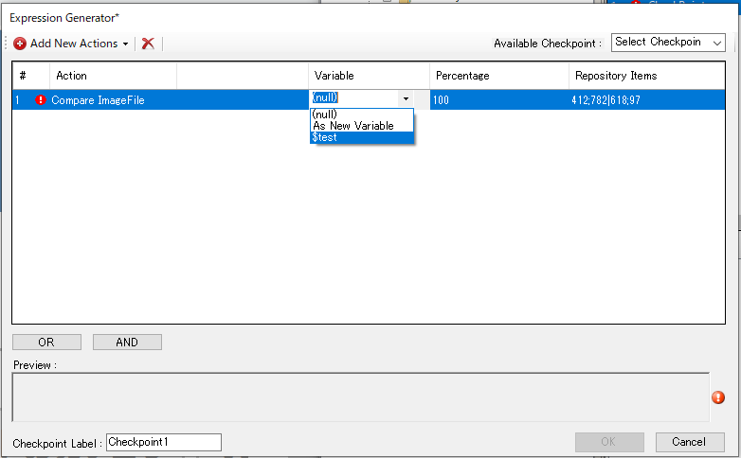

1. Users can also change the verification rate (%) when performing image comparison and verification using Template matching. However, the values that can be entered are from 10 to 100; entering any other value will result in a row validation error (described later). When comparing images using Pixel by Pixel, the Percentage field is not displayed.

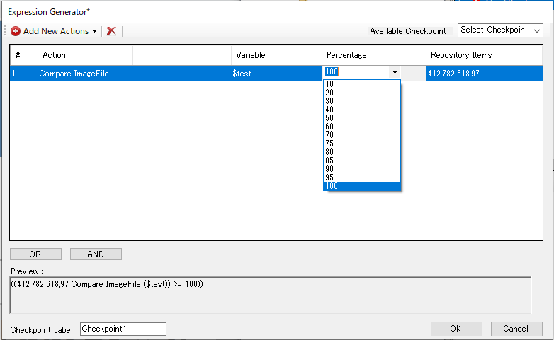

1. If each field does not have a valid value, a row validation error will occur and an exclamation mark (!) will appear near the serial number in that row, and an error message will appear when you hover over it.

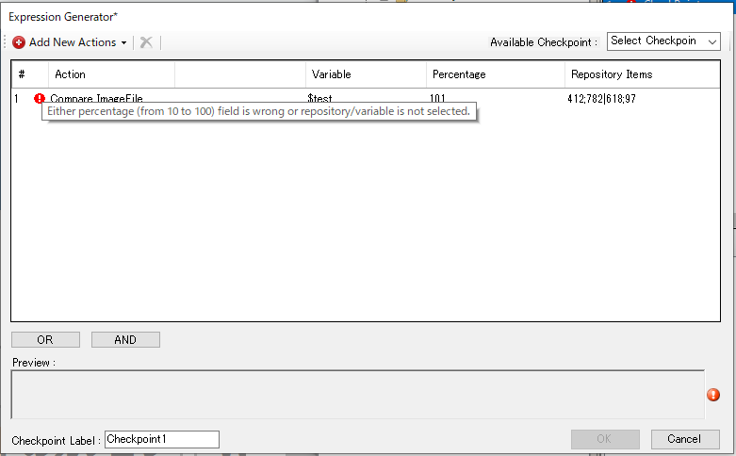

1. Once you have finished adding actions with appropriate valid values, you can create AND/OR options (see image below). Once the expression is created, a new row is added as Condition [number]. Once you have created a suitable and valid action, click the Ok button to activate it.

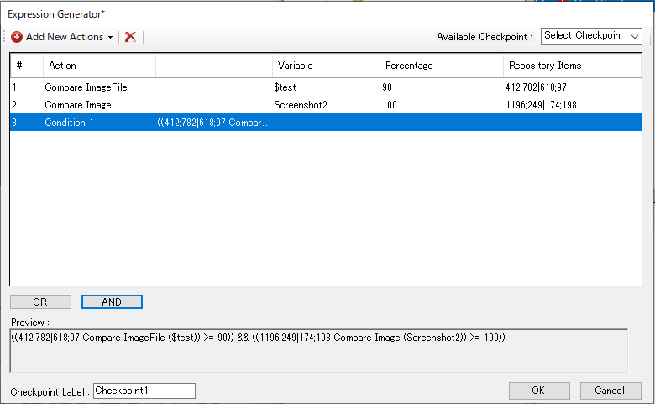

#### Get Text

This action perfoms text verification on the repository image with the value obtained from ‘GetValue’ action. user can perform “==“ , “!=“ , “Contains” , and “Not Contains” operation on the input image. This would be beneficial for the user as it provides way to perform dynamic verification of elements/images.

**How to perform Get Text**

1. Choose action ‘Get Text’. This will add new row into the Expression Generator window. Please note the default values for current row’s cells would be as same as shown below in the image.

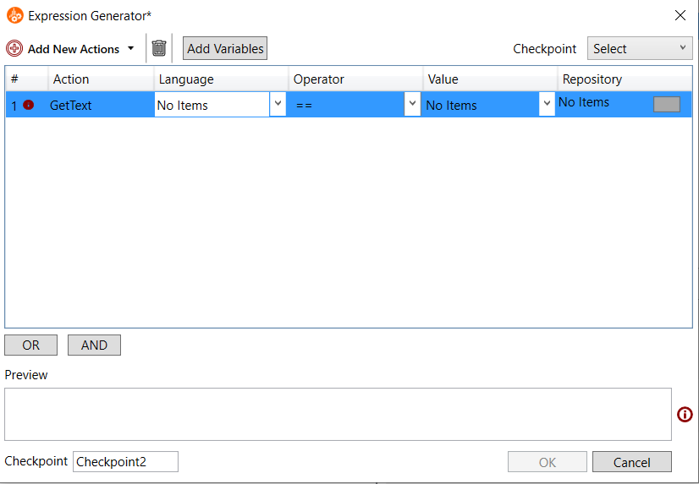

1. User can select the target language from the list provided. Following 16 languages are supported .

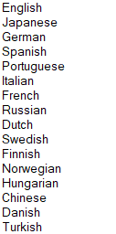

Variable support is also added for language.

1. Select the operator to decide which text verification operation need to be performed on the image. Following operators can be selected

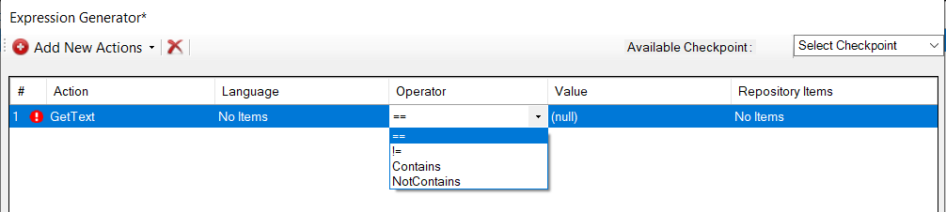

1. User can get the value for text verification from saved variables or can create new variables using ‘As New Variable’ option.
2. Click on the button present in the Repository Items cell. This dialog let’s user choose between “Select Repository” and “Add Image”.

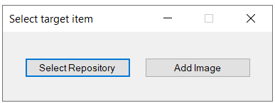

**Select Repository**: User can select controls from repository. This option is same as ‘Compare Image’ action.

**Add Image**: This option allow user to capture a screen area. This option is same as ‘Compare Image’ action.

During execution of step, concord will capture the current screen based on above selection. Once repository is selected and open repository selection dialog again, a new option will be displayed “Exclude Areas”.

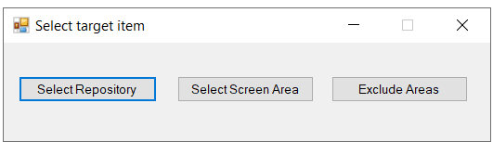

**Exclude Areas**: In exclude area dialog, user can exclude unwanted multiple regions of an image and can save the corresponding excluded image This will help user to exclude text that dynamically change like date and time.



After providing all inputs if the step is valid, the test can be run and the report will be generated. Depends on the operator selected the result of the ‘Get Text’ action may vary based on the following condition.

|  |  |  |
| --- | --- | --- |
| **Comparison operator used** | **Multiple texts in input image** | **Result of step** |
| == | No | The step will pass only if the selected variable value is exactly same as the text in the input image. Otherwise, the step will fail. |
| Yes | Fail |
| != | No | The step will pass if the selected variable value is different from the text in the input image. Otherwise, the step will fail. |
| Yes | Pass |
| Contains | No | The step will pass if the selected variable value is same or part of the text in the input image. Otherwise, the step will fail. |
| Yes | The step will pass if the selected variable matches with any of the texts or part of the texts in input image. The step will fail if there is no match. |
| NotContains | No | The step will pass if the selected variable value is different or not a part of the text in the input image. Otherwise, the step will fail. |
| Yes | The step will pass if the selected variable value does not match with all the texts or part of texts in the input image. Otherwise, the step will fail. |

Upon running the script, if the step is pased the report will be generated as follows.

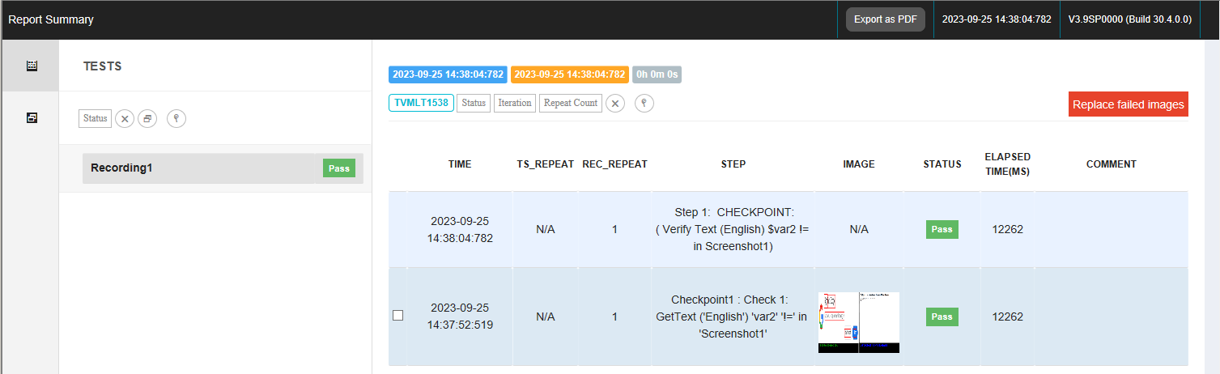

If the step fails the report will generate as below. On clicking the ‘Fail’ button custom error messges for each action will be displayed.

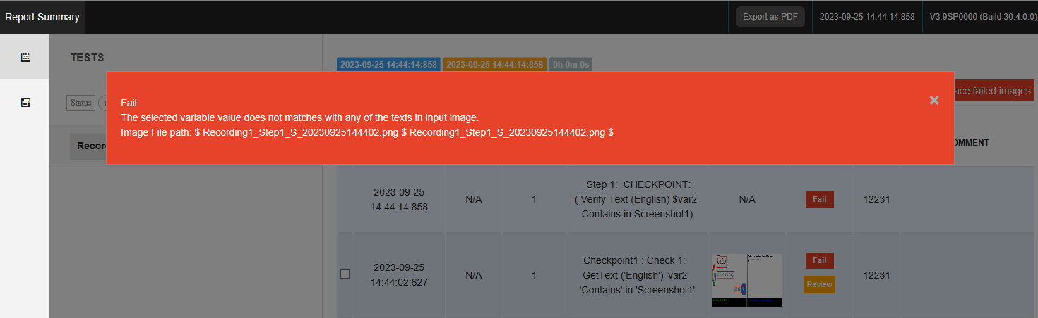

In failed report a ‘Review’ button will be displayed, in which user can view the image and statistics by selecting “Show image” and “Show statistics” option respectively. Use can also change the result of failed steps to pass by selecting ‘Consider as Pass’ option.

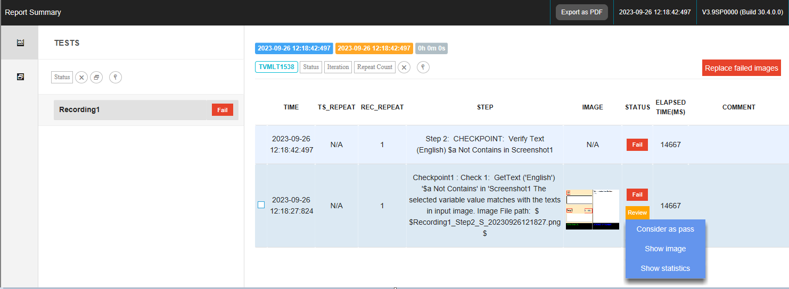

### Variable Compare

User can create expressions using Variables (String, Integer, and Decimal)/Constants or User Variables (Which is already saved in “Variable Operations” Window).  
User can create expression by two way

* **Using Variable/Constants** – User can directly enter string, integer or decimal values.

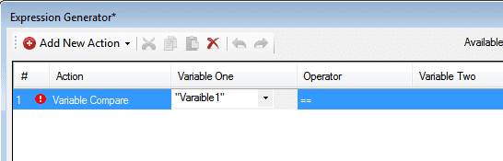

* **Using User Variables** – User can select variables from Saved variables.

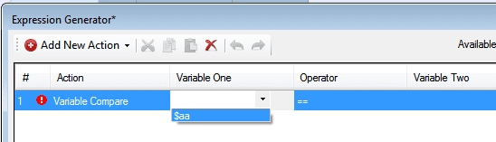

### System Information

#### Mouse Cursor

Mouse cursor provides user to check run time cursor type. It is useful to know the type of the cursor. We need to select the operator and Cursor Value to validate the step.

* + - * 1. **User can do following step**User can insert "Mouse Cursor" step in checkpoint dialog and select the operator as = or != and then select the mouse cursor type from drop down. While execution of this step it will retrieve the runtime mouse cursor value and compares it with the selected mouse cursor value to produce the result, see the figure shown below.

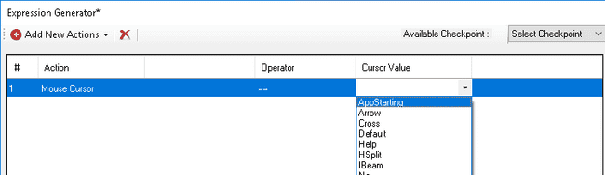

* + - * 1. **Step Added in the checkpoint dialog**In the below mouse cursor step we have selected the cursor value as “Arrow”, Now it will check whether same cursor is present on screen during execution or not. If the cursor matches then report will show “Pass” see the figure shown below.

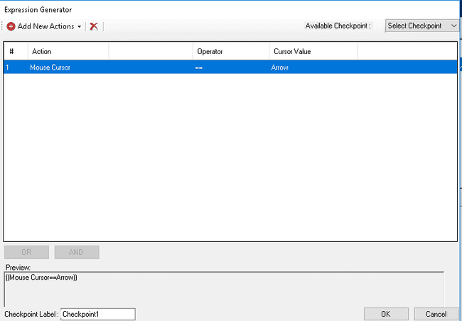

* **If the step is valid, the test can be run. The report will be generated as shown below**

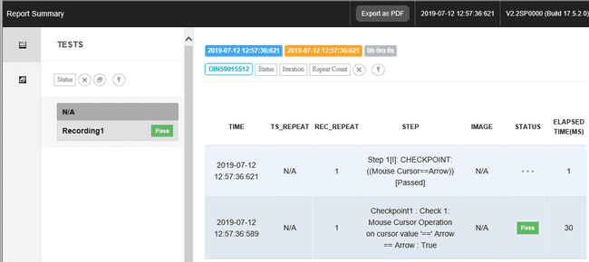

* **If the step is invalid. The report will be generated as shown below.**If cursor value does not match then step will be fail and then user can add that mouse type in mouse cursor utility. Follow the link for mouse cursor utility steps for adding cursor type see the figure shown below.

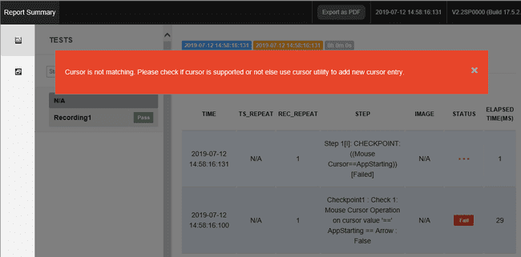

#### Cursor Position

Cursor position will provide user the runtime position of cursor it will give the coordinates wherever cursor will present on the screen.

1. **Configuring a step**To get the cursor position user need to do following steps. To select the region on screen, user can do by using below “CursorPosition” dialog by putting coordinates and width and height manually, or user can also select cursor on screen; it will provide the provision to select the region, and coordinates and width and height will fill according to the captured area see the figure shown below.

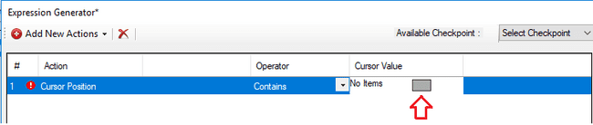

Here above figure showing the red arrow, which indicates that after clicking on it, below Select Area window will open.

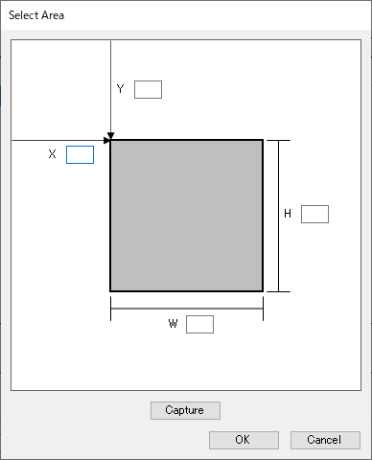

1. **Step Added in the Expression Generator* dialog**

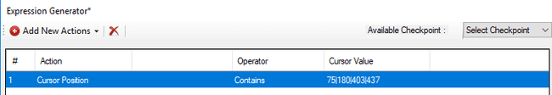

#### CursorOnDisplay

CursorOnDisplay will provide the display number on which cursor is present. It will take the primary monitor as first monitor no matter what it shows as display number. So please note that.

* **Configuring a step**Here user have to provide Display Number as expected value and it will check whether the runtime cursorondisplay(monitor number) (Actual Value) contains or not contains the expected value and accordingly the output will be shown see the figure shown below.

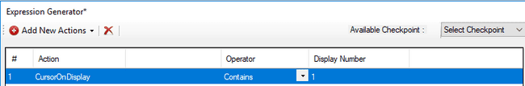

* **Result Display**

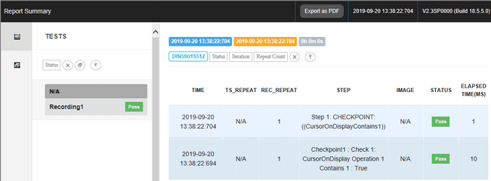

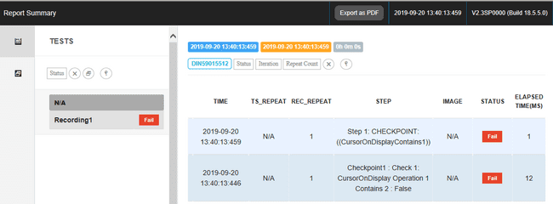

### File/Folder property

File/Folder property is used to check the size of selected file/ folder or Existence of selected file/folder. User will provide one value for comparison in variable column to check size and existence of file/folder and one value will get runtime (actual value of file/folder).

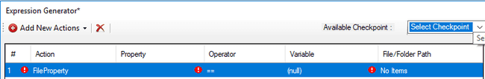

There are two ways to select file/folder we can have file/folder path in relative path or in full path.

* One way is by clicking on the button shown in the figure below

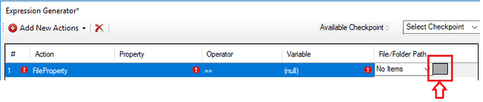

* Another way is by saving the path in the variable as shown in the below figure.

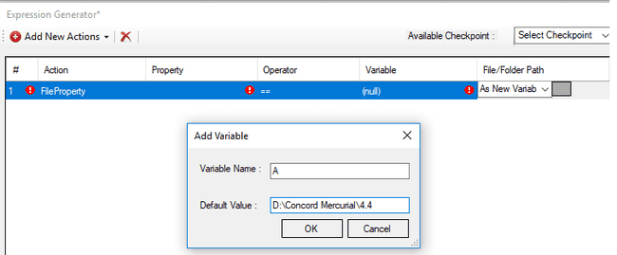

There are the two properties applicable for File/Folder.

* **Size :**Size property checkpoint will have “==”,”!=”,”<”,”<=”,”>”,”>=” operators , user can give hardcoded integer value or can connect with data connector variable in variable filled. User can give decimal value in variable column but upto only two digits after decimal, and runtime also it will take the exact size of file/folder upto two digits after decimal, and both runtime and user given value will get compare.  
    
  **Note:** Sometimes “Properties” of file/folder may show some different size value of file/folder and runtime we can get some different size value of file/folder, value can vary according to settings also in different machines. So this may happen in rare scenario, so in such scenario it is recommended to use <, >, >=, <= operator for better result.

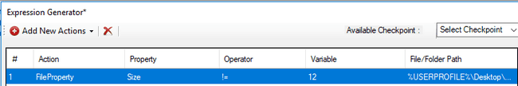

* **Exists:**Exists property checkpoint will have “==”,”!=” operators, user can give boolean value(True\False) or can connect with data connector variable in variable filled.

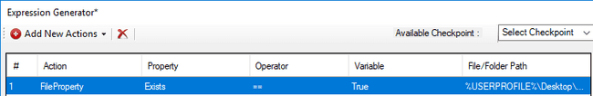

**Limitation:** *Select File/Folder with name containing special character “^” may give incorrect result.*

### Localization

Localization is the**process of adapting software for a specific region or country** by translating text and adding locale-specific components. Checkpoints in this action aids used to do localization testing. Two types of comparison can be carried out in localization: GUI Text compare and GUI Image compare.

#### 5.6.7.1. GUI Text Compare

GUI Text Compare checkpoint is used to verify the text in a GUI interface.When there is a change in the GUI due to a new requirement change like changing a string or adding a new component etc, there is a chance that the strings will get cut in the components.

In order to address this issue while testing, it is possible to use AI models to recognise the text from the GUI. By comparing with the strings that are stored previously in a configuration file, text can be verified in a GUI. In Text compare, user can add corresponding items like language,config file path and repository. GUI Text compare recognizes and verifies the texts in GUI.

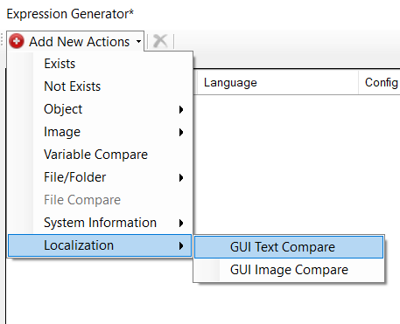

On clicking the localization option, GUI Text compare opens and the below step is generated which consists of language,config file path and repository items.

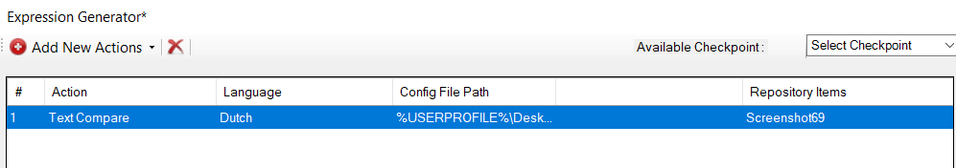

* Language: Target language can be selected. Variable support is added for language.   
  Following 16 languages are supported.



* Config file: The strings available in the UI that selected in repository in each language can be stored as a json file. The path of json file can be browsed.Variable support is also added.  
    
  If UI labes are available in excel files (i18 excel files ), then configuration files for Concord can be created using ’GUI Text Config Creator’. This utility is available in Concord installation path %concordhome%\Utilities\GUITextConfigCreator

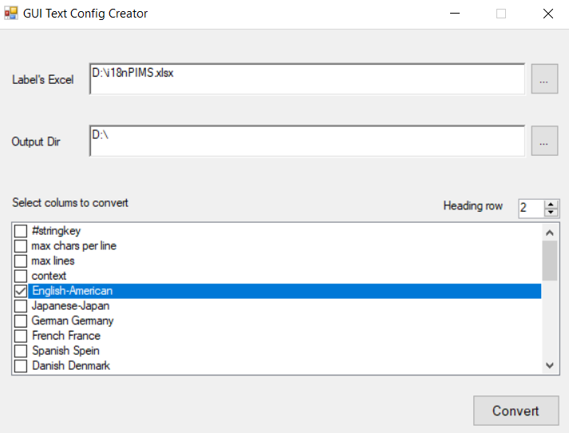

‘GUI Text Config Creator’ converts xls and xlsx files to json. User can select which all columns needed be converted as json. Each column will be converted as separate json files. The format of converted json file is shown below.

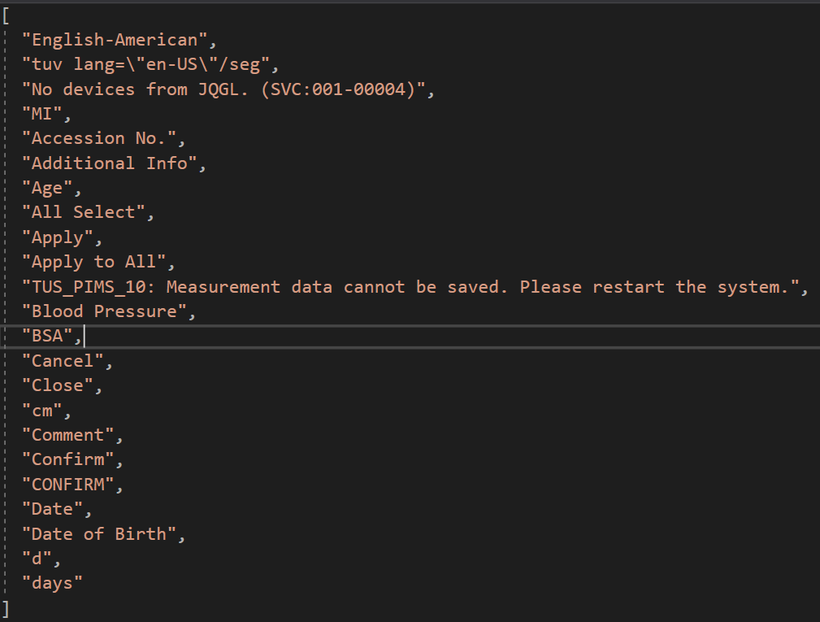

**How to perform Text compare validations**

1. Choose action GUI Text Compare. This will add new row into the Expression Generator window.
2. Click on the button present in the Repository Items cell. This dialog let’s user choose between “Select Repository” and “Add Image”.



**Select Repository**: User can select controls from repository. This option is same as ‘Compare Image’ action.

**Add Image**: This option allow user to capture a screen area. This option is same as ‘Compare Image’ action.

During execution of step, concord will capture the current screen based on above slection.

Once repository is selected and open repository selection dialog again, a new option will be displayed “Exclude Areas”.



**Exclude Areas**: In exclude area dialog, user can exclude the unwanted multiple region of an image and can save the corresponding excluded image This will help user to exclude text that dynamically change like date and time.



Once execution is completed, the following report will be generated which shows that the result is either pass or fail. Text which correctly mached will be displayed in green bounding box and not matched texts will be displayed in red bounding box.

If overlap checking is enabled and overlap is detected, overlapped regions will be marked with bounding boxes in  (majenta) color. Step will pass only if no overlap is detected.

If Use co-ordinates checking is enabled and any newly added or misplaced text are detected, the regions will be marked with thick  (Yellow) bounding boxes. The statistics area will display the count for all newly added and misplaced text. If the input configuration file is without coordinates, the same will be replaced with co-ordinates json after execution. Before further execution, user can update the configuration file with new and misplaced texts. The step will pass only if no newly added and misplaced texts are detected.

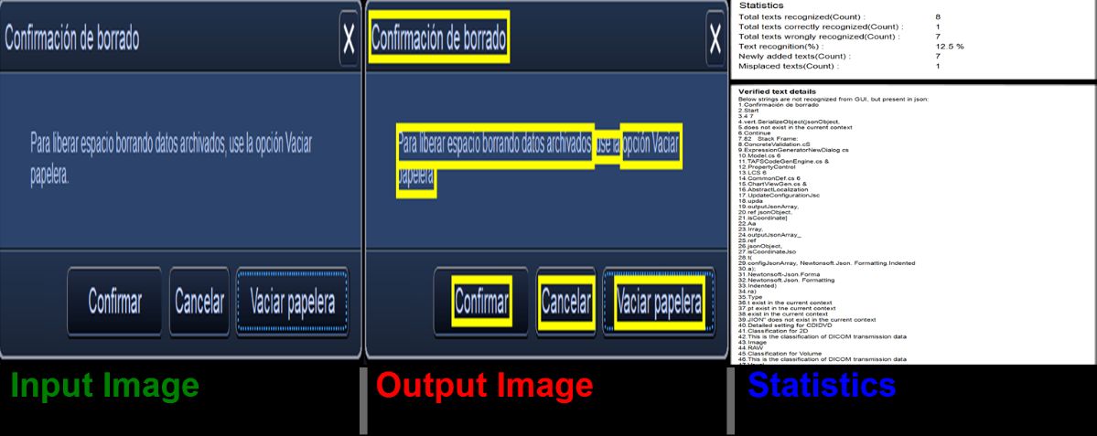

In failed report a ‘Review’ button will be displayed, in which user can view the image and statistics by selecting “Show image” and “Show statistics” option respectively. Some times, the fail might be expected as the text change is as part of new requirement or it wrongly considered as fail (as AI can not promise 100% accuracy). This such cases, user can review the result and change the result of failed steps to pass by selecting ‘Consider as Pass’ option. If ‘Use co-ordinates’ checking is enabled and the config data is a json file an additional item will be added in the review context menu that allows the user to decide whether the input configuration file needs to be updated.

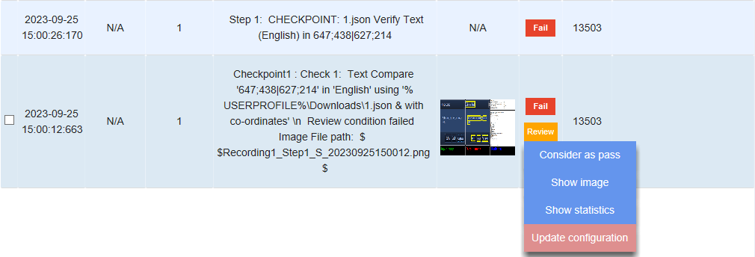

If ‘Use co-ordinates’ checking is not enabled then ‘Review’ context menu for the failed report will be as below.

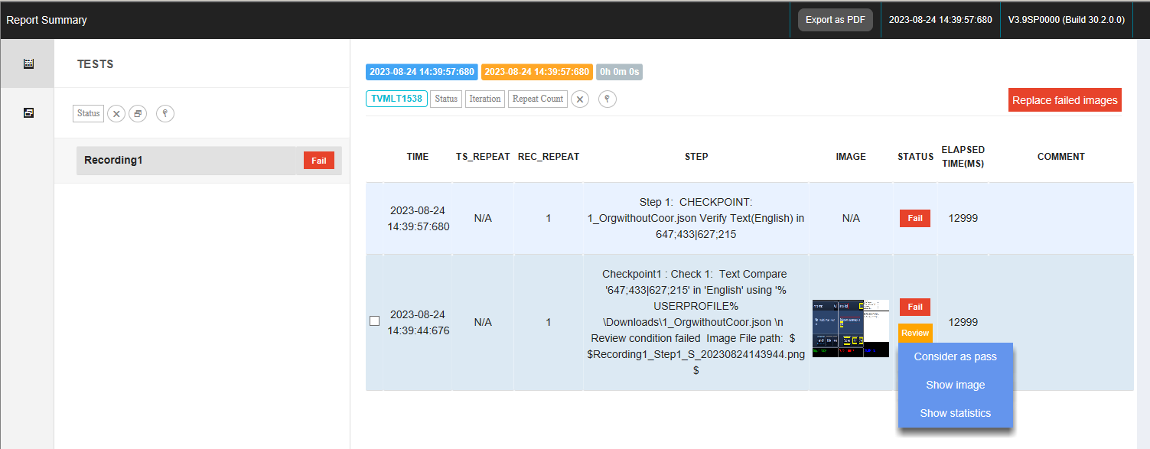

Update configuration menu provides a way for updating all the new and misplaces texts to the configuraton fle. On clicking ‘Update Configuration’ a dialog will be displayed as follows.

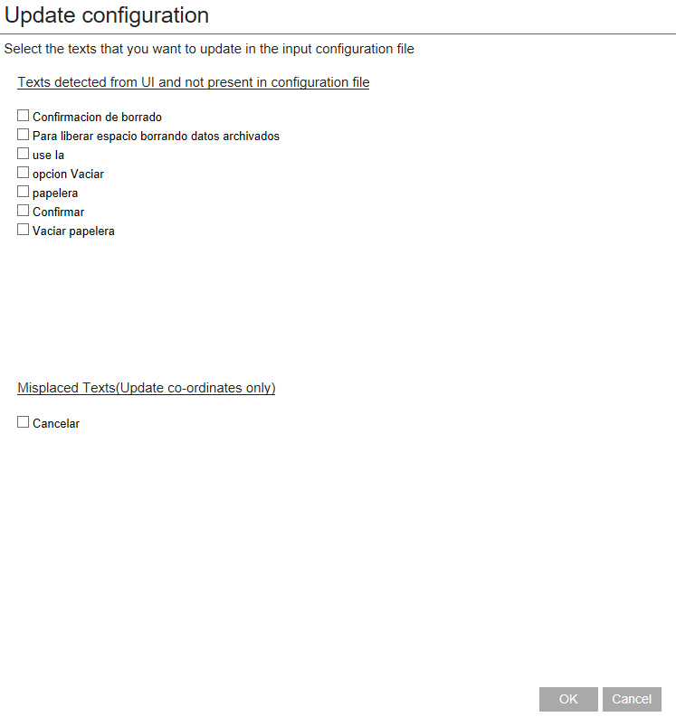

User can check the new and misplaced text that need to be updated in configuration file. On clicking the ‘OK’ button a confirmation dialog will be displayed as below.

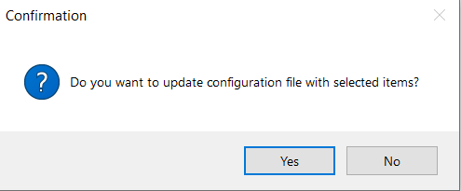

Upon confirmation, the configuration file will be updated with selected entries. If there is no new and misplaced text to update, on clicking ‘Update Configuration’ an information message box will display as below.

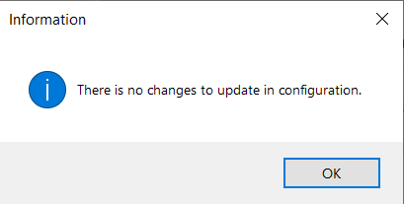

* **Configurations and Global settings**

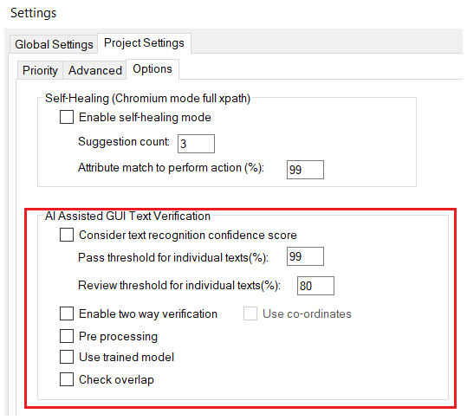

A new setting is added in Project Settings to run solution with GUI Text Verification (in Project Settings-> Options tab of Global project settings).

* **Text Recognition Confidence score**

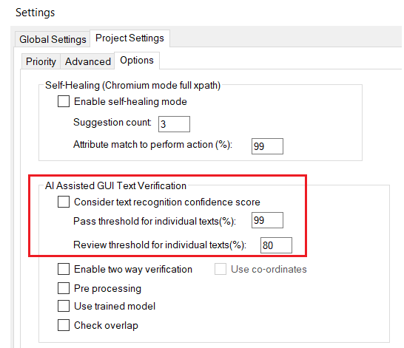

If the string obtained from the image is not exactly matched with the string in configuration file, user can decide whether the confidence score retured by the AI need to be used or not. It can be used as along with ‘text matching’ for deciding the pass or fail of a test case.

* + There is a checkbox option for Consider Text Recognition Confidence Score to determine whether we can include/not include the Confidence score.
  + If the above option is selected, we can choose the pass threshold and review threshold via edit boxes. These values are considered for individual texts. For example, if pass threshold is set as 99, all the texts with match percentage greater than or equal to 99 will be considered as pass. That is, it will be marked with green rectangle. Similarly, if review threshold is set as 80, all texts with match percentage between 80 and 99 will be considered for review and marked with orange rectangle.
  + All the text values below review threshold can be considered as ‘Fail’.

If the Text Recognition Confidence Score is not considered, all the texts that are not matched with the contents of the json file will be considered as ‘Fail’.

* **Pre-processing**

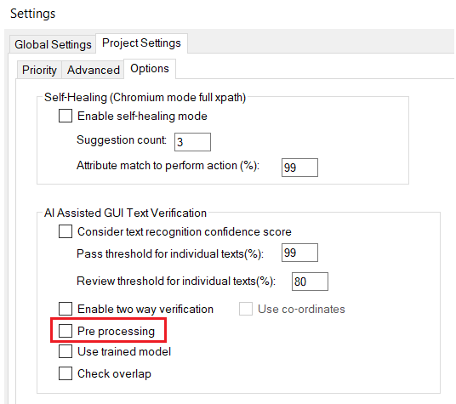

If pre-processing is enabled, accuracy of text recognition will be increased by sharpening the image. So, some strings that are not recognized earlier may be recognized after enabling pre-processing option.

* **Two-way verification**

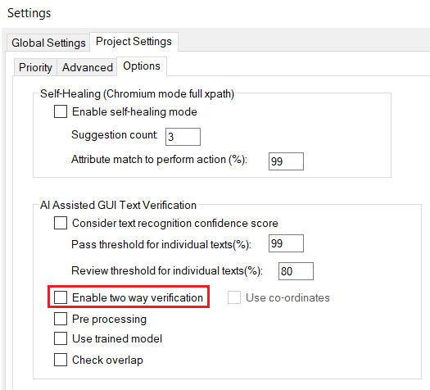

The purpose of two way verification is to check whether if strings are present in both json and image.

Enable two way verification OFF : Texts extracted from UI image will check whether it is available in the configuration file.

Enable two way verification ON : First, texts extracted from UI image will check whether it is available in the configuration file. Then it check all texts avalibable in the config file exist in UI image. When this operation is enabled, report will display the texts that are not matched.

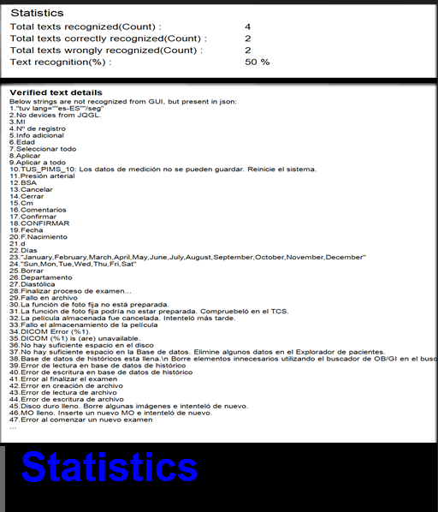

* **Use trained model**

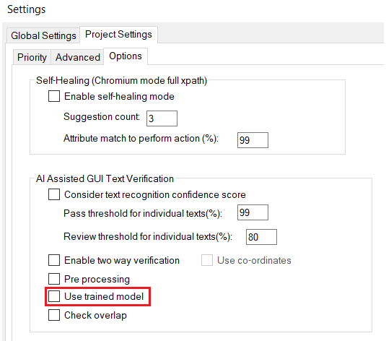

The main purpose of “Use trained model” option is to load all the latest trained models also which will improve/enhance the accuracy if the current accuracy is not upto the desired expectations. This will ensure that the latest trained model will be considered along with other pre-trained models.

* **Check Overlap**

In some cases, there may be GUI controls overlap and Text overlap over controls too. In such cases GUI verification can be done by checking overlap between controls and texts in the UI.

This overlap check can be implemented in two ways.

* Overlap between GUI controls
* Overlap between a text and its corresponding GUI controls

So, using this option, any region of overlap in a GUI can be identified using the overlap information from both approaches.

This checking can be used along with GUIImageCompare, TextCompare actions and Enable two-way verification.

* **Use co-ordinates**

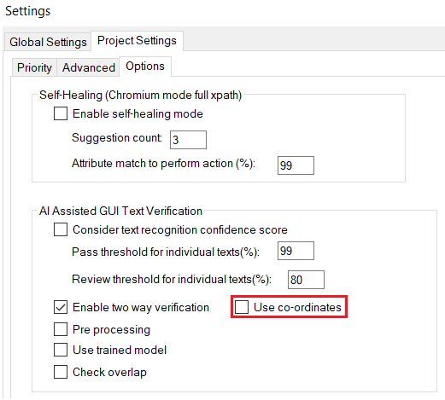

Along with text comparison in order to confirm that text is displayed on the correct control ‘Use co-ordinates’ option can be used. This settings can be used for GUI Text Compare action to incorporate co-ordinate support.

This settings can be enabled only if ‘Enable two way verification’ is checked. By enabling this settings , the co-ordinates of the text are included in the json file along with the strings for verification on the first run. Upon further execution the json file will be updated with latest co-ordinate values.

#### 5.6.7.2. GUI Image Compare

When there is a change in the GUI due to a new requirement change like changing a string or adding a new component etc, there is a chance that the strings will get cut or the strings will be absent in certain components. There may be font change issues also. To address this issue while testing, it is possible to use AI models to detect label areas from the GUI screen shots so that it can be compared with a reference GUI screenthat is already captured. By comparing with this reference image, it is possible to mark the GUI areas in which the strings are changed.

On clicking the GUI Image compare property, the below dialog opens which consists of screenshot name and repository items.

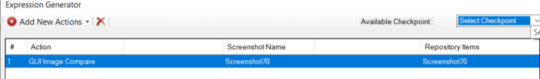

**How to perform image compare validations**

1. Choose action GUI image Compare. This will add new row into the Expression Generator window.
2. Click on the button present in the Repository Items cell. This will open up the Exclude dialog box. This dialog let’s user choose between “Select Repository” and “Add Image”. User can choose anyone option provided on the ValidationDialogBox window. On the selection of Select Repository, Repository Selection Window will open as shown in the below figure. User gets option to search any repository, Expand/Collapse the tree view and Move Up/Move Down the selections.

**Select Repository**: This will open up another dialog to select any one available repository out of available repositories list.

**Add Image**: This will open up the screen capture mode.

Once saved the image to repository, another dialog opens when clicking on repository item cell. This dialog lets user can choose between “Select Repository”, ”Select Screen Area” and “Exclude Areas”.



**Exclude Areas**: In exclude area dialog, user can exclude the unwanted multiple region of an image and can save the corresponding excluded image.

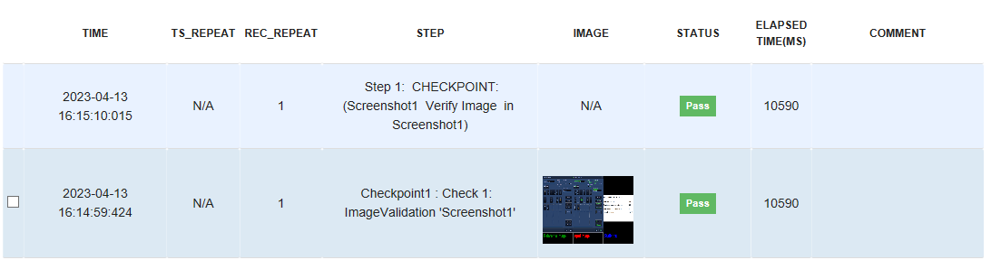

On clicking on the image, user can see the input image, output image and the statistics.

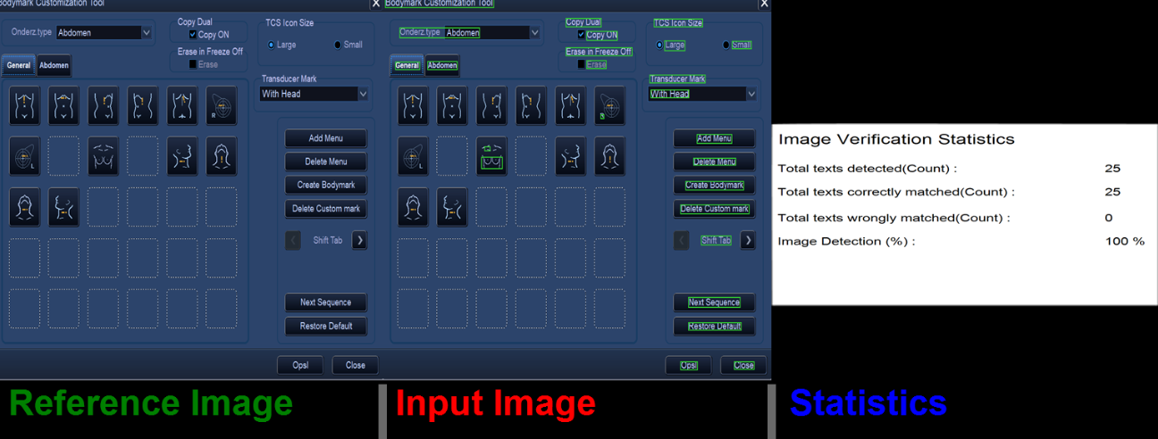

## Runtime Checkpoints

Runtime Checkpoints are created by the user at the time of recording. Objects or images can be captured during Recording and can be created as Checkpoints.

### Image Checkpoint

Image based checkpoint will add default action as contain image with captured object’s image screenshot.

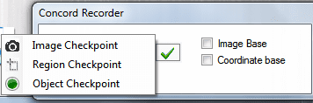

User can select the type of Checkpoint from the options shown above. On selection of Checkpoint tracking of object will begin.

User can hover on the object and Press F2 to capture the object Screenshot see the figure shown below.

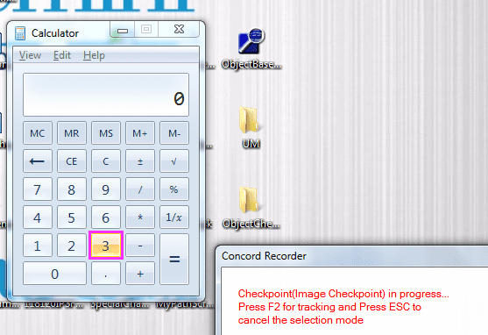

If user wants to escape from Checkpoint mode then user can click “Esc” key.

Once user captures the object’s snapshot then Checkpoint dialog will open with contain image as its default row along with the linked snapshot under Desktop see the figure shown below:

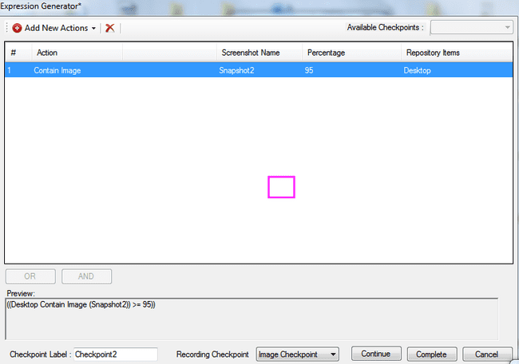

User can select different actions using “Add New Actions” menu as shown below:

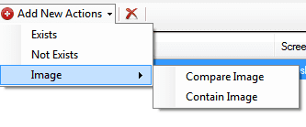

User can also create conditions by “AND” and “OR” operation as in Manual Checkpoint.

If user wants to Track new object user can click on “Continue” button and track another object with same steps. If user wants to continue with different mode of checkpoint then user needs to select the checkpoint from recording checkpoint combo box as shown in below fig:

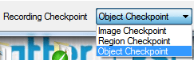

Once user is done with creating Checkpoint, user can click on “**Complete**” button to add the checkpoint in main IDE.



### Object Checkpoint

Object based checkpoint will add default action as Property with captured object.

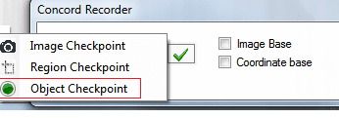

User can select object once tracking is on by pressing F2 button and can escape from checkpoint mode on pressing “Esc”.

Once user captures the object then Checkpoint dialog will open with Property as its default row along with the linked object as Repository item see the figure shown below:

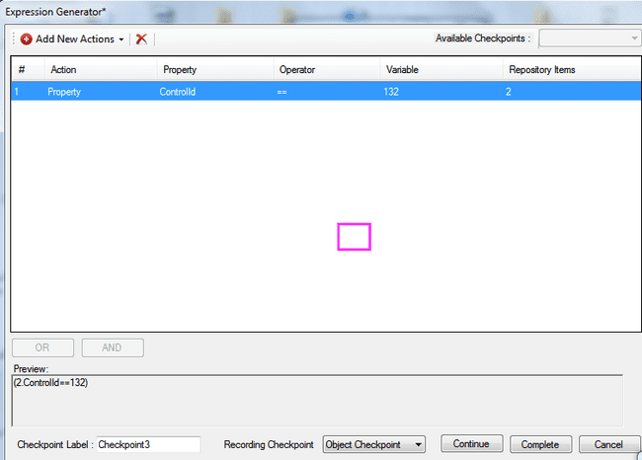

On selecting property of the object the current value of that property will be displayed in Variable column.

User can select different actions using “Add New Actions” menu as shown below:

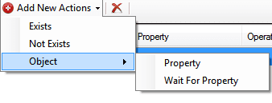

User can also create conditions by “**AND**” and “**OR**” operation as in Manual Checkpoint.

If user wants to Track new object user can click on “**Continue**” button and track another object with same steps. If user wants to continue with different mode of checkpoint then user needs to select the checkpoint from recording checkpoint combo box as shown in below fig:



Once user is done with creating Checkpoint, user can click on “**Complete**” button to add the checkpoint in main IDE.



### Region Checkpoint

Start Recording and select the Region checkpoint option from recorder window.

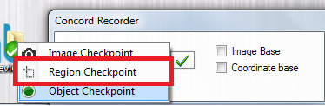

Region Cropping will start. Drag the region from the screen blurred to add in Repository. Region’s screenshot is captured and added under Desktop in repository see the figure shown below.

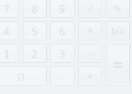

Once object is tracked, Checkpoint dialog will open along with Compare image as default action.

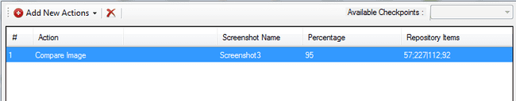

When region based then Actions which can be added see the figure shown below:

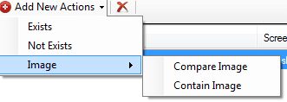

Exits and Not Exists will be linked with tracked region’s Snapshot.

If user wants to track different object/screenshot then user needs to select Recording Mode from dropdown and then click Continue.

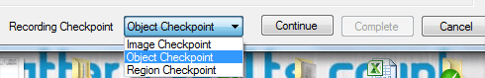

Once the steps are valid the “Complete” button will enable to complete the checkpoint addition.

Cancel will cancel the checkpoint and will resume recording.

Once user is done with creating Checkpoint, user can click on “Complete” button to add the checkpoint in main IDE.

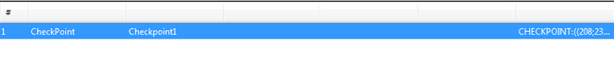

## Quick Checkpoint

Quick Checkpoint allows user to add some of the selected/frequently used checkpoint directly in the IDE. The property and its current value are visible on hovering over the object. On click of the property, a checkpoint is added in IDE which will validate the existing value.

NOTE:

Quick Checkpoint is available only for object based recording. On selection of Image or Coordinate based recording, Quick Checkpoint will automatically turn OFF.

By default, Quick Checkpoint will be turned ON. User can disable and then again enable quick checkpoint based on requirement. This will be explained in section 5.9.3.

Currently the context menu is exposing all the properties of the object. The selection of few of them or logic for figuring out frequently used properties which should be displayed in context menu still needs to be concluded.

### Addition of Quick Checkpoint

Below are the steps to add Quick Checkpoint:

* 1. Start Recording. By default, recording is started in Object based mode. Hover on the object for which checkpoint should be added. The element will be highlighted see the figure shown below:

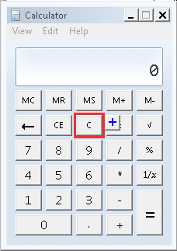

* 1. Hover on the  button. A Context Menu will be seen with frequently used properties and their current value see the figure shown below:

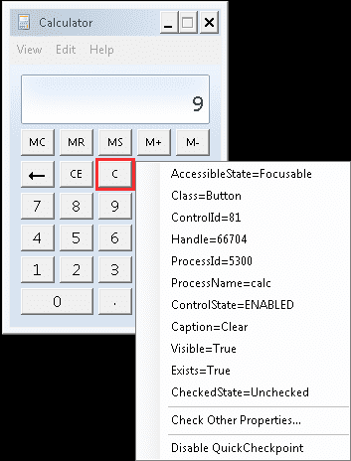

Note that when  button is hovered on, the recording goes in PAUSE mode see the figure shown below:

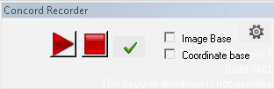

This will prevent the click for selection of checkpoint to be added as an additional step in IDE. Once the property whose checkpoint is to be added is clicked in the context menu, it will automatically go back to recording mode.

­­­­

Press “Esc key” or over away from Context menu to close the context menu.

* 1. Now click on the property in the context menu whose checkpoint is to be added in IDE.

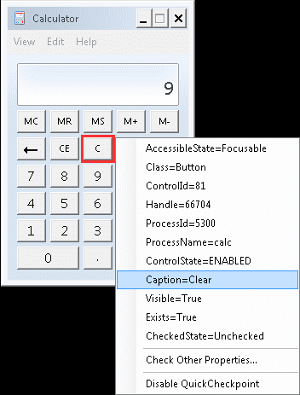

* 1. Below message will appear on screen on addition of checkpoint:



* 1. Repeat steps 2-3 till all the required checkpoints are added and then stop recording. The added checkpoints will be seen in IDE see the figure shown below:

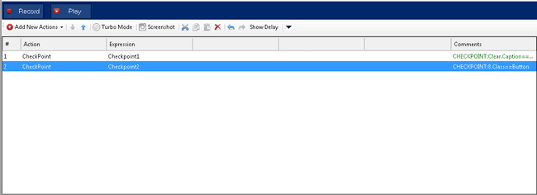

### Check Other Properties

Apart from the selected/frequently used checkpoint, user can add checkpoint for other properties using a dialog which displays the list of properties for the selected object. This dialog can be opened using the same context menu for quick checkpoint. Below are the steps to add checkpoint using Check Other Properties dialog:

1. Start Recording. Hover to the object for which checkpoint is to be added. The element will be highlighted see the figure shown below:



1. Hover on the  button. A Context Menu will be seen see the figure shown below:



1. Select the Check Other Properties option see the figure shown below:

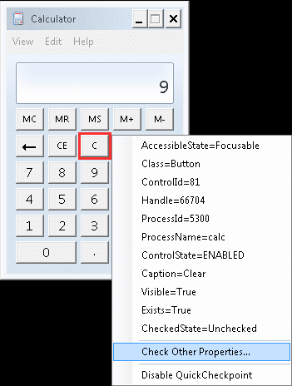

1. On click of Check Other Properties following Create Property Checkpoint dialog will open see the figure shown below:

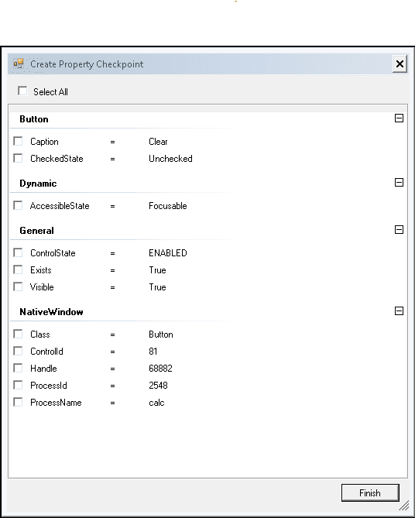

1. Select the properties for which checkpoint should be added. One checkpoint will be created for each selected property see the figure shown below.

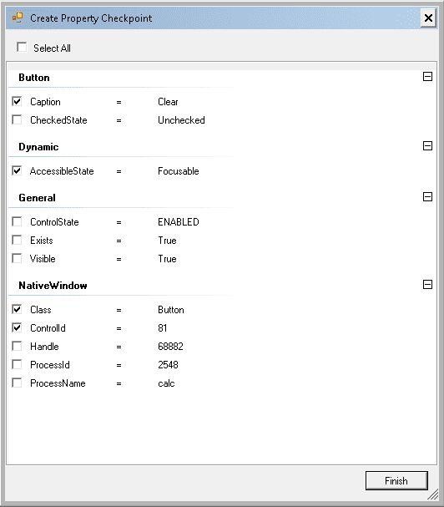

1. There is a Select All checkbox available using which user can select/deselect all the properties see the figure shown below.

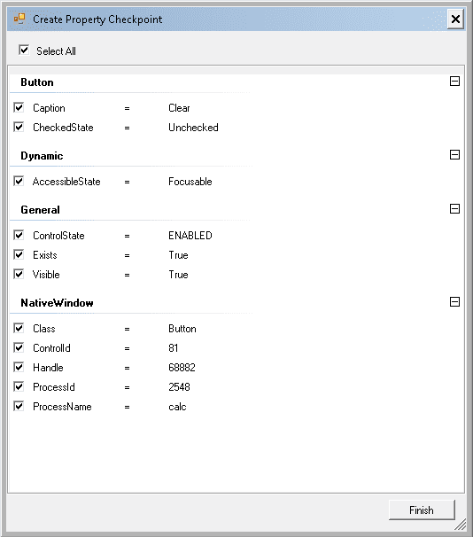

1. On click on Finish, following message will appear on screen see the figure shown below:



1. On stopping the recording, the IDE will show below checkpoint added for each selected property see the figure shown below.

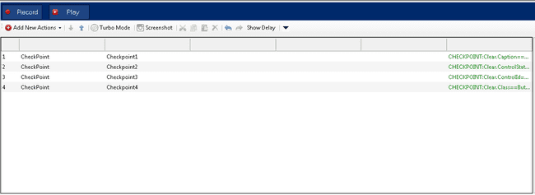

### Enable and Disable Quick Checkpoint

The Quick Checkpoint is by default ON after creating a new project and recording in object based recording mode. However it can be disabled by one of the following three ways. Once Quick Checkpoint is disabled, the  button will no longer be visible near the highlight rectangle.

1. **From Project Settings:** Open the Global Settings dialog using the following button on IDE

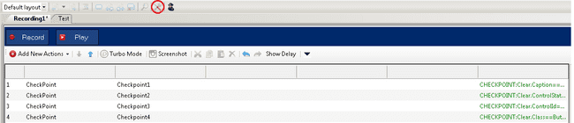

Following dialog will appear. Go to the Advanced Tab. There is a checkbox for Enable Quick Checkpoint.

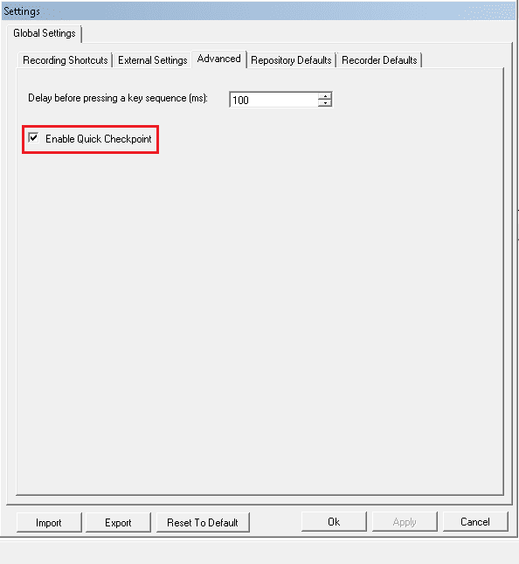

Check/Uncheck the checkbox to enable/disable Quick Checkpoint.

1. **From settings button on Recorder dialog:** Start recording. Click on the settings button shown below on Recording dialog.

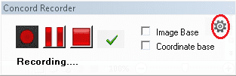

On clicking the settings button, following option will be displayed to enable/disable Quick Checkpoint. When Quick Checkpoint is enabled, it will be checked see the figure shown below.

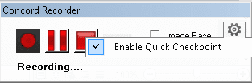

Click on Enable Quick Checkpoint again to uncheck and disable Quick Checkpoint see the figure shown below.

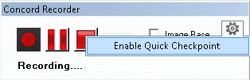

1. **From Context Menu:** There is an option to disable Quick Checkpoint from the context menu that appears on click of the  button that is shown when we start recording in object based recording mode with Quick Checkpoint ON.

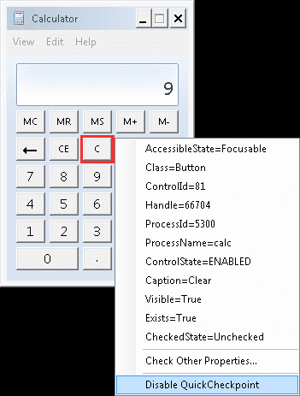

Click on Disable Quick Checkpoint to set the Quick Checkpoint mode to OFF.

Once disabled, the Quick Checkpoint can also be enabled in one of the following two ways. When Quick Checkpoint is enabled, the  button will be visible near the highlight rectangle which will show the above context menu to add Quick Checkpoints.

1. **From Project Settings:** Open the Global Settings dialog using the following button on IDE



Following Settings dialog will appear. Go to the Advanced Tab. There is a checkbox for Enable Quick Checkpoint. Check the checkbox to enable Quick Checkpoint.



1. **From settings button on Recorder dialog:** Start recording. Click on the settings button shown below on Concord Recorder dialog.



On clicking the settings button, following option will be displayed to enable/disable Quick Checkpoint. Click on the Enable Quick Checkpoint checkbox to check it and enable Quick Checkpoint.



## Delay

A delay action can be used to pause test automation execution for a specific time (column ‘Time (ms)’) see the figure shown below.

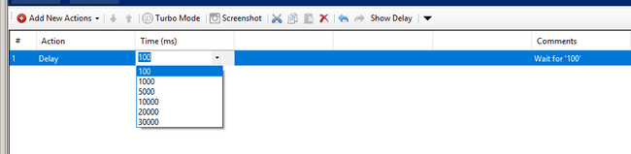

**Note:**This time delay is not scaled with the speed factor and is also present in 'Turbo Mode'

## Wait For

Waits for a given repository item to appear or disappear. Use it to wait until the assigned repository item appears (choosing the option 'Exists') or does not exist (choosing the option 'Not Exists') see the figure shown below. ‘Timeout’ can also be specified.

It supports object and image both repository items.

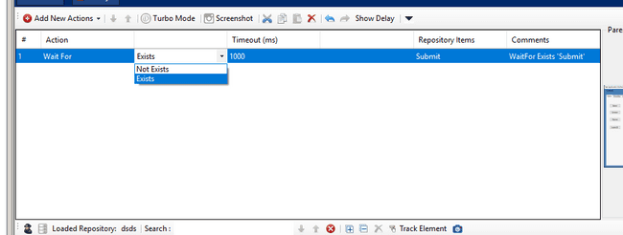

## OSD

OSD step is used to display the on- screen message any time while executing test suite. If user wants an information message or any other type of message to be displayed on the screen to user between any steps of execution, user can use OSD step.

In Concord, user can add the OSD step from IDE similar to all other actions.

### Run OSD

The Run OSD step can be added as given see the figure shown below:

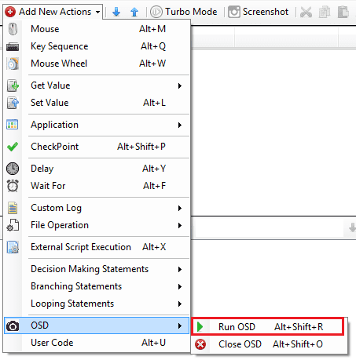

The Run OSD step addition will open a dialog to set the properties of the OSD Text to be displayed.

The “Concord OSD User Input Form” dialog will open as shown in below figure:

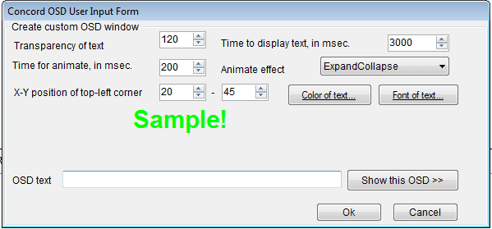

The Concord OSD User Input Form dialog contains following setting options:

**Transparency of text** – indicates the transparency of text when shown on the screen.

**Time to display text, in ms** – indicates the time for which the OSD text will be displayed on the screen for showing demo.

**Time for animate, in ms** – indicates the time for which the OSD text will undergo animation effect.

**Animate effect** – indicates the animation effect which would be applied to the OSD text.

**X-Y position of top-left corner** – indicates the x, y position of the screen where the OSD text will be displayed.

**Color of text** – color to be applied on the OSD text. The color selector window is shown in below fig:

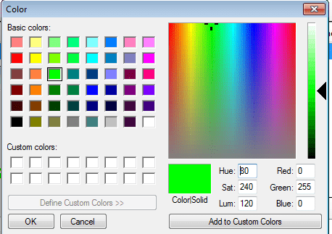

**Font of text** – indicates the font style which would be applied on OSD text as shown below:

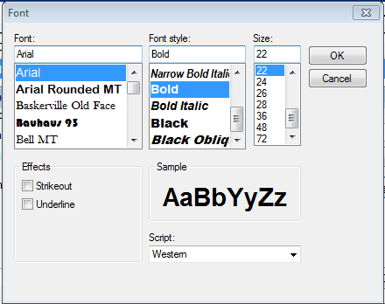

**OSD text** – user can type the message that needs to be displayed on screen.

**Show this OSD>>** - this button will show the demo for OSD message being displayed.

Once the configuration is done, user can click on OK button to add the Run OSD step in concord IDE. On cancel the step will not be added in IDE.

**OSD variable support** – User can display hardcoded string in the above cases, but if user wants to display variable value along with hard coded string then user needs to select the variable from the variable column in Run OSD action.

There are following different options for user to attach variable value or hard coded string to Run OSD action:

* + - 1. **Display only hard coded OSD message** – In this user need not to select the variable and can add hard coded value in OSD Message column see the figure shown below:

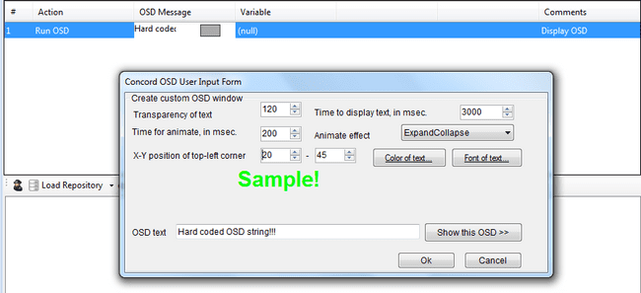

* + - 1. **Display Variable Default value** – in this user can select variable in Run OSD action by setting the default value of it in “Variable Operations” dialog see the figure shown below:  
         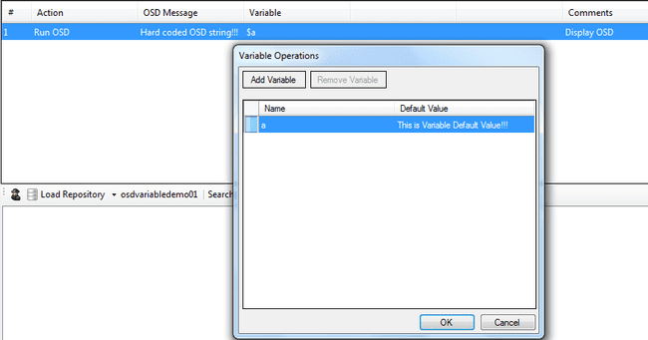
      2. **Display Variable Value set in some other action** – In this user can store the variable’s value as the result of some other action(eg: Object information) see the figure shown below:

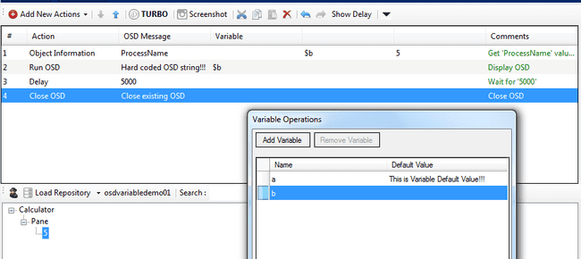

* + - 1. **Display Variable value along with Hard coded string value** – In this, user can append variable’s value(either default or set by different actions) along with hard coded string given by the user see the figure shown below:

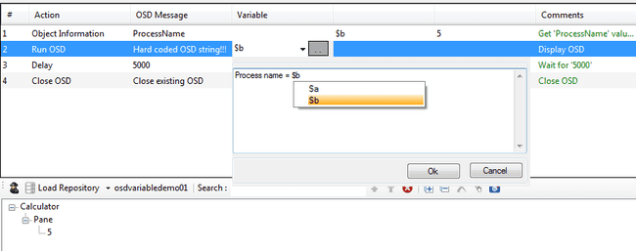

* + - 1. **Display multiple variable value in single action**- In this, user can use multiple variable value in single OSD step. This will reduce the overhead of user to add multiple OSD actions when need to display multiple variable value see the figure shown below:

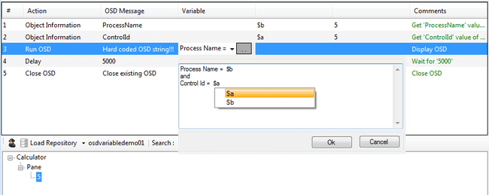

### Close OSD

The Close OSD step will be added in IDE and user cannot edit the close OSD step, see the figure shown below:

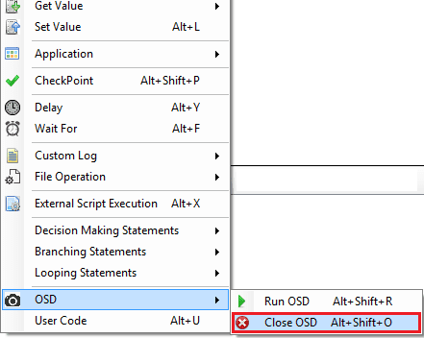

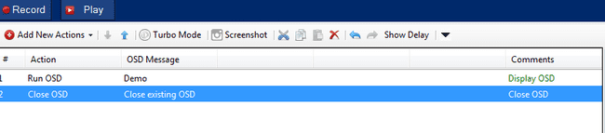

Run OSD will show the OSD text on screen once the script is played and Close OSD will close all the currently running OSD i.e. it will close the displayed OSD text.

**Note**: Each Run OSD should be closed before running the new one Run OSD step. Nesting of OSD steps is not recommended.

## ­­Custom Log

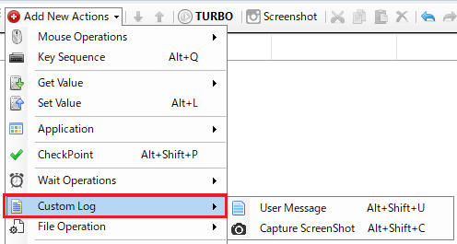

### User Message

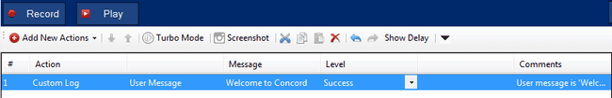

This action is used to show user provided message in the report. It also shows the level of the step.

Within concord user is able to use different levels of reporting information importance, from a debug message to failure information.

Report Levels describe the importance of a message that is delivered to the report. Using different kinds of report levels can help in keeping the reports short and better readable.

The different levels of Report/Custom Log available are shown in below figure:

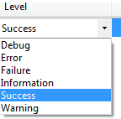

On executing the Custom Log action with User Message option below Report is created see the figure shown below:

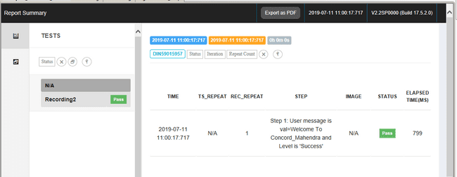

### Capture Screenshot

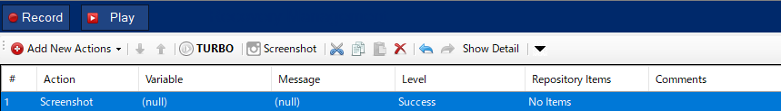

This action is used to take screenshot of the part of the screen you want to check. In this case the Repository Item is No Items. That means it will take screenshot of the desktop. Capture targets vary depending on the Repository Items setting.

[To take a screenshot of a specified repository item]

1. Select the Repository Items cell and a rectangular button will appear.

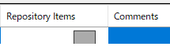

2. Click the rectangle button to display the Select target item dialog, then click the "Select Repository" button.

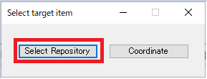

3. Select the repository item for which you wish to obtain a capture and press the "OK" button.

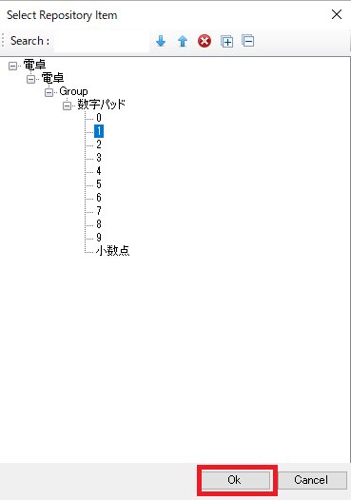

4. The selected item is registered in the step.

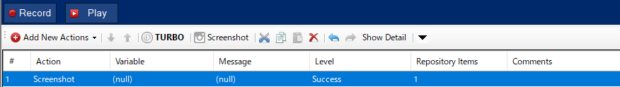

[To take a screenshot of a specified area]

1. Select the Repository Items cell and a rectangular button will appear.



2. Click the rectangle button to display the Select target item dialog, then click the "Coordinate" button.

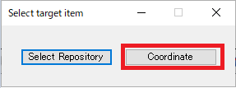

3. The Select Area dialog appears.



4. Enter values in the X, Y, W, and H fields or click the Capture button and drag & drop to specify the range.



5. When the OK button is pressed, the specified range (X|Y|W|H) is registered in the step.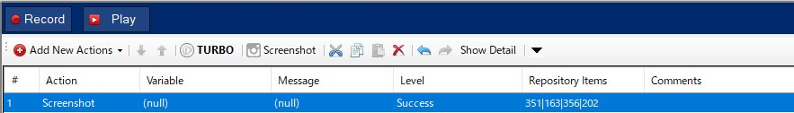

This also contains different levels of report see the figure shown below:

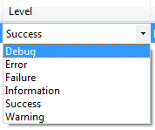

This step allows you to capture a screenshot of the portion of the screen you wish to review and store it in a designated folder. For details on specifying a folder, see Folder for saving report images.

The file path of the captured image can also be stored in a variable.

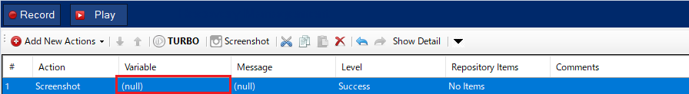

On execution following Report will be generated see the figure shown below:

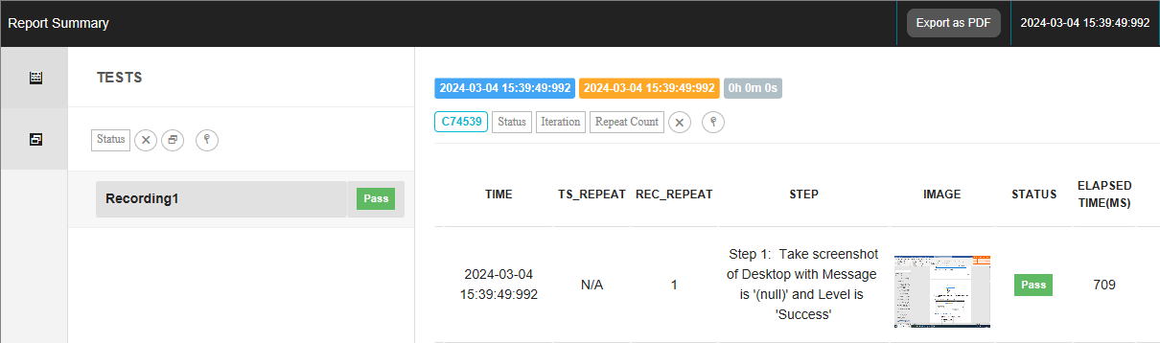

## File Operations

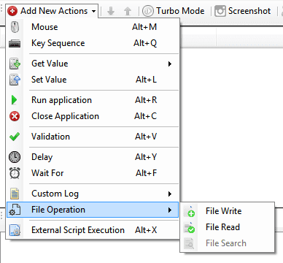

### File Write

This action is used to write value in to selected file. Value to be written can be set by using variable or directly entering a string value. Below steps should be followed for file writing operation:

1. First select file type in which contents are to be written see the figure shown below.

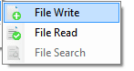

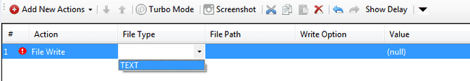

1. Choose file in which changes are to be made.

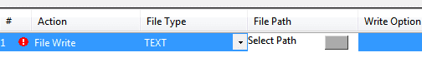

Note: User can also select file by providing its path. If path is provided from same directory where script is create, it will display relative path else full path will be display. User can also use environment variable to select path. If environment is selected then path will be displayed in term of environment path. see the figure shown below shows path selected from different location:

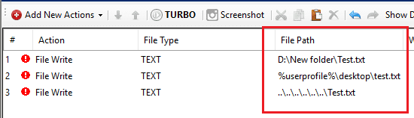

1. Select write option. In the option to write value in newline or append in same line or create new file are available. Select any one.

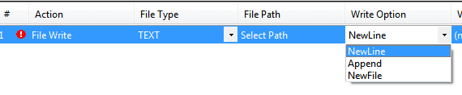

1. Select Variable or add directly string value or both for write. Here value can also be added by combining variable and string. For this click on button next to dropdown arrow. Pop window will be shown for variable. Enter dollar ($) sign. Then available variables can be seen. Using enter button variable can be selected.

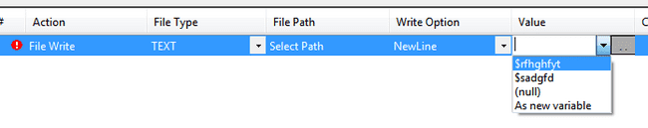

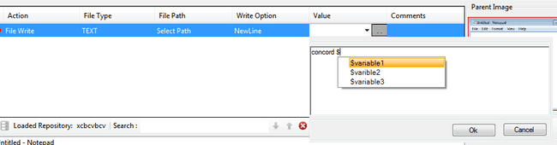

1. On executing the step value will written in selected file and following Report will be generated



### File Read

This operation is used to read value from selected file and save in selected variable. Following are the steps for file reading operation. Selected file size should be less than 2 GB. This is Maximum limit for file reading.

1. First select file type from which data has to be read.

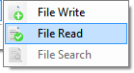

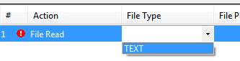

1. Choose file for reading

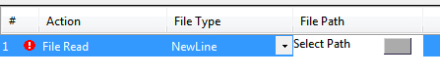

Note: User can also select file by providing its path. If path is provided from same directory where script is create, it will display relative path else full path will be display. User can also use environment variable to select path. If environment is selected then path will be displayed in term of environment path. see the figure shown below shows path selected from different location:

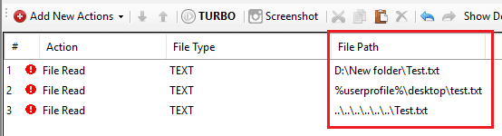

1. Select Variable in which file data is to be saved.

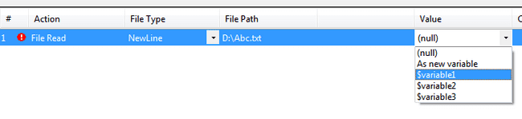

## Decision Making Statements



### IF Statement

* This operation is used to validate the expression generated by expression generator.
* User will have option to give condition checking block with the help of IF ENDIF
* This option will available in IDE in add action in ‘Decision Making statement’ section see the figure shown below.

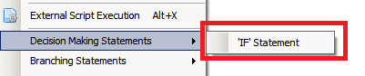

IF expression is valid then it executes the inner statement

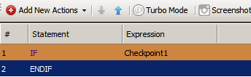

## Branching Statement



### RETURN Statement

In return statement user will stop execution of current recording see the figure shown below.

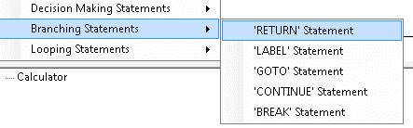

### LABEL Statement

Conditional statement will have option ‘LABLE’ which is as follows see the figure shown below

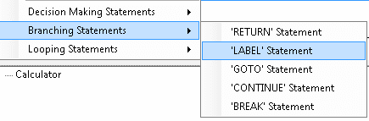

User can create label at anywhere in steps then can pass the execution control via the goto statements.

### GOTO Statement

The goto statement is a jump statement that controls the execution of the program to another segment of the same program via label see the figure shown below.

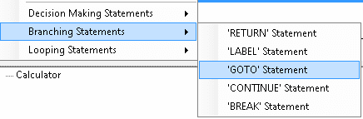

### CONTINUE Statement

This statement alters control flow. It is used in loop bodies. It allows to skip the execution of the rest of the iteration see the figure shown below.

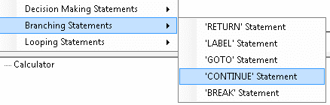

### BREAK Statement

When the break statement is encountered inside a loop, the loop is immediately terminated and program control resumes at the next statement following the loop see the figure shown below.

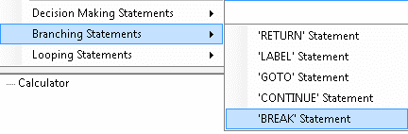

## Looping Statements



### For Loop

For loop is used to run the same statement or set of statements for a number of times. Enter a variable in Variables and use it to set the number of times the statement has to be done. The expression for For loop can be set in For Block Expression Generator which pops up on adding a For Loop see the figure shown below.

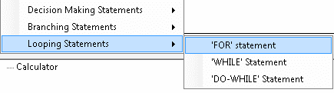

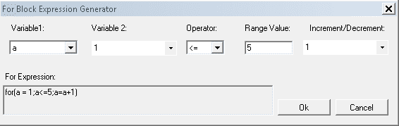

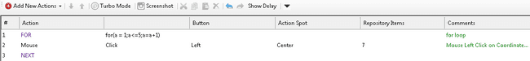

### While Loop

While loop is used to run the same statement or set of statements till a particular condition is met. The condition can be set in Expression Generator which pops up on adding a While loop see the figure shown below.

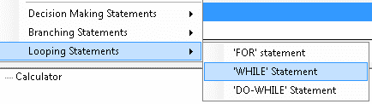

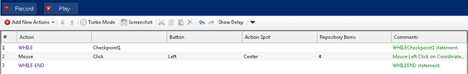

### Do-While Loop

Do-While loop is used to run the same statement or set of statements till a particular condition is met. The only difference between Do-While and While loop is that the statements are run at least for one time. The condition can be set in Expression Generator which pops up on adding a Do-While loop see the figure shown below.

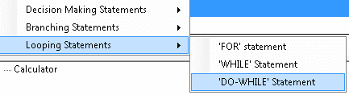

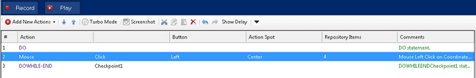

## User Code

* The user code module can be used to write user’s own custom functionality and use the same to give extended support to automation script.
* As user code is a partial class of recording, variable defined at class level or in a function in recording class can be accessible in user code.
* It is not advisable to change anything directly from background. Please use IDE for all operations.
* How to use :

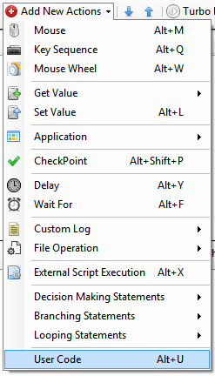

* After selecting user code action following row will get added.

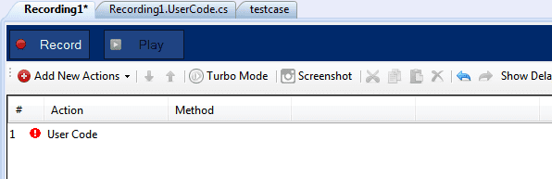

* Above Method column will show all methods which are written in user code file of current recording see the figure shown below.

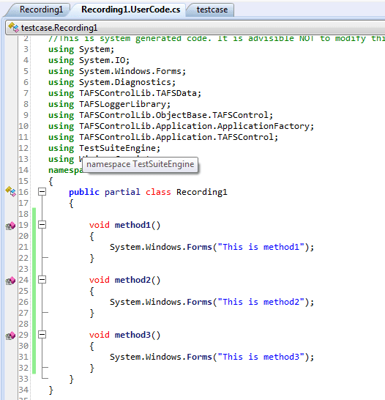

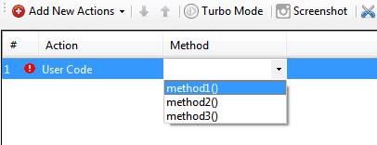

* If user has added method with parameters then it will not appear in method dropdown because it is not implemented yet.

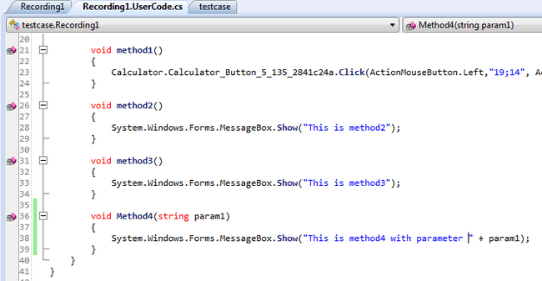



* In Recording to Recording copy paste at IDE level, if copied method which is from Recording1 is already present (comparison according to method name only) in Recording2 then it will not get pasted. If it is not present then it will get pasted in Recording2.
* In case of copy–paste within Recording at IDE level, user can paste same user code action multiple times. However, this will not create multiple copies of the same method in Recoding.usercode.cs file.
* While working with repository or external reference, user can use these objects in user code file by importing namespace. Repository Example is as follows:

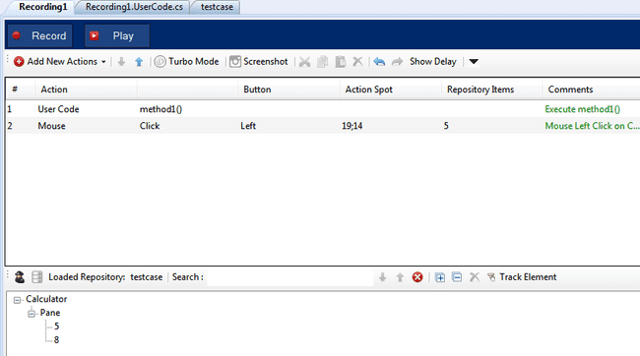

* User has to write namespace manually or import dynamically while writing code in user code file. Following image shows how user can import namespace dynamically.

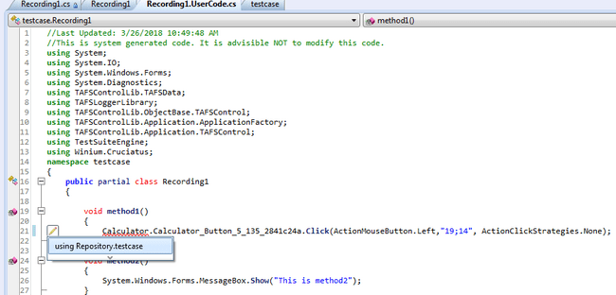

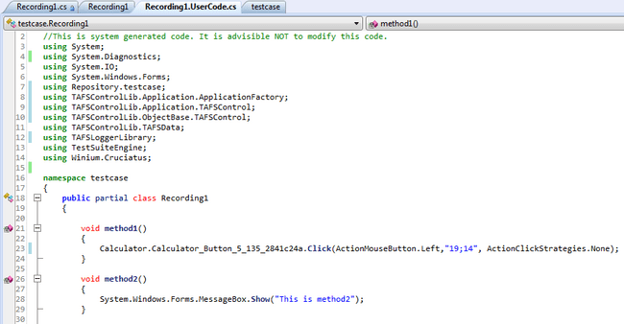

* User Code Example
  + Create a new project and select Recording.usercode.cs file. User can see namespaces and class name.

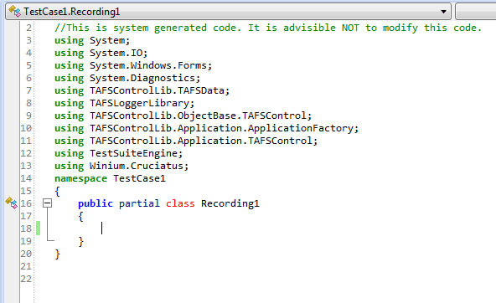

* + Now add/ write any method into Recording1 class. Following link can be used to learn basic C# coding.

<https://docs.microsoft.com/en-us/dotnet/csharp/quick-starts/>

void **Addition**()

 {  
         **int** var1 = 10;  
         **int** var2 =20;  
         **int** Total =0;  
           
          Total =var1 + var2;  
          System.Windows.Forms.MessageBox.**Show**("Addition : " +Total.**ToString**());  
 }

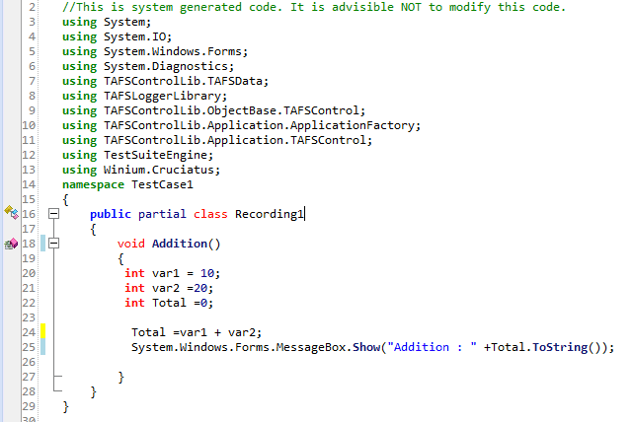

**Note** :   
We should use property (public variable ex : v1) while using variable in user code method and not the private variable(ex : _v1), As shown in the below figures.

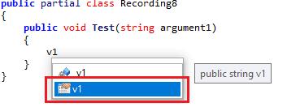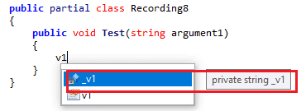

* Now open IDE to use usercode method in Recording.cs file. Add action Usercode and select method “Addition” from dropdown.

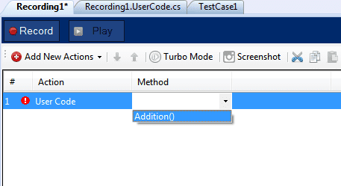

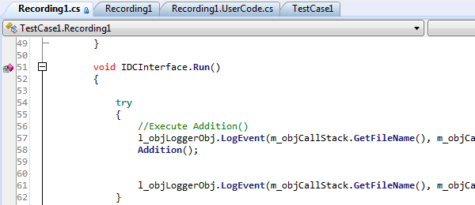

* User can also add parameters to the method using argument editor window:-



* By clicking on the above picture, argument editor window will invoked.

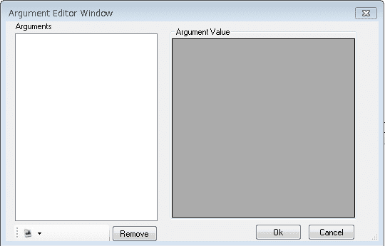

* User can add multiple arguments with different data type:-

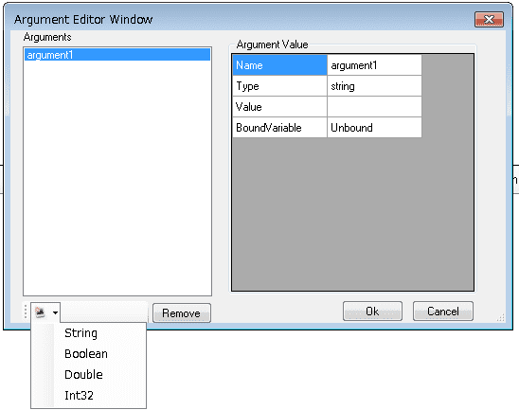

* User can add the values of the arguments in Argument value field. On click of OK button, values will be displayed in the argument field of IDE.



* Same arguments will also get updated in usercode.cs file and vice versa i.e. if any changes are made in user code.cs file, changes will be displayed in the IDE as well.
* On hovering over the methods from dropdown, tool tip will be displayed as below:-

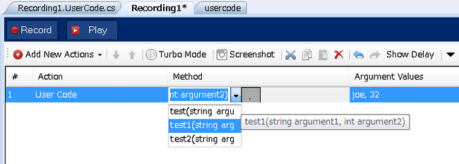

**Note:**Since users manage user code, there are many combinations and permutation users can do with functions, variables, and external libs or references.

Example:

1. Write some function and call another function from same class or different class or different lib itself or use some external entity APIs which are not part of the original Concord functionality.
2. Add reference of some 3rd party lib using “Add reference” in project solution.
3. Use Recording variable directly in user code function.

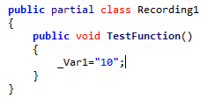

The variable Var1 is Recording variable.

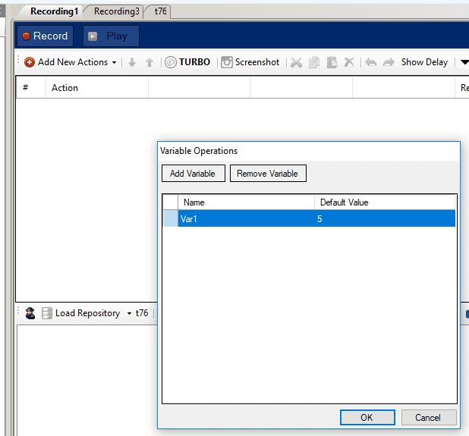

In above case, it is recommended to use Var1 instead of _Var1 as copy or moving such user code steps in IDE might lead to errors.

1. Add member variable and use in function call or use different class or lib’s variables. For some datatype user need to add using statements for example: list or array

So as users can freely programmed user code, it will be ultimately user responsibility to manage user code files in different operations like debugging and correcting code or removing compilation errors because of modification done by user.

There are some other user operations as well,

* + moving user code from one class to another class of same solution or different solution.
  + copy\paste user function directly from user code file.
  + copy\pasting user code action from IDE step.
  + using import\export operations.

While performing such operation user code function or file may refer external references which are not actually part of the user code file.

In this case, user need to correct\add them manually in new user code file or solution like,

* + Adding variable or namespace
  + Adding reference of lib in solution

Some example:

In below example we have Recording whose variable is declared in User class itself

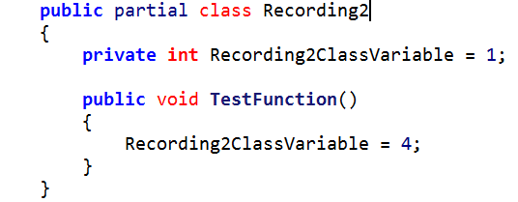

Step is added in step IDE

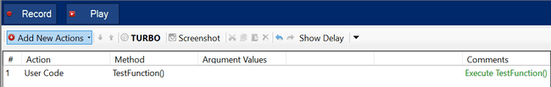

Now when user will copy-paste in another recording then s/he will get compilation error saying “The name 'Recording2ClassVariable' does not exist in the current context (CS0103)” here user need to add above variable either by manual copy-paste operation or manually typing.

*Please ensure that your files are correctly saved when you are copy-pasting; paste operation may give wrong results. Concord will not save user code file automatically without user notification to avoid incorrect save so save it manually.*

## Transaction Action

* The transaction action module can be used to find the transaction time between two execution steps.
* Transaction should be start by “Start” and end by “Stop” action, Transaction may include “Pause” and “Resume” actions to pause and resume the transaction in between the “Start” and “Stop” actions only.
* **Add transaction steps in IDE:**
* Transaction steps include the two sub steps Configure Transaction and Summarize Transaction.

### Configure Transaction

* Configure transaction include the steps Start, Stop, Pause and Resume steps indicates that transaction is in which state see the figure shown below.

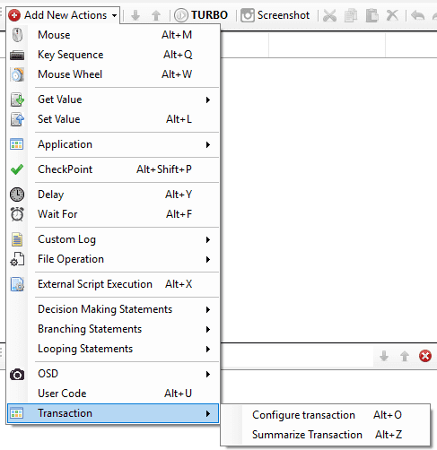

* After selecting Configure Transaction shown in below screenshot, where start is the default state user can change accordingly see the figure shown below.

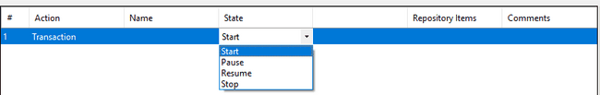

* User need to add transaction name in **Name** column to recognize the transaction individually
* After clicking on “Name” column, it will give dropdown to add “New” Transaction or “Configure” the existing transactions update/delete see the figure shown below.

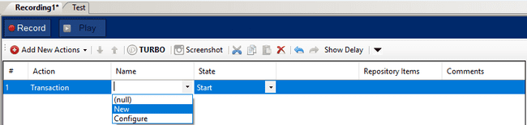

* After clicking on “New” it will show the below Add New Transaction dialog, User can add transaction name.

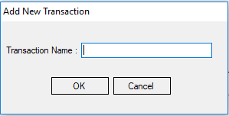

* For rename or deleting the existing transaction, user needs to click on “Configure” option. Below Transaction dialog will open in which user can rename the transaction by clicking on the transaction name and user can delete any transaction by selecting entire row of the transaction and click on “Remove Transaction” see the figure shown below.

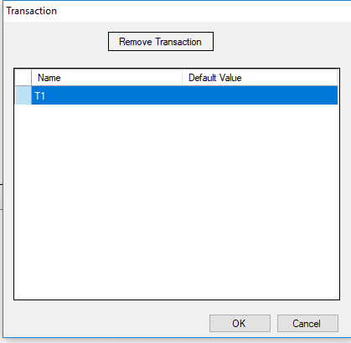

On “Stop” transaction state “checkpoint Setting” window is provided to the user with logical operation, using the applied setting, the result is displayed in the execution report see the figure shown below.

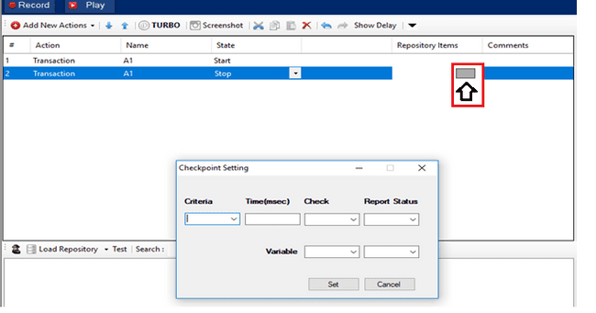

**Note**: Time calculation for transaction includes Concord's preprocessing time like finding the control, logging etc. User needs to consider these timings when applying calculation in transaction checkpoints.  
Please consider.  
  
Above window’s details are explained below,

**Criteria:** Logical Operation on the result to be performed.

**Time:** Match value to be entered. (E.g. If user wants to check the time taken from Start to stop is less than or equal to 2000 ms then user need to select <= operation in criteria and enter 2000 in Time field).

**Check:** To check the condition is true or false.

True: User wants to check time taken is <= 2000 as true condition, then user need to set true for Check field.

False: User wants to check time taken is <= 2000 as false condition, then user need to set false for Check field.

The above expression can be simply put as [(time taken<=2000)==true/false]

**Report Status:** As per the above expression user can set the report status as PASS/FAIL

Example: Scenario1 -> if [(time taken<=2000)== true] then report PASS

Scenario2 -> if [(time taken<=2000)== true] then report FAIL

Similarly false can also be used, this is based of user’s logic to validate the output of transaction time.

User can use the module variable also instead of hardcoded value.

### Summarize transaction

User can add Transaction Summary step from Transaction->Summarize Transaction see the figure shown below.

* 1. Transaction summary – Main step
  2. Transactions – User can select multiple transitions/All
  3. Math operation – User can select Sum/average/Min/Max of the selected transaction
  4. Checkpoint (optional) - User can compare transaction time value and based on result step will fail or pass.
  5. User can add one or more transaction and compare.

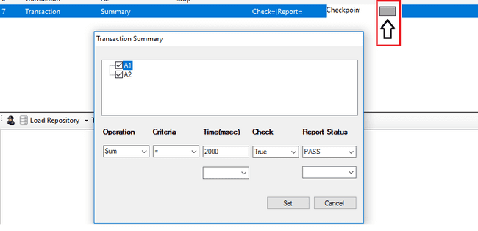

Note: User can see only the transactions available in the current recording in the Transaction Summary dialog for now.

Transaction summary dialog details as below:

**Operation:** Basic mathematical operations like sum, product etc. (These operations will be done to the output of the transactions selected. E.g: Sum(A1,A2)).

**Criteria:** Logical Operation on the result to be performed.

**Time:** Match value to be entered. (E.g: If user wants to check the outcome of operation performed on two transaction is less than or equal to 2000 ms then user need to select <= operation in criteria and enter 2000 in Time field).

**Check:** To check the condition is true or false.

True: User wants to check outcome of operation performed on two transaction is <= 2000 as true condition, then user need to set true for Check field.

False: User wants to check outcome of operation performed on two transaction is <= 2000 as false condition, then user need to set false for Check field.

The above expression can be simply put as [(Sum(A1,A2)<=2000)==true/false]

**Report Status:** As per the above expression user can set the report status as PASS/FAIL

Example: Scenario1 -> if [(Sum(A1,A2)<=2000)== true] then report PASS

Scenario2 -> if [(Sum(A1,A2)<=2000)== true] then report FAIL

Similarly false can also be used, this is based of user’s logic to validate the output of transaction time.

User can use the module variable also instead of hardcoded value.

### Adding Transaction during recording

* When user started recording on Concord Recorder window transaction icon(red marked) see the figure shown below:

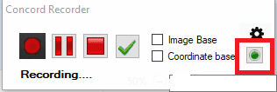

* On click of above icon below dialog will open, where user can add/select transaction name and perform Start Pause Resume Stop actions, after click on Set button steps will be added in IDE for that particular recording see the figure shown below.

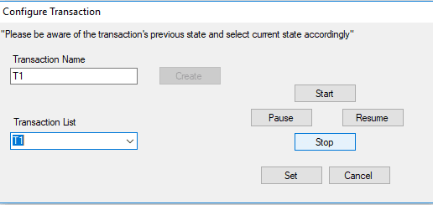

* Recording steps for Configure Transaction see the figure shown below:

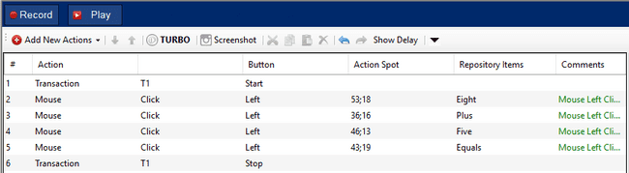

For the above recording report will generate like below screenshot, Total time taken by Transaction T1 is 10.451 sec see the figure shown below.

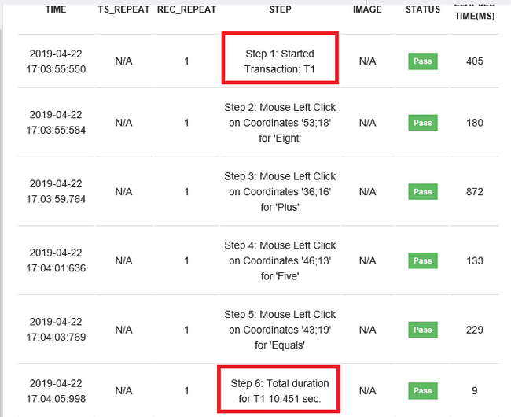

* Recording steps for Summarize transaction see the figure shown below

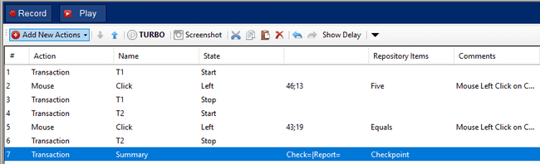

For the above summarize transaction recording report will generate like below screenshot, Transaction summary for transaction T1 and T2 is 4.799 sec see the figure shown below.

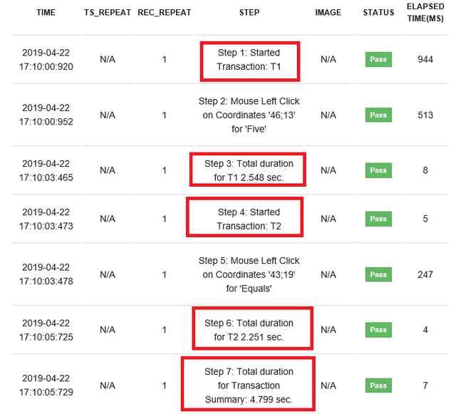

# Configure the UWSC executable path in Concord

Configure the path of UWSC in **External Settings tab** from following location see the figure shown below:

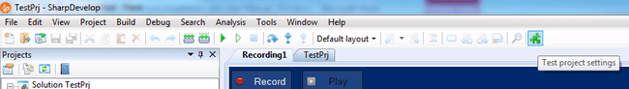

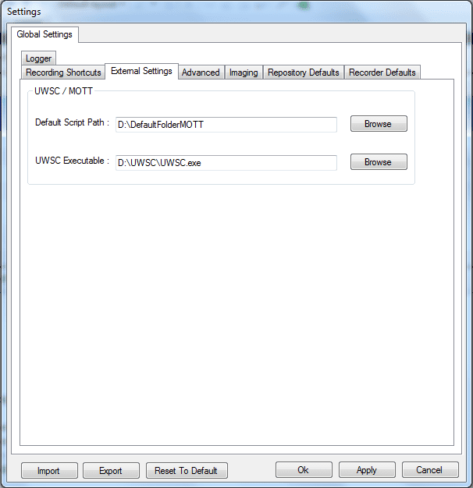

# Running and Editing the UWSC or MOTT Script

Add action “External Script execution” from the “Add New Actions” menu strip and then select the path of the UWSC/MOTT script to be execute see the figure shown below:

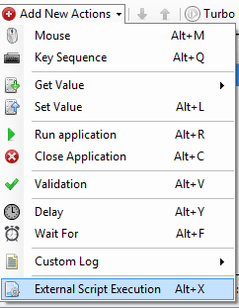

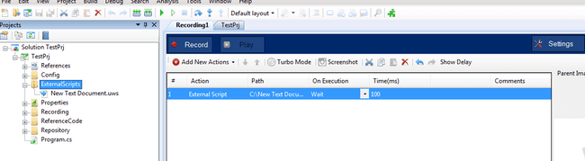

After “External script execution” step is added the code can be generated and then the UWSC/MOTT script can be run.

After external script is selected the script is added to “ExternalScripts” folder in the Project explorer window. Double click on this script and open the script for editing see the figure shown below:

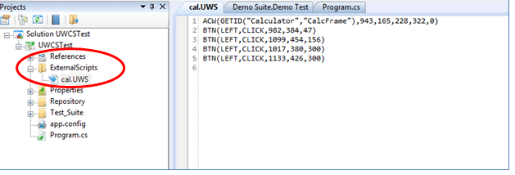

If required, edit the script and save. And then run the updated script through GUI.

Note:

1. MOTT scripts can be run using UWSC.exe. So there is no need to install MOTT tool on system where test automation is required.
2. User can also select application by providing its path. If path is provided from same directory where script is create, it will display relative path else full path will be display. User can also use environment variable to select path. If environment is selected then path will be displayed in term of environment path. see the figure shown below shows path selected from different location:

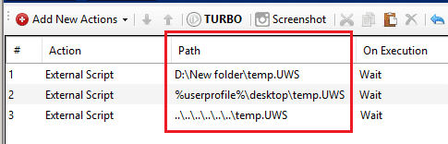

# Data binding

**Data Driven testing allows the automation tool to pass the test data that is available in configured excel/csv to a linked Control. Test case can be linked to user defined data source and variables, that fetch the values from the Data source and pass it to a Windows Object (E.g.: Edit box).Following is the workflow to achieve this through Data Source & Data Binding.** Select the Variables Option from the Header menu

Click on Variables to create the user variables see the figure shown below



This will activate the below window. Add the needed variables (these are case sensitive)

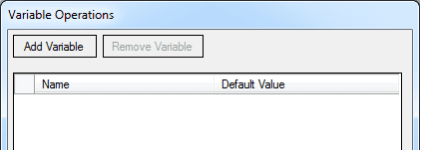

## Add the User Variables as necessary and Save

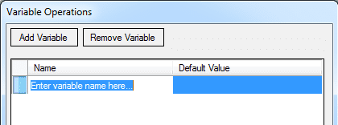

Use added variables in grid to bind data. Another way to add variables is from grid. To add variable, add “set value” action from “Add new action” drop down. Add edit type repository item to SetText. “As new variable” will be displayed in the dropdown see the figure shown below,

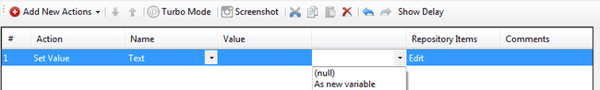

Clicking on “As new variable” will open below dialog,

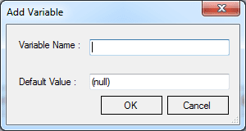

Add variable name and default value. Click on OK to save the variable.

## ­­­Add data sources from Header menu

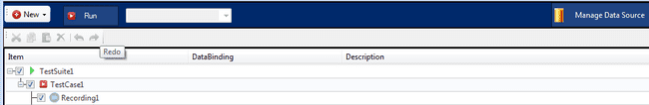

Clicking on Manage data source will open below Manage Data Sources dialog,

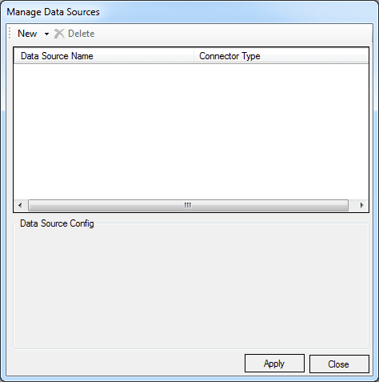

Add data source of type excel or CSV from "New" menu Item. Clicking on "New" will open drop down ,see the figure shown below,

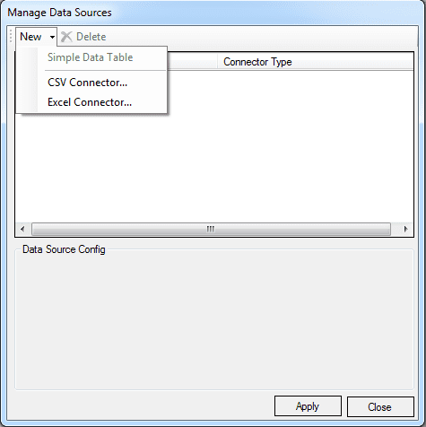

Selecting excel connector will add excel data source with blank name. Add name to data source and select excel document. Select sheet from excel document and then click on Apply to save the data source. Same procedure is used to add CSV data source. It automatically selects the “Sheet1” in Worksheet. The sheet can be changed if required. Apply and Close this window.

Data sources added are available for all Test Cases and Recording in that Test Suite. For nested Test Case, if one data source is binding with parent Test case then that data source will not be available for its child Test cases for binding and vice versa.

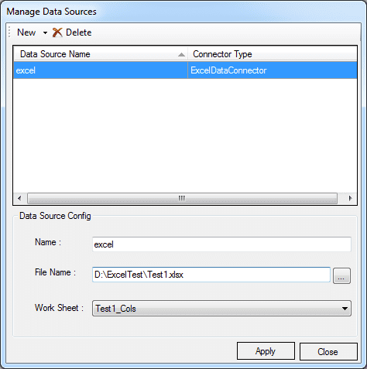

Note: User can also select application by providing its path. If path is provided from same directory where script is create, it will display relative path else full path will be display. User can also use environment variable to select path. If environment is selected then path will be displayed in term of environment path. Below figure shows path selected from different location:

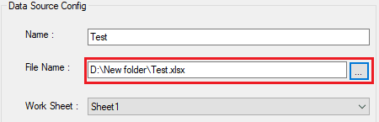

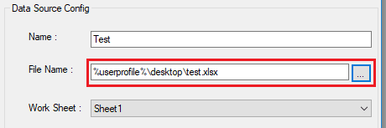

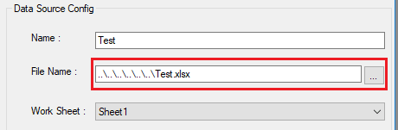

## Data binding

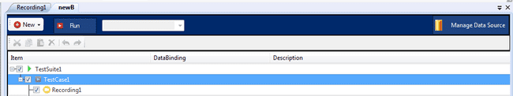

To open data binding dialog, click in front of “Test case Properties” dialog in “DataBinding” column. Add data Sources from “Manage Data Source” button present on data binding dialog see the figure shown below,

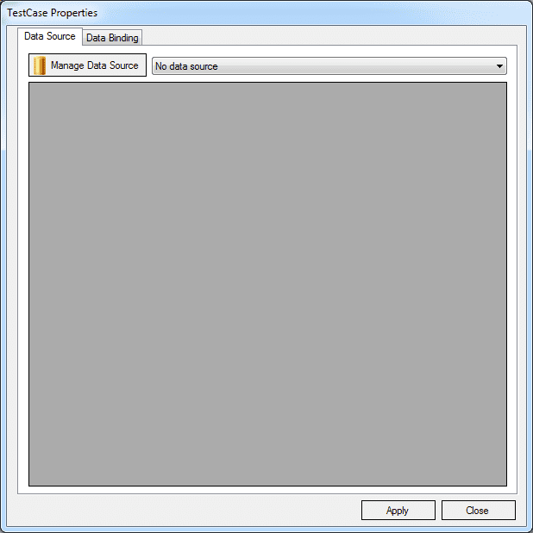

## Configure Data Source

### Selecting data source from available data sources

Data sources added from Manage data source are available for binding see the figure shown below,

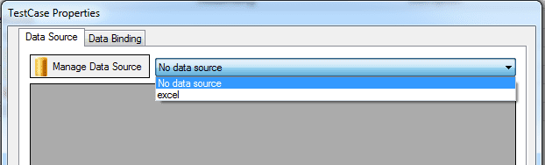

Selecting on data source will display data table from sheet in below blank space, see the figure shown below, by default all rows will be seleted.

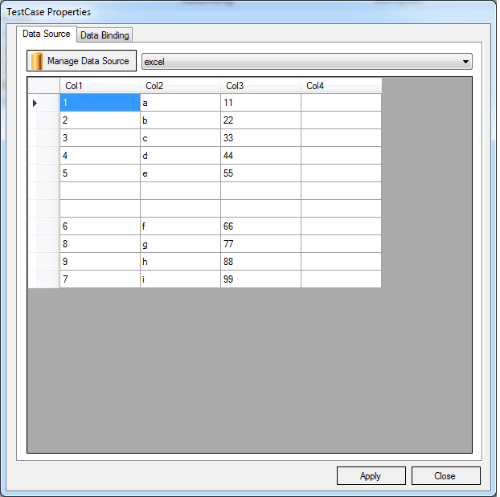

In below TestCase properties window some rows are checked and some are unchecked, user can manually clicked on checkbox to check and uncheck the checkbox.

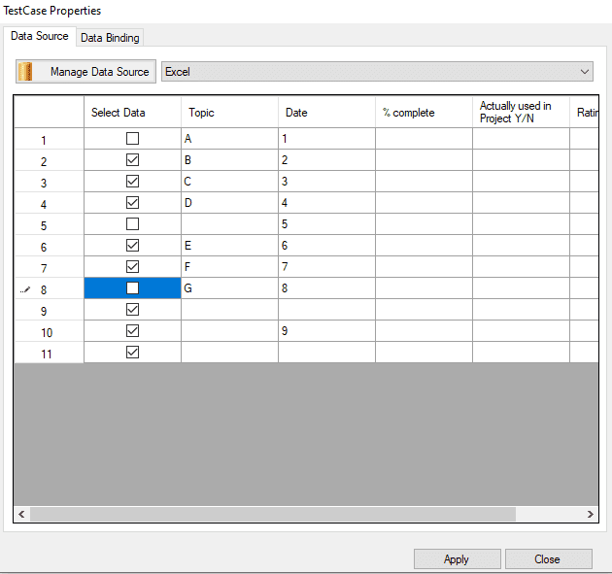

In below TestCase properties window All rows are selected , user can check and uncheck the checkbox by right click on serial number column. On click of Check row will get checked and On click of Uncheck row will get uncheck. User can select multiple rows or single row to check/uncheck the checkbox.

If row is already checked and if user performing check operation again then state should remain unchanged and same with the uncheck action also.

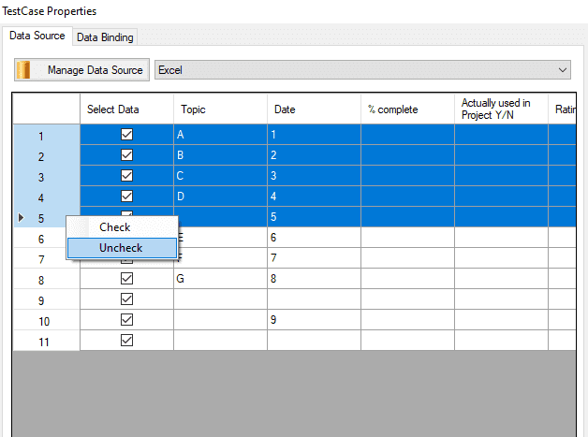

In below TestCase Properties window user can click on highlighted rectangle and can click all rows and after right click on SerialNo column Check and Uncheck option will come and for mass data user can do check or uncheck all the rows accordingly.

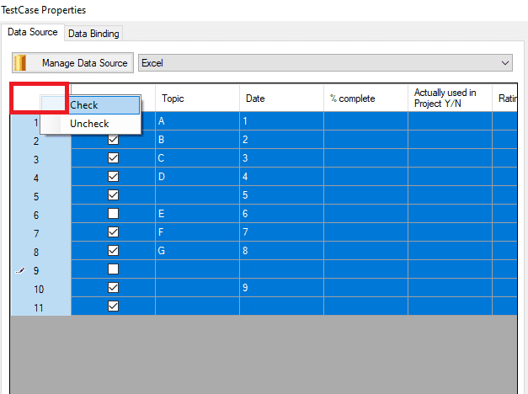

### ­­­­­­Data bind – Map the column headers to Variables

Now Click on Data binding tab. Here the data columns from the selected excel auto populate.

Bind the data column values with variables earlier defined in step 8.1. All variables under selected Test case are available for binding. Apply and Close the window see the figure shown below.

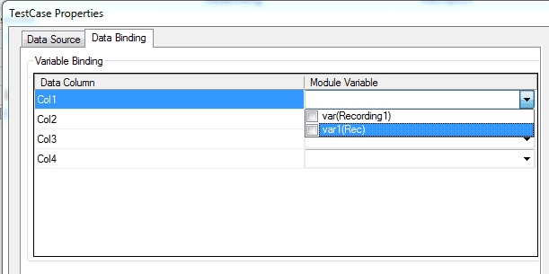

Data binding allows the selected data source file columns to map with the variable defined.

The newly created variables are now populated in the Test Step generator .

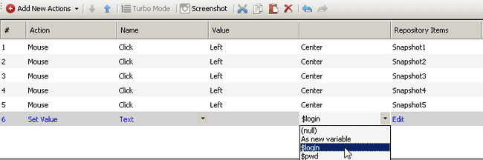

Select the object from the Repository items, and pass the value of the variable.

This will allow the variable (E.g.: $login) to fetch the data from the Data connector. If recording is run using “Play” button (present on grid), recording will run one time with default variable value. If data connector should be used, then use Run button from test suite. Variable used in recording (bind with set value/get value/key sequence action) will take values from excel sheet column to which it is bind. This will run checked (selected) Test cases with bind data sources to those Test cases (if any). Data source is bind to Test case, hence recording under that test case will run for count = number of rows in bound data source.

### Showing Range value on testsuite after adding data source in dataconnector

* + - 1. For Excel/CSV if user selected only few checkbox as checked and some as unchecked then only checked rows should add on TestSuite after click on Apply button as shown in below figure.
* If the continue rows are selected then “-“ will be given in betwwen the first and last row number.  
  For Example : we have four rows selected 1,2,3,4 then range will be add as 1-4.
* If single rows are selected then it will be seprated with comma.  
  For Example : We have 3 rows selected 3,5,9 then range will be add as 3,5,9.

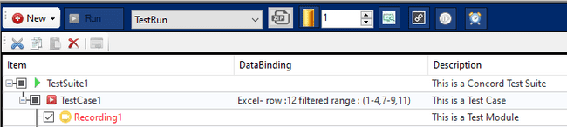

* + - 1. For Excel/CSV if user selects all the rows and add datasource by click on Apply the Range tag will not display because user has selected all the rows, as shown in below figure

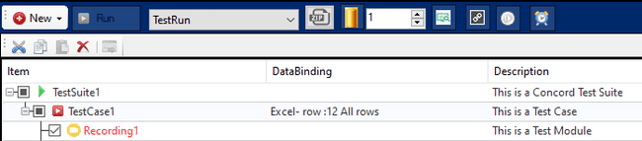

## Global variable parameter binding

Parameters are primarily used to control the course of actions within a test scenario. Parameters – in Concord – are also used to variable values through module boundaries and across test cases on test suite level run

### Add new test suite level variable

Click on data binding column of test suite item Test suite properties dialog will open see the figure shown below

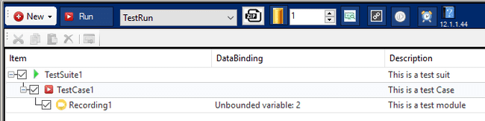

**TestSuite Properties dialog:**

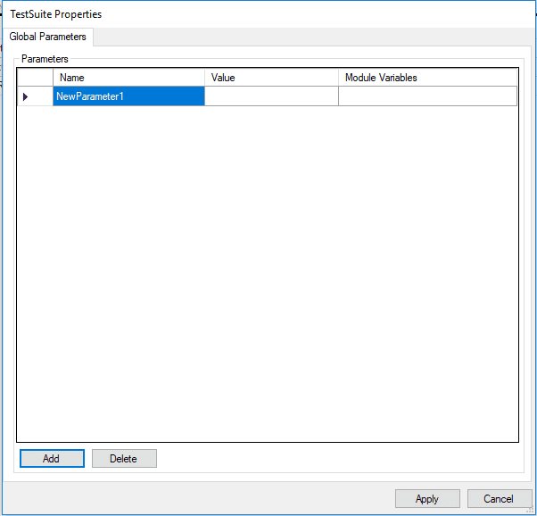

User can add new test suite variable using above dialog.

### Binding Test Suite level variable in test cases

Click on data binding column of test case item Test case properties dialog will open see the figure shown below



**Test Case Properties dialog:**

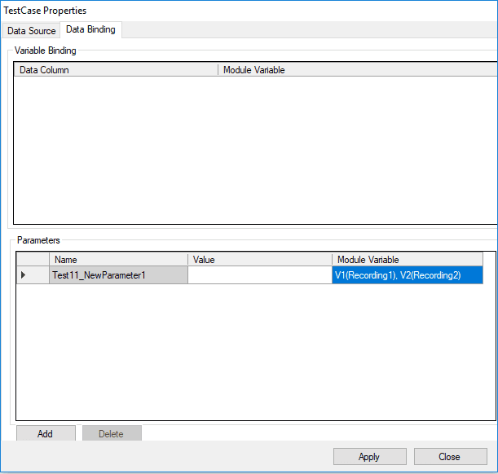

User can bind here newly added test suite variable with recording variables.

For above binding default value of test suite variable NewParameter1 will assign to V1 (Recording1) when Recording1 is finished V1 (Recording1) value assign to V2 (Recording2).

**Execution flow:** Default value=>NewParameter1=>V1 (Recording1) =>V2 (Recording2)

### Add new test case level variable

Click on data binding column of test case item Test case properties dialog will open

User can add new test case variable see the figure shown below:

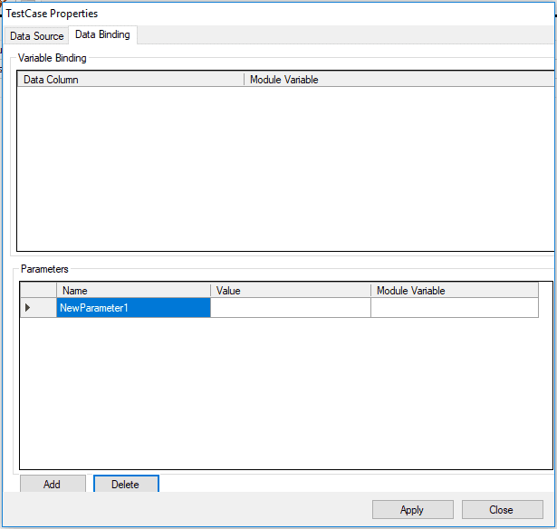

### Binding of test case level variable

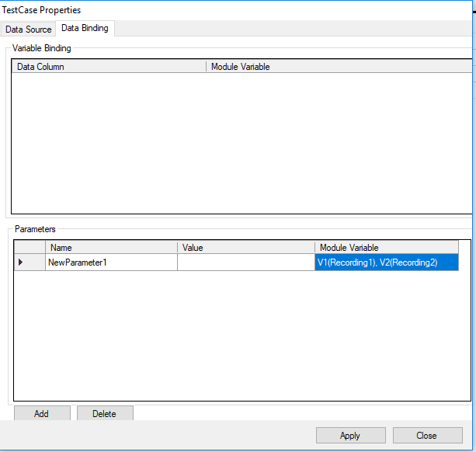

For above binding default value of test case variable NewParameter1 will assign to V1 (Recording1) when Recording1 is finished V1 (Recording1) value assign to connected variable V2 (Recording2).

**Execution flow:** Default value=>NewParameter1=>V1 (Recording1) =>V2 (Recording2)

### Points to remember

* Once variable bound to data connector cannot be used same in global variable parameter.
* Once variable bound in global variable parameter cannot be used same in data connector.
* Variable used by one parameter in test case cannot be used by other parameter in same test case.

# Recording Modes

Record and play functionality records the test step operations performed and play the recorded steps.

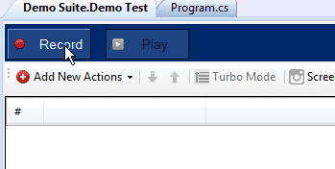

On click of Record button, “Choose recording type” screen will be shown as below:

In “Choose Recording Type” there are two different types of recording types:

1. Application recording
2. Instant recording

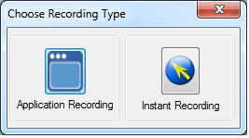

Recorder screen will be launched as below after “Instant recording” click see the figure shown below:

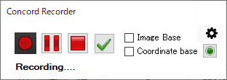

All Actions should be recorded with recorder (e.g.: Recording steps of calculator as in below screen):

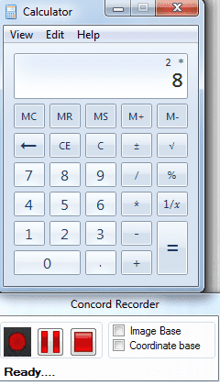

By default object based methodology and steps see the figure shown below:

## Object based Recording

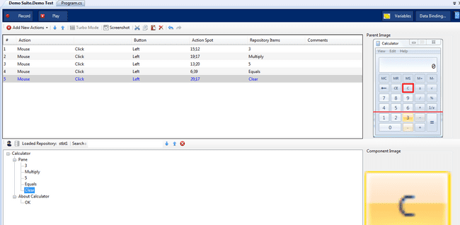

There are two other options which can be selected:

1. Image based
2. Coordinate based

**Note**: *In case of an object is overlapped by the topmost window, then still Concord will perform an operation and will show the result as pass. So if the user has such a scenario then s\he should take care while the time of script creation by adding some checks.*

## Image based Recording

User actions on the application can be captured along with the image of the action area. This mechanism is independent of object identification. Can be applied in areas where object/control is not uniquely identified or not identified at all.

User can follow the below steps for image based recording.



1. Select “Image Base” and then record the steps. This adds the image based steps to IDE.
2. On selecting Image Base, another option custom based recording is available by selecting “Custom”. In this, control can be selected and captured with the help of overlay frame.

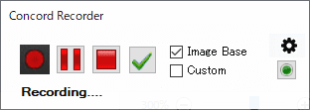

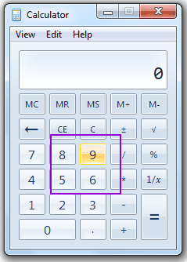

1. This frame size can increase or decrease by pressing short-cut key which is configured in project settings. After pressing shortcut key draw rectangle using mouse and size of the frame will be set as the size of rectangle draw.

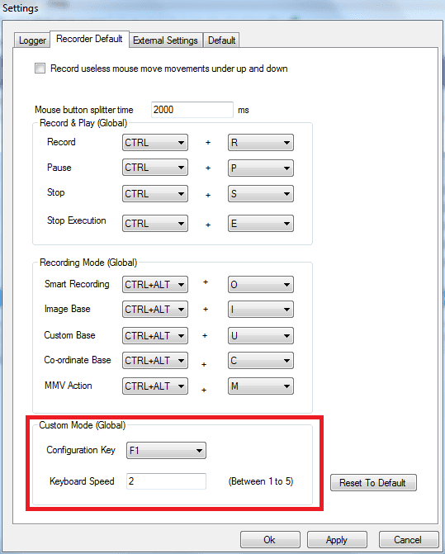

1. Steps will be added as shown below. All objects’ Snapshots are stored.

Click on the Snapshot selector to get an option to edit the Image see the figure shown below.

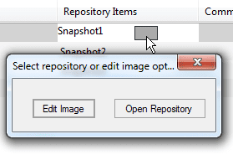

On Clicking “Edit Image”, the following window opens with multiple options for image editing. Like Crop, Zoom in, Zoom Out, and to select the point of click, by moving the “+” icon see the figure shown below.

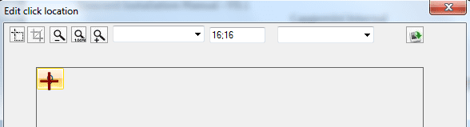

Also presets for the click location are available through a dropdown selection see the figure shown below.

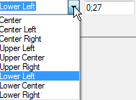

In addition, image from any other location can also be selected see the figure shown below.

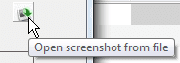

1. If we perform image based recording and attached screenshot is not present or deleted from physical location then following result will be shown.  
   In Report Summary it will show cross image shown in red rectangle in IMAGE column.

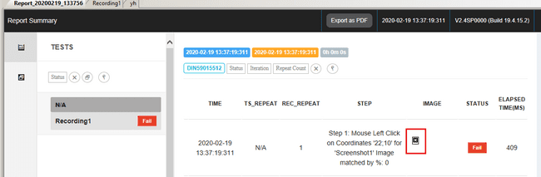

### Custom image based Drag and Drop

For remaining recording modes other than the Custom-Image base, this functionality won't be available.User can follow below steps for custom image based drag and drop:

* 1. This option can be enable by following two way:
     1. Check “Record useless mouse move movements under up and down” from “Current Recording” tab under Local Settings.

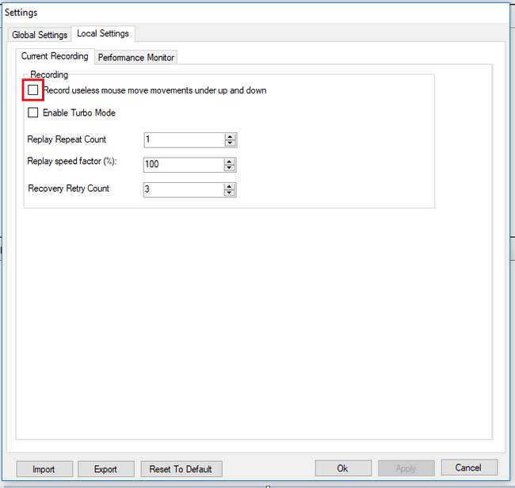

* + 1. Select “Image Base” and then record the steps. This adds the image based steps to IDE. On selecting Image Base option, "Custom" option will be visible. Now Select "Custom" option to start "Custom-Image Base" recording. see the figure shown below.

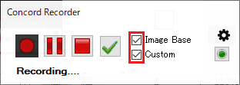

* 1. User need to start recorder by “Record” button in IDE.

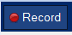

* 1. Recording will start with Recorder window in bottom right corner see the figure shown below.

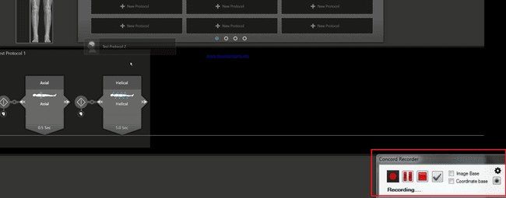

* 1. Select Image Base then custom based recording is available by selecting “Custom”. In this, control can be selected and captured with the help of overlay frame see the figure shown below.



* 1. This frame size can increase or decrease by pressing short-cut key which is configured in project settings. After pressing shortcut key draw rectangle using mouse and size of the frame will be set as the size of rectangle draw see the figure shown below.

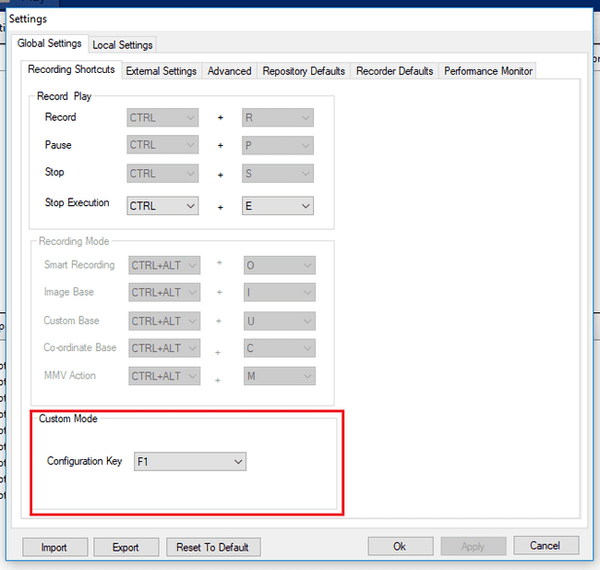

* 1. User needs to press “F3” in order to capture the area/image/region where the image needs to be dropped(destination image). On F3 key press,user will be given an option to snip the images see the figure shown below:

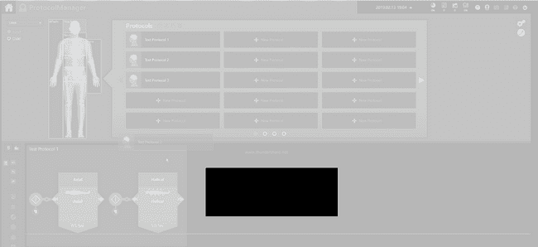

* 1. Once, the snipping is done, “Edit click location” window will appear which will let user to select the points of the cursor see the figure shown below:

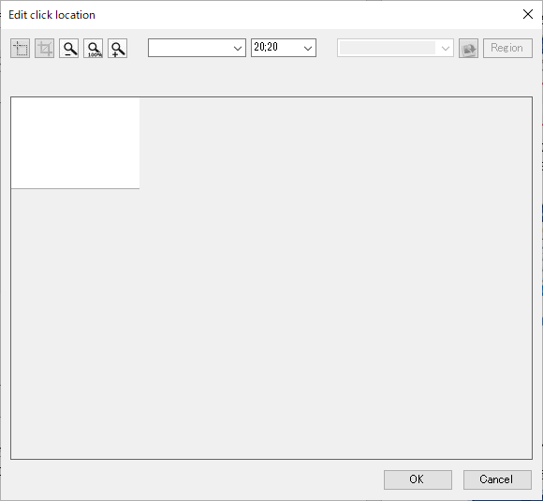

* 1. Once destination image is selected, mouse down on Image to be dragged, then mouse move till the destination and finally, mouse up on the destination area. Once above step is completed, Stop the recording from the recorder window in bottom right corner see the figure shown below.

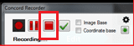

* 1. Now script is created with following steps will get added in IDE:

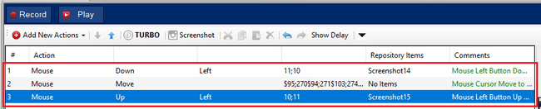

* 1. If user is trying to drag and drop images from a list which contains multiple values then user should select source image by following above mentioned steps. Once source image selected, User would need to scroll mouse (while mouse down is still pressed), then mouse move till the destination and finally, mouse up on the destination area. Once above step is completed, Stop the recording from the recorder window in bottom right corner as shown above.
  2. Now script is created with following steps will get added in IDE steps:

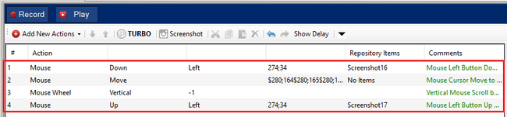

Note: If source image is overlapping with destination image, then user might observe issue with drag and drop, to overcome this issue user can update image coordinates from IDE column “Action Spot”. It is editable columns see the figure shown below.

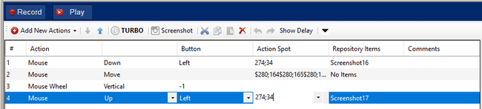

## Co –ordinate based Recording

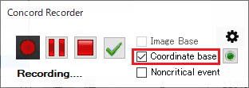

Steps added by “Co-ordinate base” steps see the figure shown below  
By selecting “Co –ordinate based” and then recording the steps adds the Co –ordinate based steps to IDE as follows:

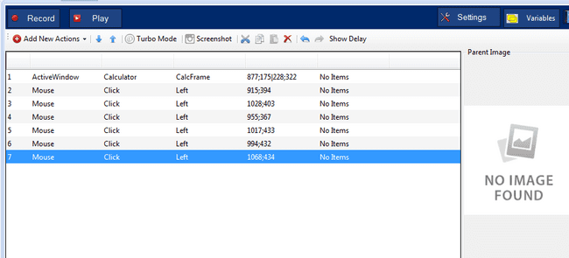

On clicking “Application recording” following screen will be opened:

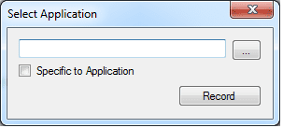

Select application as shown in below screen. In this new calculator window will be opened with recorder.

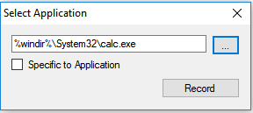

Recorder can be paused and played as shown in below screens

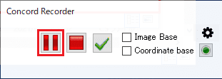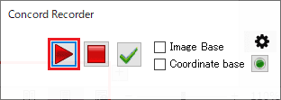

### Mouse Move (MMV)

This event is handled on the movement of the mouse. This can be done in following ways:

1. It will record Move movements between Up and Down Press of the Mouse. A checkbox for useless mouse operations need to be checked before this see the figure shown below:

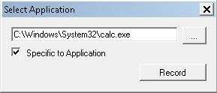

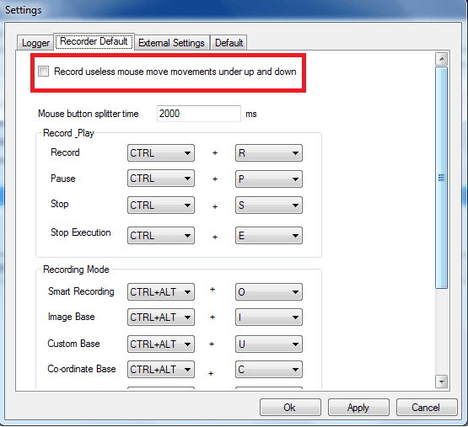

1. Then on recording using coordinate based the mouse movements along with coordinates for Mouse Up and Mouse Down will be recorded and add as steps see the figure shown below

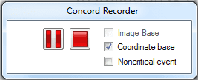

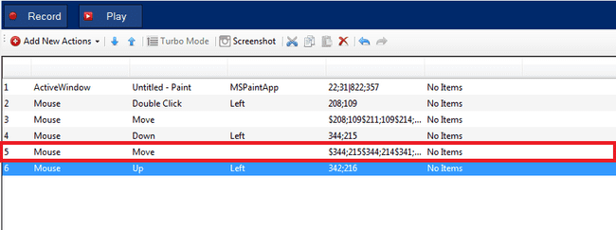

Adding Move step between Up and Down step along with all move coordinates.

1. This will record all Non-critical Move Movements. This will record all move events even if the Mouse is just being hovered over an Object or screen. For this check the “Non-Critical” Checkbox in recorder UI see the figure shown below:

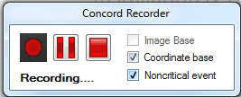

This will record all the steps for any type of mouse move movements see the figure shown below:

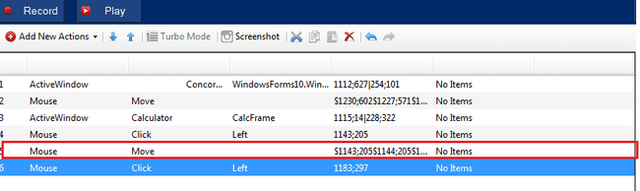

It recorded Mouse Move movements between two calculator buttons clicks.

### Active Control Window (ACW)

Active Control window will add an ACW step at the time of recording which will bring the window into same coordinates, same width and same height as it was recorded and then play the steps on the window. This step will appear only in case of Coordinate recording see the figure shown below:

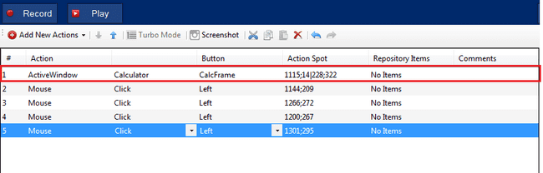

This “Active Window” step will bring the window in front if it is minimized or it will also bring it to the original height and width at the time of playing the steps.

# Play screen

Play functionality is to play the steps added in IDE.

If there are no steps added, then play button will be disabled see the figure shown below:

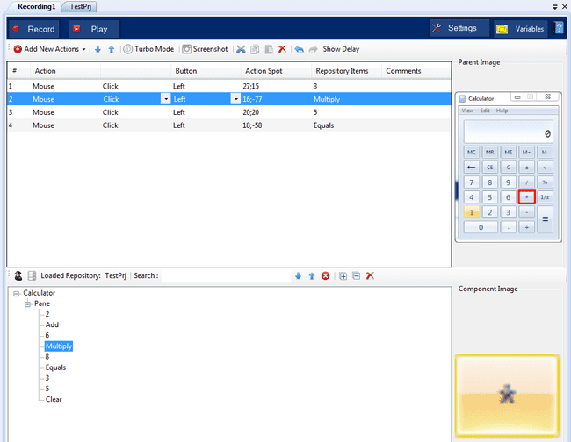

After Play button is clicked, Execution engine will be opened at bottom see the figure shown below.

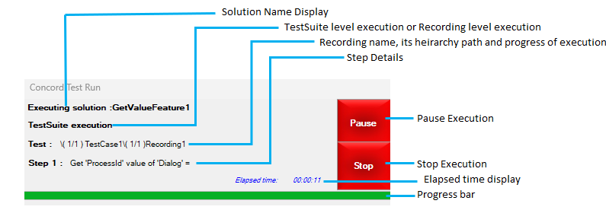

ExecutionEngine user interface description:

* TestSuite/Recording execution: When any recording is executed explicitly, then “Recording execution” and “TestSuite execution” will be shown for playing complete test suite.
* Test: This shows the current recording name with its immediate TestCase name
* Testcase and Recording details: Testcase name, recording name and its hierarchy path along with the total number of testcases and recordings will be displayed, which indicates the progress of execution.
* Step count and Step details: This shows the Step sequence along with step details.
* Stop: User can manually click on “Stop” to stop the execution or can be also stop by using shortcut key “Ctrl + E”.
* To check the Progress, see the figure shown above: Keeps on showing the live progress for the steps execution. It gets reset as current recording changes.
* Elapsed time: Shows the actual time taken to execute the requested TestSuite.
* Current step number out of total enabled steps.

On stop execution test execution will be stopped. After execution of all test steps report screen will be shown with each test step result see the figure shown below.

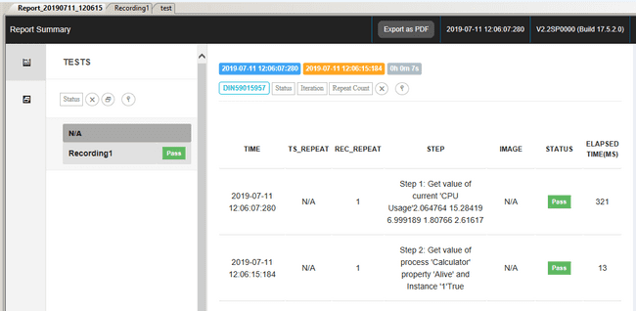

User can see the stored report from solution explorer see the figure shown below:

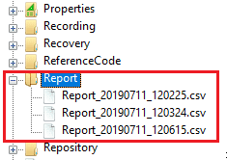

# Pause Script Execution

User can pause the execution of recording in between execution steps. Below are the steps User can perform while execution of recording. To Pause the execution and to Resume the execution user can manually click on “Pause” and “Resume” or also can use shortcut key “Ctrl + P” for both Pause and Resume the execution.

* + 1. While Test Script execution is running user will be able to see two option “Pause” and “Stop”, see the figure shown below

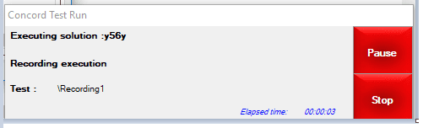

* + 1. When user click on “Pause” button, it will be disabled and status will change to “Pausing..” see the figure shown below

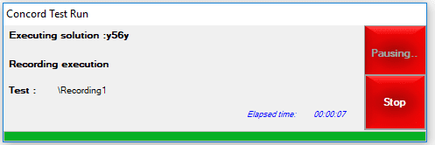

* + 1. While pausing, current step will get executed completely after that execution will pause. Once paused button text will be changed to “Resume” in execution again see the figure shown below.

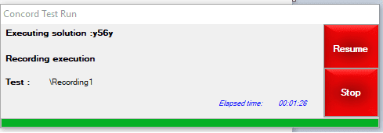

* + 1. If User clicks on “Resume” button, execution will start from the next step where it was paused earlier see the figure shown below.

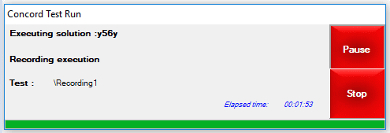

* + 1. Below things to be considered while using this functionality

-> If Execution is paused during drag drop operation (at the time of mouse down operation) then since Mouse Up event is not triggered there may be some impact to user when he try to perform any operation using mouse.

-> Paused time will be considered in Report’s total time and individual time.

-> When Image base execution is in progress then execution engine will be in hidden mode, so pause operation is performed during this time then user may not able to see the execution engine till it is paused.

-> While pausing, the current step is a failed step then on resume of execution concord will be shown instead of proceeding the execution. In this case user may get confused whether resume operation is performed or stop operation is performed.

# User manual

Help file with all basic information on the tool installation and usage is invoked in the Concord tab on clicking the “?” icon see the figure shown below.

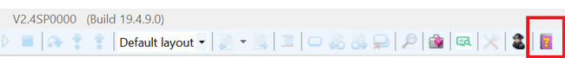

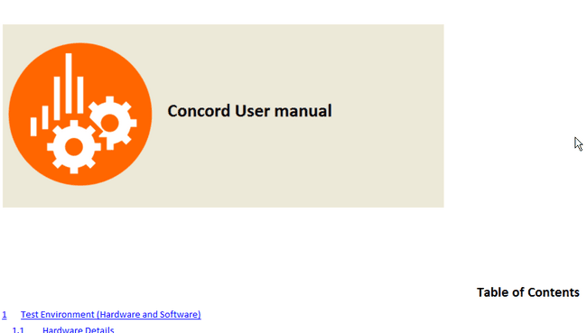

# Test Suite

Test suite is a combination of multiple test cases and recordings. User can create multiple recordings under test cases and run them as a suite.

## Open Test Suite

After creating new project test suite opens

1. User shall be able to edit the description for TestSuite, TestCase and Recording.
2. Create data binding. Data binding without variables cell show as following information.
   1. DataSourceName - row:(no of row present in the binded excelsheet).
3. Create data binding. Data binding with variables cell show as following information.
   1. DataSourceName - row:(no. of row present in the binded excelsheet)
   2. Unbounded Variables (no. of unbounded variables)/ Bounded variables (no. of bounded variables).
4. When no data binding is set with , Create variables, and user click on TestSuite. It must show
   1. Unbounded Variables (no. of unbounded variables).
5. Open the recording and try the cut, copy and paste (all possible combinations).
6. Create Databinding and try the cut, copy and paste (all possible combinations).
7. Check and run for all possible deleting options.
8. Check and run for all possible new options like create new recording etc.

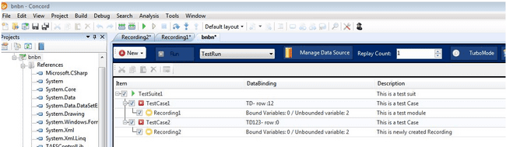

Double click on “TestSuite.cxml” in project browse pad it opens Test suite see the figure shown below.

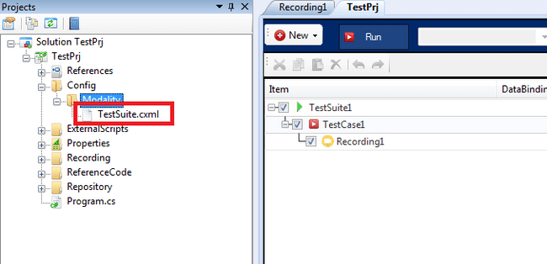

## Add New Test case

Select Test suite and click on Test case button to add a new test case see the figure shown below

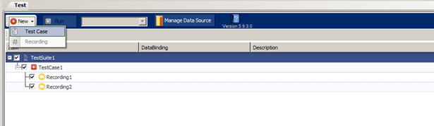

## Add New Recording/Test case

Right click on Test Case in context menu to add a new Recording/Test case see the figure shown below.

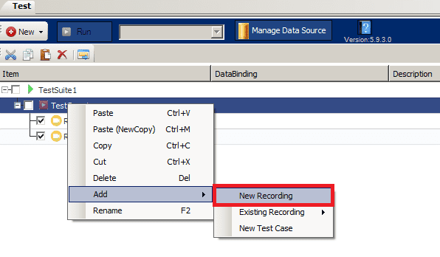

By clicking on “New Recording” new recording will gets added. See the figure shown above.  
To add the Existing Recording, Click on “Existing Recording”. See the figure shown below.

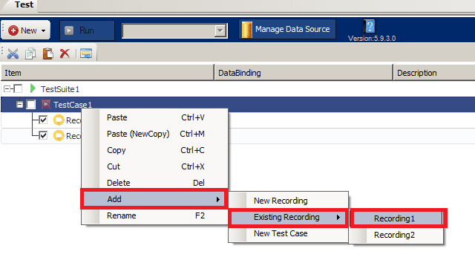

## Recording /Test case Reordering

By Dragging recording or test case it will rearrange the order of execution.

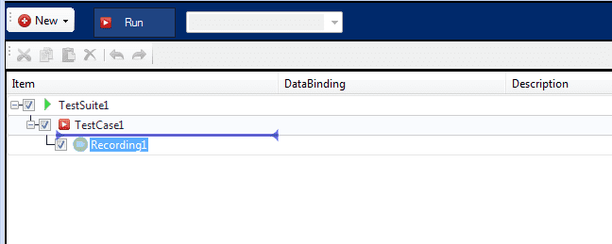

## Open Recording

Double click on recording modules in test suite. It opens recording in new tab. It can open multiple recordings from test suite see the figure shown below.

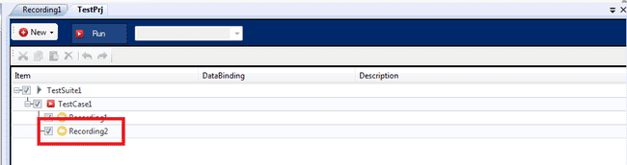

Double click on recording module in project pad[Explorer] it opens recording in new tab see the figure shown below

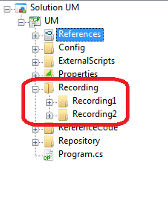

## Play Recording

Individual recording shall be executed by clicking [Play] button.

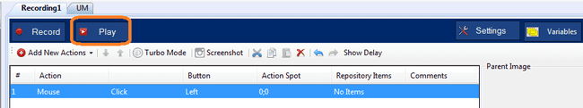

## Run Button

By clicking on run button all selected recordings are executed as per sequence

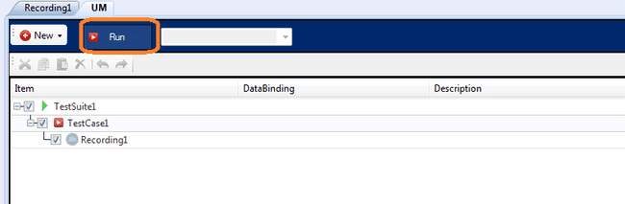

## Cut “Recording” and “Testcase”

Select recording/test case and click on Cut. Shortcut key is Ctrl+X see the figure shown below.

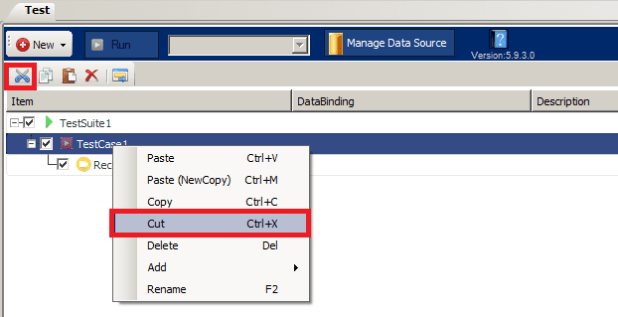

## Copy “Recording” and “Testcase”

Select recording/test case and click on Copy. Shortcut key is Ctrl+C see the figure shown below.

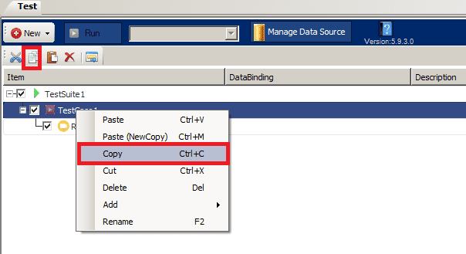

## Paste “Recording” and “Testcase”

Copied/Cut recording/test case can be pasted under selected test case. Shortcut key is Ctrl+V see the figure shown below.

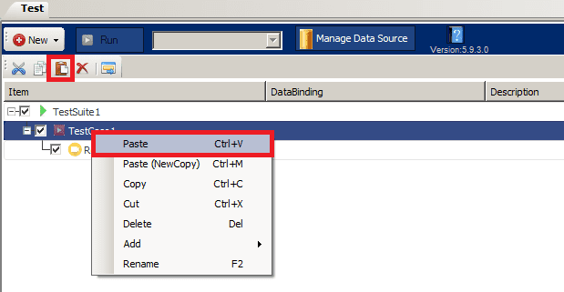

## Delete “Recording” and “Testcase”

Deletes selected recording/test case from test suite. Shortcut key is [Delete] see the figure shown below.

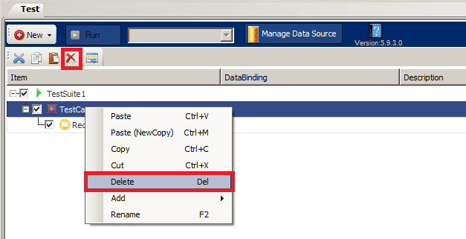

## Paste New Copy (Recording)

Copied/Cut recording can be pasted as New Copy (Physical copy gets created). Shortcut key is Ctrl+M see the figure shown below.

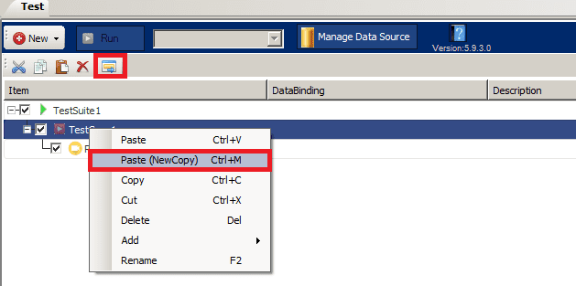

## Rename Recording (Project Explorer/ Test Suite)

You can rename the recording using the Concord Project Explorer context menu or the Test Suite context menu. The new name will be reflected in both Project Explorer and the test suite. The shortcut key is [F2] for both Project Explorer and Test Suite. See the figure shown below.

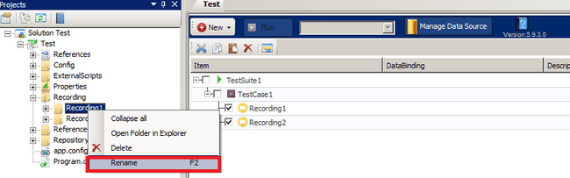

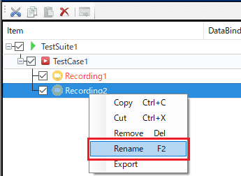

## Delete Recording (Project Explorer)

Recording can be deleted using Delete/Context menu from project explorer in Concord. Recording is also deleted from test suite. Shortcut Key is [Delete] see the figure shown below

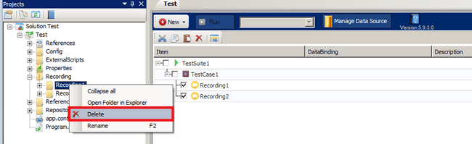

## Rename Test case (Test Suite)

Test case can be renamed by using F2/Context Menu. Shortcut key is F2 see the figure shown below.

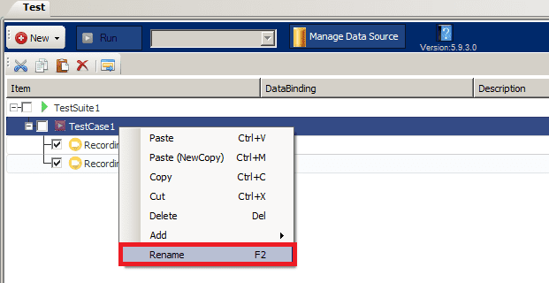

## Rename Solution (Project Explorer)

Project can be renamed using F2/Context menu from project explorer in Concord. New name gets reflected in test suite and Solution name also see the figure shown below.

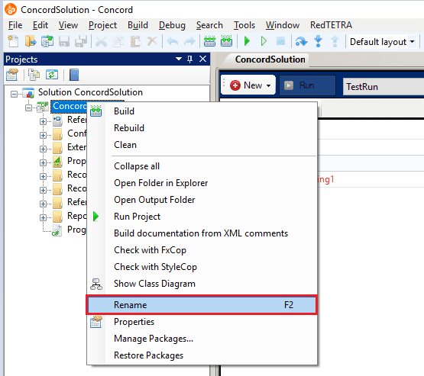

Before renaming backup will be taken as a precaution in case if rename is failed. Backup will be stored at below physical location.

Suppose path of open solution is “C:\NewFolder\ConcordTest\Test.sln” then

Backup location of solution will be “C:\NewFolder\ConcordTest_Backup\Test.sln”

So it will create solution folder with solution folder name and append it with “_Backup”.

User will get below message. If he/she clicks on “Yes”, Backup will be taken and Rename will perform. On click of “No”, Rename will be cancelled.

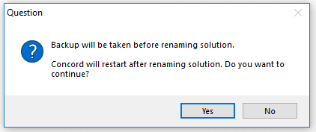

Below progress will be displayed while taking backup of solution see the figure shown below:

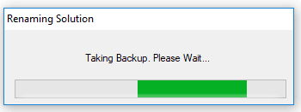

Once rename operation perform successfully, User will get below success message and on click of “OK” Concord will restart to reflect new name.

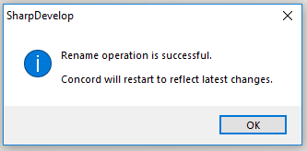

If rename operation is failed, then user will get error message, Along with reason of failure. In this case user should use backup solution for further processing.

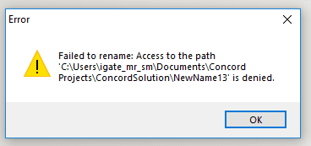

When a user does some operation like rename recording or test case its locks some file internally so while doing rename solution may corrupt. So to avoid it Concord shows this message if any file is locked.

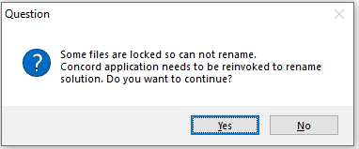

## Test suite Replay Repeat Count

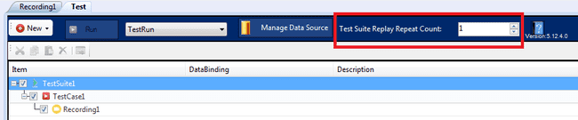

**Test suite Replay Repeat Count** of Test Suite is used to run test suite multiple times**.** Min limit of replay repeat count is 1 and max limit is 99999.

## Test suite Turbo mode

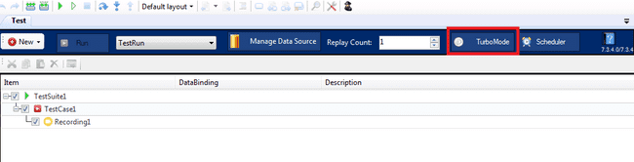

Test suite turbo mode value is stored in “TestSuite.cxml” file.

When turbo mode on test suite is OFF, Test suite will run considering every recording’s individual turbo mode. When turbo mode on test suite is ON, while running test suite, every recording’s turbo mode will be set to ON and execution is done. After execution, every recording’s original turbo mode’s value gets restored.

## Test suite erroneous recordings

To identify user if any recordings having error, marked those recordings on test suite in RED see the figure shown below.

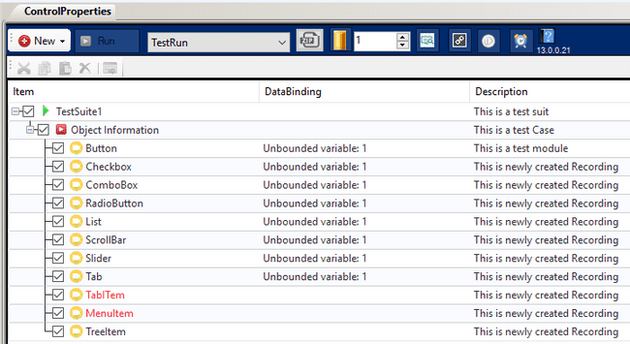

In above screenshot recording TabITem and MenuItem having errors so marked those in RED.  
When any recording on test suite has an error, it is marked in red; therefore, user can identify such recording

## Exclusive feature for user mouse control

It is possible to prohibit the user from operating the mouse while recording in the test suite.



It is possible to turn ON/OFF prohibition of mouse operation by the user by pressing the button surrounded by the red frame in the above figure.

Recording execution with mouse operation prohibited can be terminated with a shortcut key.

Shortcut keys are displayed on the step execution screen shown below.

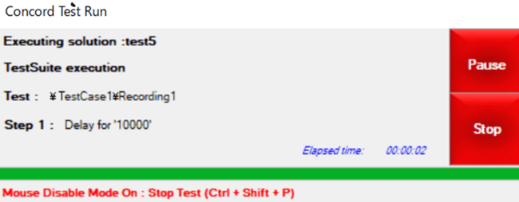

## Requirement ticket number and test ID

Requirement ticket number and test ID can be set for each TestSuite/TestCase/Recording on the Test Suite screen. RedTETRA integration is not supported. Please refer to the RedTETRA manual for setting up the linkage. (Manual: Concord-RedTetra Integration_UserManual_E.pdf)

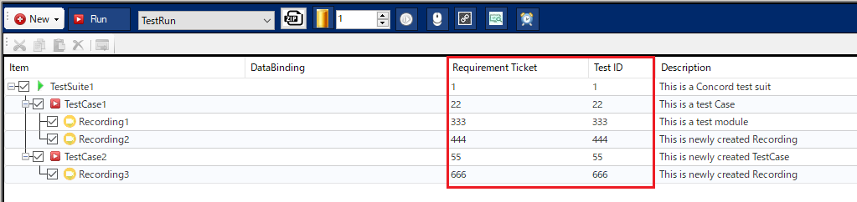

# Scheduler

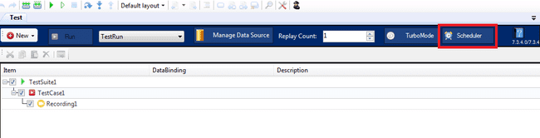

Scheduled task can be added to run test suite see the figure shown below.

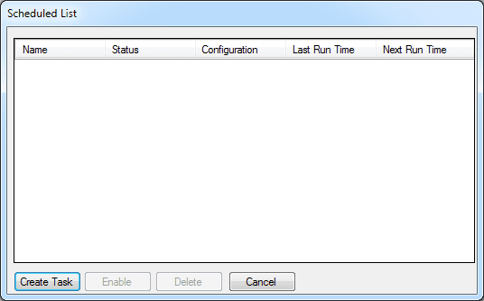

## Create Task

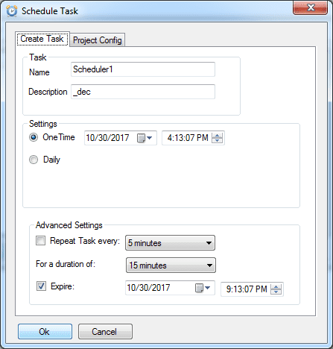

User can schedule task by giving above details. Task list is displayed in main window of Task scheduler.

## Enable task

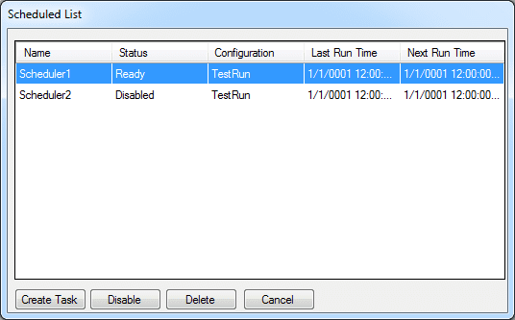

Scheduler task can be enabled or disable using Enable button.

## Delete Task

User can delete the scheduler task using delete button.

# Test Run Configuration

After click on ‘Manage Run Configuration’ it opens ‘Test Run Configuration’ window

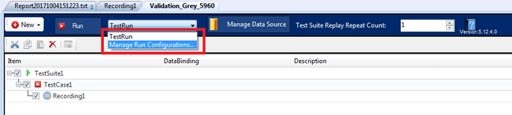

## Add Configuration

After click on Add button New Run Configuration add at the end see the figure shown below.

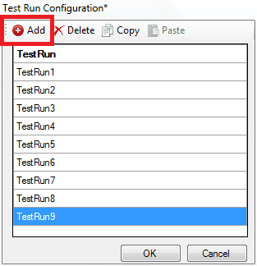

## Delete Configuration

User can delete ‘Test Run Configuration’ which is inactive. In this operation single or multiple configuration can delete see the figure shown below.

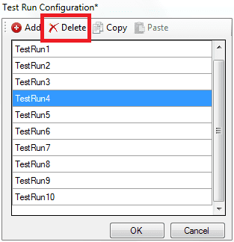

## Copy Configuration

Click on Copy to Copy the selected configuration see the figure shown below.

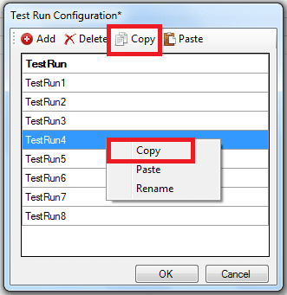

## Paste Configuration

Copied configuration can be pasted at the end see the figure shown below.

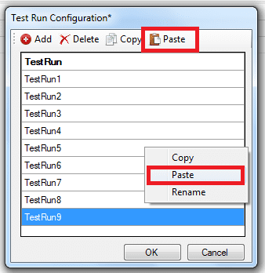

## Rename Configuration

Configuration can be renamed using F2/Context menu see the figure shown below.

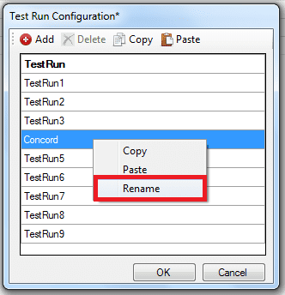

# Save/Save All

For any modification in Test Suite/Recording/Project Settings (Local)/Data Connector It will show below asterisk (*) symbol. If asterisk is present and the tab/Concord is closed, then for the unsaved changes it will show save dialogue.

Click on ‘Yes’ to save the changes. If ‘No’ is clicked then changes will revert back to its previous state.

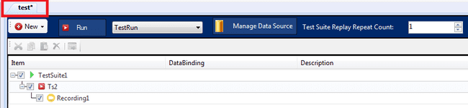

# Settings

## Project Settings

Two levels of settings are available for the Test Project:

1. Global Settings
2. Local Settings.

The Global and Local Settings related to the Test Project Solution can be done through the buttons see the figure shown below:

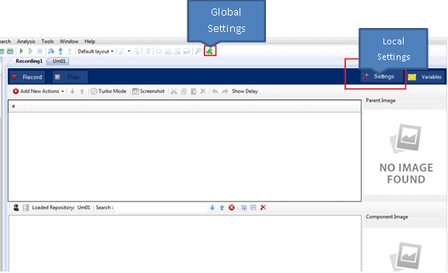

**Path Style:**Specifies whether path should be converted to relative or full path. This setting will be applicable to current solution.   
Path style can be access see the figure shown below:

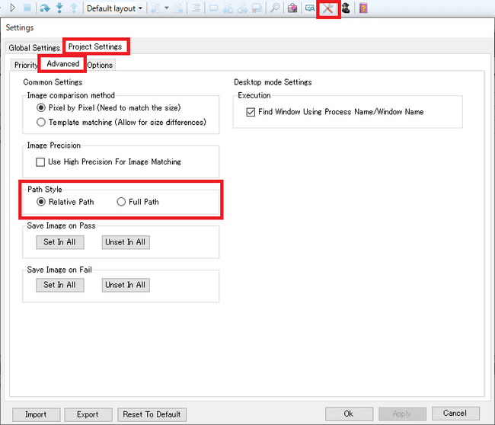

When user change path style and click “Apply”/” OK” below message will be shown once path is converted successfully. On Click of “OK” concord will restart, and latest setting will be applied see the figure shown below.

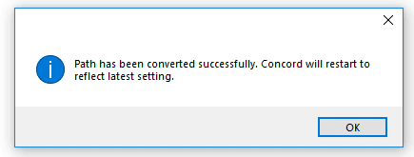

If user click on “Cancel” without modifying path settings, setting form will close and no changes will be done. If user click on “Cancel” after changing path style below confirmation dialog will be displayed see the figure shown below

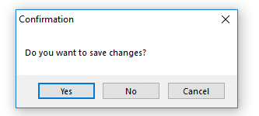

On click on “Yes” latest changes will be applied. On Click of “No” no changes will be applied in setting. On click of “Cancel” this dialog box will be closed.

**Image Precision:**When image precision settings is ON, Concord will check all image based steps precisely. For eg. If any minute difference is there in image then it will show matching percentage like 99.57%.

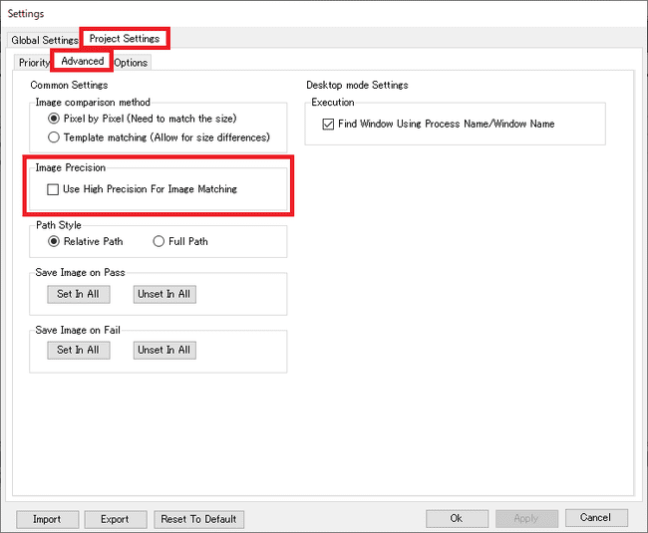

**Image comparison method:**

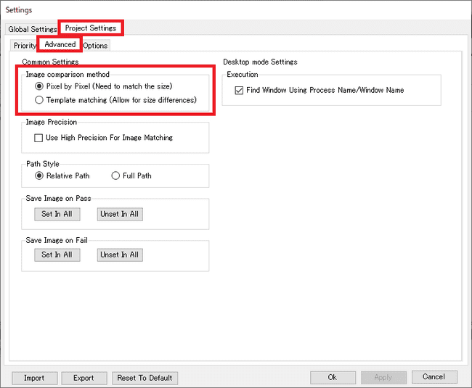

If Template matching（Allow for size differences） is on, use Template matching to perform an image comparison. When Pixel by Pixel（Need to match the size） is on, Pixel by Pixel is used for image comparison. Pixel by Pixel is on by default.

**Execution:**If checked, searches for UI controls by process name or Window name during playback. If unchecked, searches for UI controls by all processes. Therefore, if checked, UI controls can be searched more quickly and playback is faster.

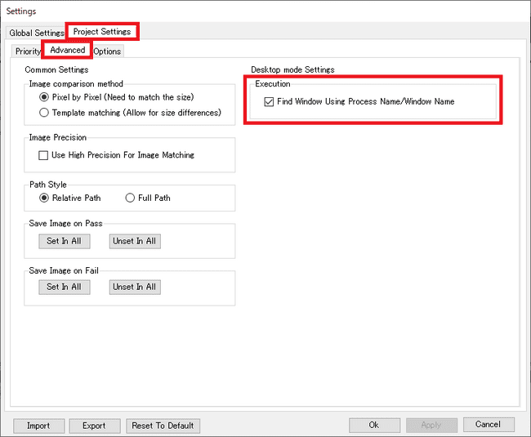

**Display position:**If changing the Display position and pressing the Set button, the position of the Execution engine is changed. This setting is applied to all recordings.

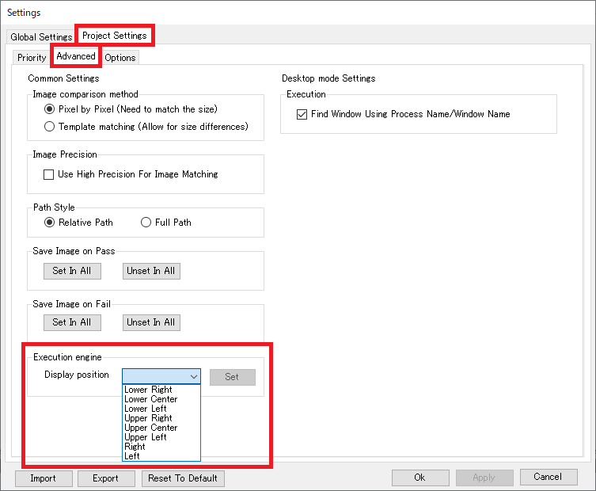

**Self healing support:**

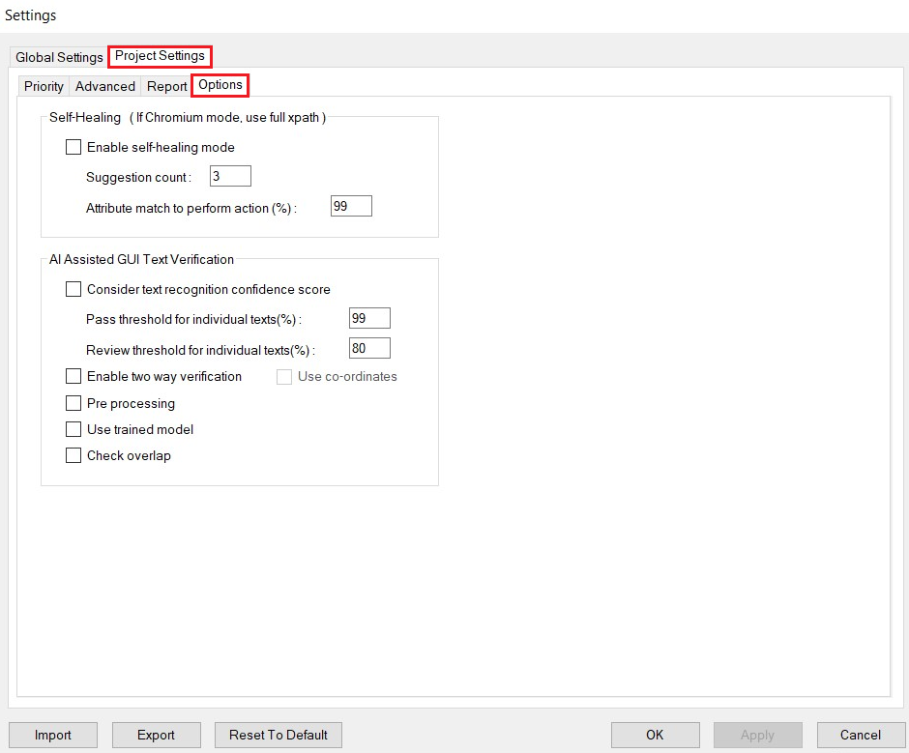

Options tab contains the settings for both self healing and localization. self healing aids in auto execution of script. When self healing mode is enabled, if element is not found during execution, self healing will be invoked.

Suggestions count is the number of suggested xpaths for each element that will be displayed in the self healing summary dialog after performing a self healing enabled action. Action will be performed if the match is greater than the match provided in the attribute match textbox and suggestions data will be updated in repository configuration files.

AI assisted GUI Text verification is a new setting that is added in Project Settings, which is present under the options tab, that helps to recognise the text from the GUI.

Text Recognition Confidence score: This can be used for deciding the color of the bounding boxes and for checking the review conditions that can either be selected or not selected as per the user requirements .If this option is selected, we can choose the pass threshold and review threshold via edit boxes. These values are considered for individual texts. For example, if pass threshold is set as 99, all the texts with match percentage greater than or equal to 99 will be considered as pass. That is, it will be marked with green rectangle. Similarly, if review threshold is set as 80, all texts with match percentage between 80 and 99 will be considered for review and marked with orange rectangle. All the text values below review threshold can be considered as ‘Fail’.

The purpose of two way verification is to check whether if strings are present in both json and image and vice versa. In addition to this,texts that are found in json and not found in GUI will also been displayed.When this operation is enabled, report will display the texts that is not matched.

By default, Concord and Localization test application will load only pre-trained model.In order to load trained model file in Concord and text recognition test application, “use trained model” is being used. First of all, train the model by making use of text recognition training utility tool. Copy the trained model to the EasyOCR folder [\Concord\lib\ GUIVerificationexe\EasyOCRmodels].Once completed, check the “Use trained model” option and click on apply button. It will load the latest model along with the pre-trained models. This will ensure that the latest trained model will be considered along with other pre-trained models. The main purpose of this option is to load all the latest trained models which will improve/enhance the accuracy if the current accuracy is not upto the desired expectations.

If “Check Overlap” is enabled, overlap checking can be done between the controls and texts in the GUI.

Use co-ordinates option can be used to confirm that the text is displayed on the correct control. By enabling this setting any newly added or misplaced text on the input image can be detected.

## Global Settings



### Shortcuts

Set the shortcuts for the recorder and the player operations in the below tab. See the figure shown below.

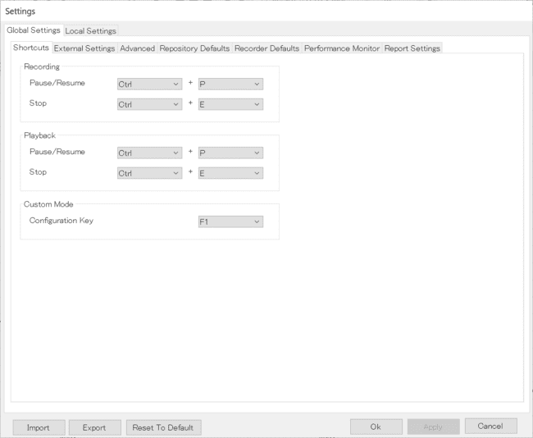

As per the above configuration, the short cut keys will be displayed on mouse hover on the respective button. Please refer Image based Recording to know more about Custom based Recording.

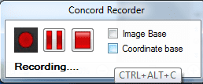

### External Settings (UWSC\MOTT)

This tab allows the user to set the path for external files and their executable see the figure shown below.

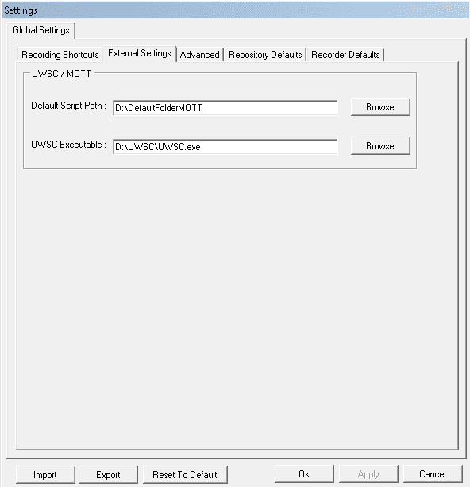

### Advanced Settings

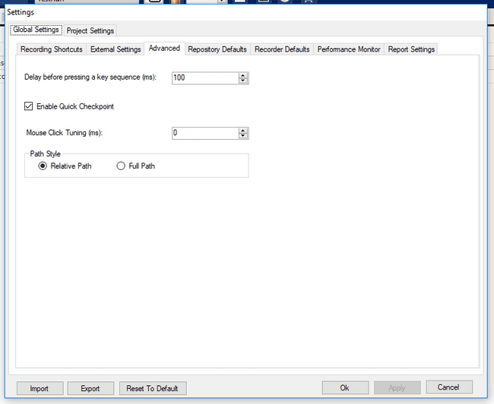

**Delay before pressing a key sequence (ms)** Specifies the time to wait in milliseconds before performing a key sequence simulation.

**Enable Quick Checkpoint:** Specifies quick checkpoint should be enabled or not at project level.

**Mouse Click Tuning:** Specifies length of time between placing the cursor on the object and clicking it.

**Path Style:** Specifies whether path should be converted to relative or full path. This setting will be applicable to next solution created by user and not for current solution.

### Repository Defaults

This tab allows setting search time-out and other general settings related to the repository see the figure shown below.

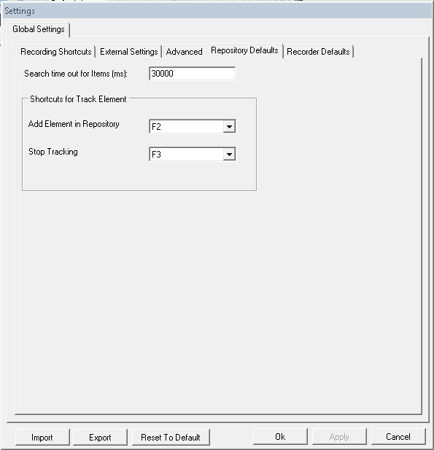

**Search time out:** When an item in repository is set as repository item in a step in IDE, on trying to execute that step, this field decides the time out for searching the item. If the selected repository item is not found in the time allotted in this field, the step fails. If the item is found, based on the condition/action in the step, the step may pass.

**Add Element to Repository:** This field is used to set the key for adding the focused element to repository when the Tracking mode is ON. The key can be changed from the options provided in the dropdown.

**Stop Tracking:** This field is used to set the key for exiting the tracking mode. Once this key is pressed, the tracking mode is set to OFF and no more elements are added to the repository on press of the key set in Add Element to Repository. Also the green border that appears on setting the tracking mode to ON will stop appearing on this key press. The key can be changed from the options provided in the dropdown.

Please refer Track Element – Manual section for more details related to tracking elements and adding them to repository.

Note: User has to take care that the allotted key does not perform any other function in the application. E.g. it is advised not to use the F1 key for adding the elements or stopping the tracking as F1 is usually used to open the help file. However this key has been provided as this behavior may differ from application to application.

### Recorder Defaults

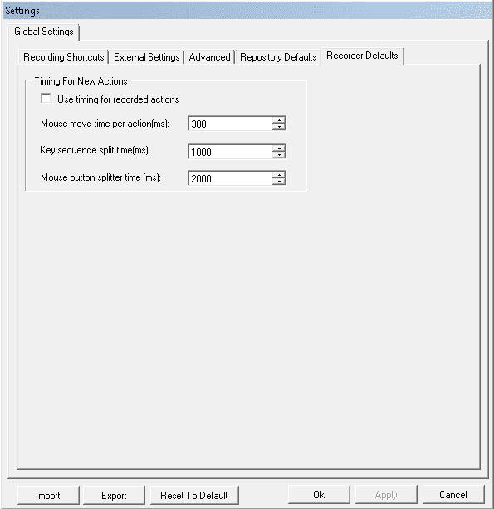

**Use timing for recorded actions:** When enabled, the specified timings will be taken instead of the recorded durations.

#### Delay Settings

It is used to add delay in milliseconds between two steps. It can either be real time delay that is recorded in steps or it can be predefined delay depending on the project setting see the figure shown below:

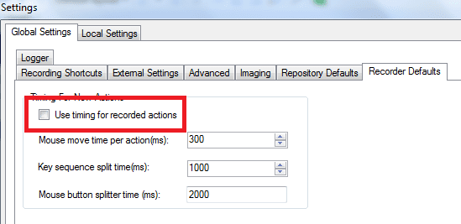

**Use timing for recorded actions** is used to record delay time between two steps at the time of recording. If it is checked it will take predefined delay time between steps. Else it will take real delay time between steps see the figure shown below.

#### Added Actions

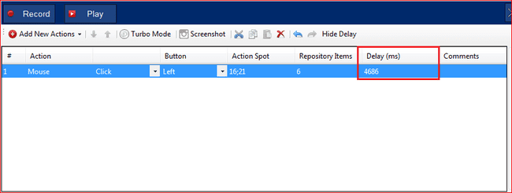

#### Manual Action

When actions are added manually or using recording there is a column for delay time , and a column of save image setting for every action which can be shown and hidden using a button named “Show Detail” see the figure shown below:

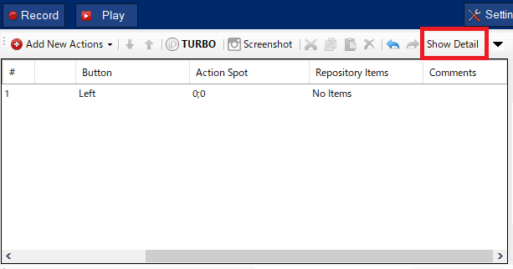

Initially Delay column and SaveImage column is not visible. If click on “Show Detail” button then “Delay (ms)” column , and SaveImage column, shows and delay time and save image setting or every action can be seen in this column. Delay column is editable and its value can be changed see the figure shown below:  
SaveImage Column can change the settings from the pull-down menu. Click the [Hide Detail] button to hide the Delay (ms) column and Save Image column.

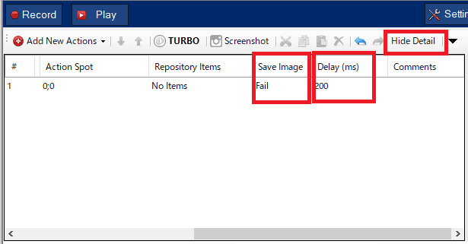

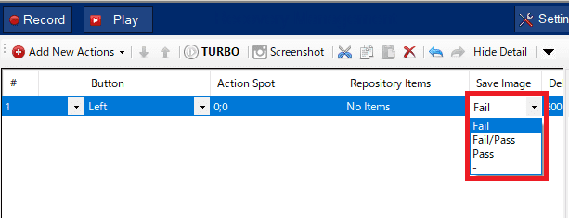

The meaning of each setting value is as follows. The initial value is Fail and the image is saved when the test execution fails.

|  |  |
| --- | --- |
| Set Value | Meaning of Set Value |
| 0 | - |
| 1 | Pass(Save image only when the test is successful) |
| 2 | Fail (Save image only when test fails) |
| 3 | Fail/Pass（Save image in both success / failure） |

#### Recording Action

If delay time is recorded in recording mode and real time recording settings have been set in “Settings” then Delay (ms) column will display real time delay see the figure shown below:

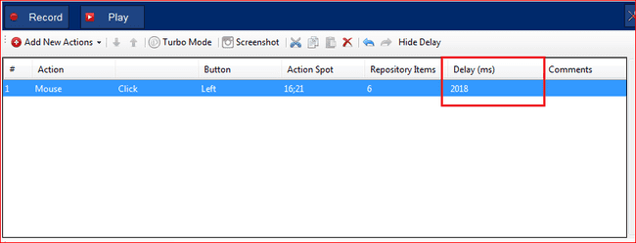

Value of “Delay (ms)” column can be changed by double click on cell see the figure shown below

**Mouse move time per action (ms)**Sets the time (in milliseconds) used to move the mouse to the UI object related to the action.

**Key sequence split time (ms)**Sets the maximum time between key presses in a key sequence during recording. If this time is exceeded, the sequence is split into multiple key sequences

**Mouse button splitter time (ms)**Sets the minimum time taken to split actions for Mouse. It decides whether to add a single step for “Click” action or to add separate steps for mouse “Up” and “Down”.

#### Image Precision:

**Sets the precision settings to all image based steps in project**.

* + If setting is checked then image precision is applicable to all newly created projects.
  + If setting is unchecked then it will take default settings to all newly created projects.

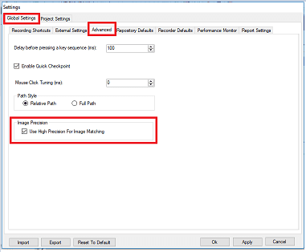

## Local Settings

### Current Recording

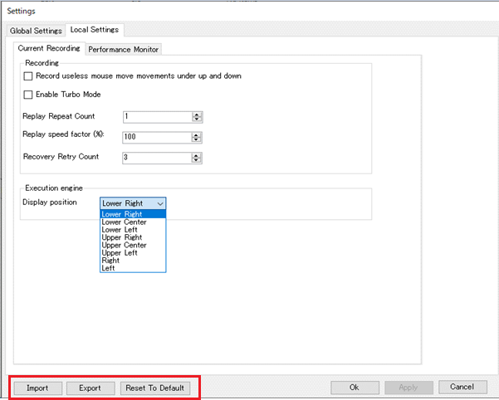

**Record useless mouse move movements under up and down**This is used to record all the move movements between mouse up and mouse down and add those as steps.

**Enable Turbo mode**This is used to specify whether recorded delays between actions should be part of the generated code. When selected, the delays between the actions are ignored.

**Replay Repeat Count**This is used to run the current recording multiple times. Different repeat count can be set for different recording i.e. replay repeat count is recording specific. Minimum limit of replay repeat count is 1 and maximum limit is 99999.

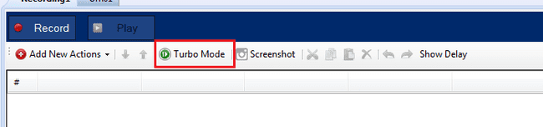

**Replay Speed Factor**The speed factor is used to increase or decrease the replay overall speed by a specific factor value.

**Display position**Change the position of the Execution engine.

Following is the functionality of other buttons on the Settings window:

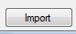 Button in Settings window is used to import the global settings as well as local setting from an xml file.

Button in Settings window is used to export the global settings as well as local settings in form of zip file which can be stored in user specified location.

 Button resets the values of all the global and local settings to their initial default values.

## Import /Export of Settings

If only global settings is open then global settings would be imported /exported, and if invoked from Local Settings window, then local settings would be.

 Button in global settings is used to import the global settings from an xml file.

Button in global settings is used to export the global settings in form of zip file and can be stored in user specified position.

 Button reset to default resets the value of current tab settings to its initial default settings.

 Button saves the changed settings.

 Button exits the global settings with saved changes.

 Button exits the global settings without saving the changes made after clicking the Apply button.

**Note:**There is no backward support for import/export for project setting.

e.g: If an old version setting is exported and tried to import in a new concord version, it will still successfully import. But there could be some loss of setting in this case if new version supports new or not supports old settings.

So please ensure while importing a setting, it is from the same version. We will also implement backward support in future concord versions.

# CSV Report

After execution, a report is generated in form of .csv file. in Report folder, with Prefix “Report” followed by DatehtmlTime stamp.

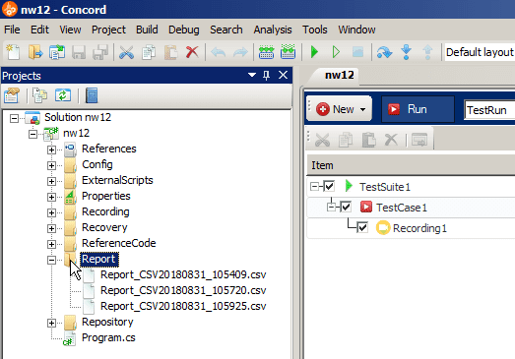

# Command Line Execution

* Add the Environment Variable path to execute “ConcordCommand.exe” from command prompt without going to physical location see the figure shown below.

For e.g. “C:\Program Files\Concord\bin\Tools\ConcordCommand"

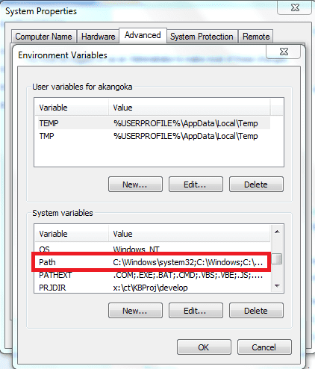

* Following commands are used to execute ConcordCommand application though command prompt.  
  Since administrative privileges are required, start the command prompt with "Run as administrator".

1. Help: - It will provide help.

E.g. ConcordCommand -h

1. EXE Solution Path: - Below is the syntax of EXE Solution Path.

E.g. ConcordCommand –p ”C:\Users\Demo\Documents\ConcordProjects\test\bin\Debug\test.exe”

1. TurboMode On/Off:-It will pass the parameter to On/Off turbomode before execution.

E.g. ConcordCommand “[EXE Solution Path]” -t True

1. Run Configuration: - It will pass the parameter to set Run Configuration before execution.

E.g. ConcordCommand “[EXE Solution Path]” -r testRun

1. Replay Repeat Count:- It will pass the parameter to Replay Repeat Count before execution

E.g. ConcordCommand “[EXE Solution Path]” -c 4

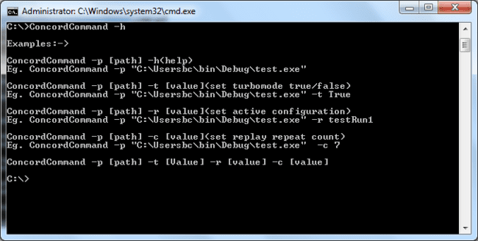

# Backward Compatibility Module

Backward module is designed to support solutions which were created in older version of Concord and those solutions will open in latest version of Concord after successful conversion of code. Let’s say a solution was created in X.X.X.X version of Concord and it should be opened it in latest version of concord which is Y.Y.Y.Y then following pop up will be seen which will ask confirmation for conversion of solution see the figure shown below.

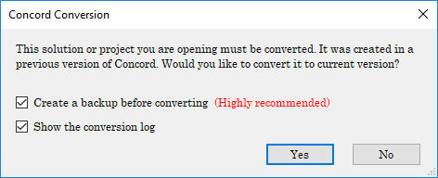

In above dialog,

* If “Create a backup before converting” is checked, then this module will take backup of the solution before conversion and stores at physical location.
  + Suppose path of open solution is “C:\NewFolder\ConcordTest\Test.sln” then
  + Backup location of solution will be “C:\NewFolder\ConcordTest_Backup\Test.sln”
  + So it will create solution folder with solution folder name and append it with “_Backup”.  
    **Note:** The backup option is highly recommended while doing conversion as there might be chances of solution corruption in case of long path or accessibility errors.
* If “Show the conversion log” is checked then after conversion, report will pop up in dialog.
* If “Yes” is clicked conversion process starts. In between process different processing dialog will appear like one see the figure shown below.
* The repository files (tafcomp) will be trimmed during solution conversion if the name is exceeding length 40 to avoid further long path related issues.

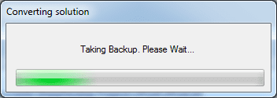

* After successful conversion report dialog will appear as shown below. Once solution is converted to latest version user will not be able to run same solution in older version of concord.

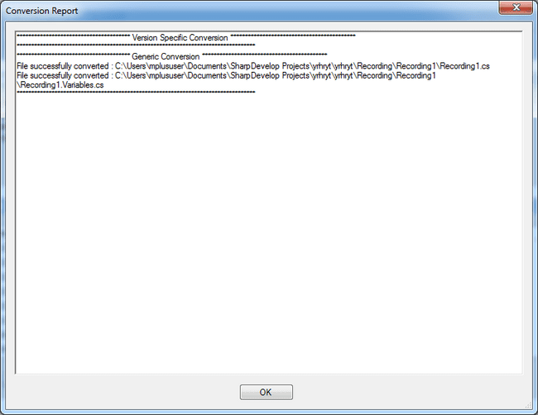

* If user presses “No” then below Warning dialog will appear and solution will not open.

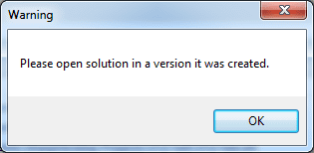

**Limitation:**

Below are certain identified limitations with respect to backward conversion and these are not the only limitations.

1. If old version number identification is not present then backward module converts it to latest version but it will not guarantee that converted solution will compile and run.
2. Erroneous builds shall be ported to latest build with previous version’s errors.
3. Previous feature of Image based recording screenshot was that it was storing image under node. Now Screenshot and Snapshot are stored in Desktop.tafcomp file. So if old version has previous feature then it will not work even after conversion.
4. If old version solution does not have .tafmap file implementation then solution will not work properly after conversion.
5. If old version solution will not have Instance feature then solution will not work.

# ­Solution Upgrade Tool

It is used to convert multiple older version concord projects into newer version of Concord. There are two utilities available for it. One is “GUI Application” and another is “Console Application”.

## GUI Application

Conversion of multiple solution through GUI is achieved using “GUI Application”. This utility is stored at “Concord\Utilities\ SolutionUpgradeTool \SolutionUpgradeTool\Winform” path.This utility looks like see the figure shown below:

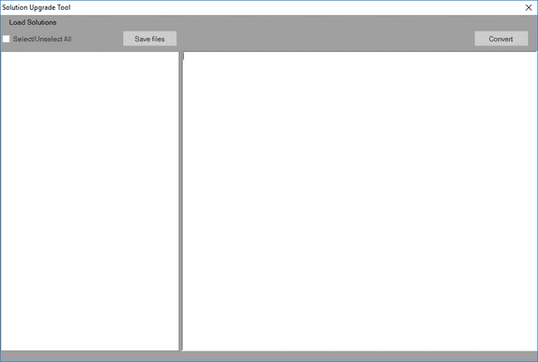

**Load Solutions:**

Two options are given to load multiple projects for conversion.

* + - 1. **Load By Folder**: By selecting this option user can select multiple projects from their computer drives and all checked folders will look for Concord projects and load them into utility see the figure shown below.

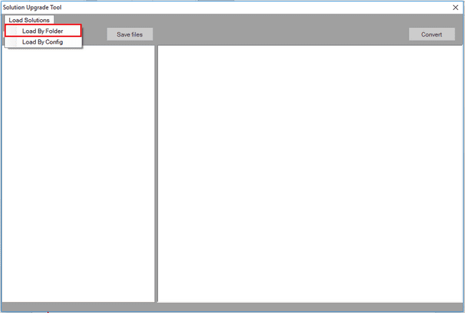

On click of “Load By Folder” a “Folder Browse Dialog” opens from where user can select multiple folders to load concord projects or by clicking on “Browse Folder” button also user can load concord projects see the figure shown below.

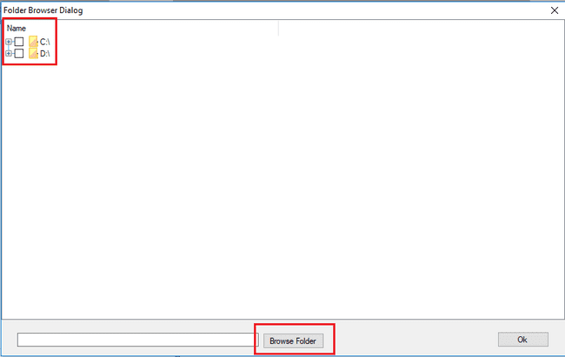

On click of “Browse Folder” button below window will open where we can select concord projects by clicking on “OK” button.

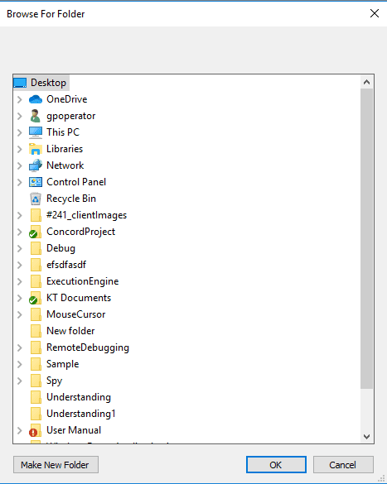

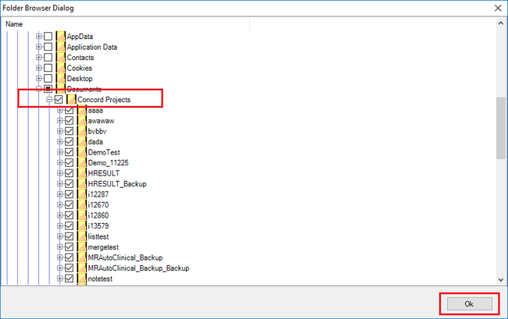

On click “OK” button all concord projects will loaded into utility see the figure shown below.

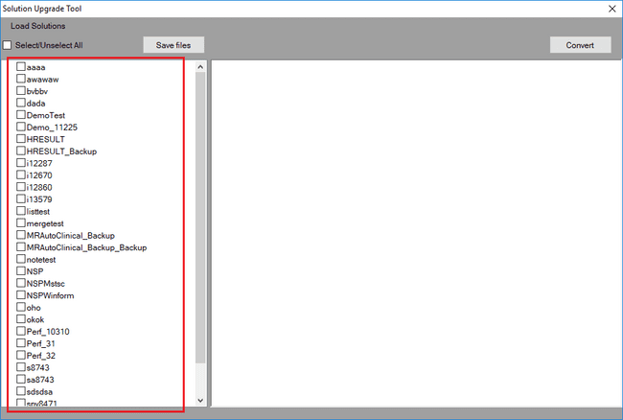

* + - 1. **Load By Config**: Using this option a browse dialog opens to select config / xml file and as per config data all concord projects will be loaded into utility see the figure shown below.

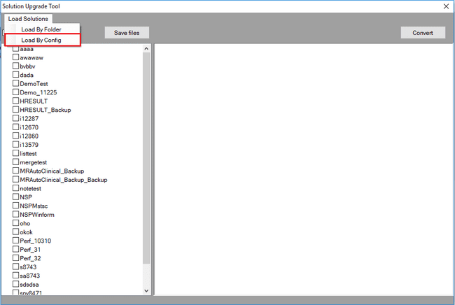

On click “Load By Config” Config Browse dialog opens to select File path.

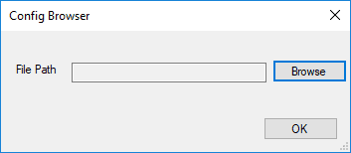

Using “Browse” button select config / xml file and click on “OK” button to load config data into utility which contains Concord projects path see the figure shown below.

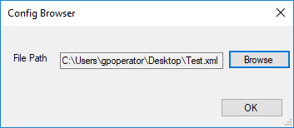

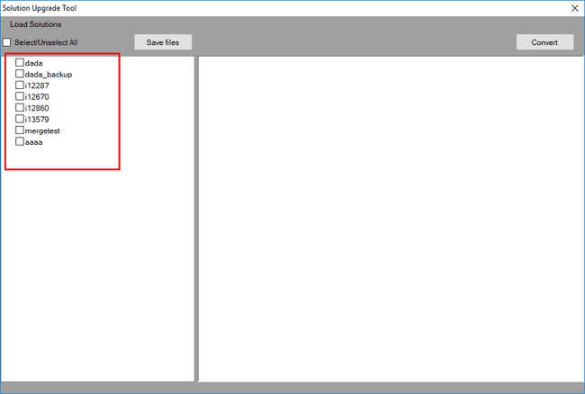

Use “Select / Unselect All” option to check / uncheck all projects for conversion see the figure shown above.

“Save files” will save all project data into config / xml file so that same file will be used for loading concord projects again see the figure shown below.

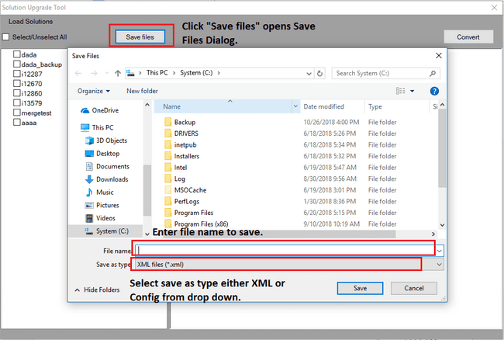

After save use “Load By Config” option to load same projects for future conversion if projects are remain on same physical location.

**Convert:**

On click “Convert” button all checked projects will be converted into latest Concord version installed on system.  
Dialog will appear to ask for taking backup of all checked projects see the figure shown below.

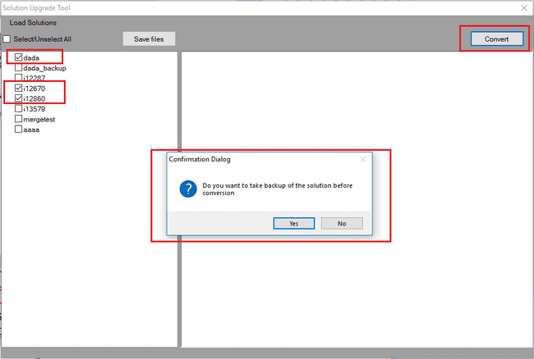

On click “Yes”, dialog appears to select folder path where backup will be saved.

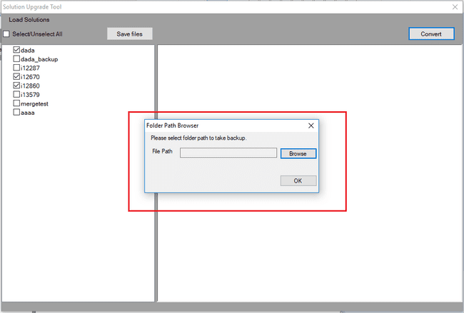

On click “Browse”, Browse For Folder dialog appears to select folder where backup will be saved see the figure shown below and above for “Browse”.

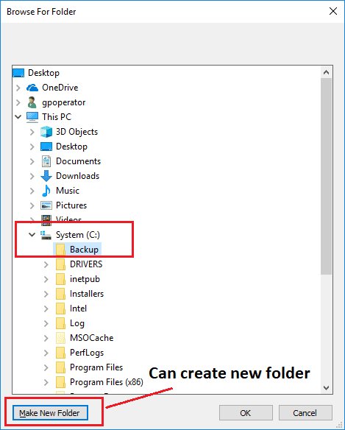

After clicking on “OK” conversion process will start converting all checked projects see the figure shown below.

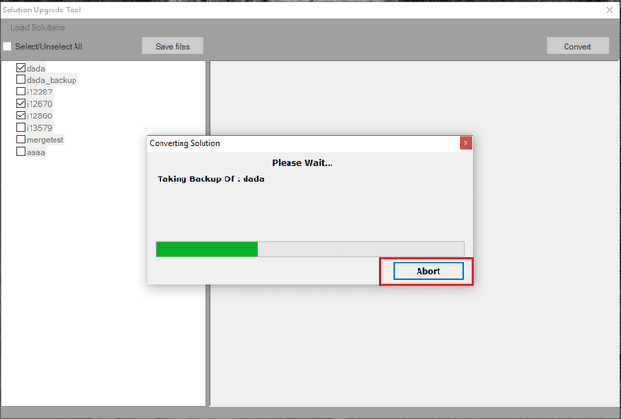

While converting solution option “Abort” is given to abort conversion. On click “Abort” utility stops conversion process. While aborting it will process project which has been taken for conversion and after its completion all other project conversion stops see the figure shown below.

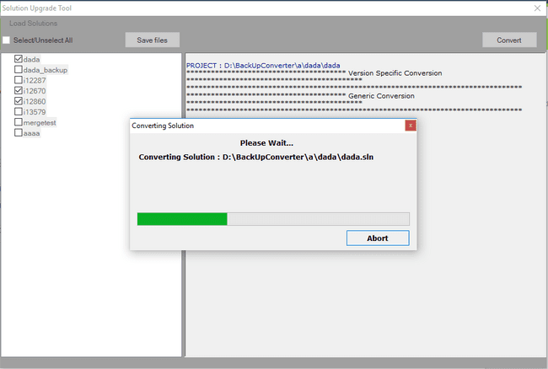

After conversion process completes, report log displays in utility and same will be stored in “Log” folder of concord installed location.

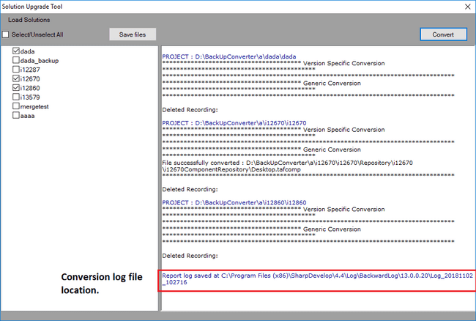­­­­

## Console Application

Conversion of multiple solution through command prompt is achieved using console application. Console utility is stored at “Concord\Utilities\ SolutionUpgradeTool \Console” path.

To start with console application, open command prompt from start menu or press “Windows key + R” and type “cmd” and click “Ok” button.

Command prompt opens and redirect to path “Concord \Utilities\ SolutionUpgradeTool \Console “see thefigure shown below screenshot using “cd” command.

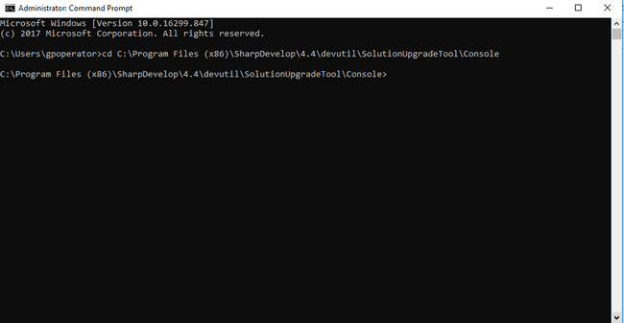

**Commands:**

SolutionUpgradeTool

🡪 Command used to convert projects.

-h 🡪 argument used to display help.

-c 🡪 argument used to provide config file location.

-f 🡪 argument used to provide folder location.

-b 🡪 argument used to provide backup folder location.

-s 🡪 argument used to convert solution file.

**Examples:**

1. SolutionUpgradeTool –h 🡪 it is used to display help and provides all commands list with example see the figure shown below.

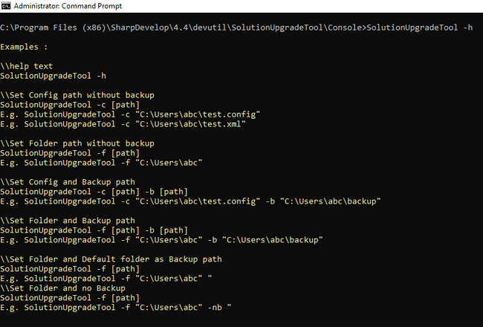

1. SolutionUpgradeTool -c "D:\Backward converter\Test.xml" -b "D:\BackUpConverter\backup” 🡪 it is used to convert all project using config file see the figure shown below.   
     
   Config file is “D:\Backward converter\Test.xml” and all project backup will stored at “D:\BackUpConverter\backup” path.

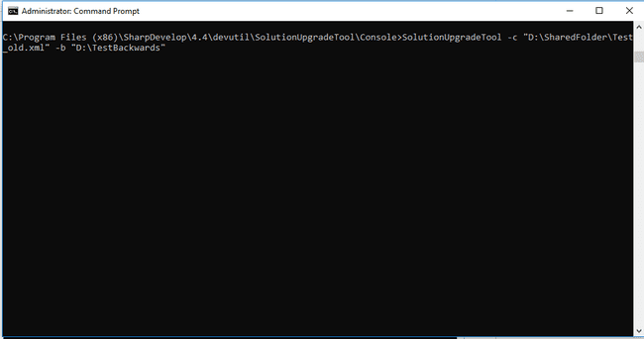

After successful conversion of all projects present in config file, report will display in console and same will be stored at path “C:\Program Files\Concord\Log\BackwardLog\13.2.0.1” where “13.2.0.1 is current concord version installed on system.

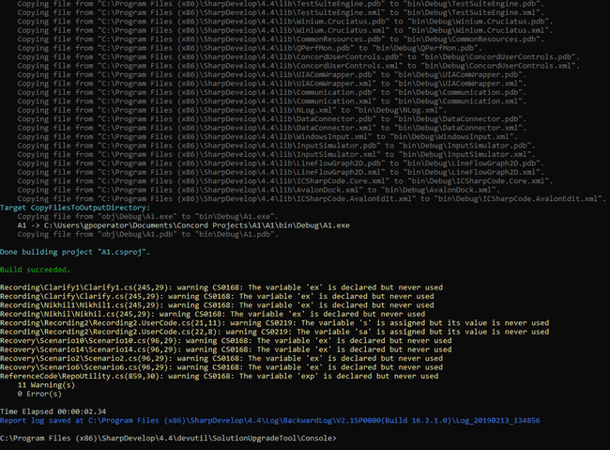

1. SolutionUpgradeTool -f "D:\BackUpConverter\ ConcordProjects " -b "D:\BackUpConverter\backup" 🡪 it is used to convert all project present in specified folder.  
   Folder location is "D:\BackUpConverter\ConcordProjects" and backup will store at "D:\BackUpConverter\backup".  
   Just like point 2, after successful conversion report will display in console and same will be stored at specified location.  
     
   If conversion fails then failure message will be displayed with reason of failure.
2. SolutionUpgradeTool -f "D:\BackUpConverter\ ConcordProjects " or   
   SolutionUpgradeTool -c "D:\Backward converter\Test.xml" 🡪  
     
   If backup argument is missed or not provided then application prompt message to ask if user wants to take backup or not. If user press “Y” then user need to provide backup location. If folder location is not present then application will create new folder.

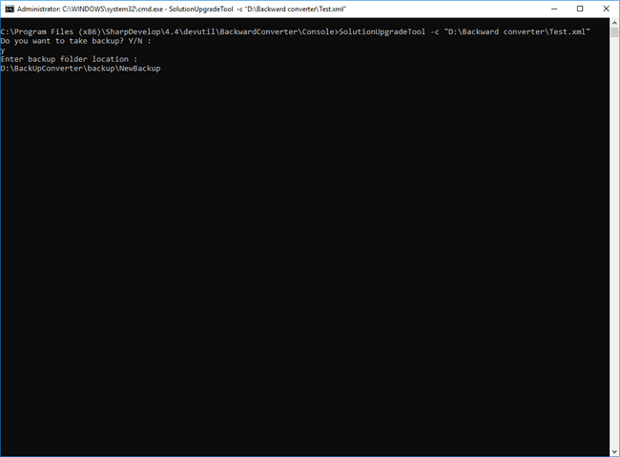

As per above screenshot, backup argument is not provided so message displays to take backup. If press “Y” then provided new backup location “D:\BackUpConverter\backup\NewBackup”.

If “Backup” or “NewBackup” folder is not present on path specified then new folder with given name will be created and conversion process will start.

1. Solution upgrade tool" passes the solutions build status to calling exe.  
   **1** = **All solutions pass  
   2** = **Some solution pass/fail  
   0** = **All solutions fail**
2. SolutionUpgradeTool -s "C:\\Users\\TestSolution\\TestSolution.sln"   
   Above command is used to convert solution file. After successful conversion report will be displayed in console and same will be stored as log at %CONCORDHOME%\Logs\BackwardLogs.

# Export Test Project

Export Test Project: This feature let user to have following:

1. Exported Test Project can be executed on any Window machine without having Concord application installed on it.
2. Export Test Project will create a separate folder at the target location. This folder will be the copy of the current opened project. But, this newly created folder, will be having all required files within it, so that the Test project exe can be executed.
3. Zip file will be created using the same folder mention in the point 2.
4. A batch file will be created at the target location (*location where user has selected to create the exported folder*). Double click on the batch file will execute the exe of the exported Test.
5. The Batch file can be used with the Window’s Scheduler. Parameters can be also passed to the batch file to override the
   1. Test run configuration
   2. Turbomode on/off
   3. Replay repeat count(*please refer the section 10.19*)
6. Important Note: Batch file can be used as same as ConcordCommand.exe, but Default Test solution name can’t be override.

Not Allowed. SampleTest_Runnuer.bat -p "C:\Usersbc\bin\Debug\test.exe"

\\set turbomode true/false

SampleTest_Runnuer.bat -p [path] -t [value]

E.g. SampleTest_Runnuer.bat -p "C:\Usersbc\bin\Debug\test.exe" -t True

\\set active configuration

SampleTest_Runnuer.bat -p [path] -r [value]

E.g. SampleTest_Runnuer.bat -p "C:\Usersbc\bin\Debug\test.exe" -r testRun1

\\set replay repeat count

SampleTest_Runnuer.bat -p [path] -c [value]

E.g. SampleTest_Runnuer.bat -p "C:\Usersbc\bin\Debug\test.exe" -c 7

## How to use Export Test Project

Export to Test Project button is available on the Test Suite UI. see the figure shown below.

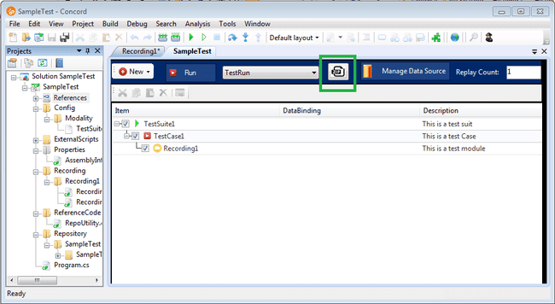

### Executing scenarios

1. On the click of Export button, It checks if current project exe is present or not. If not present, user can’t be able to proceed. Following message will be displayed.

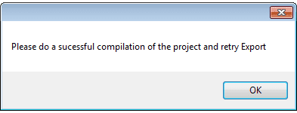

1. Do a successful compilation of the Test. This will create the Test’s exe.
2. On the click of Export button, if current project exe is present, following Export window gets open.

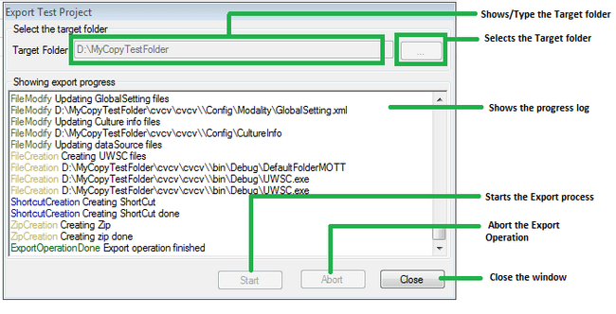

1. When the Export Window is opened, Start and Abort buttons are disabled. Once a valid Target location is selected, Start Button gets enabled.
2. Click on start button. Export process gets started. And start buttons gets disabled. During the Export Operations, Abort/Close button can be clicked to stop the Export operations.
3. Image mentioned in the point 3, shows the status of a successful execution of the Export operation. Please note the various log messages.  
   In, the bottom of the log area, “Export operation finished” with a green “ExportoperationDone” is shown. Similar, message will be there for Export fail in the red color.
4. A separate log file with the name “ExportToZipLog.txt” gets created at the target location.

### Executing Test Project exe using exported folder/zip

After Successful execution of the Export operations following folder structure will get created. In the following example, Test project “SampleTest” is used.

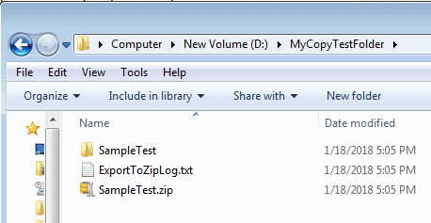

Open the “SampleTest”

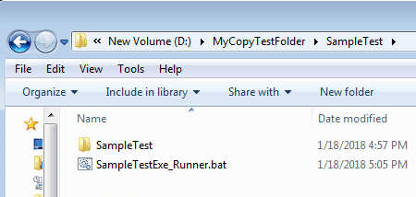

Open the “SampleTest”

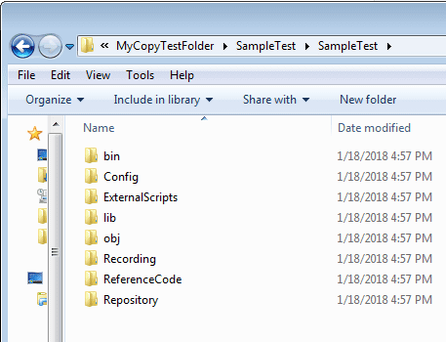

See in the zip

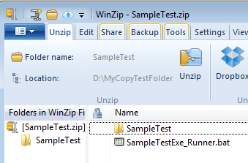

Use batch file to run. Various parameters can be given.   
Unzip the zip. Use batch file to run.

### Known Issues:

RunApplication **Action**: Export function supports only the location given of any exe during the recording steps creation. Export function, never copy any executable file (*included by Run Application steps*) to the Exported location.

# Drag and Drop

Concord Application supports following drag and drop operations:

* Dragging and Dropping of the recording steps on the same recording.
* Dragging and Dropping repository items on the recording steps.

## Steps drag and drop

This lets user to drag single or multiple steps and drop them on the same recording. This lets user to shuffle the recording steps easily.

During the drag of Loops, Conditional statements and branching statements, complete blocks gets auto selected even if user selects these partially or completely. During drop, complete dragged structure is moved.

Recording step’s serial number gets updated during Drag and Drop.

## Repository item drag and drop

This lets user to drag any repository item from the repository tree and drop it on a suitable step.

When a recording tab is opened user can add repositories. The repository tree is visible in the lower section of recording tab. And Recording steps are visible in the upper section of the Recording tab. User can drag any item from Repository tree and drop it on the Recording steps.

Repository item can be dropped only on those steps which support repository items. For example, Dragged Repository items can be dropped only on Mouse action, Get Value action, Set Value actions and Wait for Actions.

If user tries to drop any dragged repository item after the Recording step grid’s last row, user will get Context Menu to add new rows. A row will be added using the dragged repository item.

## In-Repository view drag and drop of Repository items

Users can reorder by dragging any repository item from the repository tree and dropping it into the appropriate repository tree position.

You can also select multiple repository items by holding down the Shift or Ctrl key on the keyboard and selecting repository items.

Drag-and-drop of repository items and multiple selection are functions that can only be performed within the same hierarchy of the same parent.

Similar functionality is implemented in the repository view within Object Spy.

# Performance Monitoring

Performance Monitoring allows user to monitor and log the performance data during the execution of concord test suite for individual actions.

Steps to implement this feature in any test suite is as follows,

* Create a performance profile & insert the desired performance counters.
* Use Global and local project setting for enabling this feature and choosing the profile.
* Verify the performance data in the performance report file.
* Verify the Performance graph plotted against the performance report file.

## How to create a performance profile.

1. Click on the Performance Monitor Icon in Test suite to invoke Performance Monitor window see the figure shown below.

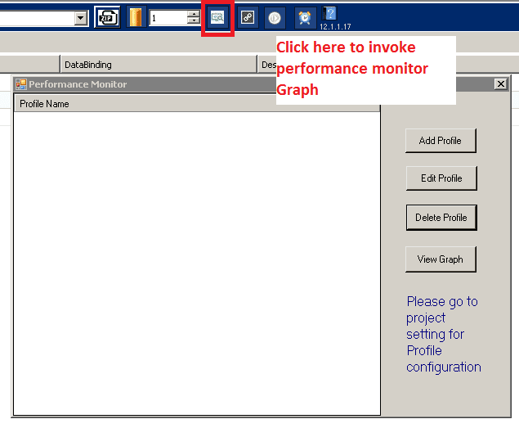

1. Click on Add Profile to invoke Performance Monitor Wizard where you can give name for your profile see the figure shown below.

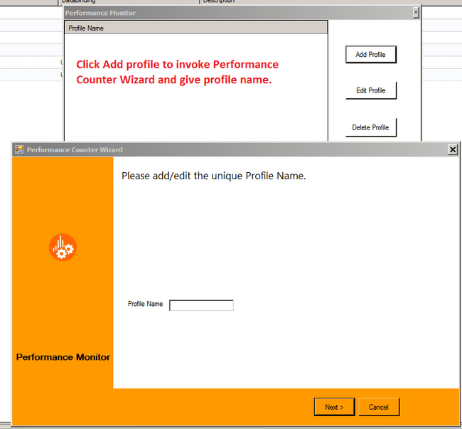

1. Click next and right click to add new performance counter.

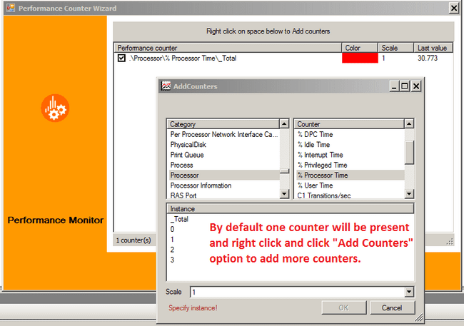

1. Add the desired counters and complete the profile creation process.

Similar to Add Profile, user can edit the already created profile and delete a profile. Also user can create multiple profiles.

## Global and Local settings related to Performance Monitor.

In Global settings, a newly introduced tab is available named “Performance Monitor”. This tab is available in Local settings also. From here user can enable and disable Performance monitor for the solution and recording. Also user can choose the profile in these settings.

1. Global settings.

To explain this settings, we will explain each global settings of performance monitor.

**Usage of selecting individual profiles in Global settings** -> If user check individual profiles in global settings then user can't uncheck it in individual recordings. i.e.

Case1: Those profiles which are checked in Global are mandatorily executed and report will get generated.

Case2: And those which are unchecked can be checked or left unchecked in individual recordings.

**"Enable Performance monitor in all recording" in global settings** -> If this is unchecked (i.e. disable) then the user can't select any performance profile in individual Recording settings. i.e. The performance profiles list item will be in disabled state and Case2 from above can't be performed.

**"Enable Performance profile in global" in global settings** -> If this is unchecked (i.e. disable) then no matter the profiles checked or unchecked in recordings/global, reports won't be generated.

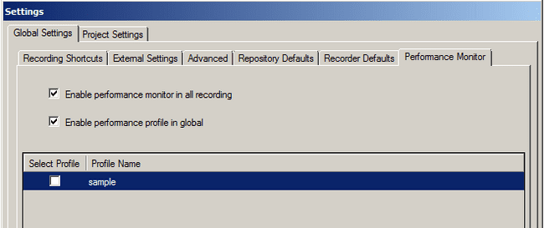

1. Local Settings.

Local settings also have a Performance Monitor tab. From this tab user can enable or disable performance Monitor in recording level. Also we have an option to select profiles for performance monitor. The profile which is globally selected in Global settings cannot be unchecked in local settings see the figure shown below.

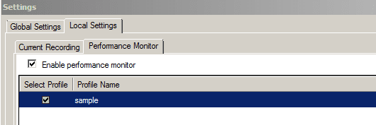

## Performance Monitor report.

After a successful execution of the solution, performance report in csv format will be generated. If user has selected multiple profiles then for each profile one report will be generated. If user has selected single profile and executed the script more than once then different report will be generated depending on the timestamp. This report will be available in “<SOLUTION_PATH>/Report/PerformanceReports/” folder. This report will contain performance data for the selected counters in the profile against each action available in the solution.

## Performance Monitor Graph.

Once the csv file is ready with all the values and counters, user can plot a graph using the same csv. User can invoke the Graph view from two places see the figure shown below.

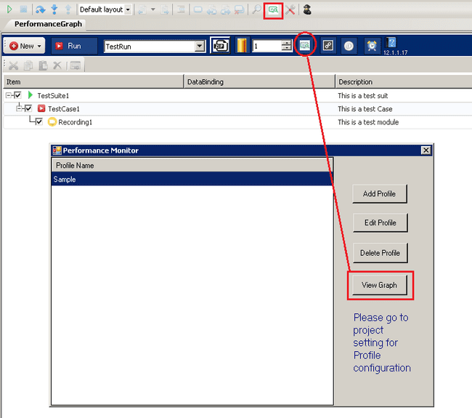

Once View Graph is clicked we will get the “Performance Graph” window. From this window the first step is to select the csv file for graph display.

Once the csv file is selected and user clicks on OK button, the counters will be listed and the graph would be drawn according to the values of the counter see the figure shown below.

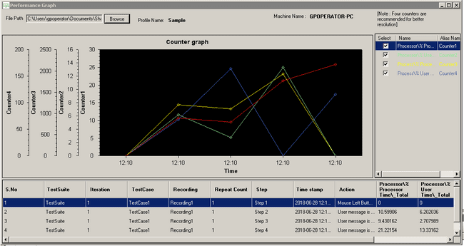

The counters will be listed in right hand column with the fore color same as the color of the graph. User can check the counter fore color with the color of the curve.

X-axis contains the time stamp and y-axis for each counter has different scaling by using auto scaling of the parameters.

User can select 4 counters at max which would be displayed in the graph. If user wants to see different counters then user needs to unselect some of the selected counter and then select the needed counters. Once user unchecks some counter the graph of the unchecked counter will not be displayed and again on checking the counter user can see the graph plotted for the same counter see the figure shown below.

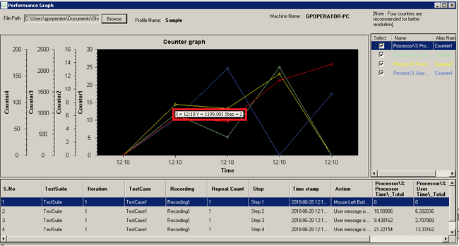

On hovering on a point, user can see the X and Y axis value at that point and the step number for which this point have been plotted.

# Recovery Scenario

Recovery scenario is a concept of recovering from any unexpected fail scenario during the execution of a Concord Test Suite. Unexpected fail reason could be because of any reason such as unwanted popup displayed, application (AUT) crash during the test execution etc.

Recovery scenario consists of following,

* Possible recovery scenario (trigger action).  
  In this section we need to create possible scenario which can overcome the unwanted fail scenarios of our actual test suite.
* Post Action.

This is the setting we need to do for the post action which the tool should trigger after the recovery scenario execution.

## How to use recovery scenario in concord.

Using Recovery scenario consists of following points in Concord.

* Create a Scenario in Recovery suite.
* Linking the scenario with Recording.
* Decide Post Action.

## Create a scenario in Recovery suite.

For creating a scenario in Recovery suite user first needs to switch from main test suite to Recovery suite. Double click on the Recovery.cxml file under Config\Modality folder from project explorer, and then the following UI will be displayed see the figure shown below.

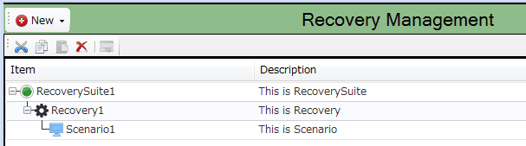

Recovery suite is very similar to Main Test Suite UI, here user will be able to create multiple Scenarios and Recoveries. On double clicking on the Scenario present under Recovery, it will open a Scenario IDE which is similar to Recording IDE.

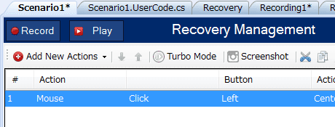

From this IDE user can Record the recovering steps or add manually. User can also copy paste the actions present in the Recording IDE to Scenario IDE.

## ­­­Linking the Scenario with Recording.

Once the scenario creation is completed the next step is to link it with the Recordings. From the Main test suite, user needs to click on the Recovery icon to invoke recovery configuration manager window.



## Recovery Configuration Manager

See the figure shown below shows recording list its related linked recovery list and post action.

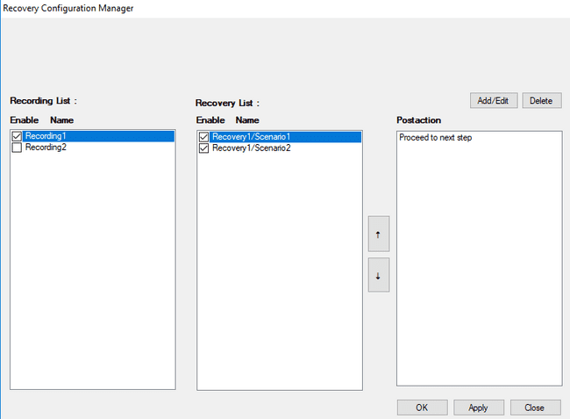

* **Recording List:** Recording List will contain the recording list available in the main test suite
* **Recovery List:** Recovery List will contain the linked scenario list for recording.

Below are the operations, user can perform on Recording List and Recovery List are:

* **Enable/Disable Recording:** User can enable/disable recording by checking/unchecking from recording list column.
* **Enable/Disable Scenario:** User can enable/disable scenario for selected recording by check/uncheck from recovery list column (unchecked scenario will skipped during execution).
* **Delete:** User can delete linked scenario for recording.
* **Change Preference**: User can change preferences of scenario execution using **Up/Down** arrow button.
* **Post action:** User can see which post action is configured for scenario in post action column.
* **Add or Edit Scenario:** To link a new scenario to recording user can click on **Add/Edit** button Linking configuration manager will open which will display the available scenarios in the Recovery suite; user can select or deselect the scenarios to link it with the recording see the figure shown below.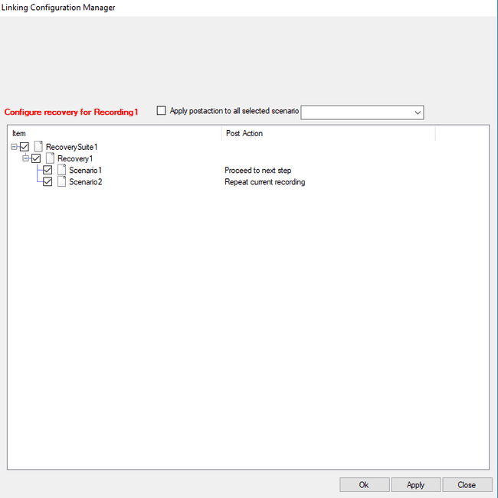
* **Update Post action:** User can update post action for selected scenario from available post action list in combo box see the figure shown below.

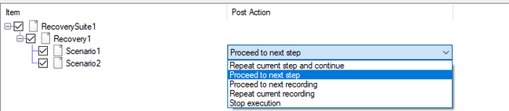

* **Apply post action to all selected scenario:** If user checked option apply post action to all selected scenario on click Ok/Apply button selected post action will be applied to all checked scenarios see the figure shown below.



Once configured the needed scenarios against the recordings, during execution recovery scenarios will be executed during any fail scenario in recording.

* **Ability to proceed to the next recording without stopping the test if step execution fails:** When "Proceed to the next Recording..." is checked, the test proceeds to the next recording if the step execution fails. When "Proceed to the next Recording..." is unchecked, the test is terminated at the failed step.

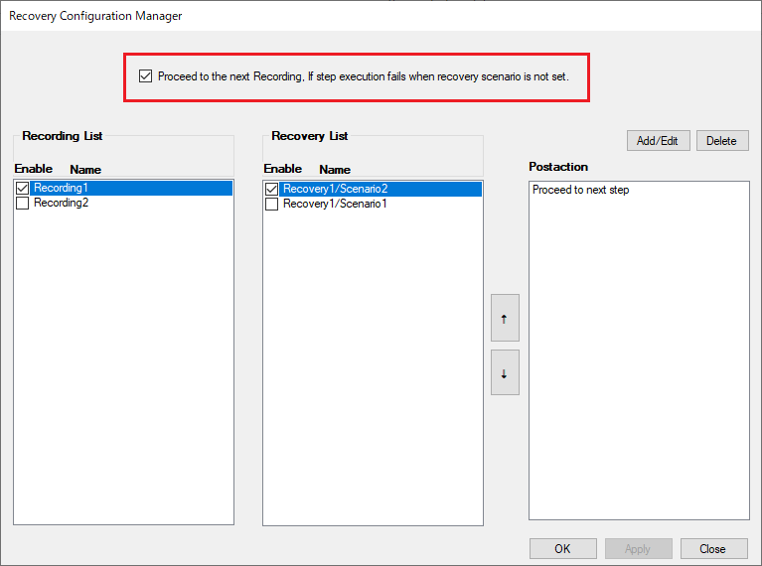

If a Recovery scenario is set, the Recovery scenario is executed regardless of the check status.

After that, the configured Postaction is executed.

## Decide Post Action

Once the recovery is executed the execution will continue again from recording module. For this we have five options to specify from where the execution should continue. (1) Restart the action where it failed, (2) Start from next action, (3) Start from next recording , (4) Repeat current recording and 5) Stop Execution is added.

1. Restart the action where it failed.  
   If we specify this option then the execution will continue from the action which is failed in the recording.
2. Start from next action.  
   If we specify this option then the execution will start from the next action of the failed action in the recording.
3. Start from next recording.  
   If we specify this option then the execution will start from the next recording from the recording where the action is failed.
4. Repeat current recording  
   If we specify this option then the execution will start from first step of the failed recording.
5. Stop Execution  
   If we specify this option then the script execution will stop from failed recording step.

**Note**: Scenario post action will be applicable at recording level.

# Macro

Macros can perform tests such as:

* Repeatedly perform the test of the fixed procedure.
* Determines whether or not to execute depending on conditions

## Macros in the project tree

The following functions can be performed from the context menu of the Macros folder on the project tree and each Macro folder.

**Macros folder**

1. New macro

Generate Macro data.

1. Collapse all

Expand the Macros folder.

1. Open Folder in Explorer

Access the actual folder in explorer.

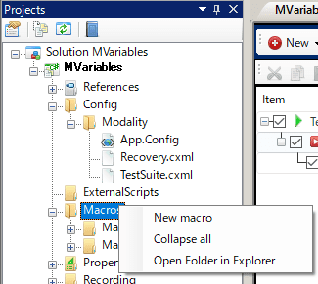

**Macro folder**

1. Collapse all

Expand the Macros folder.

1. Open Folder in Explorer

Access the actual folder in explorer.

1. Delete

Remove from project.

1. Rename

Change the macro name.

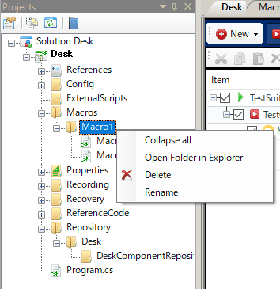

## Macro edit screen

Double-clicking the Macro folder opens a macro editing screen similar to the recording editing screen.  
It is possible to call the test set in the macro edit screen from the recording or scenario.

### Add Macro Variable

Press the Variable button to add a variable for the macro. By adding a macro variable from the macro edit screen, it can be set in Variables of the RunMacro action.  
（The procedure is the same as adding variables on the recording edit screen）

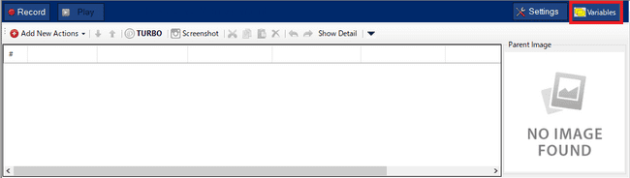

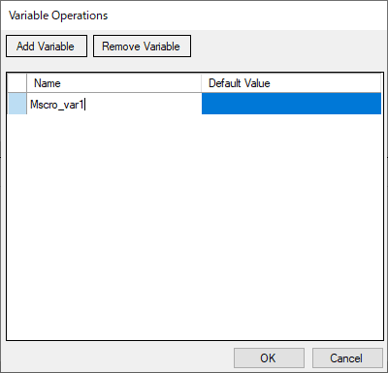

### About changing macro variables

If the macro variable has already been set on the RunMacro action side、even if you change or delete the macro variable name.   
Changes are not reflected on the RunMacro action side.If you change or delete the macro variable name, you need to update RunMacro.   
Therefore, the following warning screen is displayed during macro editing.

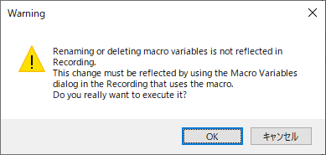

"**OK**" button…The macro variable settings are changed. (The associated RunMacro action setting is not changed)）

"**Cancel**" button…Return to the macro variable setting screen.

## Using macros in recordings/scenarios

Macro calls are possible from recordings and scenarios. To use the macro, set the RunMacro action on the recording edit screen and scenario edit screen.   
However, calling a macro from a macro is not allowed.

### Adding a RunMacro Action

You can add it by selecting Run Macro from Add New Actions in the menu bar or context menu.

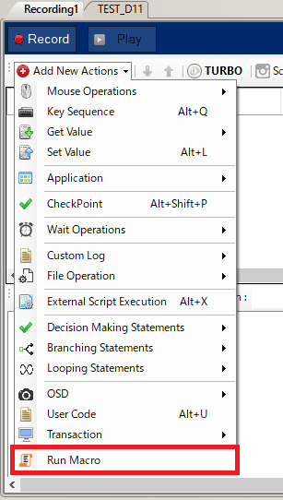

### Macro file settings

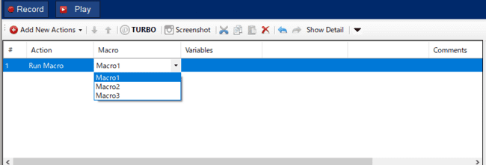

Selecting the Macro cell will display all Maco files created in the Macros folder. Macro files can be set by selecting them from the combo box.

## Variables setting

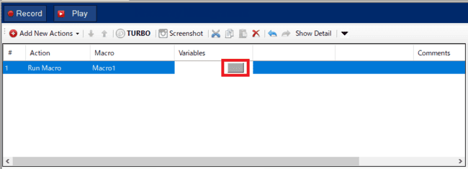

By setting the Macro cell, the button in the Variables cell can be selected.  
Selecting the Variables column will bring up the Macro Variables screen.

### Macro Variables screen

You can display the Macro Variables screen by clicking the button in the Variables column of the RunMacro action.

※This can be set only when a macro is set in the Macro column.

On the Macro Variables screen, set the initial values of variables in the macro when calling the macro.

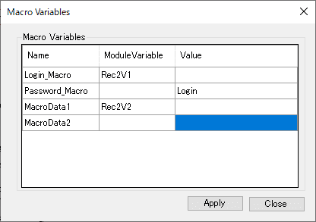

1. Name

All variables of the corresponding macro are displayed.

1. ModuleVariable

Variable of the corresponding recording can be selected from the pull-down

※Recording variables are not displayed unless they are set on the recording edit screen.

1. Value

You can enter the initial value of Name when calling a macro from recording

1. Apply Button

Determines the initial value when calling a macro from recording with the current setting value.

If both ModuleVariable and Value have inputs, ModuleVariable takes precedence.

If Variable does not exist in the corresponding macro, it becomes Disable.

1. Close Button

Close the Macro Variables screen.

※If the Apply button has not been pressed while the setting value has been changed, a save confirmation dialog will be displayed.

If you apply and close the Macro Variables screen, it will be reflected in the settings of the Run Macro action.

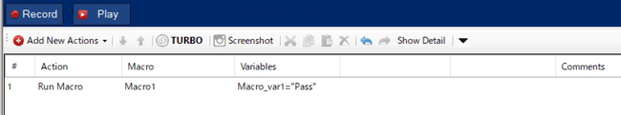

## Continue on Fail

Each action has a Continue on Fail setting, and you can set whether to continue or abort the process when the target step fails.  
The behavior when Continue on Fail is set in the macro, recording or scenario is as shown in the table below.

|  |  |  |  |
| --- | --- | --- | --- |
| Macro side [Continue on Fail] | Recording/Scenario side [Continue on Fail] | When there is a failed step on the Macro side, About decision to suspend/continue test execution | |
| **OFF** | **OFF** | Macro side **break** | Recording/Scenario side **break** |
| **OFF** | **ON** | Macro side **break** | Recording/Scenario side **continue** |
| **ON** | **OFF** | Macro side **continue** | Recording/Scenario side **break** |
| **ON** | **ON** | Macro side **continue** | Recording/Scneario side **continue** |

(example）

* Macro side action1 -Continue on Fail [ON]
* Recording side RunMacro -Continue on Fail[OFF]
* Action1 fails during execution

In the above example, actions after Action1 on the Macro side will continue, and the Recording side will be interrupted after the target RunMacro is called.

# Configuration management using Git

Git AddIn adds support for the git version control system to Concord.

* Tortoise Git must be installed on the system in order to use the git addin. It is used as git interface.
* Git should be available in the solution path

To work with Git addin, git create should be done manually by user, either one of following 2 options.

1. If multiple solutions are in a root folder. Git can be created inside root folder itself. (Common for all solution)

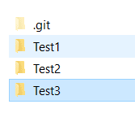

1. Each solution should be in a git repository

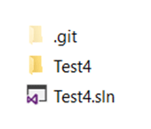

## Git options

Following four options will be added to the right click context menu of solution node as part of git addin.

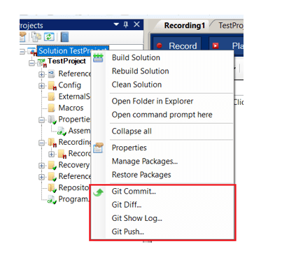

**a.** **Git Commit**

Tortoise Git’s commit window will appear if the user clicks commit option from project explorer context menu.

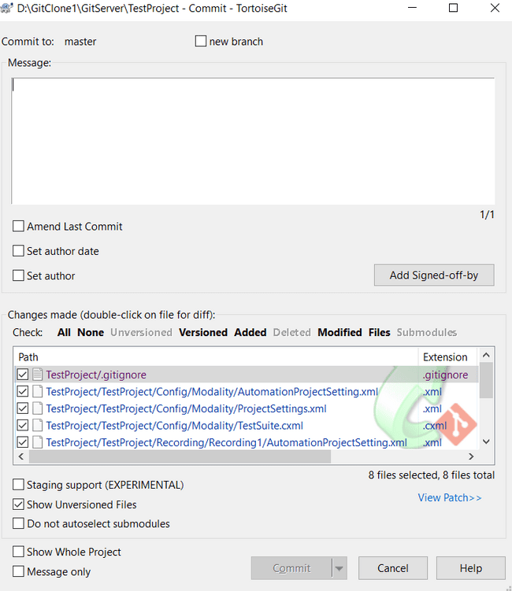

When the user clicks commit option, all the files in the selected project will be automatically added in git before commit. So no un-versioned files will be displayed on commit window.

The commit dialog will show every changed file, including added, deleted and modified. If we don't want a changed file to be committed, just uncheck that file. Double clicking on any modified file in the commit dialog will launch the external diff tool to show our changes. Be sure to enter a log message which describes the changes we are committing. This will helps to see what happened and when, as we browse through the project log messages at a later date.

**b. Git Diff**

If we want to see what (uncommitted) changes we have made in the solution, use the explorer Git Diff option from explorer context menu. Tortoise Git’s Diff window will appear if the user clicks “Git Diff” option from project explorer context menu.

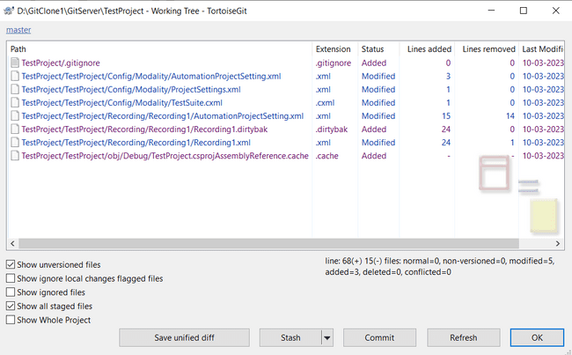

**c. Git Show Log**

Git log lists the commits made in that repository in reverse chronological order; that is, the most recent commits show up first. The following window will appear if the user clicks “Git Show Log” option from project explorer context menu.

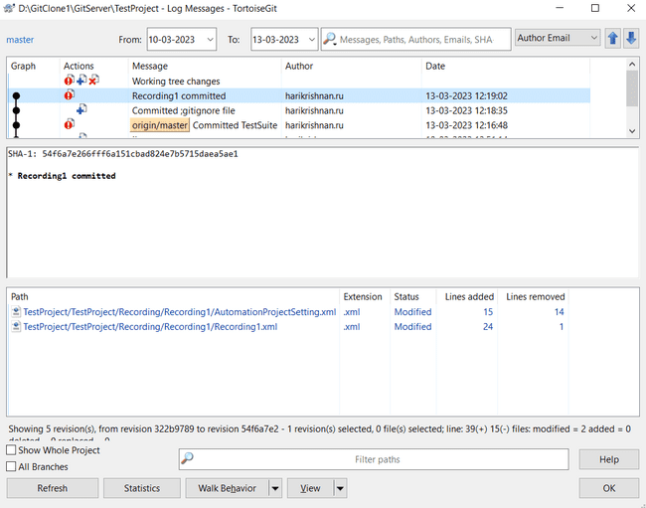

This command lists each commit with its SHA-1 checksum, the author’s name, the date written, and the commit message.

**d. Git Push**

The git push command uploads the content of the local repository to the remote repository.  The following window will appear if the user clicks “Git Show Log” option from project explorer context menu.

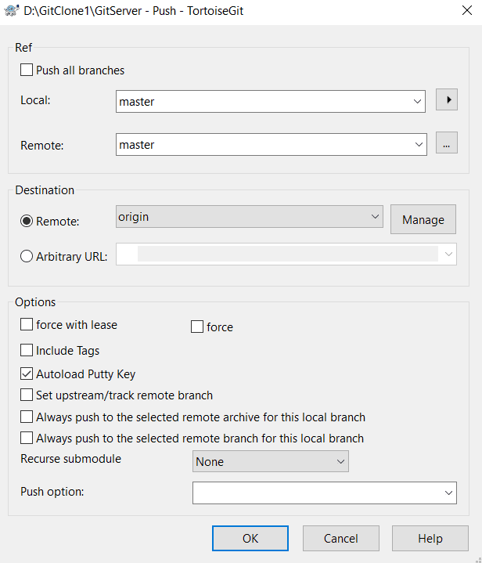

## Specific scenarios

* **Adding a new solution**When a new solution is created inside a git repository from concord, no status icon will be displayed in project explorer.

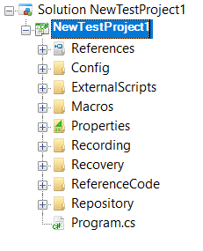

If the user selects commit option, all files will be automatically added in git. So if the user clicks commit option from context menu and did not committed the files, the folders will show modified status since they are added to the project and not committed.

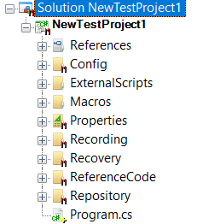

Once the user commits the solution, green checkmark will be displayed on project explorer. If the user updates the solution, for e.g. if the user executes the solution, recording cs files will be updated. So, the corresponding folders will be marked as modified.

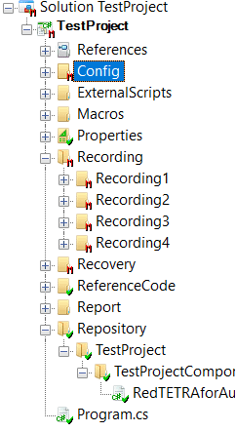

The changed files will appear on commit window. Git addin provides no facility to take update from git. So, user has to manually take update using tortoise git’s context menu. For that user has to first select fetch option and then select pull.

* **Renaming a solution**

On renaming a solution, user have to commit the entire solution again, since git treats the renamed solution as a newly created folder. Also, the backup of the created solution will remains in the root folder as uncommitted. As per the current implementation, user has to manually delete the backup solution from the folder.

* **Deleting a solution**

If the user deletes a solution from local, then user has to go commit those missing files manually from the folder using tortoise git’s commit option. There is no option to commit deleted solution from addin.

* **Converting a solution**

After converting an old solution to latest version, user has to commit TestSuite.cxml file and recovery folder since those folders were modified during conversion process. Also, backup of the solution will be created in the root folder and remains there in uncommitted stage. User has to manually delete the backup solution from the folder.

**Use of .gitignore file**

The .gitignore file is a text file that tells Git which files or folders to ignore in a project. A .gitignore file will be automatically added to the solution path when the user clicks commit option.

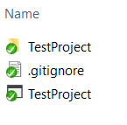

The folders bin, obj and Report need not be committed. So these folders are added in the .gitignore file.

# Concord Reporting

Concord Reporting displays the test results generated after the test case execution in html format using charts and tables. It displays information about the execution environment, number of test cases, steps, start time, end time, total execution and details about individual recordings.

Two views are there – dashboard view and details view. Dashboard view gives the overall idea of the test case execution and details view displays the detailed information about each recording executed.

Report will give info about machine name, user name, Windows information, system type, processor RAM information, information about project like build version, project name, Active configuration name etc.

“[Recording break]” will display in report between two recording execution. That means, when one recording execution ends and second starts, “[Recording break]” gets display between two lines. Testsuite column displays project name.

If turbo mode of recording is ON then after recording, Report will show “[T]” in front of recording. If “Enable continue on fail” flag set to the step, then when steps gets failed, report will show “[E]” in front of step.

## System operations

Concord Reporting contains two views

* Dashboard view
* Details view

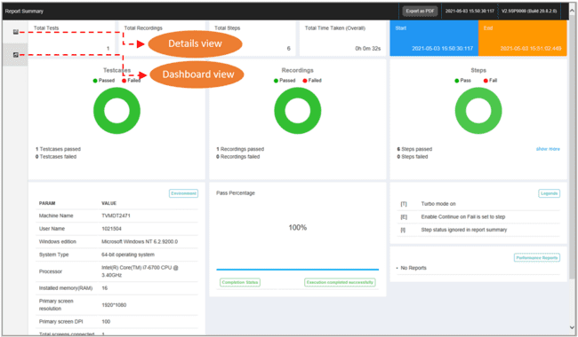

## Dashboard view

This view displays the overview of the test case execution see the figure shown below. It contains the following details

* Total number of test cases
* Total number of steps
* Total time taken
* Start end of execution
* End time of execution
* Concord build version
* Number of recordings passed/failed
* Number of steps passed/failed
* Pass percentage
* Execution environment info

And while clicking on “show more” button in the Steps, we can see more details like

* Number of steps fail status ignored
* Number of steps set Enable Continue on Fail
* 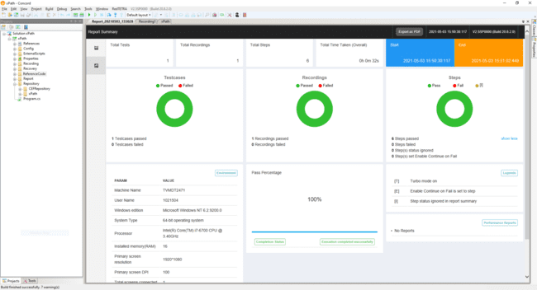

## Details view

Details view displays the following details see the figure shown below

* Recording names in left side
* Selected recording step details will be displayed on right side
* Author who executed the test cases
* Start, end and total time of the selected recording
* Filters for filtering recordings and steps
* Enable dashboard view
* Search field for searching recordings and step actions

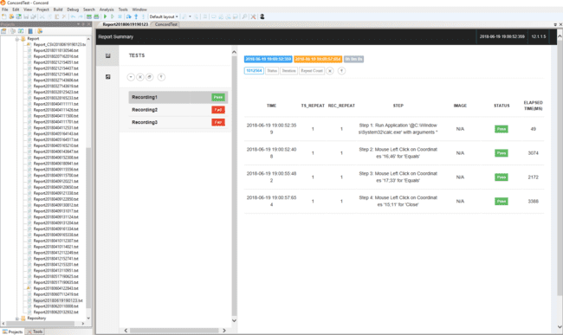

Recording status will be displayed along with the recording name in the left side. Steps which have screenshots will be displayed in the IMAGE column on the right side see the figure shown below.

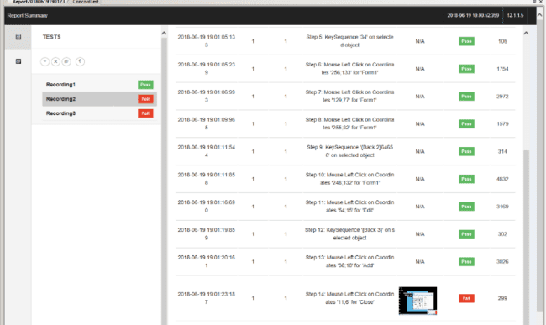

The user can click the screenshot in IMAGE column and view the image in full size see the figure shown below.

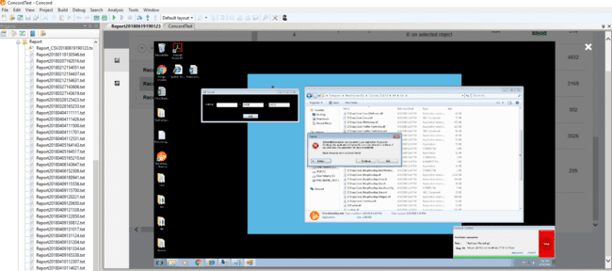

Reference: About screenshot naming rules.

The step execution result screenshot displayed in the IMAGE column may have a prefix, which has the following meanings. (See table below)

|  |  |
| --- | --- |
| prefix | Meanings |
| B | Meaning of Before. Capture the state before executing the test step. |
| A | Meaning of After. Capture the state after executing the test step. |
| F | Meaning of Fail. Capture the state when the test step is executed and the result is rejected. |
| S | Meaning of Stitch. Captures image-based actions failing.(See 26.5 Image Stitching for details) |

The reason for step failure can be seen by bringing the mouse over the fail text in the STATUS column on the right side see the figure shown below.

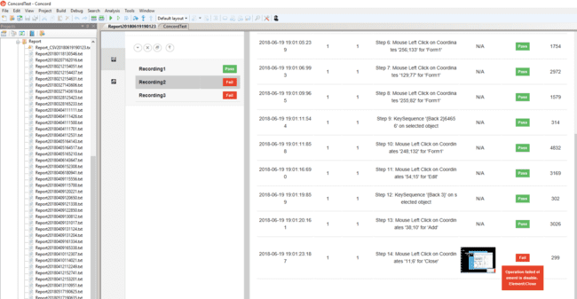

Users can filter the recordings on the left side based on the pass/fail status by using the filter see the figure shown below.

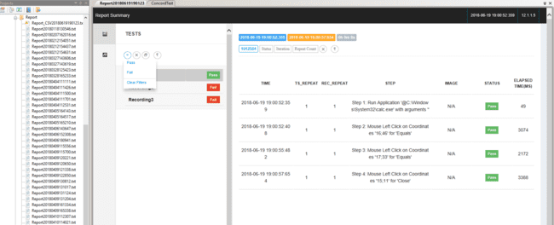

The enable dashboard enables the user to view the dashboard along with the details view see the figure shown below.

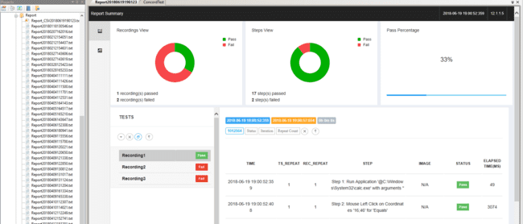

Similarly TS_Repeat, Rec_Repeat and status filters are also available for the steps displayed on the right side see the figure shown below.

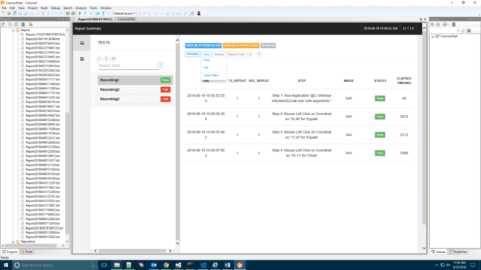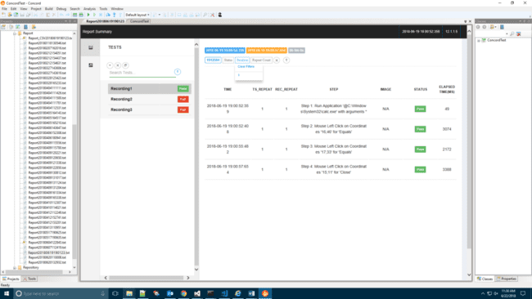

Users can also search for their recording using the search option on left side see the figure shown below.

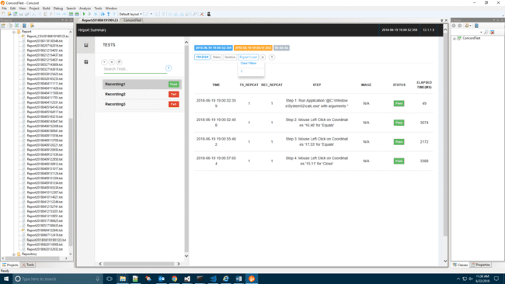

Steps can be searched using the step search option available on the right side see the figure shown below.

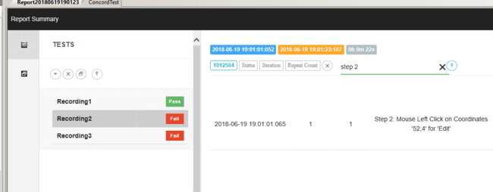

Checkpoints will be displayed as sub steps i.e. when you click on a particular step containing checkpoint, the checkpoint will be displayed as a sub step below the step see the figure shown below.

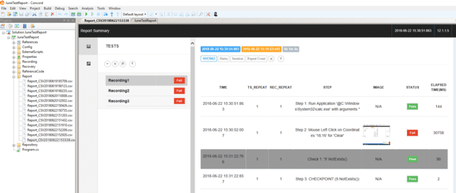

Checkpoint displayed as sub step

## Export HTML report

1. User can Export report by right click on the Report folder in project explore in concord, as shown in below figure.

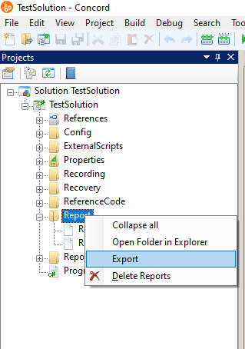

1. After clicking on “Export” Menu option ExportReport window will open as shown in below figure to select the report .
2. On the left side of below figure all the report list will be shown from that particular solution user can export multiple reports or single report by checking checkbox. And after clicking on any of the report user can see the preview of report on the right side of ExportReport window, as shown in below figure.
3. On click of “Export” button shown in the below figure, after clicking on that button needs to select the folder path where user wants to export the reports.

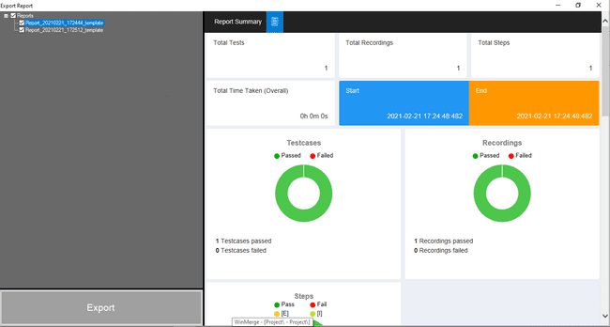

## ­­Image stitching

When any image based action like “Mouse action / Exists / Not Exists / Contain Image / Compare Image / Compare ImageFile” fails, the failure reason is shown in report in the form of image. This image is stitched image having expected image and current image.

Expected image is the image captured by the user at the time of creating script and current image is the image captured at time of execution/Playing the script. Looking at these images, user can come to know the reason of failure of action/step.

### Image based action/ Select repository

When the action is linked with image (in case of image based recording i.e. the image of the object), Exists/Not exists is linked with the image of the object or when contain/Compare image, Compare ImageFile is linked with the desktop as repository and checks the if the image is there under desktop then, the report generated will contain expected image stitched either with desktop or the current image (image at the time of execution of script) of the object see the figure shown below. These cases are listed below:

* Mouse action linked with screenshot/snapshot.
* Image/custom based recording.
* Mouse click, double click, up, down and move.
* Exists/Not exists linked with snapshot/screenshot.
* Contain/Compare linked with desktop as repository and screenshot/snapshot as Screenshot name.

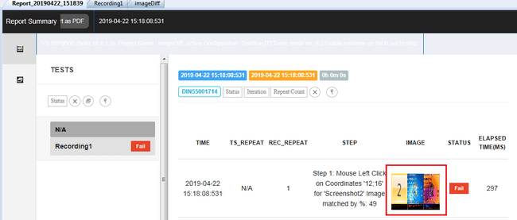

Clicking on that image will open image. Which will display stitched image. Stitched image see the figure shown below,

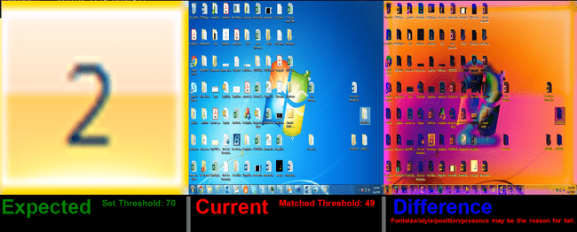

If any action fails, the report is generated with stitched image. If the image is not present on the desktop or if the expected image matching percentage is less than 50% from the current image then the expected image captured by the user is stitched with the desktop image see the figure shown below:



**Image with percentage less than 50% and action fails and image stitched with desktop image.**

If the percentage matching of expected image is more than 50% or Pixel by Pixel , then the expected image is stitched with the current image of object is taken at time of execution of the script see the figure shown below:

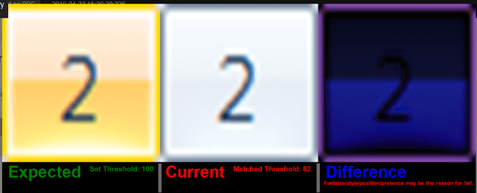

**Image with percentage more than 50% but action fails and image stitched with current object’s image.**

### Checkpoint actions/Get coordinate

When Compare Image /Compare ImageFile/Contain Image step is linked with some coordinate cropped by the user, the image cropped is linked in the same step as screenshot name. When the step fails containing coordinates, the report is generated with the stitched image. This stitched image is different from the other scenario as given below:

* When compare/Contain image fails with “Get coordinate” option with less than 50% (e.g.: if image captured is not present in desktop) then the expected image (image captured while creating suite) is stitched with the current image at that particular coordinate with the same width and height of the expected image. see the figure shown below:

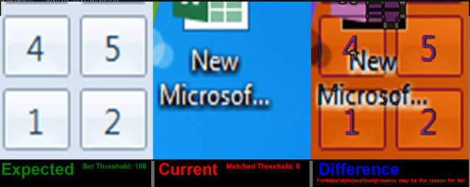

* When compare/Contain image fails with “Get coordinate” option with more than 50% (e.g.: if image captured is present in desktop but with less percentage as expected) or Pixcel by Pixel then the expected image (image captured while creating suite) is stitched with the current image at that particular coordinate with the same width and height of the expected image. see the figure shown below:



For given search time out, application will take screen shot of desktop for every second, and will use last screen shot as current image.

These stitched images are stored/ saved in Report folder with name having date time of captured image.

### Difference in Image

This feature displays the difference in Expected and Current Image when the image based actions or image base checkpoint action fails. This shows the mismatched part of the image see the figure shown below:

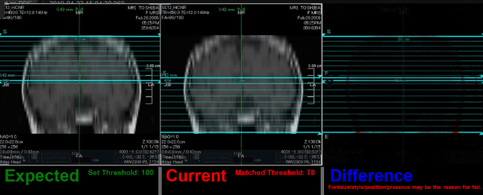

The **Expected** image is the image captured by the user while creating script and the **Current** Image is the image present at captured coordinate while playing script. The **Difference** Image shows the difference between two images because of which the action is failing.

Note: The difference image is the overlapped image of Expected and Current Image.

## Reporting -Ignore Fail Case:

Test steps can be ignore/consider in report using the “Ignore in Report/Consider in Report” option that appears on the right click of the test steps as shown in following figures. By default step is “Consider in Report” for all steps except Decision/branching/Looping/Checkpoint steps. For these steps default is “Ignore in Report”. When step is consider in report, only “Ignore in Report” option appears in the context menu on right click. If step is ignore in report, only “Consider in Report” option appears in the context menu on right click.

Right click on the “Ignore in Report” step in order to get the option to “Consider in Report” the step see the figure shown below:

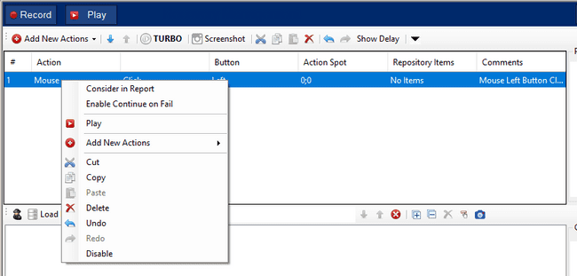

Right click on the “Consider in Report “step in order to get the option to “Ignore in Report” the step see the figure shown below:

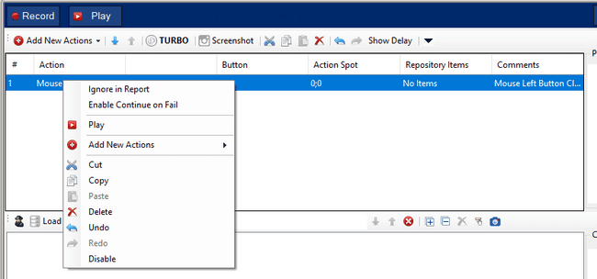

When a mix of “Ignore in Report”/”Consider in Report” steps is selected, user gets the option to “Ignore in Report”/”Consider in Report” in the context menu on right click. “Ignore in Report” will ignore all the selected steps and “Consider in Report” will consider all the selected steps see the figure shown below.

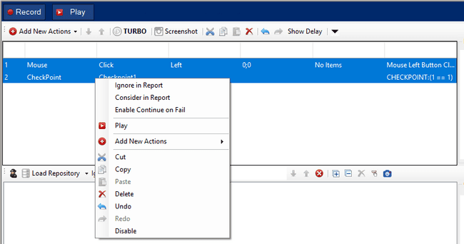

Undo and Redo can also be performed on the enabling and disabling steps.



When any step is ignored in steps, Result will show below “…” in status and [I] will be shown in that step.

Report when some steps are ignored and some are considered see the figure shown below,

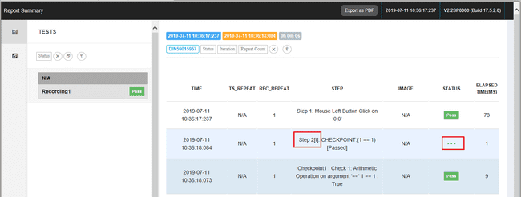

When some steps are marked as “Ignore in Report”, Report will display pass irrespective of the status of ignored steps see the figure shown below.

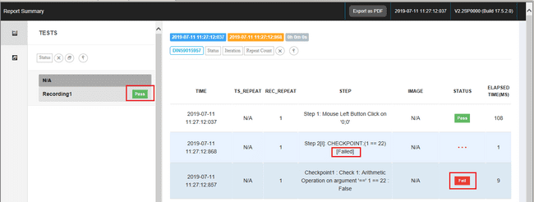

## Batch setting/canceling about image saving settings

User can set / cancel the image save settings.When setting to save all the steps that passed the test case execution, Use the buttons in the Save Image on Pass field on the Advanced tab of Project Settings (see figure below).

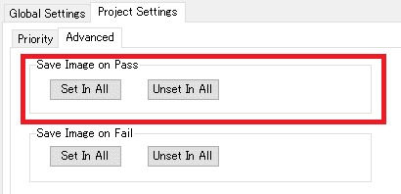

User selects one of the buttons in this field, If user click the [OK] button in the displayed dialog, this setting applies to all recordings that exist in the currently selected project.

If user click the [Set In All] button in the Save Image on Pass field, a confirmation dialog of "Set all steps to save image on Pass." message will be displayed. If you click the [OK] button, the setting to save the image when the test case passes will be applied to all recording steps. The batch save setting is set according to the following rules.

* + - * F → F/P
      * F/P → F/P
      * P → P
      * － → P

If user click the [Unset In All] button in the Save Image on Pass field, a confirmation dialog of "Unset all steps to save image on Pass." message will be displayed. If you click the [OK] button, the image will be displayed when the test case passes. The save setting is removed from all recording steps. The batch release setting is set according to the following rules.

* + - * F → F
      * F/P → F
      * P → －
      * － → －

On the other hand, if user want to set the image save settings for all test cases that failed to execute the test case, use the button in the Save Image on Fail field on the Advanced tab of Project Settings (see the figure below).

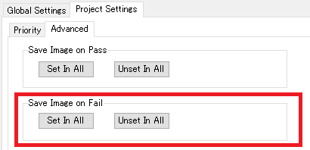

If user click the [Set In All] button in the Save Image on Fail field, the confirmation dialog of "Set all steps to save image on Fail." Is displayed. If you click the [OK] button, the image will be displayed when the test case fails. The save settings apply to all recording steps. The batch save setting is set according to the following rules.

* + - * F → F
      * F/P → F/P
      * P → F/P
      * － → F

If user click the [Unset In All] button in the Save Image on Fail field, a confirmation dialog of "Unset all steps to save image on Fail." Is displayed. If you click the [OK] button, the image will be displayed when the test case fails. The save setting is removed from all recording steps. The batch release setting is set according to the following rules.

* + - * F → －
      * F/P → P
      * P → P
      * － → －

Once user selects this option and click on Ok button, this setting is applied for all recording present in a particular project.

Once user plays the recording with image save setting, the screenshots of the desktop will be taken after execution of each step. The screenshots taken are saved in Report folder at physical location of the concord project.

The screenshot taken will be linked to each pass step of the recording and user can see this on report see the figure shown below:

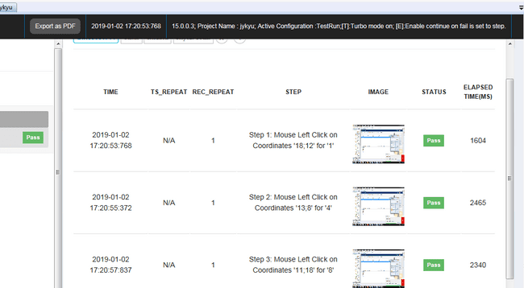

User can click on the image linked in each step to check the image captured after each step which is passed see the figure shown below:

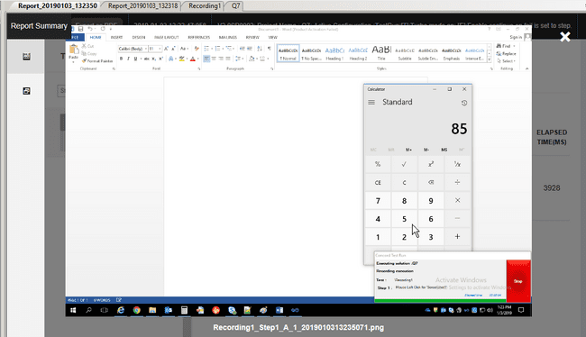

**If save image setting is enabled in Project Settings then**

1. If step is not image based concord will save desktop image and same will be shown in report for passed steps.
2. For image base steps concord will show below stitched image even on pass case.

* **Main step**
* **Checkpoint step**

1. For checkpoint sub steps, pass image will get display in report even step is not image base see the figure shown below:

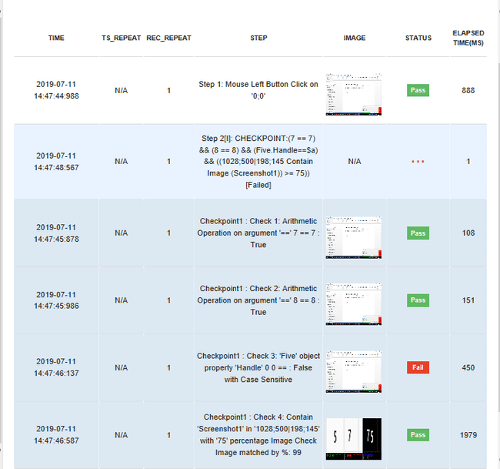

## Replace Image

“Replace Image” option is used to replace runtime image with the captured image when an image-based action fails. If a user has captured /selected an image and attached to an image-based action. User comes to know that the image captured by the user at the time of script creation is not the same as at the time of execution. If in this case user wants to get the image at the time of execution as the expected image, then user can use this feature of Replace Image.

Note: These options will be specific to the recording. i.e. When a user performs the replace operation then it will be applied to the specific recording which is opened in the report.

User can replace image in the following three ways:

### Replace All

When any image based action gets failed, user can see an option for Replace All on the top right corner of the report as shown in below fig:

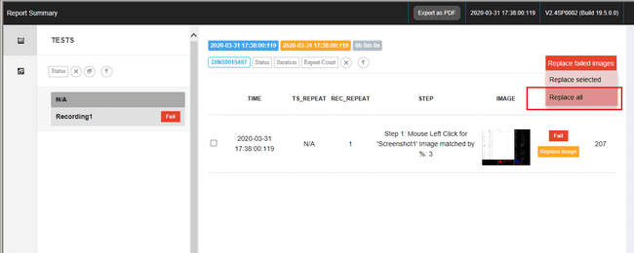

When user selects the option of Replace All then in all the failed image based actions, the static image captured by user while creation of script get replaced by the runtime image captured at execution time. This change in images will be saved in repository as well.

The dialog appears for confirmation as shown below:

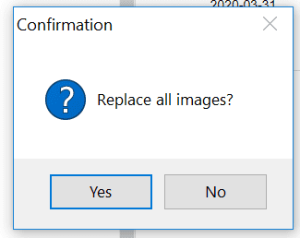

If user select yes for the above dialog, the static/captured images will be replaced by the runtime/execution images with the message as shown in below:

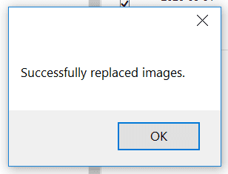

User can now go to repository and check if the images are replaced in repository as well.

### Replace Selected

When any image based action gets failed, user can see option for Replace selected on the top right corner of the report as shown in below fig:

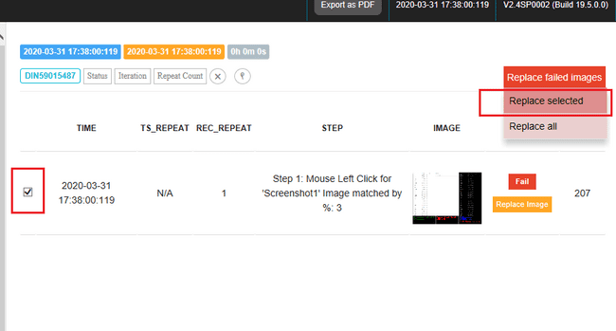

When user selects the option of **Replace Selected,** user needs to select the checkboxes present at each row in order to replace the image of selected steps. On Replace selected the static image captured by user while creation of script get replaced by the runtime image captured at execution time only for those steps in which user has checked the checkboxes.

The dialog appears for confirmation as shown below:

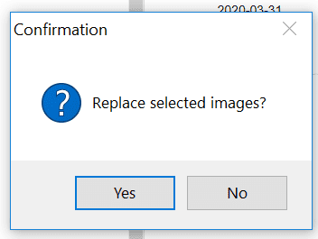

If user select yes for the above dialog, the static/captured images will be replaced by the runtime/execution images with the message as shown in below:

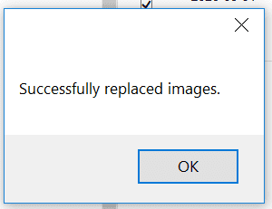

User will be able to see the change in repository only for those images which was linked to the steps checked by the user in the report.

### Replace Image on step

When any image based action gets failed, user can see option for Replace image on each step along with Fail text as shown in below fig:

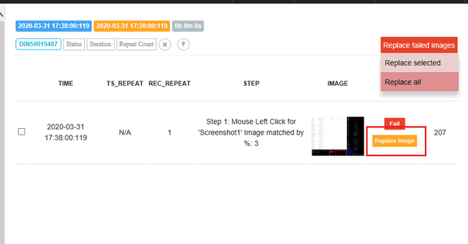

When user selects the option of **Replace Image on step,** this will be applicable to only the current step where this option is present, no other step/action will be affected by this option. On **Replace Image on step** the static image captured by user while creation of script get replaced by the runtime image captured at execution time for that particular step only.

The dialog appears for confirmation as shown below:

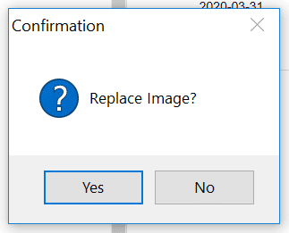

If user select yes for the above dialog, the static/captured images will be replaced by the runtime/execution images with the message as shown in below:

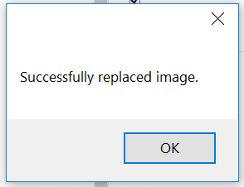

Points to Remember:

* + - 1. If user view an old report and the target image has been deleted or renamed, the image replacement will fail.
      2. If user tries to replace image which is present in multiple step then the issue may occur.
      3. If user opens the report in a browser and these operations can’t be performed.
      4. If a WaitFor Exists & NotExists is failed then the whole desktop image will be taken as runtime image. In this case Replace option won’t be displayed.
      5. If Exists & NotExists checkpoint is failed then the whole desktop image will be taken as runtime image. In this case Replace option won’t be displayed.
      6. If image contain & Image compare checkpoint uses ‘Desktop’ in the repository and the checkpoint fails then the runtime image will be taken as whole desktop, in this case also replace option won’t be displayed.
      7. If image contain & Image compare checkpoint uses any object in the repository and the object is not identified during runtime then the replace option won’t be displayed since the runtime image will display concord error string.
      8. If a mouse action linked with image (Without coordinates) fails then the runtime image will be taken as whole desktop, in this case also replace option won’t be displayed.

# Smart Path Object Identification (Profiles & Path Editor)

Smart Path functionality is to identify the target objects using strong mechanism. In many scenarios object identification is not possible with default properties “Automation ID”, “Text” and “Control type”. In such a case user can customize object search path using smart path editor.

## Profile settings

Profiles:

Profile in concord is used to set priority of individual control’s property. As per priority of control’s property, SmartPath is created. SmartPath is used to find control at the time of script play.

Note: Modality specific default profiles are available. User can add or modify those profile as per need. **Navigation:**

1. Go to TestSuite and click on “Global Project Settings” button in below screenshot.

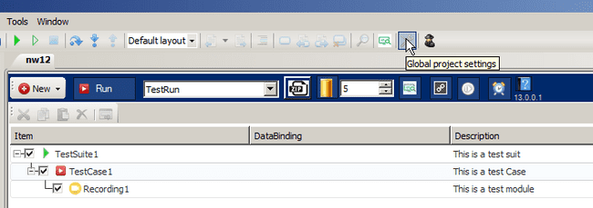

1. Go to “Project Settings” tab. Four profiles will load and default profile name is “DefaultProfile” see the figure shown below.

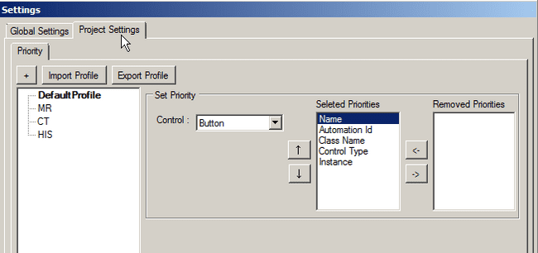

1. Right click on any profile will display 3 options: Default, Rename and Delete see the figure shown below
   1. Default: Set current selected profile as default. Default profile will appear in bold letter.  
      As per selected default profile and its priority settings, smartpath will be generated. In below screen shot default profile is set to “CT” so smartpath will be generated with settings of “CT” profile.
   2. Rename: Rename current selected profile name.
   3. Delete: Delete current selected profile.

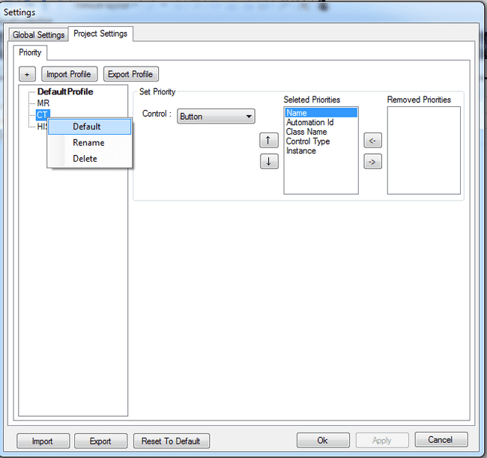

1. Selected profile’s priority will display on right side see the figure shown below. Select any control from Drop down and set priorities with help of Up and down button or Remove priorities with help of Left and Right button.

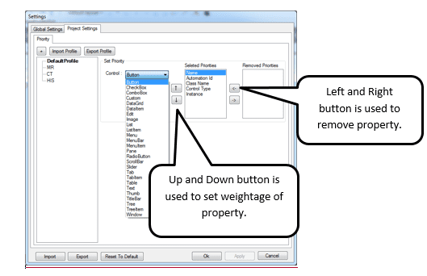

1. Set property weightage of different controls using Up and Down button. Priority of property which is present first will be given highest weightage while smartpath generates.   
   see the figure shown below, Button smartpath will be generated using “Name” property because “Name” property is having highest weightage if button control is not found using “Name” property then concord will use other properties (Automation Id, Class Name, Control Type, and Instance) as per weightage to find Button control and creates SmartPath.

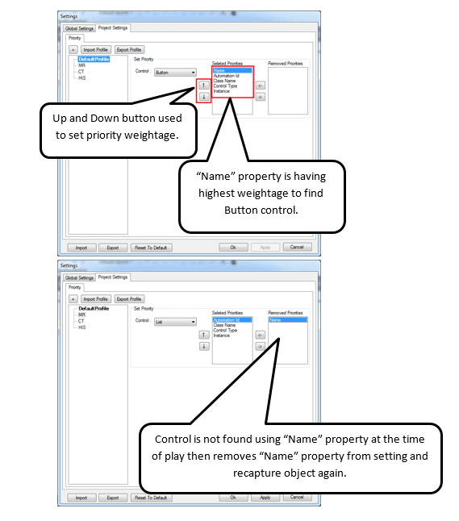

1. Remove priority using left and right button which will not be used to generate smartpath.  
   see the figure shown below, Automation Id and Instance will not be used to generate smartpath for Button control.

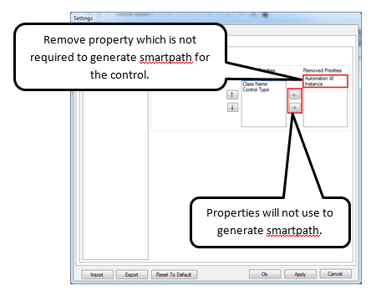

1. Add new profile using “+” button. Set priorities of newly added profile as per point 4 to 6. User can create their own profile and make it to default and use it for their project see the figure shown below.

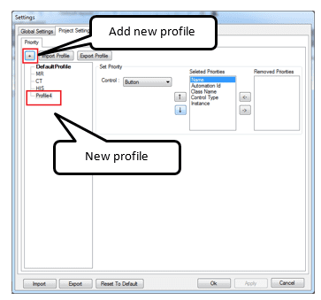

1. Export Profile: User can export selected profile into .zip file.

see the figure shown below, profile “CT” will export on click of “Export Profile” button.

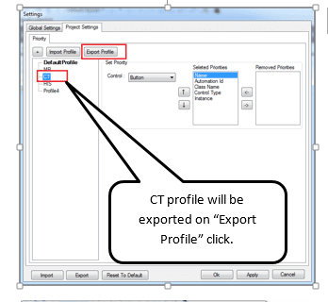

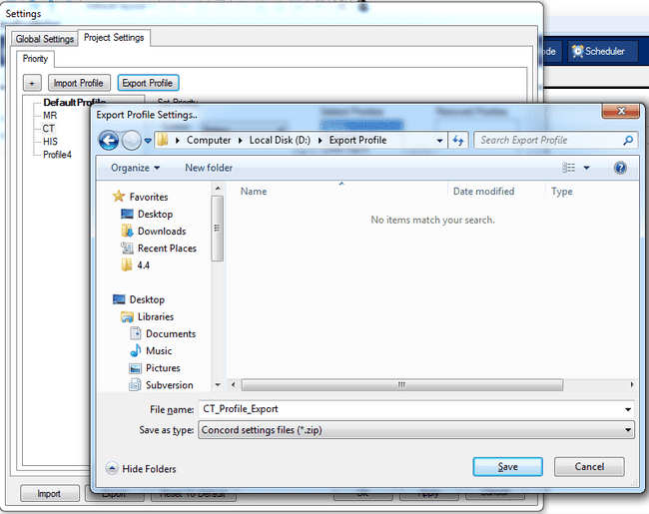

1. Import Profile: User can use import profile option to import already exported profiles into project see the figure shown below.

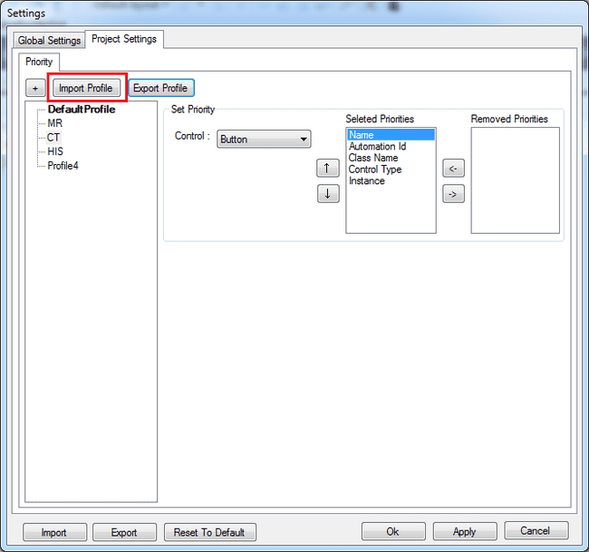

Select profile to import from “Import Profile Settings” dialog see the figure shown below.

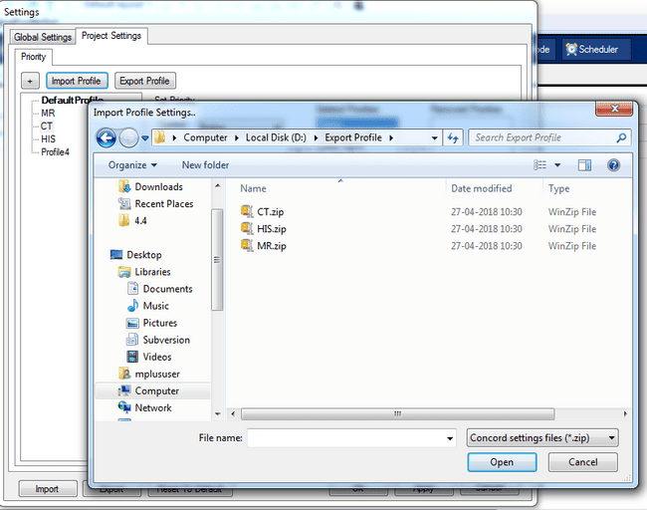

If import file contains already present profile name then user will be asked option of overwrite existing file or rename import file name.

If Overwrite option chooses then “CT” profile data will be overridden by import file data see the figure shown below.

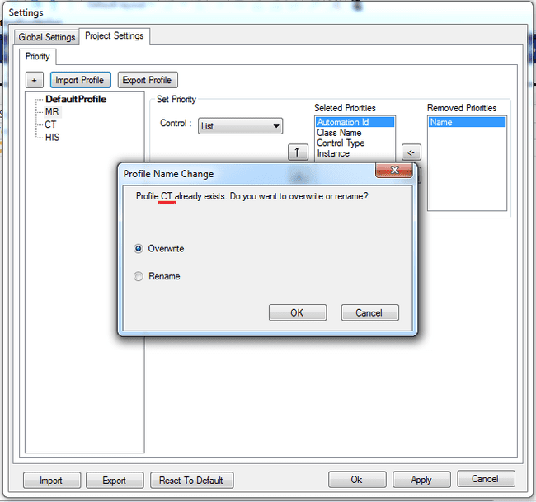

If Rename option chooses then user will be asked to enter new profile name. On click of “OK” button new profile will be added into settings see the figure shown below.

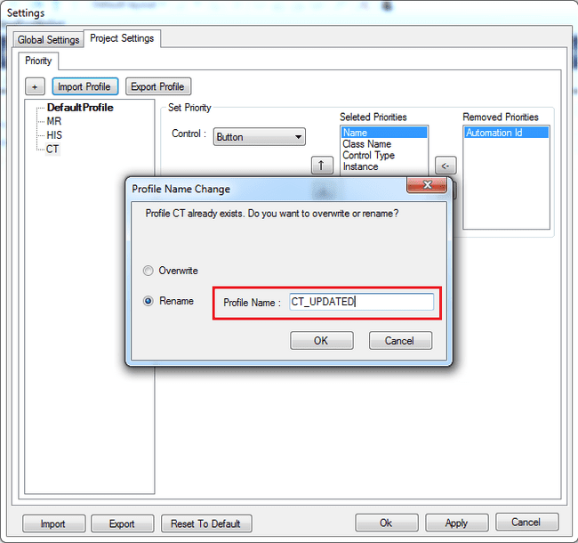

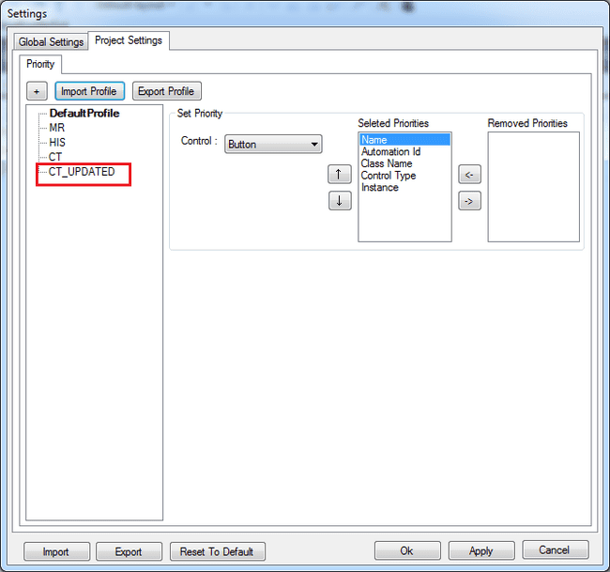

**When and how to use with example:**

You can find the following application at “%CONCORDHOME%\devutil\TestApp\TestApp.exe”

Application: **TestApp** Control: **Button**

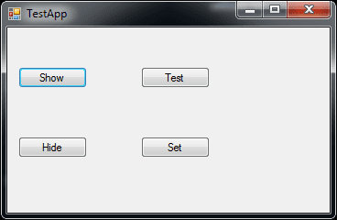

Priority for button for profile “DefaultProfile” is set as per below screenshot. “DefaultProfile” settings will use to generate smartpath.

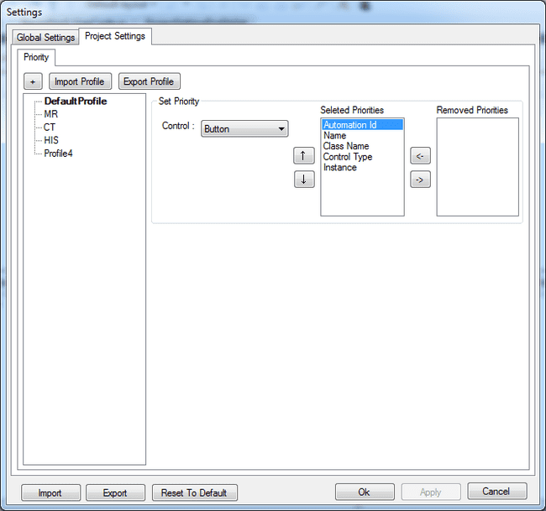

If clicks “Show” button 2 dynamic buttons (Test and Submit) appears on application.

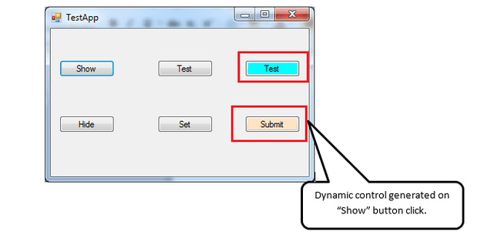

Add dynamic button “Submit” into repository and check smartpath see the figure shown below.

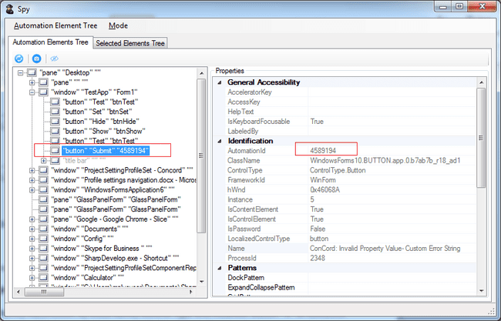

As per priority of button in profile highest priority is given to “Automation Id” followed by Name, Class Name, Control Type and Instance to generate smartpath hence smartpath of “Submit” button generates as below.

**/Window[@AutomationId="Form1"]/Button[@AutomationId="4589194"]**

Button “Submit” of TestApp application is uniquely found using highest weightage priority which is “Automation ID” only hence other priorities are not used in smartpath generation.

Now click on “Hide” button to remove dynamic buttons from application and invoke them by clicking on “Show” button.

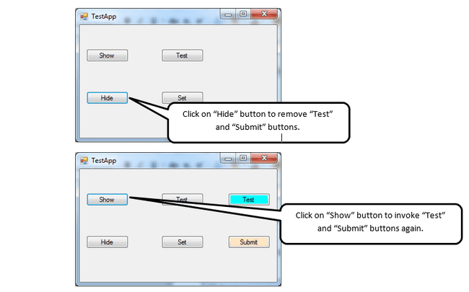

By doing this “Automation Id” of button will change as this controls are dynamic controls. see the figure shown below of SPY.

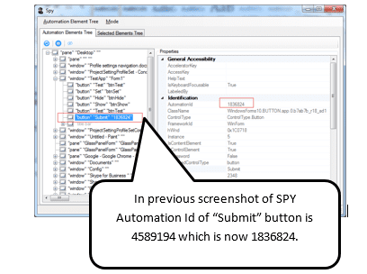

Smartpath for same is

**/Window[@AutomationId="Form1"]/Button[@AutomationId="1836824"]**

In this scenario, Button “Submit” Automation Id property is changing every time button is invoke again and “Automation Id” property is used in smartpath to find this control.

If “Automation Id” is changed then at the time of play control will not be clicked. In this case user has to remove “Automation Id” property in settings and need to set other priority to highest weightage (which should not be dynamic and needs to be static) to make this control work.

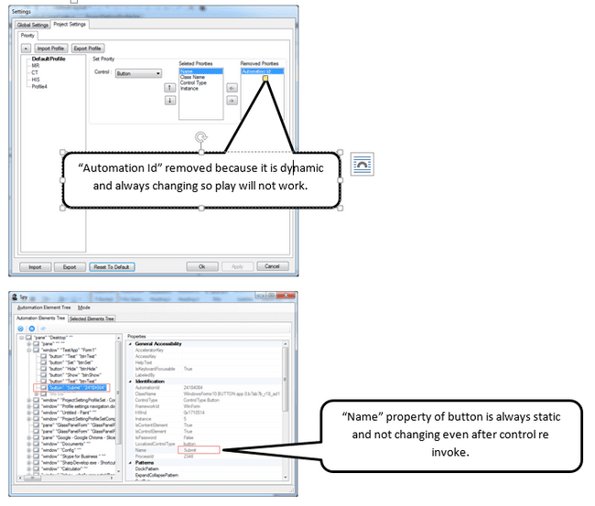

As per priority changed highest weightage is now given to “Name” property followed by Class Name, Control Type and Instance. Smartpath generates as below.

**/Window[@AutomationId="Form1"]/Button[@Name="Submit"]**

In this case, Smartpath of button “Submit” generates as per “Name” property which is static for that control and not changing even if control is invoke again so at time of play button will be found using “Name” property and it will always work even if “Automation ID” property is changing because it is not used to find “Submit” button at time of play.

**Note: If user is adding any child element and if its immediate parent is not needed to find same then smart path will not generate (It is to optimize search logic). If smart path is not present and user wants to use that element for automation then same can be updated by adding element again from SPY. No need to delete and add again element. Only pre-condition is correct profile should be selected.**

**If Concord is not able to find element then please check if smart path is generated correctly or not and correct profile is selected and profile setting is correct.**

### Optimization to Smartpath:

**To improve the performance of the tool, while recording/ hovering, we have changed the approach of capturing object information.**

**Earlier Smartpath was getting captured across the object hierarchy, which was reducing the performance during hover.**

**Now, Smartpath of object is generated only for object which is captured through SPY / recorder and top most parent of captured object.**

For example, in the sample application “TestApplicationWinform.exe”, available in $CONCORDHOME/Devutils

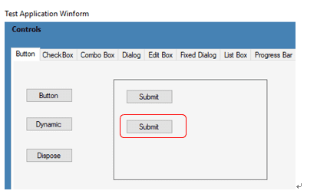

* Smartpath is being captured for “Submit” button object whose hierarchy is like,

TestApplicationWinform **(**Window control**) 🡪 Button (**Tab control**) 🡪 Pane (**Pane control**) 🡪 Submit (**Button control**)**

For above hierarchy, Smartpath will generate **ONLY** **for** “TestApplicationWinform ” window object and “Submit” button object because, “Submit” button is captured object and “TestApp” is topmost object of “Submit” button.

* SmartPath will not generate for “Tab” and “Pane” control present in hierarchy.
* If user wants to generate “Tab” and “Pane” control’s smartpath than user needs to recapture object by selecting them in SPY and add to repository or highlight object in recorder and click on it will generate smartpath of already present object.

## Path Editor

Path Editor is used for updating search path of individual objects. User can select / unselect any properties and its value while update the path in path editor. Path editor can be invoked in two ways. One is through SPY and another is from IDE.

### Path editor through SPY:

Path Editor is in the 3rd tab of SPY. User needs to click on any object in “Selected Elements Tree” and then click on Path Editor Tab to display the path hierarchy.

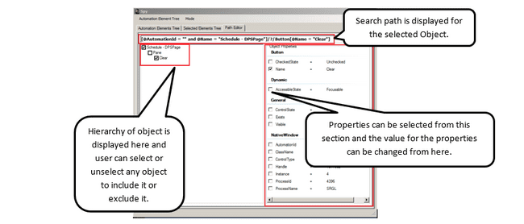

If search path of selected object is not generated then message will display in red highlight see the figure shown below.

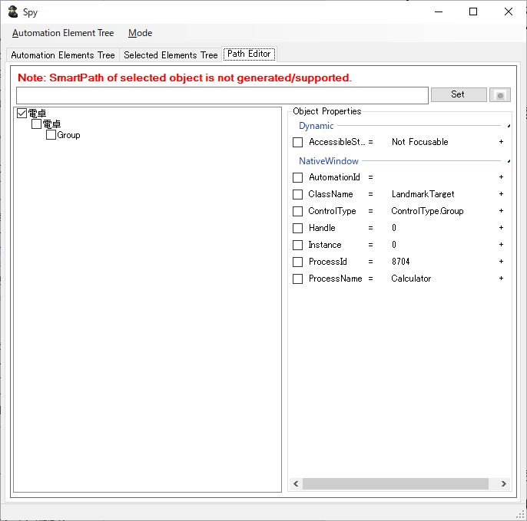

**Note:   
When specifying an instance property,  
 - Be sure to select the immediate parent.  
 - Be sure to select only the ClassName or ControlType property. Do not select any other properties.**

### Path editor through IDE (Inline Path Editor)

Path Editor is used for updating search path of individual objects. User can select / unselect any properties and its value while update the path in path editor. Path editor can be invoked in two ways. One is through SPY and another is from IDE on button click.

Inline path editor will be invoked through button click. See the below image for reference:

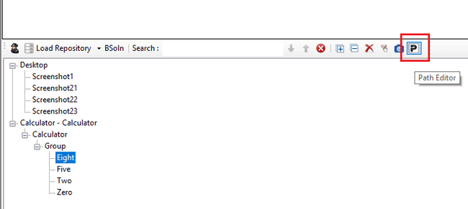

On click of above mentioned button, a modal dialog window will be popup for Inline Path Editor

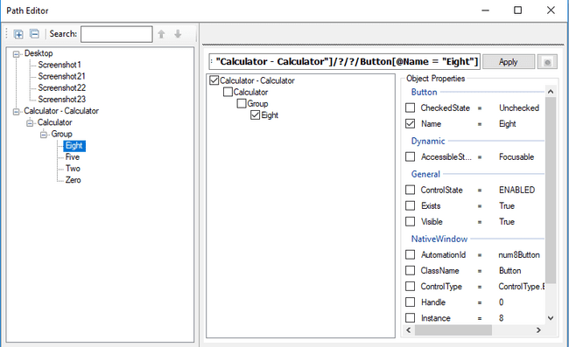

User needs to click on any object in the loaded repository, then Path Editor Side it will display the path hierarchy of selected object. At the same time if user wants to see the search path of another object, he needs to select that object from the loaded repository in Path Editor window.

If search path of selected object is not generated, then message will display in red highlight see the figure shown below.

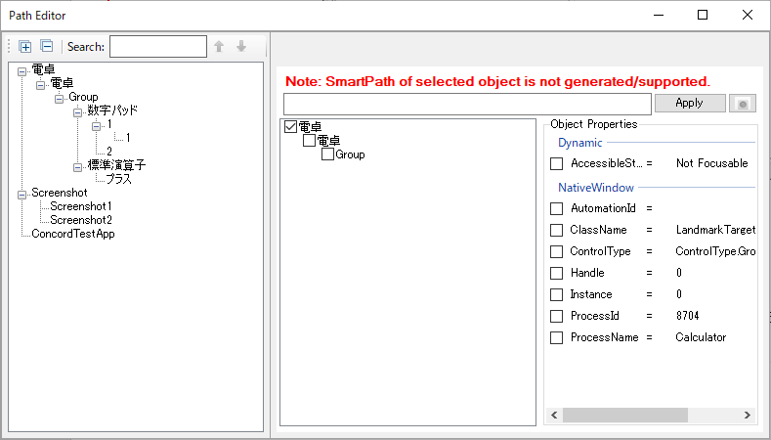

Points to remember while using inline path editor,

1. To update search path changes user needs to click on “Apply” button.
2. At least one property should be selected before applying the path.
3. Search path of one control can be updated at a time.
4. Updating path for parent object will not be reflected automatically for the same object if user selects child object.

User can highlight saved repository item whose smart path has been created successfully, See the figure shown below:

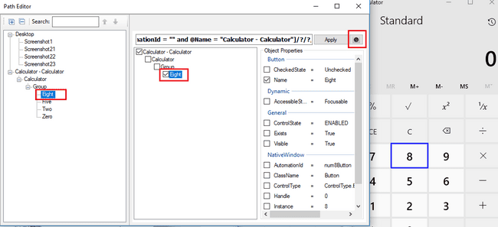

If selected item could not be found in 30 second, Spy will see the figure shown below with error message.

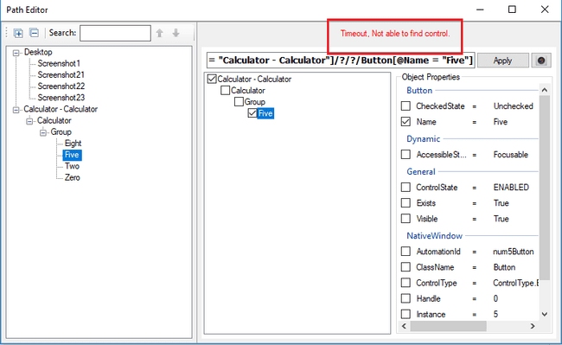

When user will try to open “Inline Path Editor” Window for link repository, a warning message will popup that any changes in search path of link repository will reflect to all solutions as well wherever this repository is linked.

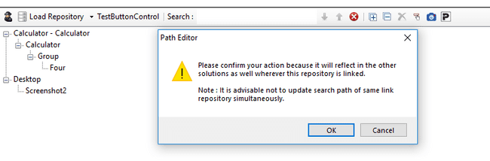

### Support Regular Expression (Regex) in Path Editor:

Regular expressions can be used to search and manipulate text. User has to provide pattern to any property of an object to find object which matches specified pattern at the time of play. The pattern defined by the regular expression may match one or several times or not at all for a given string.

**Example of smartpath with use of equal (=) operator:**

/Window[@AutomationId = "frm"]/Tab[@AutomationId = "tabControl1"]/?/?

/Button[@Name = "Submit" and @AutomationId = "button2"]

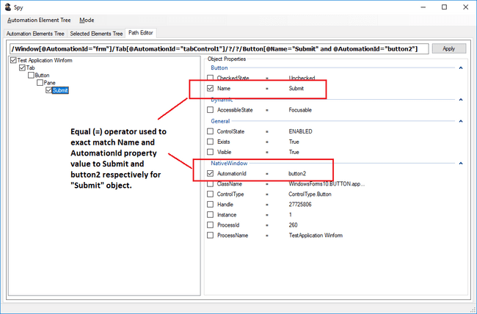

**Example of smartpath with use of tilt (~) operator:**

**Regex use with constant string value:**

/Window[@AutomationId = "frm"]/Tab[@AutomationId = "tabControl1"]/?/?

/Button[@Name ~ "Submit" and @AutomationId ~ "button2"]

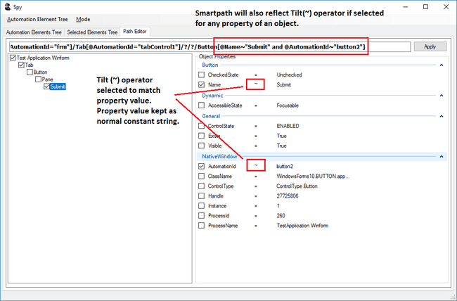

**Regex use with pattern string value:**

/Window[@AutomationId = "frm"]/Tab[@AutomationId = "tabControl1"]/?/?

/Button[@Name ~ "Submit" and @AutomationId ~ "\w+\d"]

In above example of Regex, object “Button” will be identified with two properties. One is “Name” which will match Regex pattern “Submit” and another is “AutomationId” which will match Regex pattern “\w+\d”.

For Name, Regex will work as

Submit matches the characters Submit literally (case sensitive)

For AutomationId, Regex will work as

\w+ matches any word character (equal to [a-zA-Z0-9_])

+ Quantifier — Matches between one and unlimited times, as many times as possible, giving back as needed

\d matches a digit (equal to [0-9])

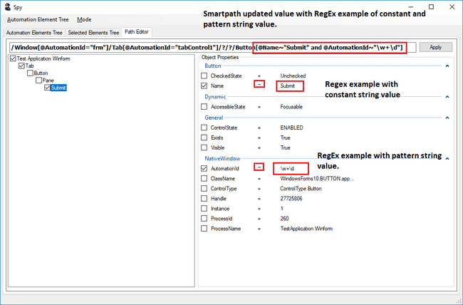

User has to check any property to update operator value either equal (=) or Tilt (~) from drop down. To reflect changes in smartpath click on “Apply” button.

**Information:**

Use below link to check Regex pattern.

<https://regex101.com/>

### Regular expression Evaluator:

Button “+” is present to right of Property value. This button is enable if the operator ~ is selected for that property, otherwise this button is disabled see the figure shown below.

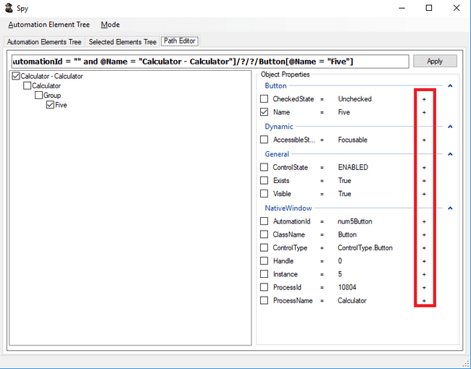

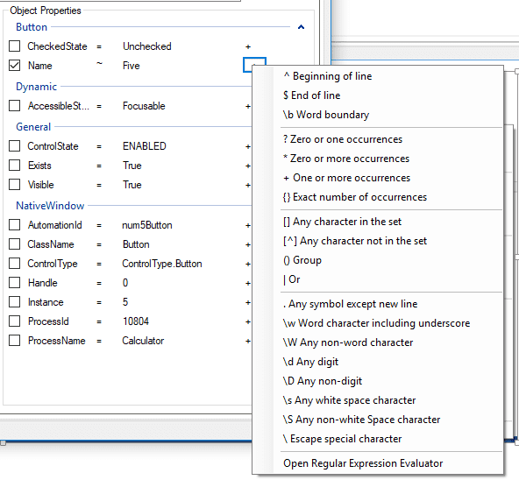

Button (+) is used to generate Regex. Clicking on button will display context menu shown above,

Selecting any option will update property value. That means,

If value of property is “**Five**” and user select “^ Beginning of line” from context menu, then value of property will become “**Five^**” see the figure shown below. The sign gets appended to existing property value.

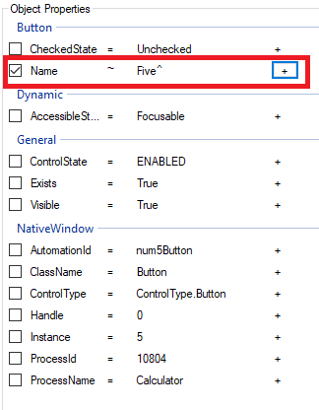

If user click on “Open Regular Expression Evaluator”, help dialog gets display see the figure shown below,

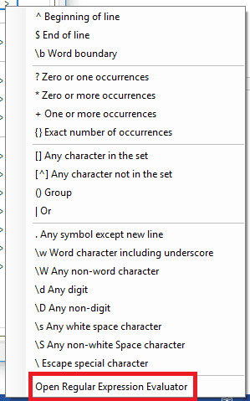

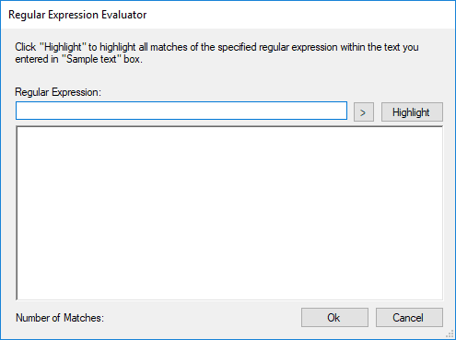

User can test the regular expression here. “>” button will display same context menu see the figure shown above.

Provide some text in multiline text box and write some regex expression in Regular expression text box. It is case sensitive. Click on highlight button, if given text is matching with regex then it will highlight the text, see the figure shown below,

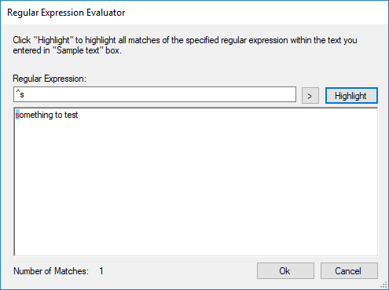

Clicking on ok will update property value with regular expression present in Regular expression text box.

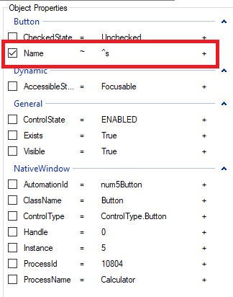

## Using Smart Path Variables

Variables can be used in smart paths. Smart path variable settings are set from the PathEditor screen.Select any property from Object Properties to set the variables reflected in the smart path.

When you select the setting value of the object, a pull-down list is displayed, and you can add new variables by selecting "As New Variables". Variables handled by smart paths are treated as repository variables and managed separately from variables used in recording.

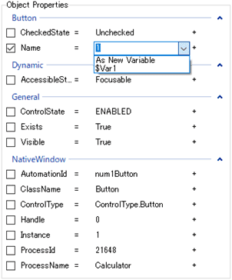

### Add/Remove Repository Variables

Pressing the Variables button at the top of the repository view displays the Variable Operations dialog for editing repository variables.



【Variable Operations Dialog（Repository）】

The Variable Operations dialog for variables in the repository allows you to add, remove, rename, and change settings for variables. However, variables used for repository smart paths cannot be deleted.

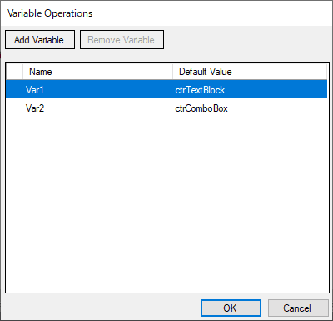

### Use variables in coding

Variables used in recordings can be used as repository variables.

The variable in the recording and the variable in the repository must have the same name in order to be used. If there is a variable with the same name, the value of the recording variable will be used for smart path, otherwise the Default Value of the repository variable will be used.

Press the Variables button on the right of the step view to display the Variable Operations dialog for editing recording variables.



【Variable Operations Dialog（Recording）】

The Variable Operations dialog for recording variables allows you to add, remove, rename, and change values for variables. However, variables used in recording cannot be deleted.

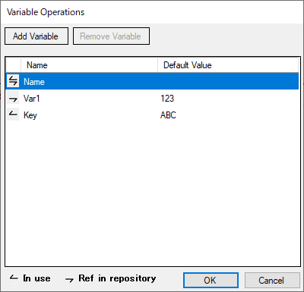

Each variable is preceded by an icon representing a reference.

|  |  |
| --- | --- |
| Icon |  |
|  | Variables used in Recording |
|  | Variables referenced by repository variables |
|  | It is used in Recording,  Variables that are also referenced by repository variables |

## Inherit the changes of smart path to descendant controls

Changes to the smart path of a parent object can be propagated to child objects.

1. Select the parent object and open the Path Editor.

2. Change the smart path (e.g. Name) to be changed and click the Set button.

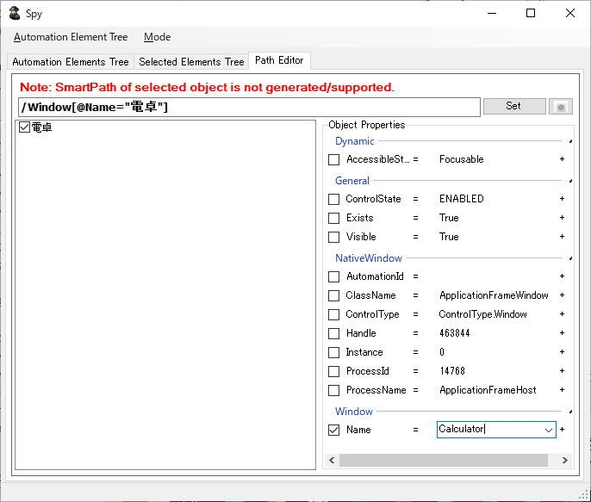

3. Select “Yes” when the propagation confirmation screen is displayed.

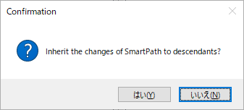

4. If the save is successful, the following save notification dialog is displayed.

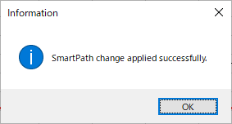

Select the child object and open the Path Editor to see that the parent object's smart path changes have been reflected in the child object.

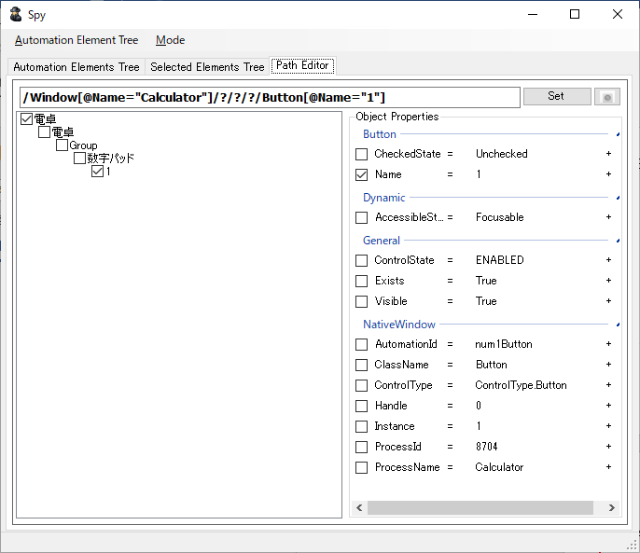

# Import/Export Recording and Recovery

Use to import/export recording or recovery from current concord solution and use it in any other concord solution. It will help to use same recording or recovery in multiple concord project without recreating recording and recovery in individual project with same steps. When user exports any recording, all the related files of the recording along with the linked recovery scenarios are exported and the same are imported in Testsuite and Recovery. User can import/export recovery scenarios also.

## Export Recording and Recovery

Export recording or recovery file and all attached repository items with it. Single/multiple recording or recovery can be exported at a time. Right click on “recording” and “testcase” will display menu with export option see the figure shown below.

Single Recording/Recovery can be exported from the “TestSuite” and the “ProjectView “.

1. Export from TestSuite/Recovery

Open testsuite and right click on any recording will display “Export” option.

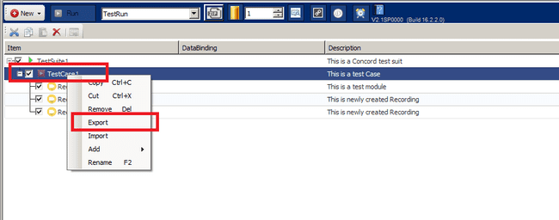

On “Export” click Export Recordings dialog with all recording names will display. User can select recording/s which he/she wants to export. See the figure shown below,

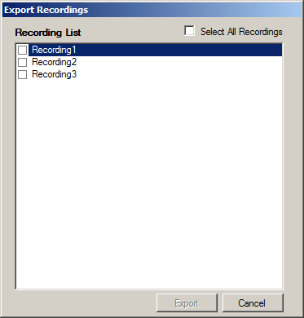

From above dialog select single or multiple recording/s and click on Export will open see the figure shown below,

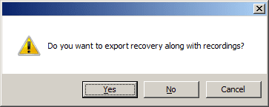

If user clicks “Yes”, then selected recording/s with its linked recovery files gets exported at given location. If user clicks on “No”, then only selected recording files gets exported and save with extension “.crzip”. Every selected recording will create separate .crzip file. For selection of path for exported file see the figure shown below,

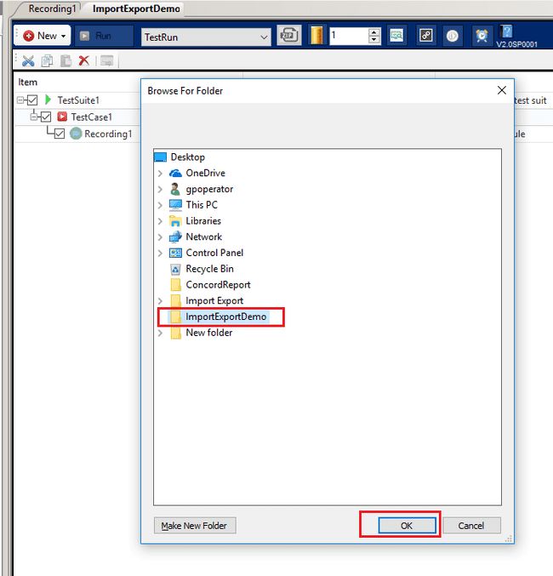

After click on “OK”, confirmation dialog appears for option to remove unused/unnecessary image files from current project as below,

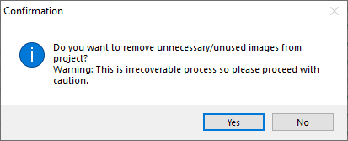

If you click on “Yes”, all the image files which are not linked anywhere in the project i.e. those images whose entry is not present in Desktop.tafcomp file but they are present in physical location (Desktop folder) will be removed. If you click “No”, the Export process will start without this clean-up.

After above confirmation dialog, “Exporting Files” wait dialog appears and export process starts. All export process related details will appear in below wait dialog.

Abort option is used to abort export process.

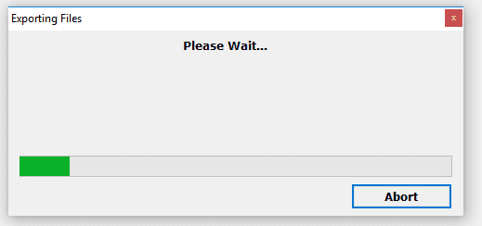

After export completes Report dialog appears to display failure or successful message of export process.

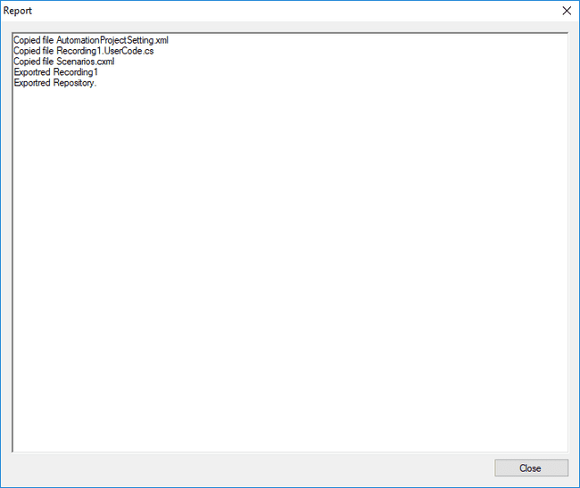

File is saved with naming convention “Recording1_15.0.0.1.crzip” at specified location.

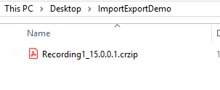

Similarly if user export Recovery file then it is saved with name “Scenario1_15.0.0.1.cszip”.

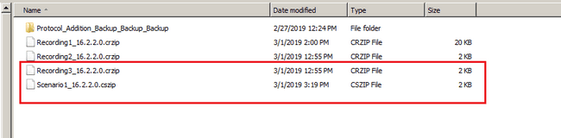

NOTE: Do not rename “Recording1_15.0.0.0.crzip” file name as it is used for backward conversion.

Similarly, from Recovery Mangement IDE on right click of any Recovery Scenario will display “Export” option.On “Export” click selected scenario/s recovery file and linked repository item will export and save with “.cszip” extension.

This “.crzip”/”.cszip” file will save with proper naming convention and user should not change this name.

If “Recording1” is exported and current concord version is “15.0.0.0” then “.crzip” file name will be “Recording1_15.0.0.0.crzip”.

If “Scenario1” is exported and current concord version is “15.0.0.0” then “.cszip” file name will be “Scenario1_15.0.0.0.cszip”.

Version is used to check backward compatibility of exported recording/recovery file.

Example:

If “Recording1”/ “Scenario1” file have mouse click action and button “5” of “Calculator” application is added as repository item in mouse click step, button “5” repository item and its parent repository items will be exported on export.That is “Calculator.tafcomp” repository file with items button “5” and all its parent repository item will export see the figure shown below.

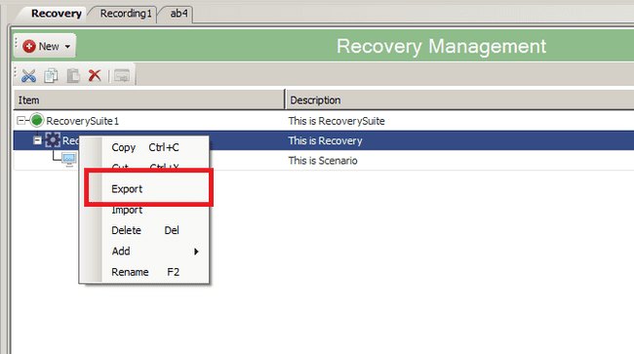

On “Export” click, below Export Scenarios dialog will open to select single or multiple scenarios to export.

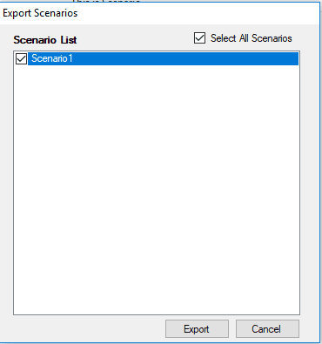

On export click below dialog will open to browse folder to save exported scenarios.



On “OK” click, “Exporting Files” wait dialog appears and export process starts. All export process related details will appear in below wait dialog.

Abort option is used to abort export process.



After export completes Report dialog appears to display failure or successful message of export process see the figure shown below.



Similarly if user export Recovery file then it is saved with name “Scenario1_16.4.5.0.cszip”.

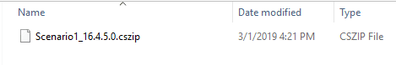

NOTE: Do not rename “Scenario1_16.4.5.0.cszip” file name as it is used for backward conversion.

1. Expot from ProjectView

Select the Recording/Scenario folder you want to export in the project view, and select [Export] from the context menu. After that, the folder selection dialog will be displayed in the same way as when exporting from the test suite screen, and the procedure will be the same.

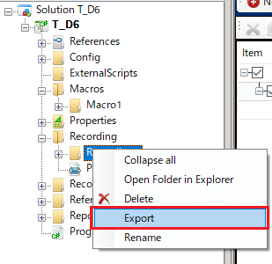

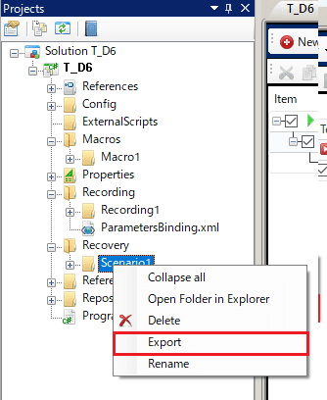

## Import Recording and Recovery

Import recording or recovery file and all attached repository items with it. Single recording or recovery exported file can be imported at a time. Right click on TestCase of TestSuite to import recording or right click on Recovery of RecoverySuite to import scenario file.

Single Recording/Recovery can be exported from the “TestSuite” and the “ProjectView “.

**Import from TestSuite**

Open “TestSuite” and right click on any “TestCase” will display “Import” option see the figure shown below.

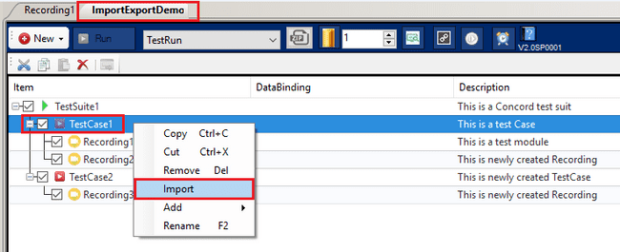

Similarly, open “RecoverySuite” and right click on any “Recovery” will display “Import” option see the figure shown below.

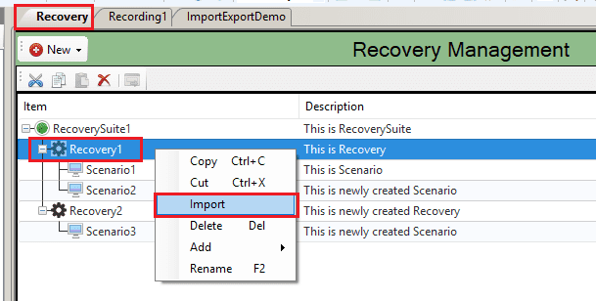

On “Import” click, File dialog prompts to select exported “.crzip” file of recording and “.cszip”for recovery.

Select recording/recovery “.crzip”/”.cszip” file from location and click “Open” will start importing recording/recovery files.

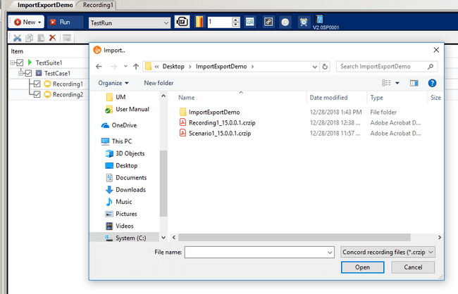

On “Open” click, wait dialog appears and import process starts. All import process related details will appear in below wait dialog.

Abort option is used to abort import process. In case of abort import process current concord project may not work properly.

If import aborted then user need to take backup solution of current open concord project. Path of backup solution will display in Report dialog.

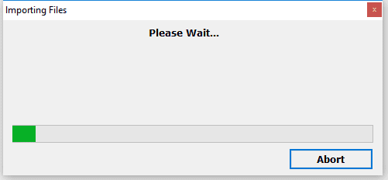

If import failed or aborted, then take backup solution and close current open concord project.

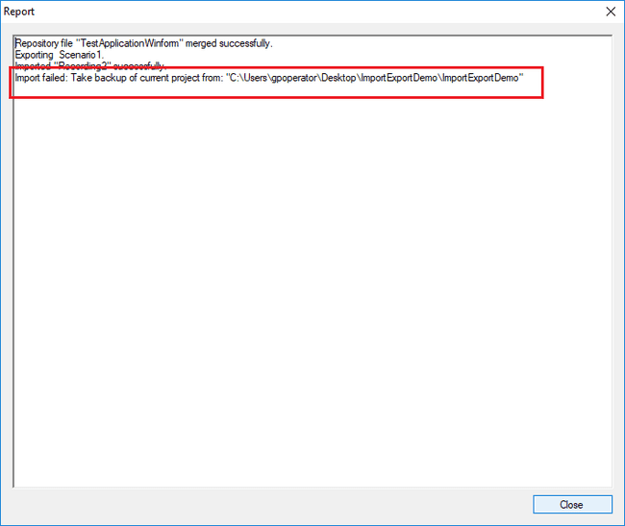

Any failure or successful import process messages will display in Report dialog as shown in above screenshot.

**Import Recording:**

It imports recording files, repository items linked in recording and recovery scenario files linked with recording. If no recovery scenario file is linked with recording then scenario files will not import.

If recording file which is importing is already present in current project, then it will rename imported recording file name.

Example:

If current project have “Recording1” file present and imported “.crzip” also contains “Recording1” file then it will increment file name using auto number and rename imported recording file name to “Recording2”.

**Import Recovery:**

It imports recovery files and repository items linked in recovery. It will not import recording files in import of recovery.

If scenario file which is importing is already present in current project then it will rename imported scenario file name.

Example:

If current project have “Scenario1” file present and imported “.cszip” also contains “Scenario1” file then it will increment file name using auto number and rename imported scenario file name to “Scenario2”.

**Import Repository:**

It imports repository files into current concord project. All import repository items will merge into current concord project repository.

Example:

If current concord project have “Calculator” repository and import “.crzip” file also contains “Calculator” repository and both file are similar then both files will be merge into current project repository.

If repository is not same then imported repository file will be added as new repository file in current project. Name of imported repository file will change to “Calculator1” because “Calculator” repository file name is already present in current project.

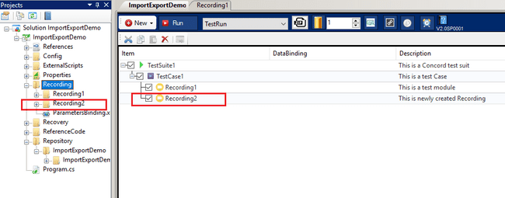

After successful import of recording, scenario and repository, files will be added in Recording, Recovery and Repository folder in project explorer and reference of recording, scenario files will be added under TestSuite and Recovery respectively.

**Note:** On each import .cszip or .csconfig from any location it will always create backup of solution with **“SolutionName_DateTime”** at same location.

**Impot from ProjectView**

Select the Recording/Recovery folder in the project view and select [Import] from the context menu.

After that, the same file selection dialog as importing from the TestSuite will be displayed, and the procedure will be the same.

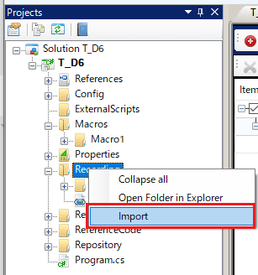

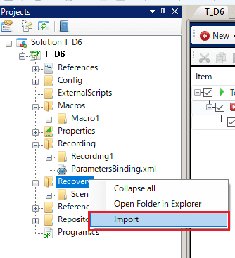

## Import/Export with Recording Wise Repository

**Export Recording:** We can export single/multiple recordings at a time (in one go) with different repository.

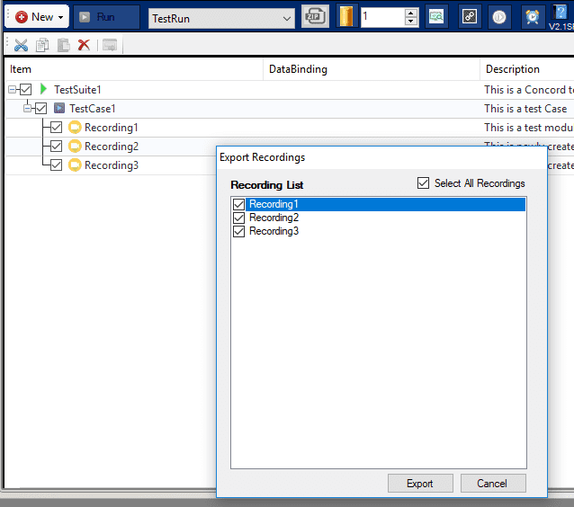

We have three recordings Recording1, Recording2 and Recording3, we are exporting all three recordings in one go see the figure shown above.

So whatever the Repository is linked with Recordings it will export that.

Recording1 -> TesApplication repository

Recording2 -> Test1 repository

Recording3 -> no repository added.

Report of Export will show the below details of repository as well see the figure shown below.

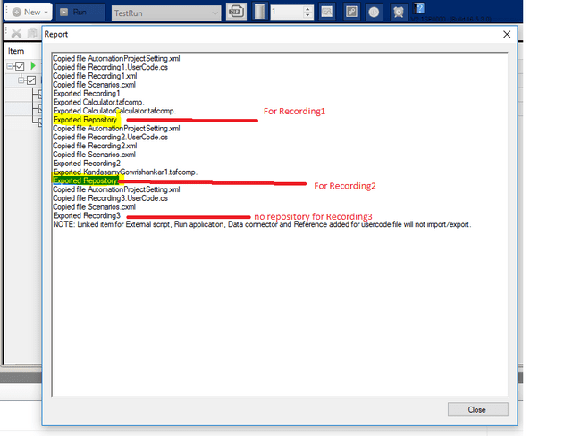

**Export Scenario:** We can export single/multiple scenarios at a time (in one go) with different repository see the figure shown below.

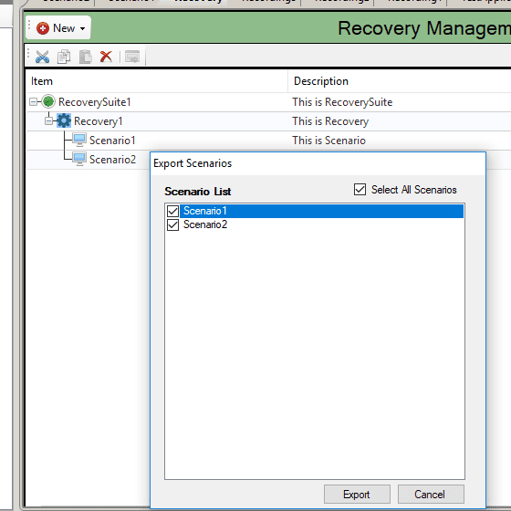

We have two Scenario Scenario1 and Scenario2, we are exporting all two scenario in one go.

So whatever the Repository is linked with Scenarios it will export that.

Scenario1 -> TesApplication repository

Scenario2 -> Test1 repository

Report of Export will show the below details of repository as well.

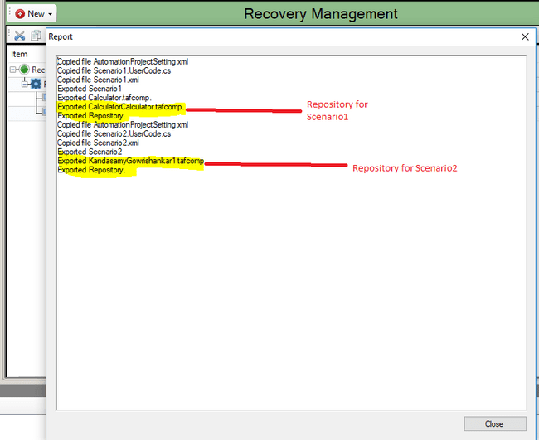

**Import Recording:** We can import multiple recordings at a time with repository see the figure shown below.

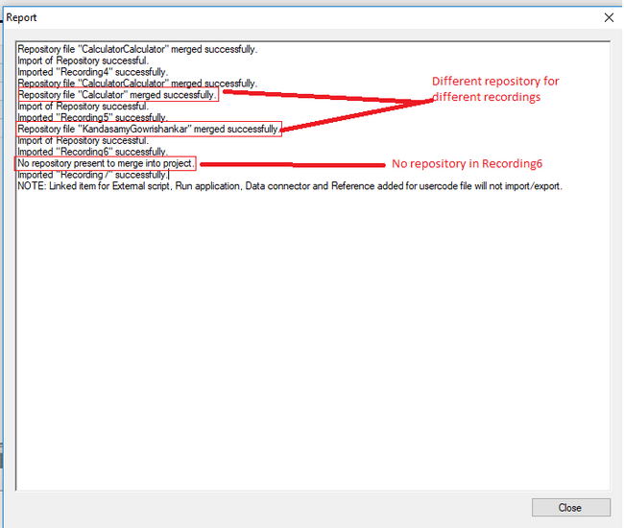

**Import Scenario:** We can import multiple scenario at a time with repository see the figure shown below.

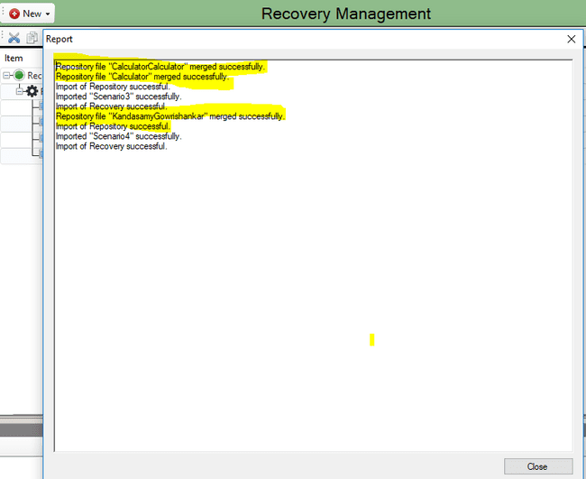

**Note:** On each import .crzip or .crconfig from any location it will always create backup of solution with **“SolutionName_DateTime”** at same location.

# Import/Export Macro

Use to import/export macro from current concord solution and use it in any other concord solution.

## Export Macro

Export a macro file. You cannot export multiple macro files at once from the project tree. You can export related macro files at once by exporting the recording associated with multiple macros.（reference：Multiple Import/Export in sequence order）

1. Select the macro folder you want to export from the project tree.

Select [Export] from the context menu to display the folder selection dialog.

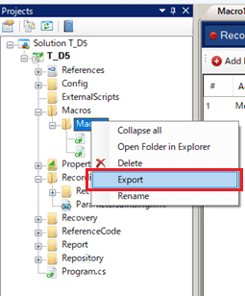

1. Select the export destination and press the OK button.

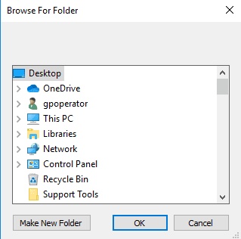

1. After above confirmation dialog, “Exporting Files” wait dialog appears and export process starts. All export process related details will appear in below wait dialog.
2. Abort option is used to abort export process.



1. When the export is complete, a report dialog will appear with messages indicating the completion or failure of the export process.

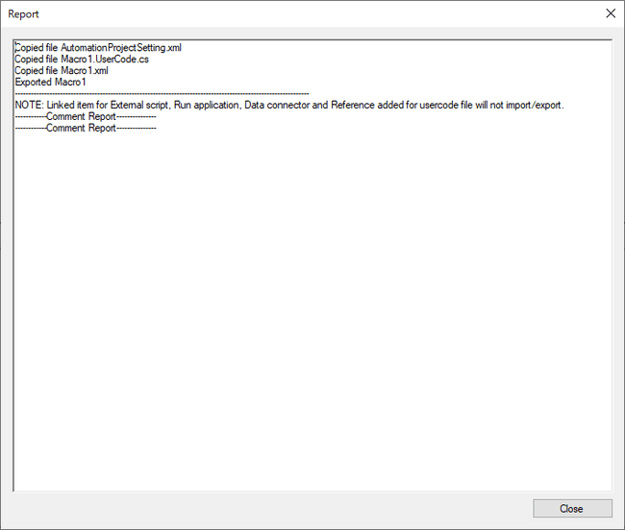

1. The file will be saved in the specified location with the name Macro name_X.X.X.X.cmzip according to the naming convention.

## Import Macro

Import macro files.

1. Select the Macros folder from the project tree.
2. Select [Import] from the context menu.

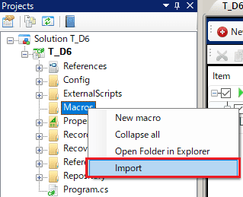

1. A file selection dialog is displayed, and only cmzip can be selected.
2. Select the cmzip you want to import and press the OK button.
3. After above confirmation dialog, “Importing Files” wait dialog appears and import process starts. All import process related details will appear in below wait dialog.



1. When the import is complete, Report will be displayed and

You will see the imported macro folder in the project tree.

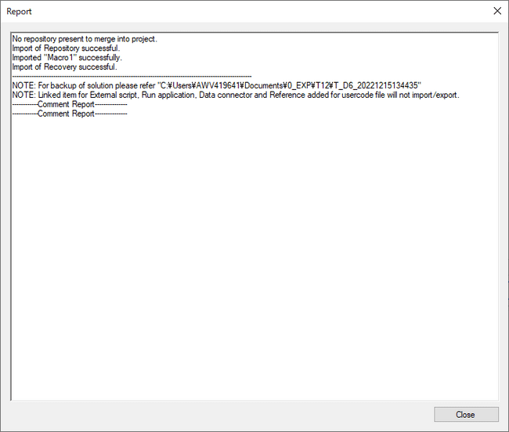

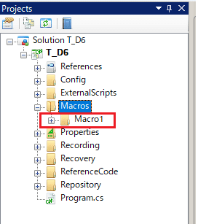

# Helper Utility

* Helper Utility having two tabs one is “Mouse Cursor Utility” and other is “Identify Monitor Screen”.
* For adding the cursor in mouse cursor utility, we need to click on “Helper Utility”. (Highlighted part) see the figure shown below

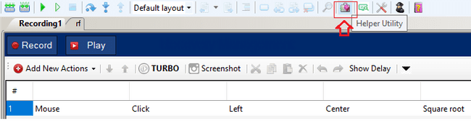

Below is the Mouse Cursor Utility having the list of cursors type. User can add a new cursor from this utility. Added cursor will be added in the list, see the figure shown below.

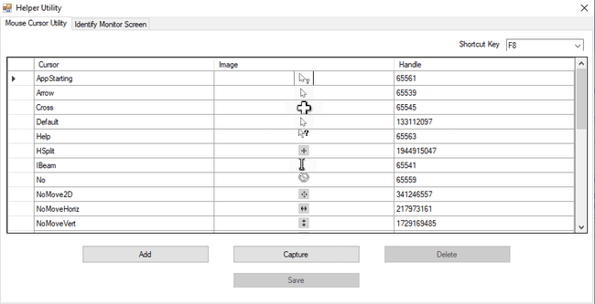

* **Add:** Add value manually.
* **Capture:** Add value by tracking live cursor, user can click on capture and after getting desired cursor user can press shortcut key (F8) to add in database. After capturing click on Add then save and close the utility. Cursor will get added into the utility.
* **Delete:** To delete any cursor.
* **Save:** To save the any newly added cursor.
* If user wants to edit the row value in above dialog, then user needs to double click on the row. On double clicking row shall become editable.

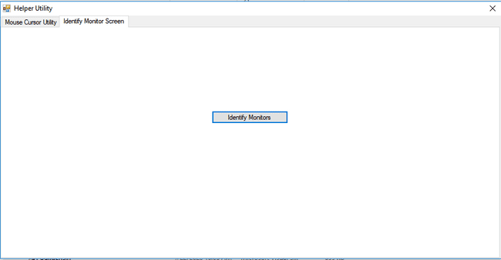

By clicking on “Identify Monitors” button, it will display number and that number will be shown up to 5 sec as shown in above figure.

# Copy Repository

It merges repository files into current concord project. All repository items will merge into current concord project repository.

To merge repository of other concord project into current concord project, use load repository option from IDE see the figure shown below.

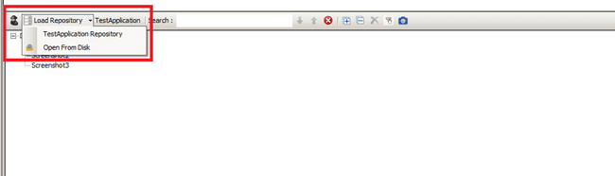

On click of “Load Repository” option dialog appears to select “.tafrepo” repository file of any other project which user wants to merge into current concord project see the figure shown below.

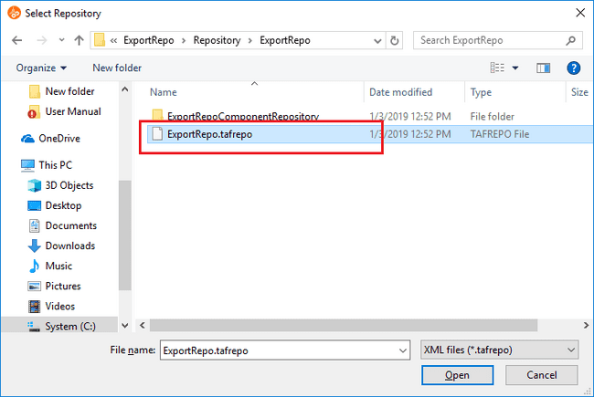

Select “.tafrepo” of any other concord project and click on “Open”. If any repository item is linked into recording then see the figure shown below.

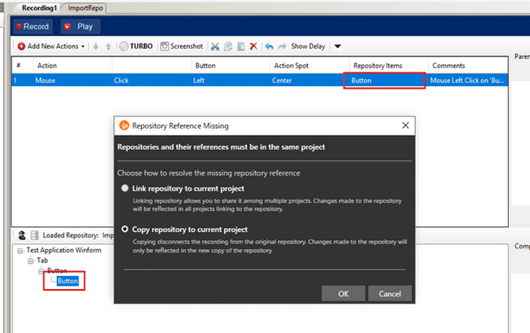

Select “Copy Repository to current project” option to copy repository items into current project. All repository files and folders will copy into current project repository location. With option of copy, repository items which are linked in recording will be merged into repository which are being copied. To merge linked recording items into copied repository below pop up message will appear see the figure shown below.

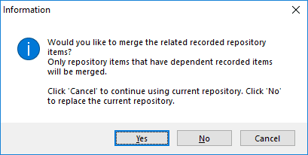

If click “Yes” all linked repository items in recording will be merged into copied repository. If click “No” all linked items will not merge into copied repository and all repository items linked in recording steps will show in the below as “No Item”. Click “Cancel” will cancel merge process and existing repository will remain as it is.

Click “Yes” then repository is merged and item is not unlink see the figure shown below.

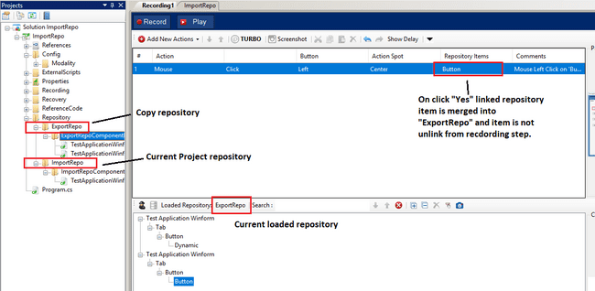

Click “No” then repository is not merged and item is unlink from recording step see the figure shown below.

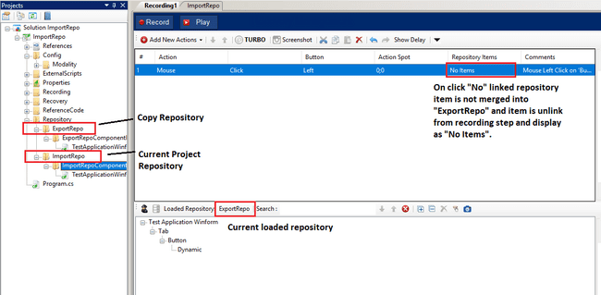

After merging of repository, files will be added in Repository folder of project explorer.

# Recording wise Repository

This is an enhancement of Repository. Earlier we used to have single repository for each and every Recording/Scenario of a solution. So now we can have different repository for different Recordings.

Please check following example:

Here we have two recordings Recording1 and Recording2.

For Recording1, Repository TestApplication is loaded see the figure shown below.

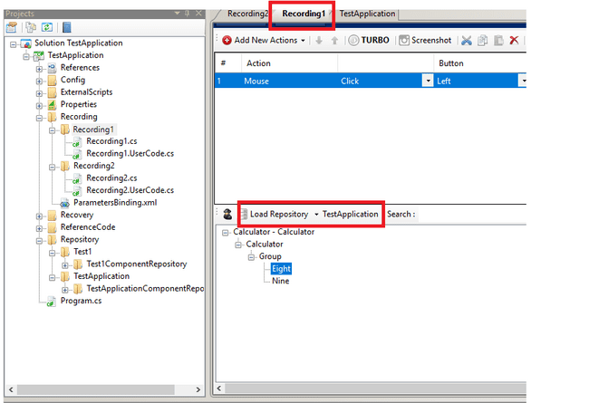

For Recording2, Repository is different that is Test1 see the figure shown below.

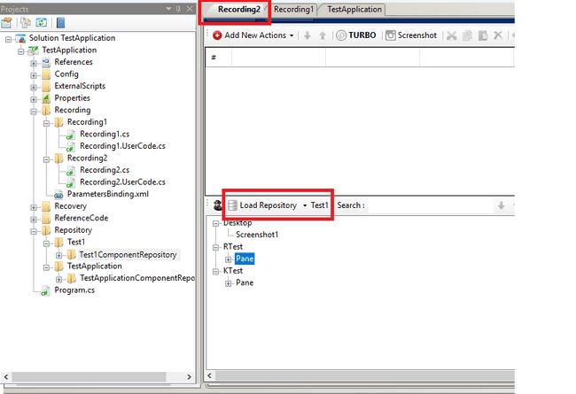

Similarly we can have different repository for different scenarios as well.

Whatever the changes done (Rename/Delete) in Repository, it is Recording/Scenario specific. It won’t reflect to any other Recording/Scenario until and unless same recording is loaded in other Recording/Scenario.

# Multiple Import/Export in sequence order

Use to import/export recording or recovery in the same order to maintain the sequence in which it is available in the solution. The same order can be used in any other concord solution. It will help to use same recording or recovery in multiple concord project without recreating and remembering the sequence of recording and recovery in individual project with same steps. When user exports any recording, all the related files of the recording along with the .config file for multiple recordings are exported and the same are imported in TestSuite and Recovery. User can import/export recovery scenarios also. At this time, if macros are associated with recording or recovery, they are also exported and imported at the same time.

Configuration file for recordings will be .crconfig and configuration file for scenarios will be .csconfig.

## Export Recording and Recovery

Export recording or recovery file and all attached repository items with it. Single/multiple recording or recovery can be exported at a time. Right click on “recording” and “testcase” will display menu with export option see the figure shown below.

Open TestSuite and right click on any TestCase/Recording will display “Export” option.

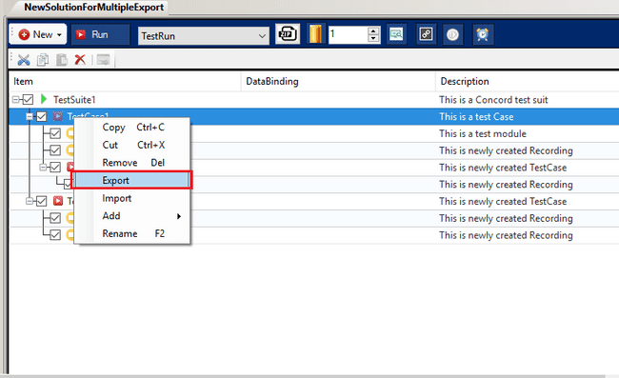

On “Export” click of TestCase level, “Export Recordings” dialog with all recording with same structure as TestSuite will display. User can select recordings/TestCase which wants to export. See the figure shown below,

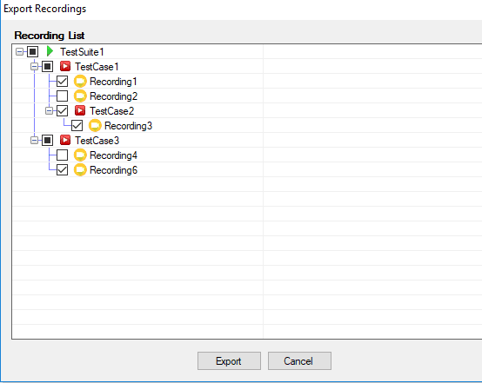

When we select any “recording” and “testcase” by clicking the checkbox, Export button will get enabled.

On click of “Export” button, all the selected “recording” and “testcase” will get exported to the selected specified path.

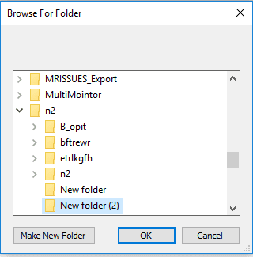

After saving the path, Files for all the selected recordings is saved with naming convention “Recording1_19.4.3.0.crzip” and along with a .crconfig file with naming convention RecordingConfig_19.4.3.0.crconfig at specified location.

RecordingConfig_19.4.3.0.crconfig file contains all the hierarchal structure and sequence order of recordings and TestCase.

Note: All are same for Scenarios/Recovery with config file naming convention ScenarioConfig_19.4.3.0.csconfig.

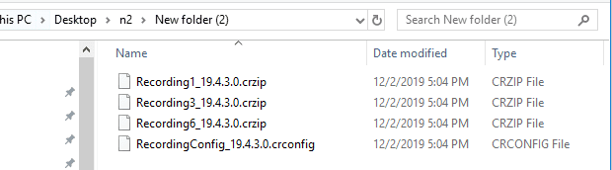

On “Export” click of Recording level, Browse For Folder dialog window will open to select the folder where we want to save the exported recording.



After saving the path, File is saved with naming convention “Recording1_19.4.3.0.crzip” at specified location.

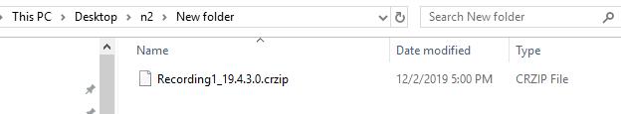

## Import Recording and Recovery

Can import multiple recordings/TestCase in TestSuite level or TestCase level.

TestCase level Import  
Right click on TestCase will display menu with Import option see the figure shown below.

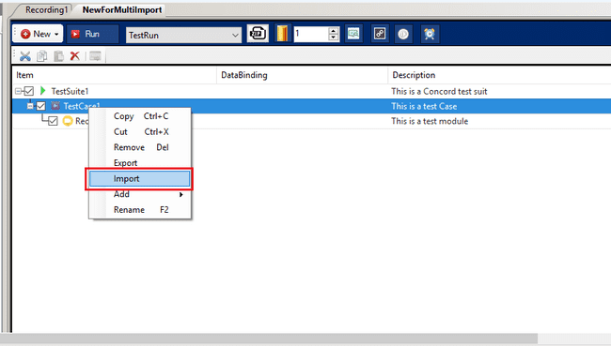

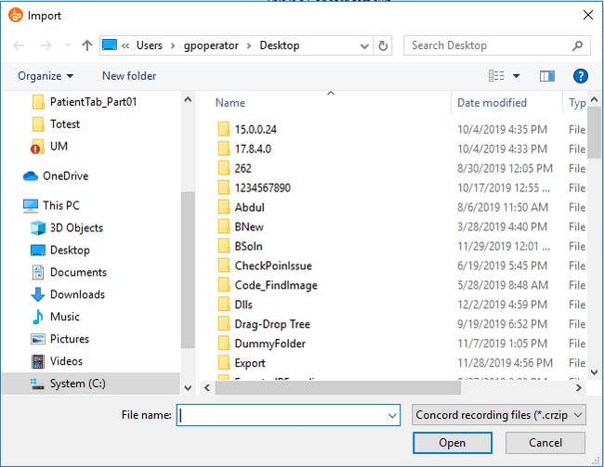

We have two filter extension for file selection, .crzip and .crconfig. Default is .crzip.

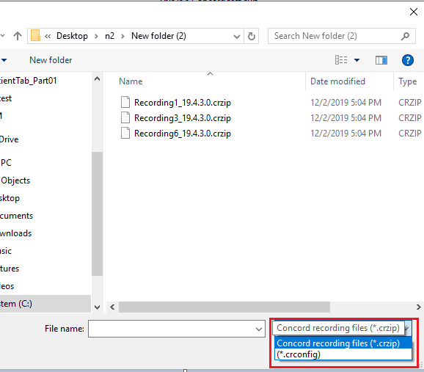

User can select single/multiple .crzip file for single/multiple recordings import. (Multiple recordings will not follow the sequence order)

For multiple recordings in sequence order we need to select .crconfig file. After selection of config file a small window for Import

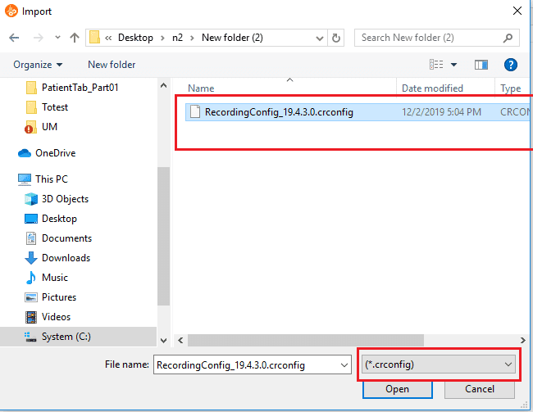

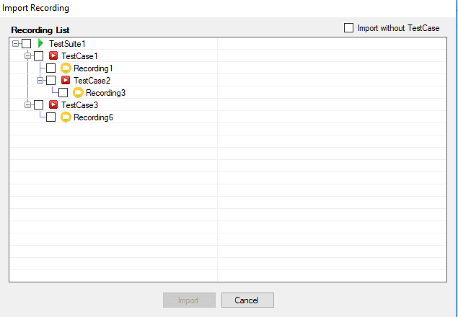

When we select any “recording” and “testcase” to import, Import button will get enabled.

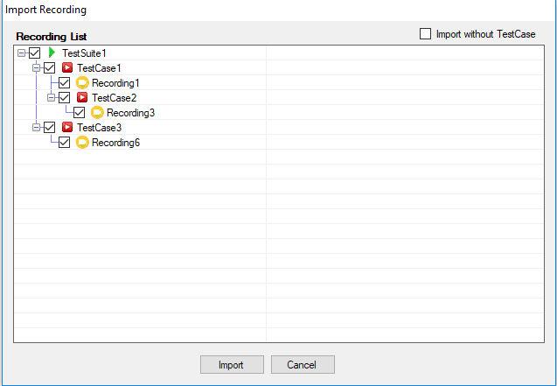

On click of Import, all the selected Recordings will get imported with TestCases in the same sequence order.

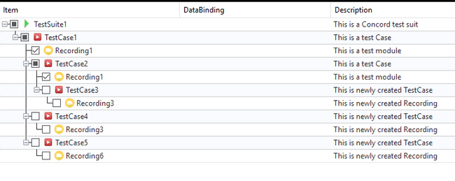

User can import all the recordings in sequence order without TestCase.

Here in below image, a checkbox option is available where user can checked the checkbox to enable the feature of Import without TestCase.

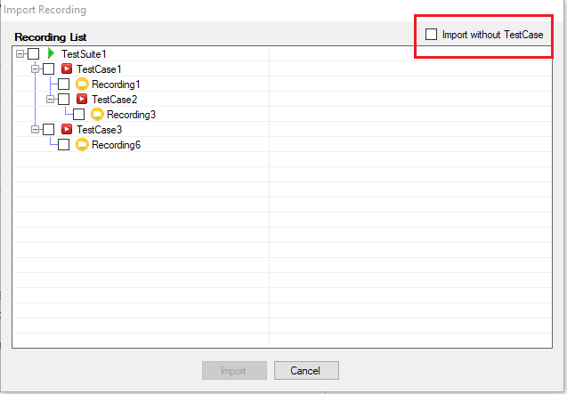

Select all the recordings to import and enable the checkbox so that TestCase will not get added with recordings.

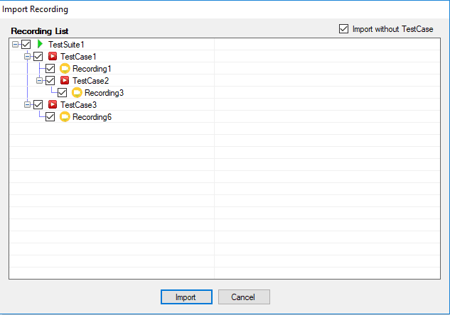

All the recordings will get added under the selected TestCase, without TestCase. See the below image for reference:

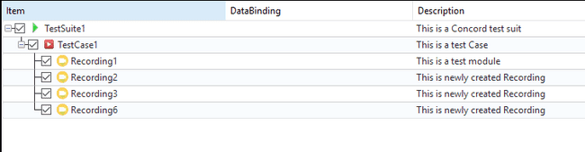

TestSuite level Import: User can import TestCase under TestSuite level.

On right click of TestSuite, Import option is available.

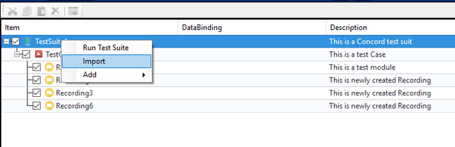

On click of Import, a file Dialog window will open with only .crconfig file selection filter.

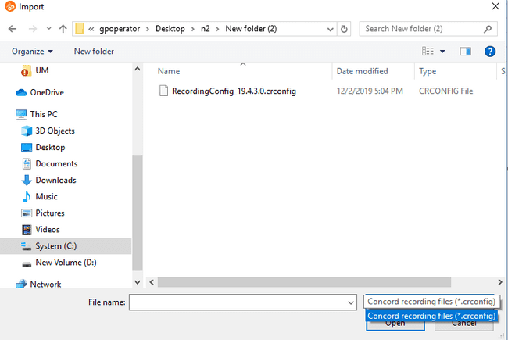

On selection of config file, a smaller Import window will popup with all the recordings structure.

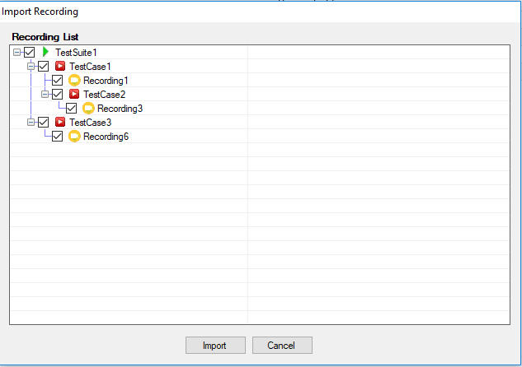

User can select all the TestCase or can select any TestCase to Import. It will import the selected TestCases under TestSuite level.

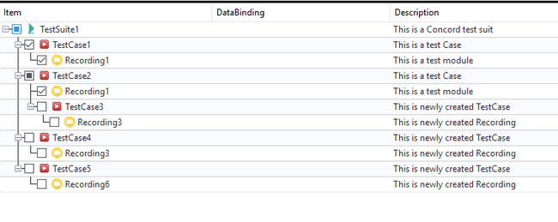

# Self Healing Summary



The following dialog will appear on clicking on the self healing summary icon.

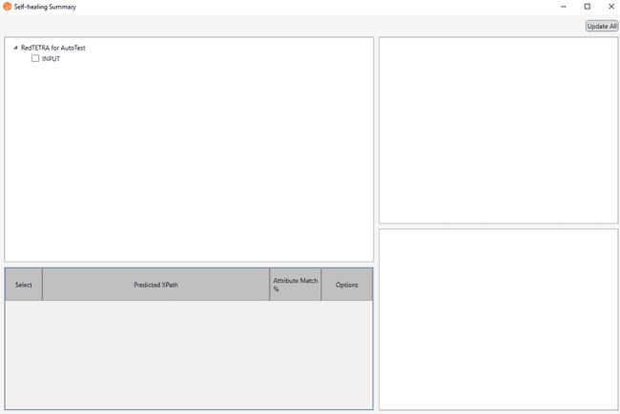

This dialog will display the repository items in those steps that were executed using self healing.

Upon the selecting a repository item, the predicted xpaths as per the suggestion count in AI settings and their corresponding attribute match percentages will be displayed.

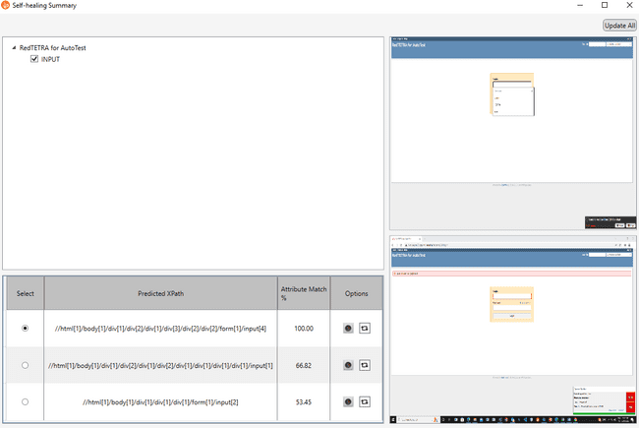

“Highight” and “Replace Xpath” options are provided with each of the suggested xpath.

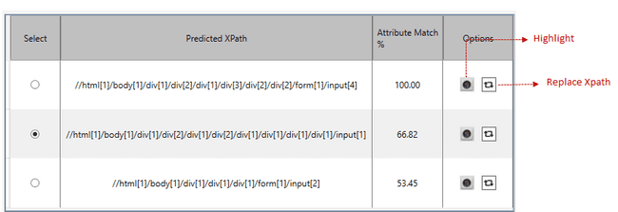

On clicking Highlight button, the element will be highlighted if it is visible.

If the element is not visible, error message will be displayed.

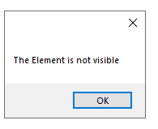

User can replace the xpath of the selected element with any of the suggested xpaths. The following confirmation dialog will be displayed if the user clicks on “Replace Xpath” button.

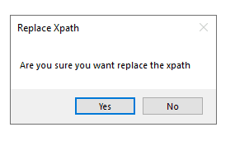

Xpath of the selected element will be updated with the selected xpath if the user selects “Yes” and save.

User can also update xpath of multiple items using “Update All” button.

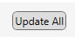

The following confirmation dialog will appear when the user selects “Update All” button.

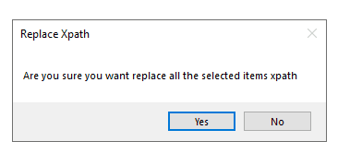

By clicking “Yes”, the xpaths of all selected items will be replaced.

The self healing summary dialog also displays the original image of AUT during recording as well as the image captured during the self healing supported execution.

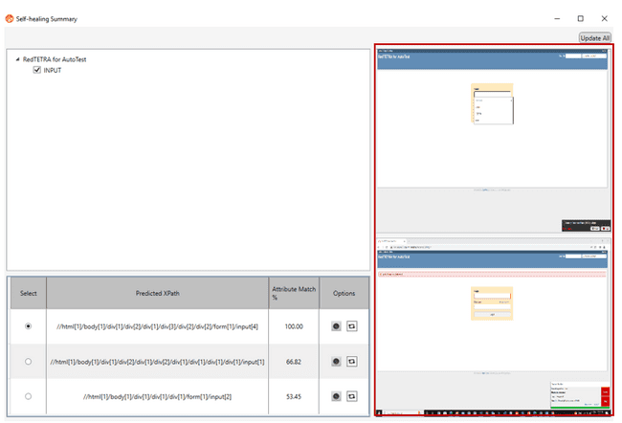

On closing the Self Healing Summary dialog, below dialog will appears if there are any unsaved items and the user can save all the unsaved items from here.

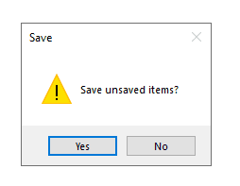

For desktop mode the self healing dialog will be as follows.

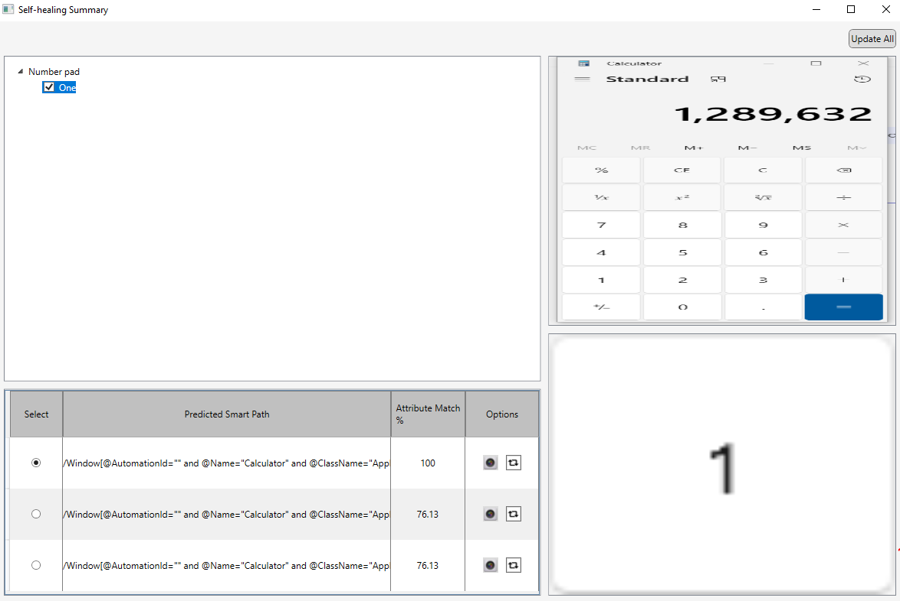

**Limitation:**

There is one limitation in desktop mode self healing. If the parent hierarchy changes after version upgrade, the changed attributes will not be displayed in path editor after replacing xpath.

# Concord Chromium

## What are chromium applications?

Chromium Apps (google chrome, Microsoft edge etc.)let you use HTML5, CSS, and JavaScript to deliver an experience comparable to a native application. Instead of writing and maintaining separate applications for Windows, OS X and Linux, you can write a single application that runs anywhere Chromiumruns. This includes Windows, Linux, and OS X.

## Working environment

Concord provides a simple and organized working environment. It has following parts - Test suite, Recording and Report. Each part is detailed below. The UI layouts can be customized based on the user needs. Since the automation tool generates C# based source code, the generated code can be viewed by the user. There is an option for writing code for users.

### Test Suite View

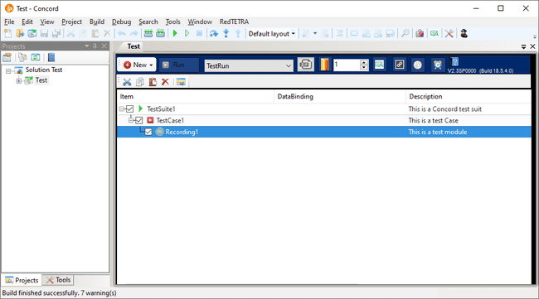

|  |  |
| --- | --- |
| TestSuite Headers | |
| **New:** To create new test case or recording under the selected test suite.  **Run:** To execute all the selected recordings as per sequence.  **Test Run Configuration:** To configure the recording to be executed while running the test suite.  **Export Test project:** To export the test project as a zip file.  **Manage Data Source**: Please refer Data Binding for more details.  **Replay Repeat Count**:To run test suite multiple times**.**  **Performance Monitoring**: Performance Monitoring allows user to monitor and log the performance data during the execution of test suite for individual actions.  **Recovery Linking**: This is an option to specify the steps to be executed, when any step in the recording fails.  **Turbo Mode**: This option is used to ignore the default delays between the steps (actions).  **Scheduler**: To create scheduled task to run test suite. | |
| TestSuite Toolbar | |
|  | **Cut:** To cut selected recording / test case. (Ctrl + X)  **Copy:** To copy selected recording / test case. (Ctrl+C)  **Paste:** To paste the copied / cut recording / test case. (Ctrl+V)  **Delete:** To delete selected recording / test case. (Delete)  **Paste New Copy :** The Copied/Cut recording can be pasted as new copy (Physical copy gets created). (Ctrl+M) |

### Recording View

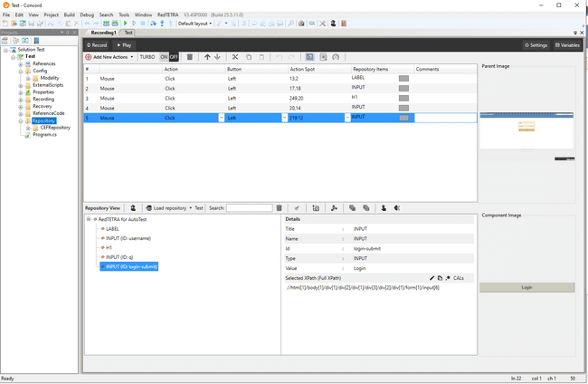

**Move steps by drag and drop:**

This lets user to drag single or multiple steps and drop them on the same recording. This lets user to shuffle the recording steps easily.

During the drag of Loops, Conditional statements and branching statements, complete blocks gets auto selected even if user selects these partially or completely. During drop, complete dragged structure is moved.

Recording step’s serial number gets updated during Drag and Drop.

**Add variables:**

User can add variables by clicking on the “Add variables” button in the top right end of steps header.

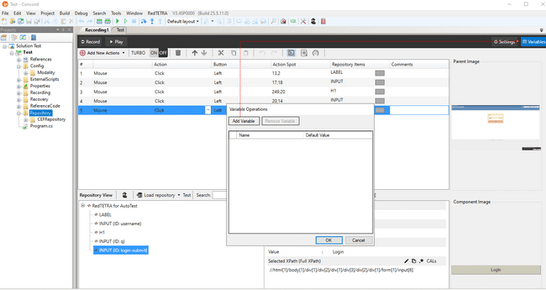

User can also add new variable to selected step by clicking “As New Variable” button in variable field of selected step.

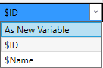

Refer Data binding for more details on variables.

The following dialog will appear on clicking on “As New Variable” button.

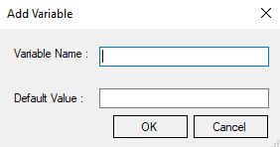

|  |
| --- |
| Recording Header menu |
| **Record**: To record the user action performed on an AUT. Each user action is considered as a step.  **Play**: To execute the actions (steps) in the selected recording.  **Variables** : Refer Data Binding section for more details on variables. |
| Recording Toolbar |
| **Add New Actions**: To create automation step (action) manually, refer “36.6.9 Manual Step Creation”.  **Turbo mode**: To ignore the default delays between the actions.  **Delete Step**: To delete step (action) from recording.  **MoveUp /** **MoveDown**: To move the selected steps (actions) up or down in the recording.  **Cut**: To cut the steps (actions) from the recording.  **Copy**: To copy the steps (actions) from the recording.  **Paste**: To paste the cut / copied steps (actions) in recording. User can Copy multiple steps from one Recording and can Paste those steps into another Recording.  **Undo** **/** **Redo**: To undo/redo any user action performed on the recording.  **Show/Hide Screenshot:** To toggle the visibility of the Screenshot field.  **Show/Hide Delay:** To toggle the visibility of the Delay field.  **Replay Speed Factor: To** increase or decrease the replay overall speed by a specific factor value. |

|  |
| --- |
| Repository view. |
| **Spy**: To capture the test control/objects required for the test automation.  **Delete repository**: To delete nodes from repository in IDE.  **Load repository:**To load repositories.  **Search:** To search repository items by name.  **Regex editor:**To set regular expressions.  **Capture Image**: To capture the screen shot images.  **Expand All:** To expand the entire tree structure.  **Collapse All:** To collapse the entire tree structure.  **Track element:**To add elements in repository.  **Self Healing Summary:** To display details of self healing |

### Report View

Concord Reporting displays the test results generated after the test case execution in html format using charts and tables. It displays information about the execution environment, number of test cases, steps, start time, end time, total execution and details about individual recordings.

Two views are there – dashboard view and details view. Dashboard view gives the overall idea of the test case execution and details view displays the detailed information about each recording executed.

Report will give info about machine name, user name, Windows information, system type, processor RAM information, information about project like build version, project name, Active configuration name etc.

“[Recording break]” will display in report between two recording execution. That means, when one recording execution ends and second starts, “[Recording break]” gets displayed between two lines. Test suite column displays project name.

If turbo mode of recording is ON then after recording, Report will show “[T]” in front of recording. If “Enable continue on fail” flag is set to the step, then when step gets failed, report will show “[E]” in front of the step.

There are two types of view in report

* Dashboard view
* Details view

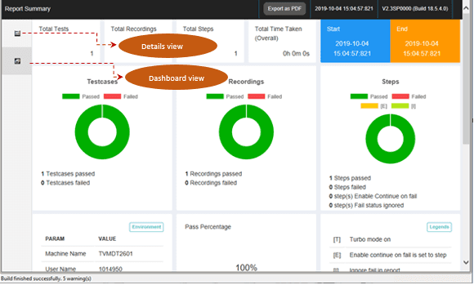

#### Dashboard view

This view displays the overview of the test case execution. It contains the following details

* Total number of test cases
* Total number of steps
* Total time taken
* Start time of execution
* End time of execution
* Concord build version
* Number of recordings passed/failed
* Number of steps passed/failed
* Pass percentage
* Execution environment info

And while clicking on “show more” button in the Steps, we can see more details like

* Number of steps fail status ignored
* Number of steps set Enable Continue on Fail



#### Details view

Details view displays the following details

* Recording names in left side
* Selected recording step details will be displayed on right side
* Author who executed the test cases
* Start, end and total time of the selected recording
* Filters for filtering recordings and steps
* Enable dashboard view
* Search field for searching recordings and step actions

Recording status will be displayed along with the recording name in the left side. Detail view of the each recording will be displayed on right side.



Steps which have screenshots will be displayed in the IMAGE column on the right side. The user can click the screenshot in IMAGE column and view the image in full size.



The image will enlarge on clicking as shown in the below figure.



The reason for step failure can be seen by bringing the mouse over the fail text in the STATUS column on the right side.



Users can filter the recordings on the left side based on the pass/fail status by using the filter.



The enable dashboard enables the user to view the dashboard along with the details view.



Similarly TS_Repeat, Rec_Repeat and status filters are also available for the steps displayed on the right side.



Users can also search for their recording using the search option on left side.



Steps can be searched using the step search option available on the right side.



Checkpoints will be displayed as sub steps i.e. when you click on a particular step containing checkpoint, the checkpoint will be displayed as a sub step below the step.

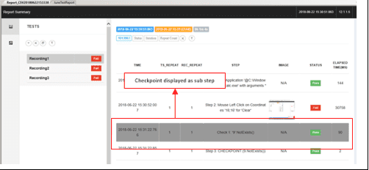

The steps executed using self healing will be highlighted with background of grey color.

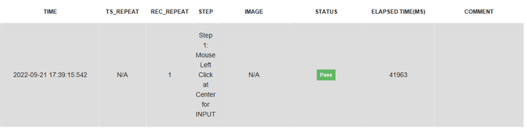

##### **Replace failed image**

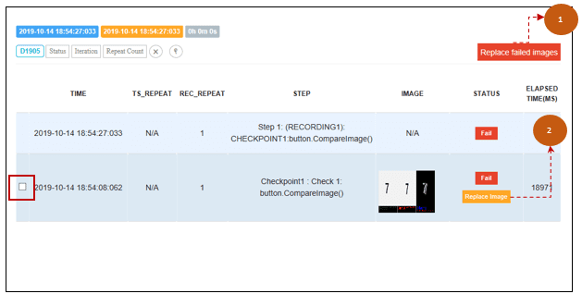

1. **Replace failed images:** User can select the images which they want to replace by clicking the checkbox. After selecting the images to be replaced, clicking on the “Replace failed images” button will replace the failed images with the expected images.
2. **Replace Image:** This is similar to the “Replace failed images” functionality except that it will replace a single image in which the button is placed. This button will only be displayed if the expected image is present.

##### **Ignore in Report**

Test steps can be ignored/considered in report using the “Ignore in Report/Consider in Report” option that appears on the right click of the test steps as shown in following figures.

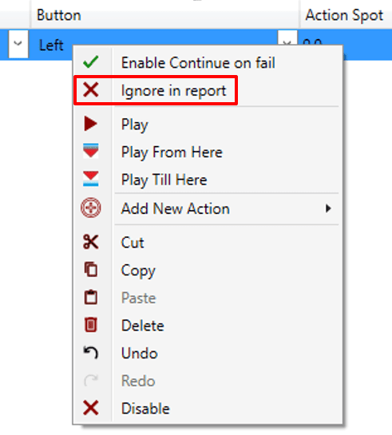

By default, step is “Consider in Report” for all steps except Decision/branching/Looping/Checkpoint steps. For these steps default is “Ignore on Report”. Right click on the “Ignore on Report” step in order to change the option to “Consider in Report”.

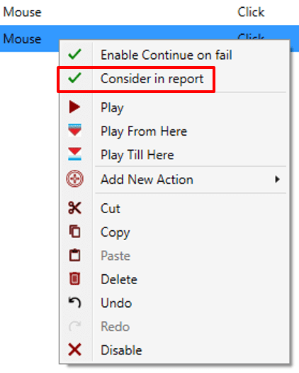

When any step is ignored in steps, Result will show “…” in status and [I] will be shown in that step. Report when some steps are ignored and some are considered, is shown below,

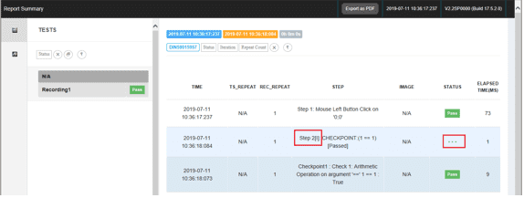

When some steps are marked as “Ignore in Report”, Report will display pass irrespective of the status of ignored steps.

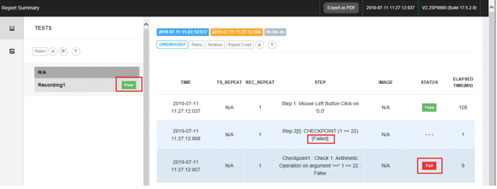

##### **Continue on Fail**

If “Enable continue on fail” flag is set to the step, then when step gets failed, report will show “[E]” in front of the step.

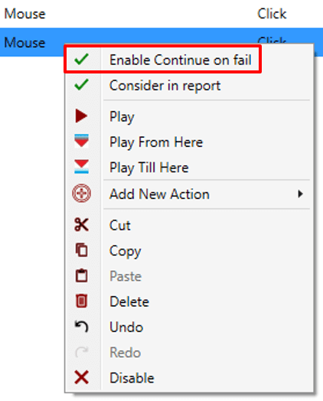

Right click on the “Enable continue on fail” step in order to get the option “Disable Continue on fail”.

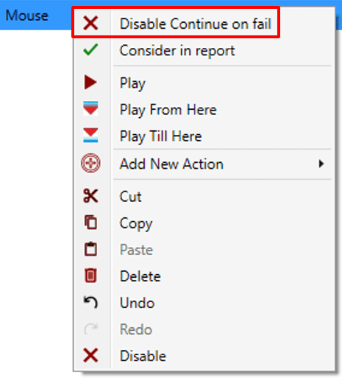

Refer section ‘Concord Reporting’ for more details regarding concord reporting.

## How to create new Project

A new concord test project can be created from the File menu. Click on File → New → Solution. Select Chromium protect type.

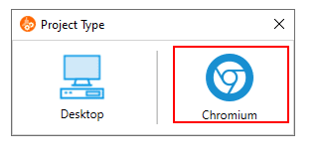

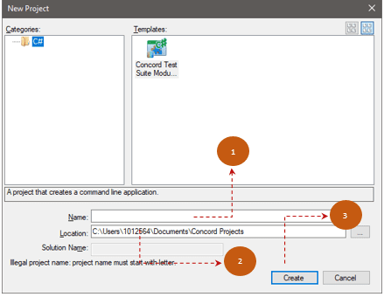

New concord test project will be created in the following scenario:

1. Set a suitable name for test project.
2. Select the location where project was saved.
3. Click [Create] button.

New concord project will be created and the project files will be listed in project explorer.

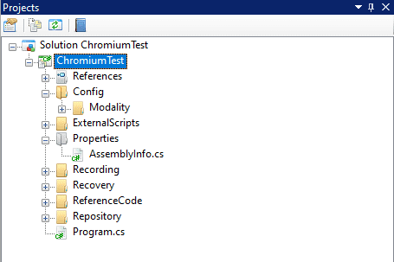

Initially, Repository folder will be empty. CEFRepository folder will be created under Repository folder upon opening the Recording by double clicking it.

## How to create Test case

To create a new test case, right click on TestSuite/Test Case and select ‘New Test Case’ option from ‘Add’ context menu.

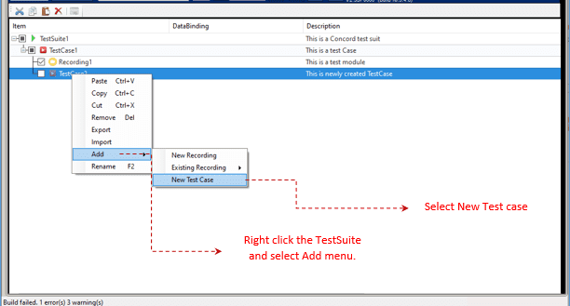

## Rename Solution

Solution can be renamed using F2/Context menu from project explorer in Concord. New name gets reflected in test suite and Solution name also.

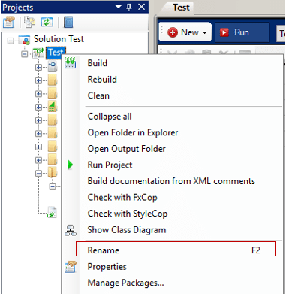

Before renaming user will be asked to take backup as a precaution in case if rename is failed. User can take backup manually by copy pasting it from file explorer. User will get below message. If he/she clicks on “Yes”, Rename will perform. On click of “No”, Rename will be cancelled.

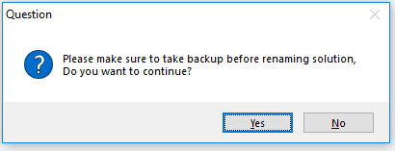

Once rename operation perform successfully, user will get below success message.

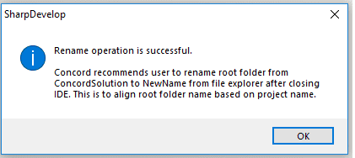

On renaming, Project’s root folder name will remain unchanged. If user want to change it then he/she can change it from file explorer. As a good practice it is always recommended to rename the root folder.

If rename operation is failed, then user will get error message, Along with reason of failure. In this case user should use backup solution for further processing.

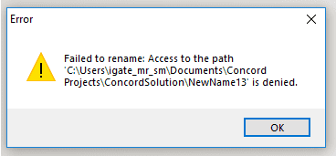

## How to create Recording

Recording is a set of actions that must be performed during play back. In Chromium Automation, instant recording and manual step creation are supported.

### Instant Recording

Record operation is used to record live action of user on a running application.

* Start recorder by clicking [Record] button in IDE
* Recording will start with Recorder window in bottom left corner as shown below.

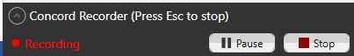

* Click the [Expander] button in the recorder window to display the last five actions performed by user.

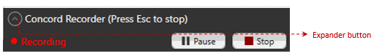

User can pause the recording by clicking [Pause] button. While the recorder is paused actions performed by the user will not be recorded. The status of the recorder will change to paused from recording as shown below.

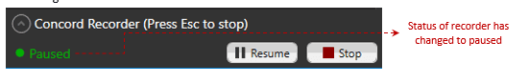

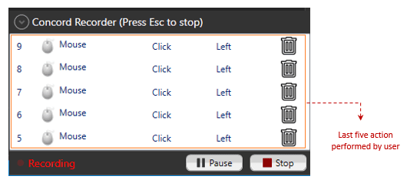

* Stop the recording from the recorder window in bottom left corner as shown.



* Now script is created with following steps will get added in IDE:

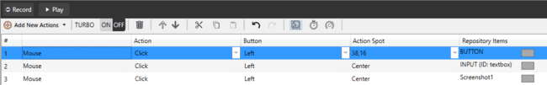

### Executing Recording [Play]

Play functionality is to play the steps added in IDE.

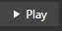While executing recording all the steps that are present in recording will be executed. Execution is performed based on the selected xpath type . That is, if Full XPath is set as selected xpath, execution will happen based on Full XPath value Otherwise, it will be based on Custom XPath value.

After [Play] button is clicked, Execution engine will be opened at bottom as shown in below screen.

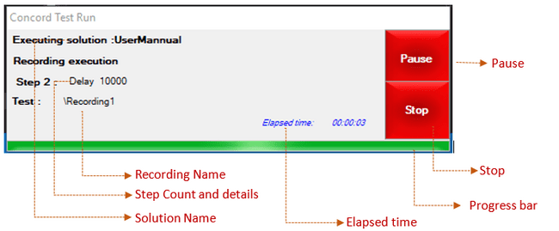

Execution Engine user interface description:

* **Step count and Step details:** This shows the Step sequence along with step details.
* **Pause:** Pause the execution
* **Stop:** Stops the execution.
* **Progress bar:** Keeps on showing the live progress for the steps execution. It gets reset as current recording changes.
* **Elapsed time:** Shows the actual time taken to execute the requested Recording.

When user click on “Pause” button, it will be disabled and status will change to “Pausing...”

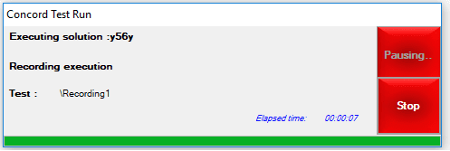

While pausing, current step will get executed completely after that execution will pause. Once paused button text will be changed to “Resume” in execution again.

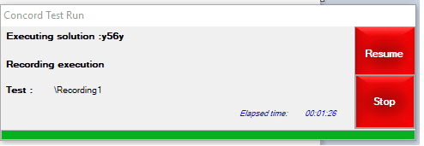

If User clicks on “Resume” button, execution will start from the next step where it was paused earlier.

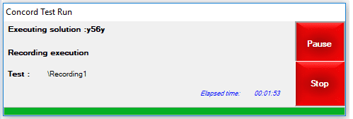

Below things to be considered while using this functionality

* Paused time will be considered in Report’s total time and individual time.
* When Image base execution is in progress then execution engine will be in hidden mode, so pause operation is performed during this time then user may not able to see the execution engine till it is paused.
* While pausing, the current step is a failed step then on resume of execution concord will be shown instead of proceeding the execution. In this case user may get confused whether resume operation is performed or stop operation is performed.

It is possible to execute the script created in one browser in another browser. Also, if same session is opened in multiple browsers, execution will fail and the below error message will be displayed on report.



### Copy / Paste Recording

#### Copy Recording

Select Recording and click on Copy. Shortcut key is Ctrl+C see the figure shown below.

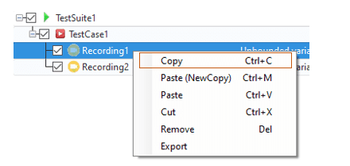

#### Paste Recording

Copied/Cut Recording can be pasted under selected test case. Shortcut key is Ctrl+V see the figure shown below.

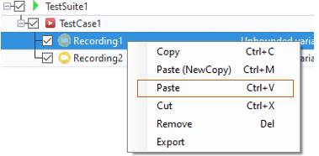

#### Paste (New Copy) Recording

Copied/Cut Recording can be pasted as New Copy (Physical copy gets created). Shortcut key is Ctrl+M see the figure shown below.

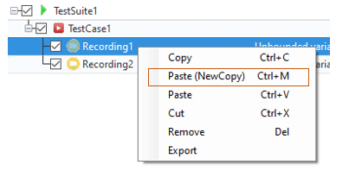

### Copy / Paste Scenario

#### Copy Scenario

Select Scenario and click on Copy. Shortcut key is Ctrl+C see the figure shown below.

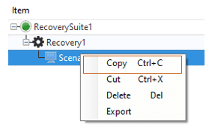

#### Paste Scenario

Copied/Cut Scenario can be pasted under selected Recovery. Shortcut key is Ctrl+V see the figure shown below.

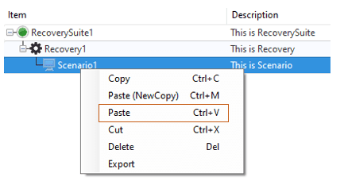

#### Paste (New Copy) Scenario

Copied/Cut Scenario can be pasted as New Copy (Physical copy gets created). Shortcut key is Ctrl+M see the figure shown below.

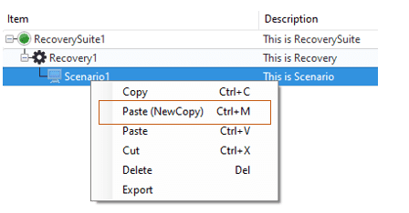

### Import / Export Recording

Use to import/export recording or recovery from current concord solution and use it in any other concord solution. It will help to use same recording or recovery in multiple concord project without recreating recording and recovery in individual project with same steps.

When user exports any recording, all the related files of the recording along with the linked recovery scenarios are exported and the same are imported in Test suite and Recovery. User can import/export recovery scenarios also.

#### Export Recording

Export recording or recovery file and all attached repository items with it. Single/multiple recording or recovery can be exported at a time.

Single Recording/Recovery can be exported from the “TestSuite” and the “ProjectView “.

1. **Export from TestSuite/Recovery**

Open test suite and right click on any recording will display “Export” option.

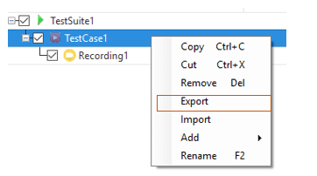

On “Export” click one dialog with all recording names will display. User can select recording/s which he/she wants to export. Dialog is as shown below:

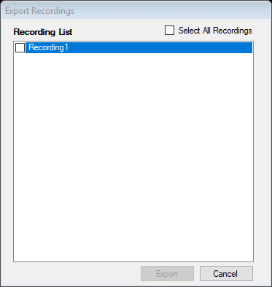

From above dialog select single or multiple recording/s and click on Export will open below dialog,

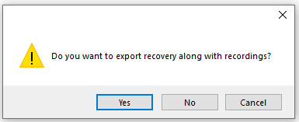

If user clicks “Yes”, then selected recording/s with its linked recovery files gets exported at given location. If user clicks on “No”, then only selected recording files gets exported and save with extension “.crzip”. Every selected recording will create separate .crzip file. For selection of path for exported file below dialog will open,

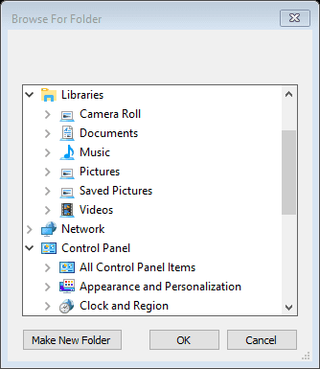

On “OK” click, wait dialog appears and export process starts. All export process related details will appear in below wait dialog.

Abort option is used to abort export process.

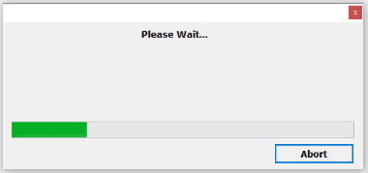

After export completes report dialog appears to display failure or successful message of export process.

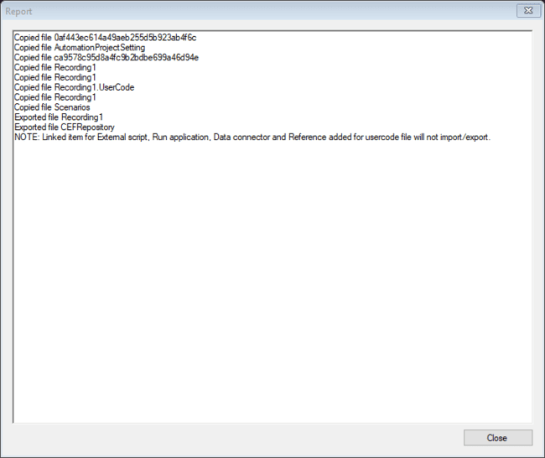

File is saved with naming convention “Recording1_18.5.4.0.crzip” at specified location.

NOTE: Do not rename “Recording1_15.0.0.0.crzip” file name as it is used for backward conversion.

1. **Expot from ProjectView**

Select the Recording/Scenario folder you want to export in the project view, and select [Export] from the context menu. After that, the folder selection dialog will be displayed in the same way as when exporting from the test suite screen, and the procedure will be the same.



#### Import Recording

It imports recording files, repository items linked in recording and recovery scenario files linked with recording. If no recovery scenario file is linked with recording then scenario files will not import. Single recording or recovery exported file can be imported at a time.

Single Recording/Recovery can be exported from the “TestSuite” and the “ProjectView “.

1. **Import from TestSuite**

Open “TestSuite” and right click on any “TestCase” will display “Import” option.

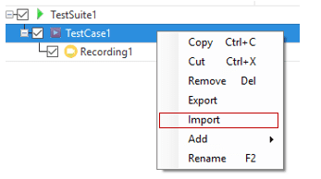

On “Import” click, File dialog prompts to select exported “.crzip” file of recording and “. cszip” for recovery.

Select recording/recovery “.crzip”/”.cszip” file from location and click “Open” will start importing recording/recovery files.

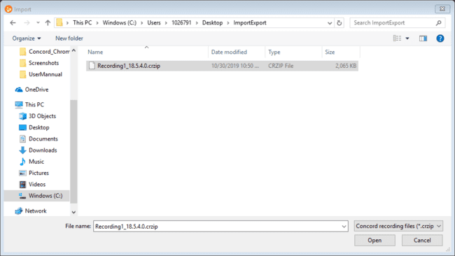

On “Open” click, wait dialog appears and import process starts. All import process related details will appear in below wait dialog.

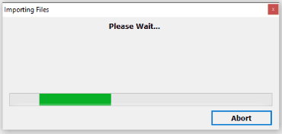

Abort option is used to abort import process. In case of abort import process current concord project may not work properly. If import aborted then user need to take backup solution of current open concord project. Path of backup solution will display in Report dialog. If import failed or aborted then take backup solution and close current open concord project.

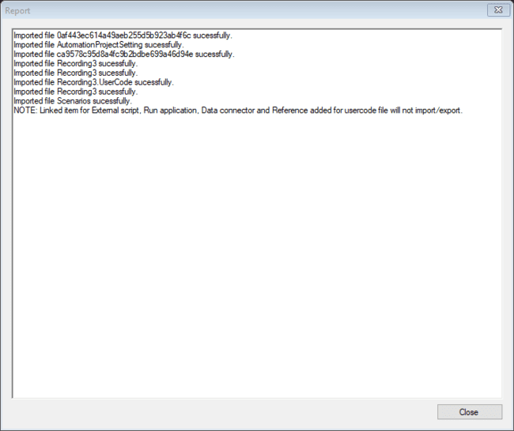

Any failure or successful import process messages will display in report dialog as shown in above screenshot.

If recording file which is importing is already present in current project then it will rename imported recording file name.

Example:

If current project have “Recording1” file present and imported “.crzip” also contains “Recording1” file then it will increment file name using auto number and rename imported recording file name to “Recording2”.

1. **Impot from ProjectView**

Select the Recording/Recovery folder in the project view and select [Import] from the context menu.

After that, the same file selection dialog as importing from the TestSuite will be displayed, and the procedure will be the same.





#### Import Recovery

It imports recovery files and repository items linked in recovery. It will not import recording files in import of recovery. If scenario file which is importing is already present in current project then it will rename imported scenario file name.

Example:

If current project have “Scenario1” file present and imported “.cszip” also contains “Scenario1” file then it will increment file name using auto number and rename imported scenario file name to “Scenario2”.

#### Import Repository

It imports repository files into current concord project. All import repository items will merge into current concord project repository.

Example:

If current concord project have “Calculator” repository and import “.crzip” file also contains “Calculator” repository and both file are similar then both files will be merge into current project repository. If repository are not same then imported repository file will be added as new repository file in current project. Name of imported repository file will change to “Calculator1” because “Calculator” repository file name is already present in current project.

### Import / Export Macro

Desktop/Chromium common operation. (reference: Import/Export Macro )

### Repository & Spy

Repository of test objects/controls can be created using Spy tool. Test operations can be performed on the added objects/controls when adding steps manually.

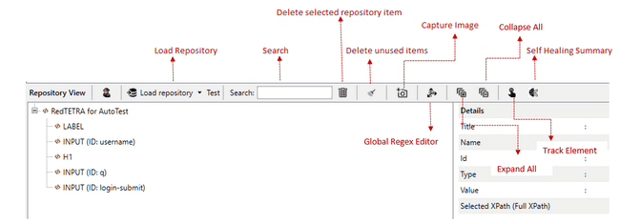

The details of selected repository element will be displayed on the Details section.

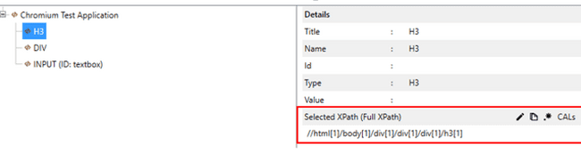

The Full XPath of repository item will be displayed by default. If the xpath type is Custom XPath, cutom xpath of repository item will be displayed as shown in the below figure.

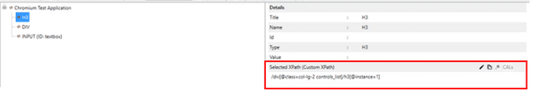

User can set the xpath type by clicking on the edit button which is located right to the selected xpath label. If the selected xpath type is Custom XPath, then the “RegEx editor button” and “To CALS RegEx” button will be disabled.

#### Spy tool

It is used to capture the test control/objects required for the test automation. Spy tool can be opened either by clicking the spy icon in the repository view header or by clicking the edit icon in the repository details view, if a repository element is selected.

If the user opens spy by clicking on the spy icon, UI Elements tab will be loaded. Snapshot of Spy tool with elements from the target application is given below

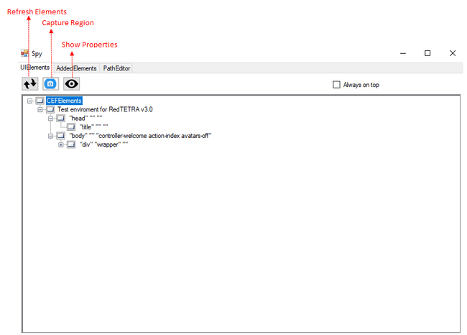

* **Show/hide properties:** To toggle the visibility of the properties window.
* **Capture Region:** Allows user to take screenshot. The control will be enabled if the user clicks on any tree item.

If the user selects a repository item in the repository view, and then opens spy by clicking on the edit icon, AddedElements tab will be displayed with that repository item selected and the details of selected repository item will be displayed.

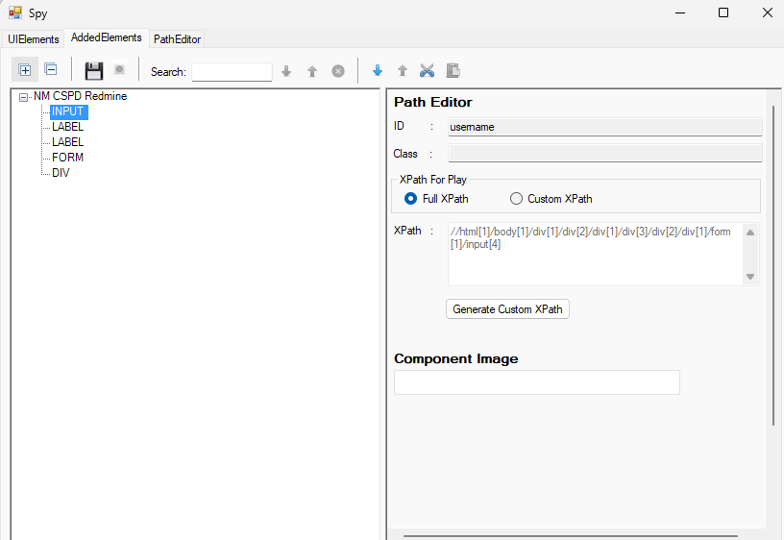

User can switch between Full XPath and custom path by clicking the radio buttons.

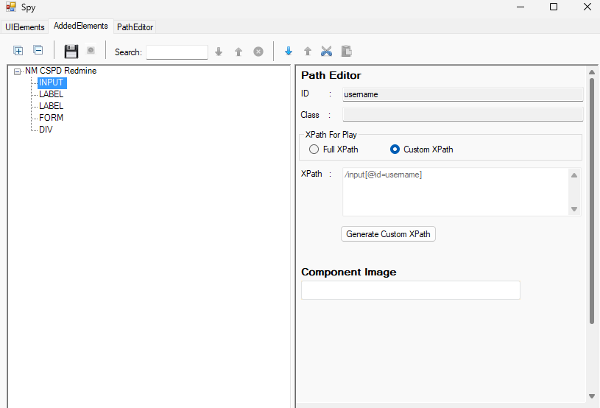

If the selected repository element is present in AUT , user can generate Custom XPath by clicking on the “Generate Custom XPath” button. That element will be highlighted and a confirmation dialog will be displayed as shown below.

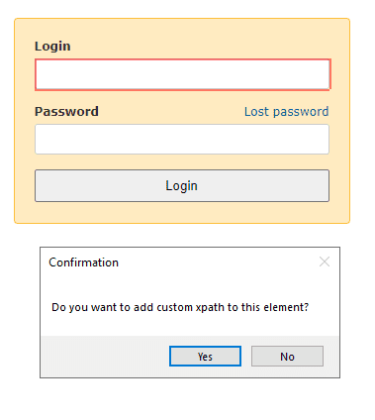

If the user clicks on “Yes”, Custom XPath will be generated for the selected element.

If the element is not available in AUT, “Element not found” message will be displayed.

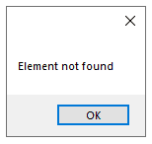

If session is not available, “Session not found” message will be displayed.

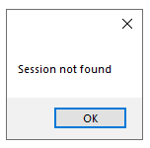

Also, if the same session exists in multiple browsers, custom xpath cannot be generated and the following error message will be displayed.

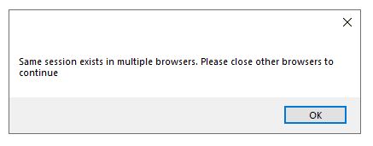

XPath generation is based on the selected priorities in Project Settings.

User can edit the Custom XPath in Path Editor tab.

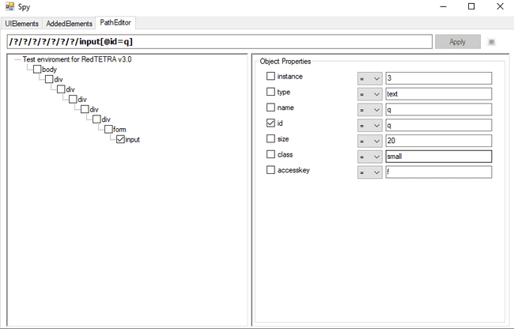

Path editor tab will display the Custom XPath , tree structure and object properties of the selected element. User can edit Custom XPath by adding or removing intermediate tree nodes and/or object properties.User can also apply regex to attribute values. It supports the regex operations not equals, starts with, ends with and contains.

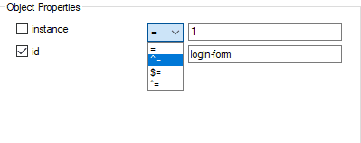

Path editor tab will be loaded only if a repository item will be selected. Otherwise, it will be blank.

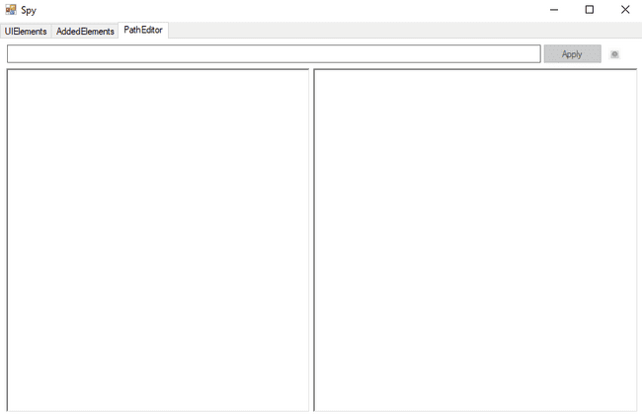

If a repository item is selected in AddedElements tab and its selected xpath type is Full XPath, then the path editor tab will load, but it will be in disabled state so that the user could not edit the xpath value.

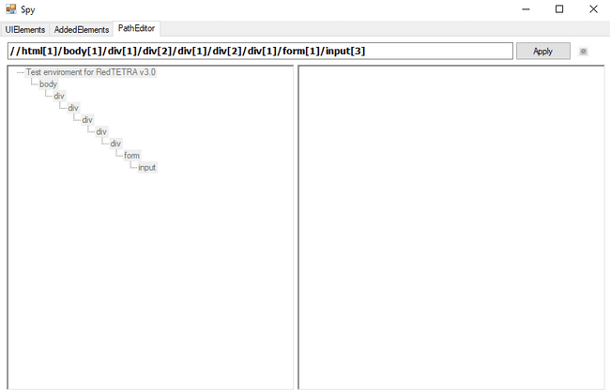

Elements can be tracked by pressing Ctrl key when the spy is open. Tracking is done based on the xpath type selected on Project Settings.

PathEditor tab contains a “Highlight Control” button.If the button is enabled and the user clicks any checked control in the treeview, that control will be highlighted, if the selected control is available in AUT.

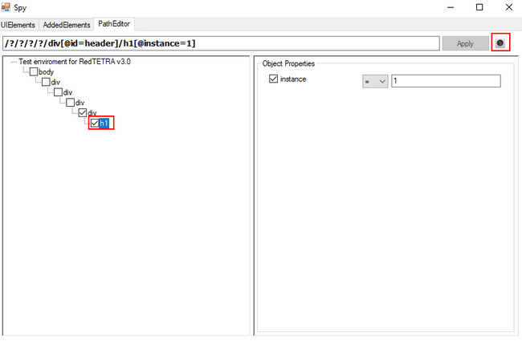

Otherwise, timeout message will be displayed.

If the selected control is available in multiple browsers under the same session, the element will not be highlighted and error message will be displayed.



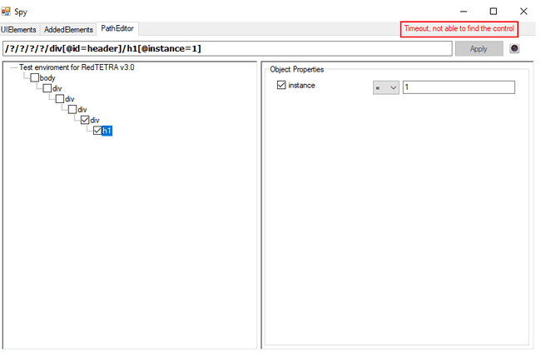

The Reset button can be pressed to restore the XPath values at the time of capture. The Reset button is enabled only if the file is saved in FullXPath format at the time of capture.

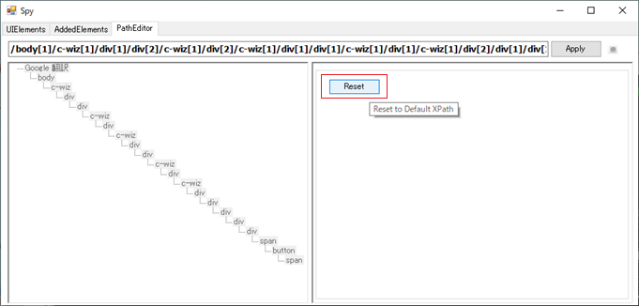

#### Adding repository to step

To add repository items, click on the button present in the Repository Items cell. This will open up the Select Repository dialog box from which the user can select the desired item.

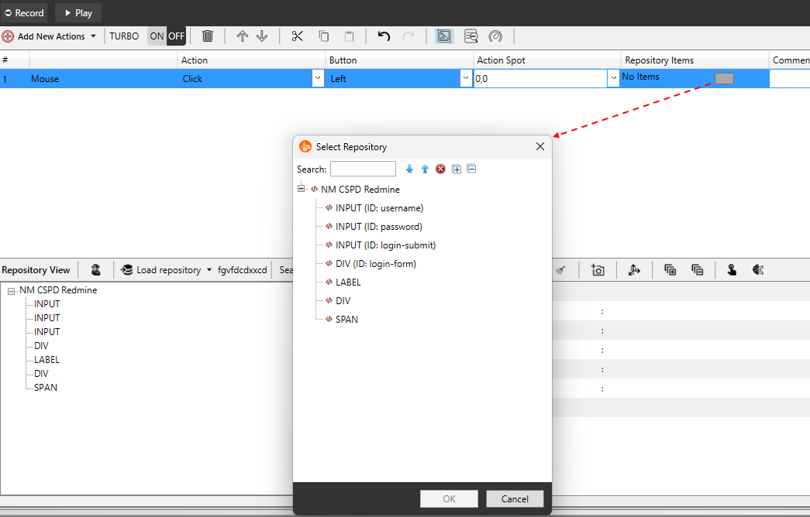

User can search a repository element/title from the repository list.

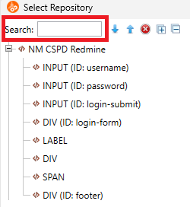

All elements that contains the searched text will be highlighted with blue color.

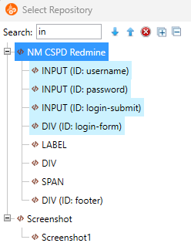

User can also navigate up or down through the search result using the search up and search down button.

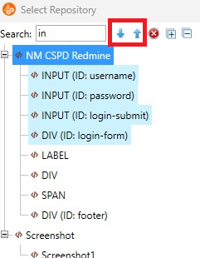

User can clear the search result by clicking the cancel search button.

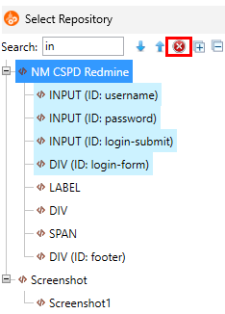

#### Adding element to repository

To add an object/control to the repository, select and right click on it and click on ‘AddItemToRepo’ option.

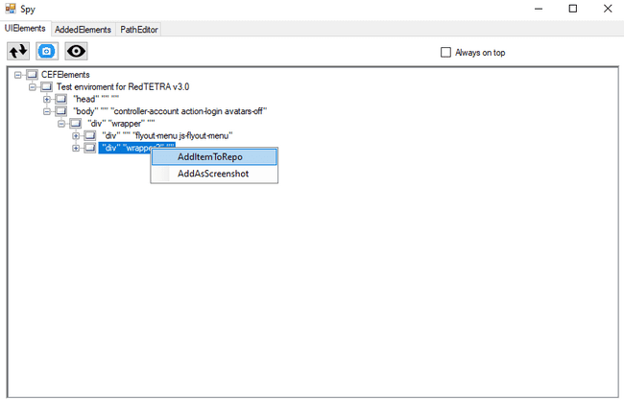

If the selected item does not exists in repository, the item will be added to repository and the added item will be listed in the ‘AddedElement’ tab in the Spy tool.  
The added repository item is highlighted (blue) and displayed. The highlights are retained until you save the repository. It also persists when you rename a repository item.

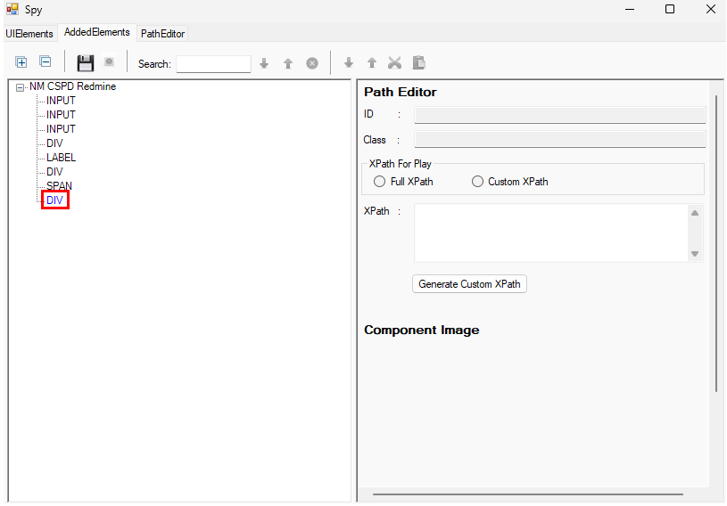

If the selected item already exists in repository, an alert will be displayed.

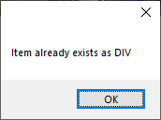

On the right side panel, the details of the element like the ID, Class name, XPath and image will be displayed.  
The element’s default Xpath is based on the Xpath selected in Global settings dialog.

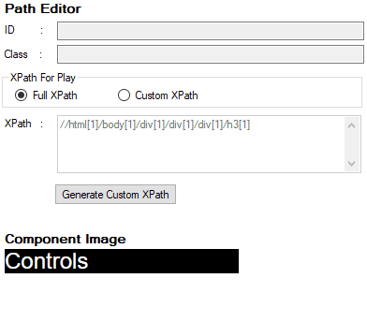

#### Add component image of a control as screenshot from Spy

User can add component image of a control from spy.

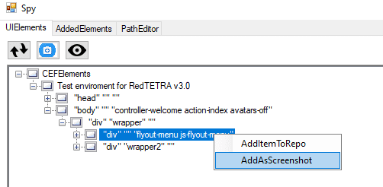

If the user clicks on “AddAsScreenshot”, the component image of corresponding element will be added as screenshot in “AddedElements” tab.

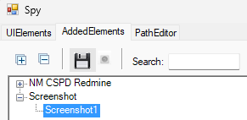

There will not be any images for controls like HEAD, IMAGE etc. So if the user adds such images “No Image found” image will be added in the “AddedElements” tab.

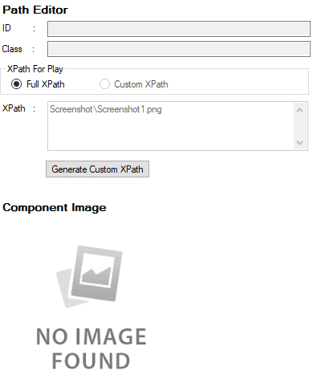

#### Adding screenshots of objects/controls with SPY (Timer)

* Automatic addition of elements

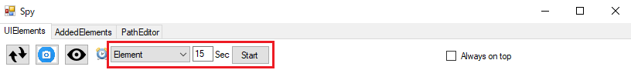

You can automatically add selected elements to the repository using the following method.

1. Select the [UIElements] tab and select [Control] from the registration type.
2. Set the timer time. (Settable time: 1 to 999Sec)
3. Press the Start button. When pressed, the timer time countdown starts.
4. Place the cursor on the element you want to register and wait until the countdown reaches 0.
5. When the countdown reaches 0, the element under the cursor will be added automatically.
6. The added element will be displayed in a red frame (*) and the corresponding node will be highlighted in the Tree.

*After the additional processing is completed, the corresponding element will be displayed in a red frame, so there will be a delay from countdown 0 until the red frame is displayed.

* Automatically add screenshots

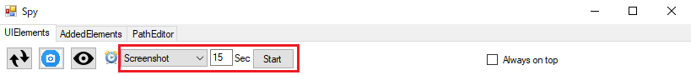

You can automatically add the selected element (Screenshot) to the repository using the following method.

Select the [UIElements] tab and select [Screenshot] from the registration type.

Set the timer time. (Settable time: 1 to 999Sec)

Press the Start button. When pressed, the timer time countdown starts.

Place the cursor on the element you want to register and wait until the countdown reaches 0.

When the countdown reaches 0, a screenshot of the element under the cursor will be automatically added.

The added element will be displayed in a red frame (*) and the corresponding node will be highlighted in the Tree.

*After the additional processing is completed, the corresponding element will be displayed in a red frame, so there will be a delay from countdown 0 until the red frame is displayed.

#### Saving the added objects/controls to repository

The saved elements in the ‘AddedElements’ tab can be saved to repository by either clicking the [Save] button in the ‘AddedElements’ tab or a confirmation dialog will be prompted when you close the Spy tool.

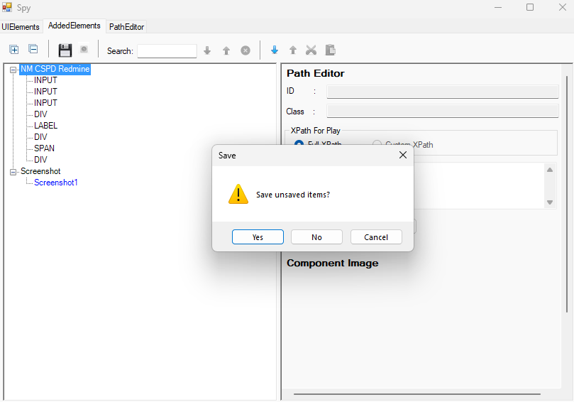

There is a toggle named “Highlight Control” in ‘AddedElements’ tab. Initially, the toggle is in disabled state. When the user enables the toggle and clicks any of the saved item, the item will be highlighted in AUT, if it is available. If the clicked item is not there in the AUT, an error message will be displayed.

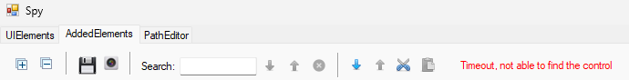

If the same session exists in multiple browsers, element will not be highlighted and the following error message will be displayed.

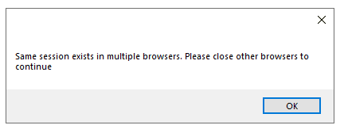

#### Rename Repository in Spy tool

User can rename a repository element/title in AddedElements by clicking on the Rename button that appears while right clicking on the repository element/title.

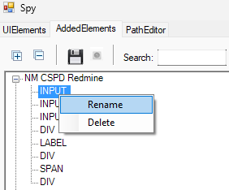

An alert will be displayed if the user provides an empty or blank name.

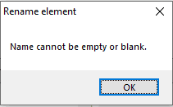

While renaming a screenshot, duplicate names and special characters except “_” and “ ` “ are not allowed. The following dialog boxes will be displayed.

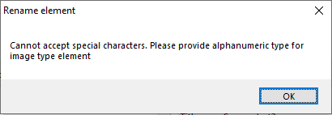

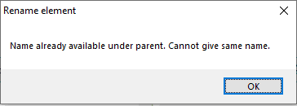

#### Delete Repository from Spy Tool

User can delete a repository element/title in AddedElements by clicking on the Delete button that appears while right clicking on the repository element/title.

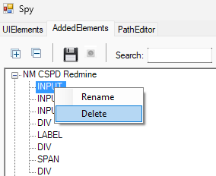

When the user clicks on the Delete button, the dialog displays a list of the steps for which the repository item is being used.

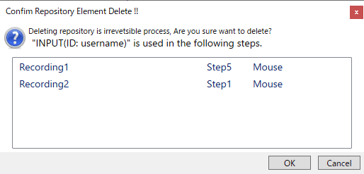

If the user click on *“OK”* that repository element/title will be deleted.

#### Search Repository in Spy Tool

User can search a repository element/title from the repository list.

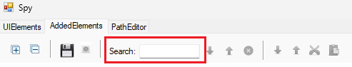

All elements that contains the searched text will be highlighted with blue color.

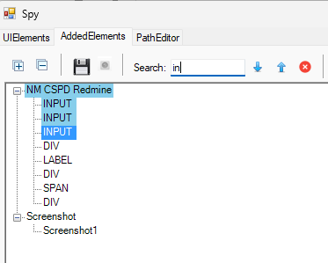

User can also navigate up or down through the search result using the search up and search down button.

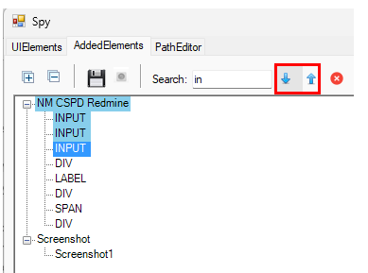

User can clear the search result by clicking the cancel search button.

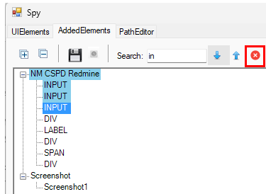

#### Capture Image

Screenshots can be taken by clicking the Capture Image icon in the repository view header. On clicking the icon, a grey background overlay will be displayed in the screen and the user can select the area to be captured by clicking and dragging the mouse.

The screenshots will be saved automatically and will be displayed in the repository window under the title “Screenshot”.

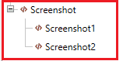

#### Load Repository

To load Repository, use Load Repository option from IDE.

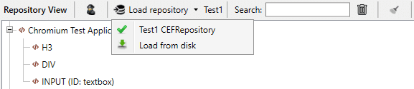

On click of “Load Repository” option dialog appears to select the root folder containing the repository file of any other project which user wants to merge into current concord project.

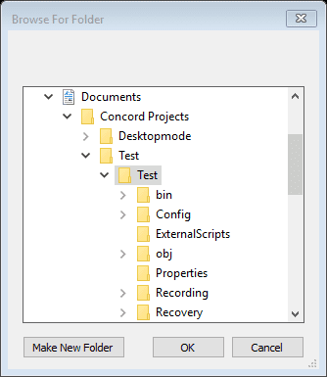

If the root folder doesn’t contain “VitreaElements.xml” file then a Message box will be displayed as shown below.

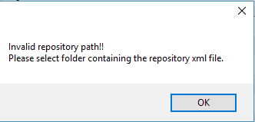

On selecting the root folder, a dialog box will be displayed for selecting whether to copy or link the selected repository file.

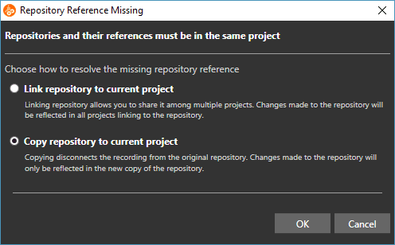

#### Copy Repository

Select “Copy Repository” option to copy repository items into current project. All repository files and folders will copy into current project repository location. With option of copy, repository items which are linked in recording will be merged into repository which are being copied. To merge linked recording items into copied repository below pop up message will appear.

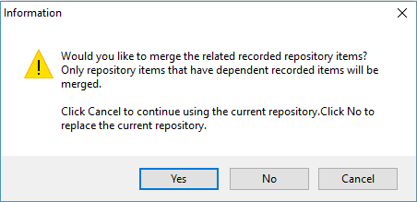

If press “Yes” all linked repository items in recording will be merged into copied repository. If press “No” all linked items will not merge into copied repository and all repository items linked in recording steps will show as “No Item”. Press “Cancel” will cancel merge process and existing repository will remain as it is.  
After copying a repository, a folder with name CEFRepo_ProjectName will be created under the repository folder in Project explorer.

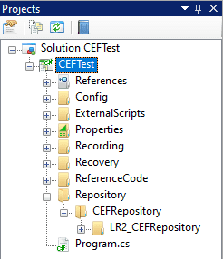

#### Recording wise repository

This is an enhancement of Repository. Earlier we used to have single repository for each and every recording of a solution. So now we can have different repository for different recordings.

Please check following example:   
Here we have two recordings Recording1 and Recording2.  
For Recording1, Repository ChromiumTestApp is loaded.

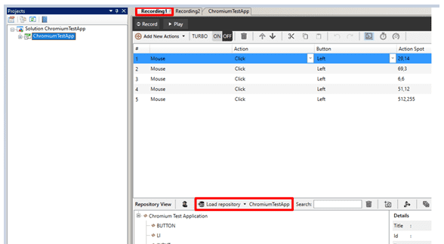

For Recording2, Repository is different that is TestApp1.

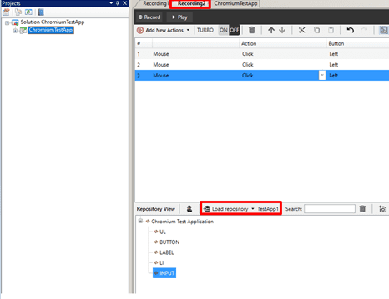

Whatever the changes done (Rename/Delete) in Repository, it is recording specific. It won’t reflect to any other recording until and unless same recording is loaded in other recording.

#### Rename repository

User can rename a repository element/title by clicking on the Rename button that appears while right clicking on the repository element/title.

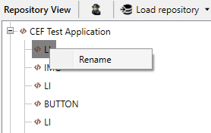

An alert will be displayed if the user provides an empty or blank name.



While renaming a screenshot, duplicate names and special characters except “_” and “ ` “are not allowed. The following dialog boxes will be displayed.



#### Delete repository

Repository item can be deleted by selecting the repository item and clicking the delete icon in the repository view header. User can also delete the repository item by right clicking the repository element and click on delete button.

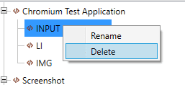

On clicking Delete button, check if the deleted repository is linked to any step and display a list of link information dialog will be displayed.

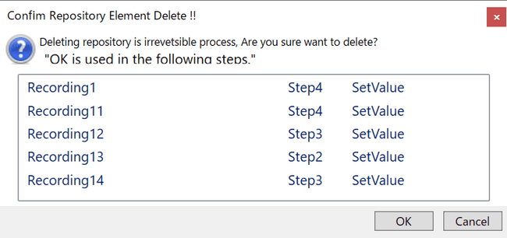

The selected repository element/title will be deleted on clicking on “OK” button.

If the repository title is selected and deleted, then the title and all its child elements will be deleted. If a repository element is selected and deleted, then the element will be deleted from the repository view.

#### Bulk deletion of repositories

User can delete unlinked repositories / nodes at once by clicking the button shown in the figure below.

Here's how to delete repository items / nodes from the tree at once.  
Click the Delete unused item button.  
Displays a list of unlinked repository items / nodes in a dialog.  
Dialog for unlinked repository items / nodes:

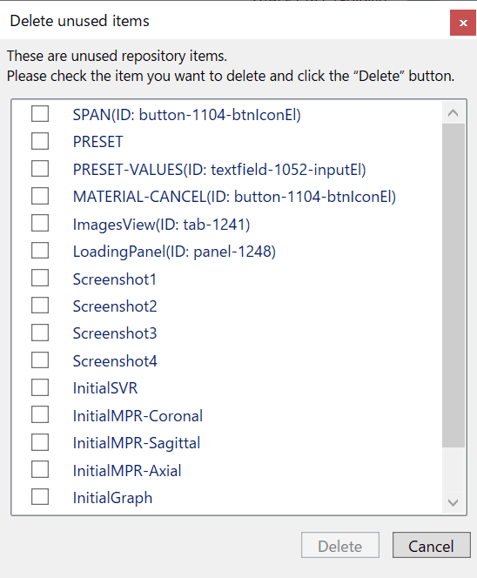

Check and select the checkbox of the repository / node you want to delete.  
Click the [Delete] button in the displayed dialog to delete all selected repositories / nodes.  
Click the [Cancel] button in the displayed dialog to cancel the batch deletion.

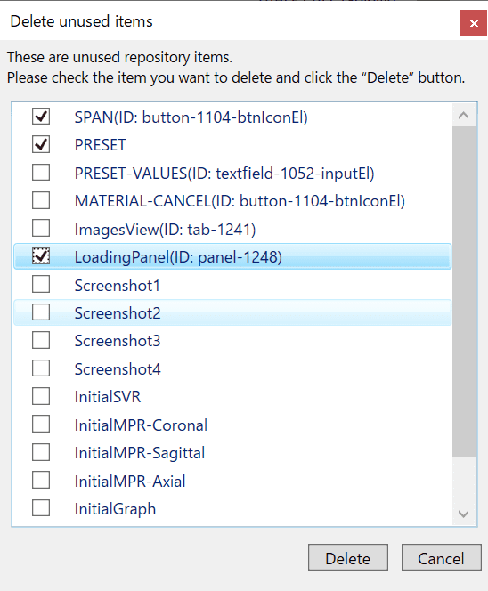

#### Search repository

User can search a repository element/title from the repository list.



The search result shows all repository elements/title that contains the search text.

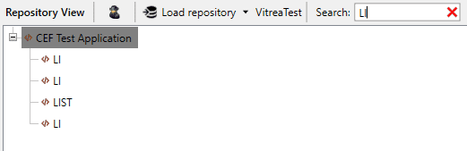

#### Expand / Collapse all repository

On click of Expand All button the entire tree structure is expanded



On click of Collapse All button all the tree nodes are collapsed.



#### User group feature for repositories

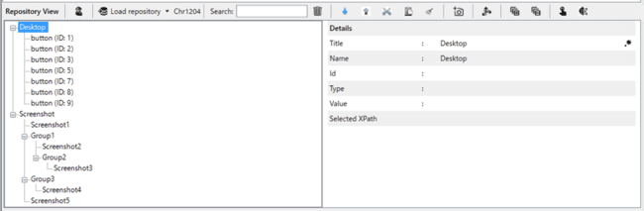

The repository user group function allows users to create arbitrary groups in the tree hierarchy created by default in the repository tree and move repositories into the created groups.

Repository items can be moved using the context menu or drag & drop, and can be moved across repository items, images, and group hierarchies within the same session and Screenshot.

Multiple repository items can be selected as long as the conditions under which they can be moved are the same.

#### Track element



Track element is a way of adding elements in the repository. In this the user need not search for the element in spy tool. User can click the Track Element button on Repository View which will set the tracking mode to ON. The cursor should be then pointed to the element that should be added to the repository. A red box can be seen bordering the selected element. User can then click the allotted button (F2 by default) to add the element in repository. User can pointed to any element and a tooltip will also be displayed along with the marker as shown below,

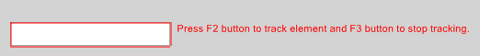

Tracking is done based on the selected xpath type in Project settings.

If the element already exists in repository, a message “Item already exists” will be displayed.

User can exit from the track mode by pressing the button (F3 by default) allotted for exiting the tracking mode. Once the tracking mode is set to OFF, the red border will stop appearing around the selected element.

The buttons for adding the elements in repository and exiting the tracking mode can be configured in global settings.

### Play/Pause Script Execution

#### Play script execution

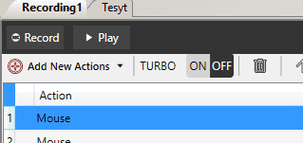

This would Build Project & Run the script. After the Test case is executed, Report is displayed in new tab.

#### Pause script execution

User can pause Script execution in between Script steps. Below are the steps User can perform while Script execution.

While Script execution is running user will be able to see two option “Pause” and “Stop”.

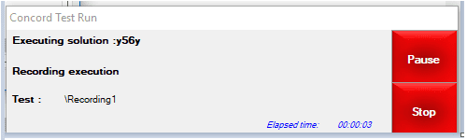

1. When user click on “Pause” button, it will be disabled and status will change to “Pausing...”

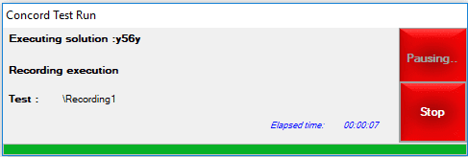

1. While pausing, current step will get executed completely after that execution will pause. Once paused button text will be changed to “Resume” in execution again.

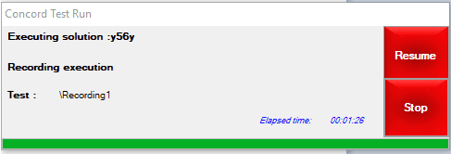

1. If User clicks on “Resume” button, execution will start from the next step where it was paused earlier.

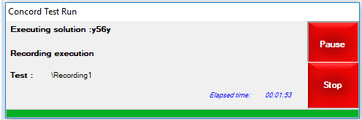

### Manual Step Creation

User can add steps for automation manually. This option helps the user to add checkpoints, read information of control/system etc. and manually modify the already recorded steps. It has more options than the instant recording. The steps that can be added manually is given below.

Actions can also be added through context menu that is displayed on right click on any added step in the steps grid as shown below:

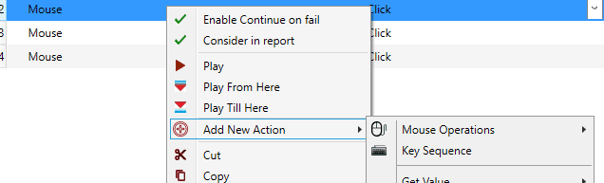

The context menu contains edit options like Cut, Copy, Paste, Delete, Undo, Redo etc.

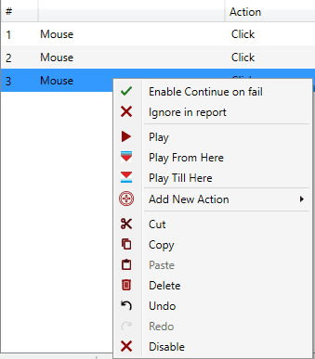

**Play**: Select one or more steps of a recording and click on “Play” in the context menu. It will execute only selected rows.

**Play till here**: This will execute the steps from step no. 1 till the currently selected step on which right click was done.

**Play from here**: This will execute the steps from currently selected step on which the right click was performed till the last step.

Please Note:

1. “Play till here” and “Play from here” context menu options will be not available on selecting more than one steps.
2. “Play from here” context menu will be not available on right click for last step.
3. “Play from here” context menu will be not available on right click for last step.
4. “Play from here” context menu will be not available on right click for last step.

An error icon will be displayed, when there is an error while creating the step and when the user hover on the error icon a tooltip will be displayed, which describes about the error while creating the step as shown below,

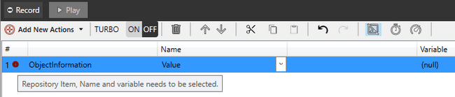

On clicking on any step, the linked repository element will be highlighted in the repository view as shown below,

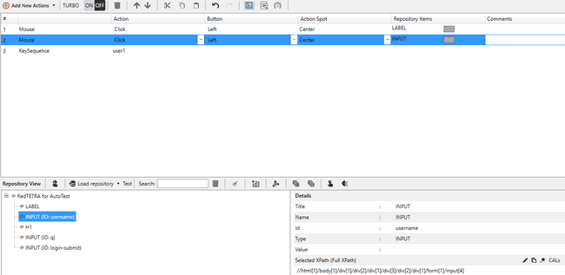

#### Mouse Operations

##### **Mouse**

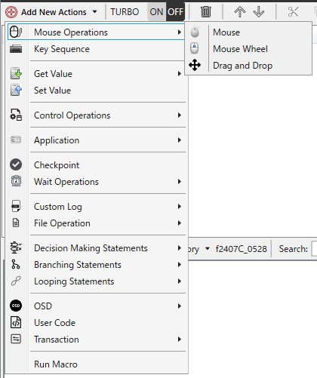

User can automate the click, double click, move, up and down operations of left, right and middle button of mouse .



In Action, the mouse operation can be set from Up/Down/Click/Double Click/Move (see figure below).

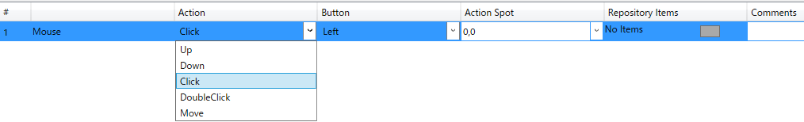

Button allows you to specify a mouse button (see figure below).

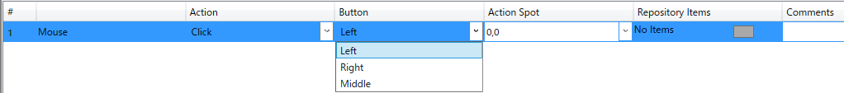

The Action Spot allows you to specify the mouse operation position.You can enter the coordinate position directly or select “Center” or a variable from the combo box.

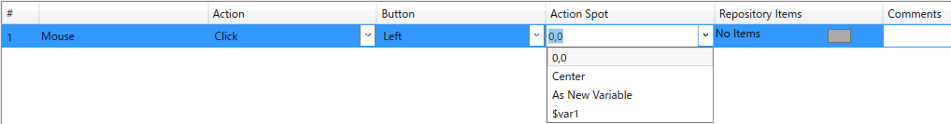

Repository Items allows you to associate repository items (controls) with actions. During the execution of this step, the specified mouse action is executed on the associated repository item (control).

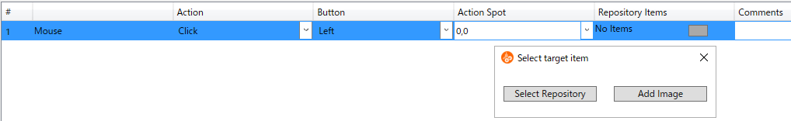

Select Repository: Allows the user to select an existing repository and link to mouse actions.

Add Image: Opens Screen Capture mode. The user can select the area that needs to be captured. After capturing, the selected area will be saved in the repository as a screenshot. The Edit click location window will then open.

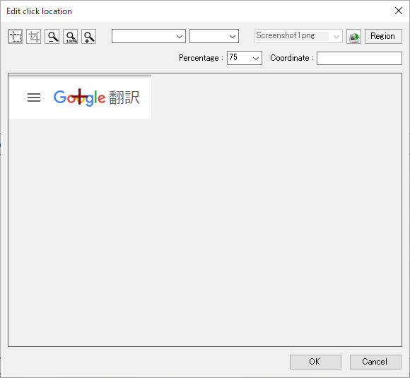

The Edit click location window allows you to specify the mouse operation position.You can enter the coordinate location directly or select a variable from the combo box.

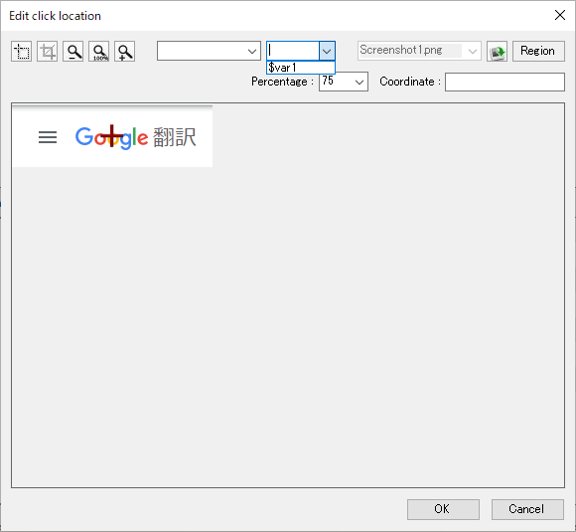

Clicking the OK button causes the Action Spot to reflect the mouse operation position specified in the Edit click location window.



##### **Mouse Wheel**



User can automate the mouse wheel operation such and scroll of horizontal and vertical scroll bar in the views using this option by specifying the unit. For this action a repository item assignment is not required. Default Mouse Wheel action selection gives the following entry.

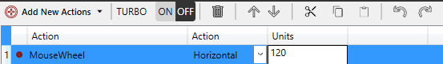

##### **Drag and Drop**



User can automate the drag and drop operations using this option by specifying both drag and drop action points. For this a repository item assignment is required. While executing this step, the specified mouse action will be performed on the linked repository item.

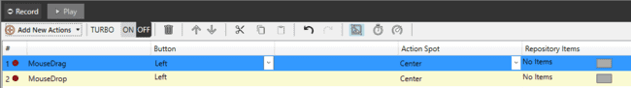

**How to add drag and drop step manually**

Select the element to be dragged as the repository item for MouseDrag step. Choose which mouse button has to be clicked for drag operation in Button column. The coordinates where the drag operation has to be initiated has to be mentioned by the user in the Action spot column of the MouseDrag step. For Canvas element, the coordinates entered will be taken and for other elements the Action Spot value will be taken as Center during the drag operation.

Select the element in which the dragged item has to be dropped as the repository item for MouseDrop step. The coordinates where the element has to be dropped should be mentioned in Action Spot column. For Canvas element, the coordinates entered will be taken and for other elements the Action Spot value will be taken as Center during the drop operation.

If the selected repo element is other than canvas the drag and drop operation will be performed in the middle of the element.

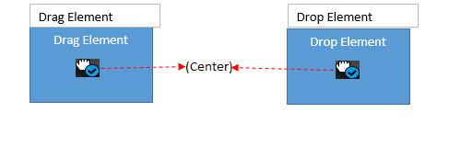

If the selected repo element is canvas element then the coordinates provided will be added with the x and y location of the canvas element.

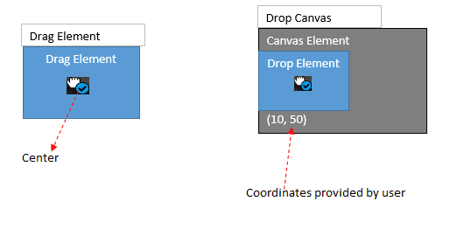

If the selected repo element is canvas element then the coordinates provided will be added with the x and y location of the canvas element.

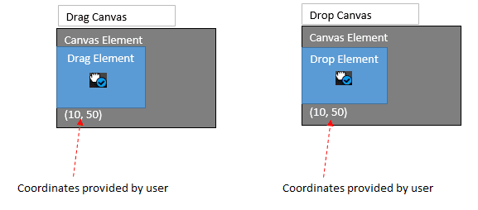

**Note:** Repo element other than canvas the coordinates provided by the user will not be considered. Element's center will be used as drag start location and drop location.

#### Keyboard Operations

##### **Key Sequence**

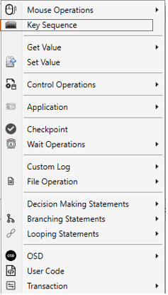

User can simulate the keyboard sequence using this option, this action makes it possible to generate keyboard events. This action is typically recorded in a form filling scenario (e.g. username field in login process). For this action a repository item assignment is not required.

Adds a new key sequence action item (Ex. ‘How are you’).



Key sequence action only stores the keystrokes made during a recording.

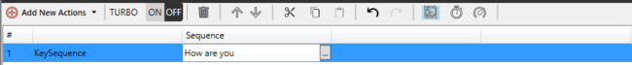

Open Keystroke dialog

Key stroke dialog.

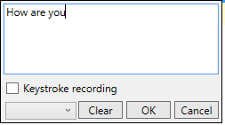

It can also add short-cut key combination (e.g. Ctrl+A).

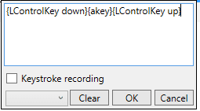

|  |  |
| --- | --- |
| Keys | Representation in Concord Key Sequence action |
| Enter Key | {Return} |
| Esc | {Escape} |
| PrtScn | {PrintScreen} |
| Backspace | {Back} |
| Windows key | {L/Rwin} |
| Control Key | {L/RControlKey} |
| Shift Key | {L/RShiftKey} |
| Alt Key | {L/RMenu} |
| Window/Shift with any key | {Window/Shift down}key{Window/Shift up} |
| Alt/Control with digit | {Alt/Control key down}{Ddigit}{Alt/Control key up} |
| Alt/Control with alphabets | {Alt/Control key down}{Alphabetkey}{Alt/Control key up} |
| Numpad key when numlock is on | {NumPaddigit} for example NumPad7 for 7 |

User can make use of already created variables by selecting it from the combo box of Key stroke dialog.

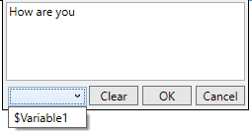

Specify the variable name and the default value which is automatically set to the same value as it was recorded initially.

After adding variable from keystroke dialog

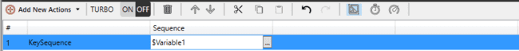

**Keystroke Recording**: Checkbox “Keystroke Recording” enables the feature to record the special key character, hot keys in the form of key codes.

For example, to record the Key Combination of Alt+F4 or Ctrl+Alt+Del, simulate such key combinations by entering them manually. Just check the “Keystroke Recording” and enter the keys manually.

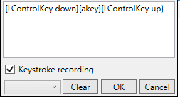

**AutoSave:** As soon as focus changes from the Keystroke user interface if “Keystroke Recording” is checked, contents of the text area will get saved.

**Clear:** Cleans the text input area.

**Ok**: Saves the text.

**Cancel:** Ignore the current text inputs in the text area.

#### Get Value Operations

##### **Object Information**

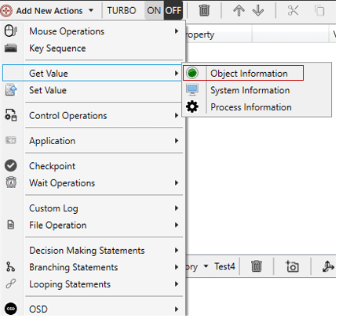

As the action name indicates, this option can be used to get values from repository items i.e. object. Depending on the assigned repository item, the available attributes can be different. The value obtained can be assigned to a module variable. This module variable can be used for ‘Set Value’ action, i.e. user can set the obtained value to another repository item.

There are 3 attributes for Object Information – Value, Variable and Repository Items.



User can select the desired value from the drop down.

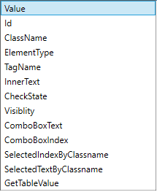

User can get information about the following items.

* **Value**: Gets value of repository items that have value attribute.
* **Id**: Gets Id linked of repository item.
* **ClassName**: Gets ClassName field of repository item.
* **ElementType:** Gets ElementType for linked repository item (E.g.: BUTTON, INPUT etc.).
* **TagName**: Gets TagName attribute for linked repository.
* **InnerText**: Gets innerText of repository item.
* **CheckState**: Checks the checkbox control.
* **Visibility**: This property is available for all controls.
* **ComboBoxText**: This property is used to get combo box text.
* **ComboBoxIndex**: This property is used to get combo box index.
* **SelectedIndexByClassName:** For list control, user can get selected index by giving input as classname.
* **SelectedTextByClassName:** For list control, user can get selected text by giving input as classname. Classname is defined in the css.

If “SelectedIndexByClassName” or “SelectedTextByClassName” is selected, then the class name should be entered in the “Classname” field. Both these items are used to get text or index of the list item.



Repository item of this step should be immediate parent of “li” such as “ul” or “ol” tags.

* **GetTableValue**: This option is used for fetching table value (row, column). This is for fetching data (innerHTML) inside <td> element of a table. The row and column values of the table should be entered in the “Row,Column” field.



|  |  |
| --- | --- |
| Variable field contains available variables and also user can add additional variables by clicking on the variables button in the top right corner of the application. |  |

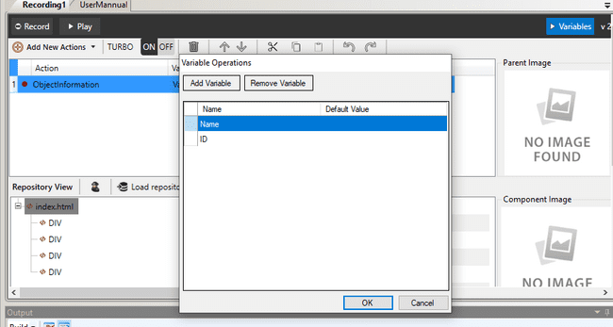

Refer 8.3 section for more details on variables.

To add repository items, click on the button present in the Repository Items cell. This will open up the Select Repository dialog box from which the user can select the desired item.

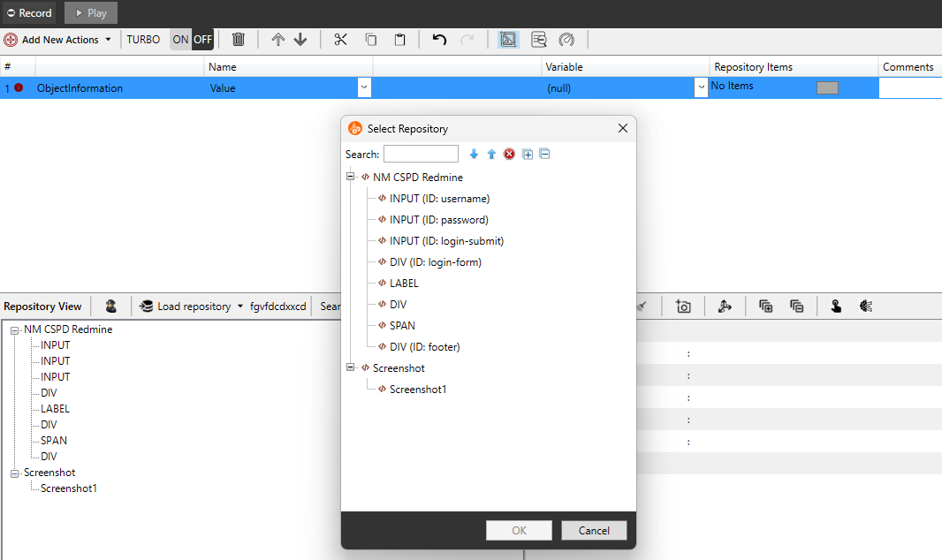

##### **System Information**

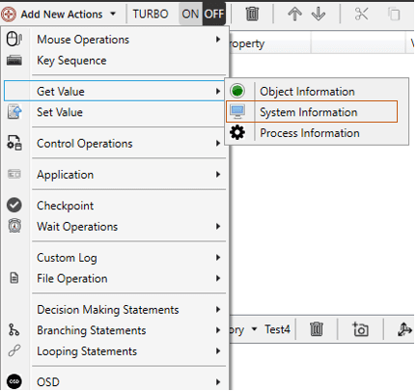

This option is used for getting system information such as:

* CPU Usage
* Get RAM (Available Mbytes)
* Date Time
* Mouse Cursor
* Cursor Position
* Cursor On Display

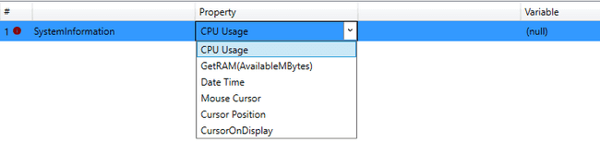

These information can be stored in variables, which can later be used for other purposes.

**CPU Usage:**

To get the value of current CPU usage select CPU usage from property.



Then select the variable in which result is to be stored.

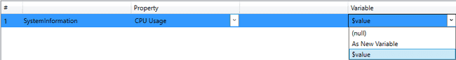

**GetRAM (AvailableMBytes): T**o get the value of current RAM select GetRAM option from Property. Also, select the variable in which the result is to be stored.



**Date Time:** To get the value of current Date and Time select Date Time option from Property and also select the variable.



The result will be stored in the selected variable.

**Mouse Cursor:** To get the value of current Mouse Cursor arrow select Mouse Cursor option from Property



**Cursor Position:** To get the value of current cursor position select the option Cursor position from property and also the variable in which the result is to be stored.



**Cursor on Display:** To get the value of Current Cursor on Display select the option CursorOnDisplay from the property and the variable in which the result is to be stored.



##### **Process Information**

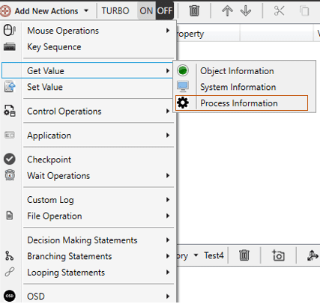

This action is used for getting information of the process which is currently running in background. It require the process name and the property name of the process whose information need to obtained.



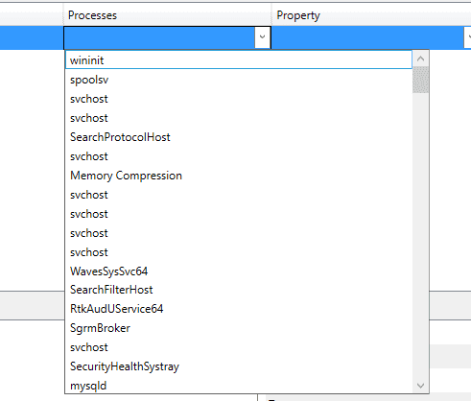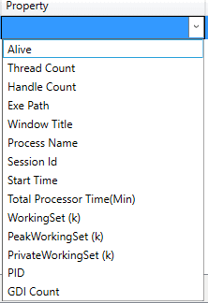

**Working Set (K):** To get the information regarding the process having property working set select working set from property.

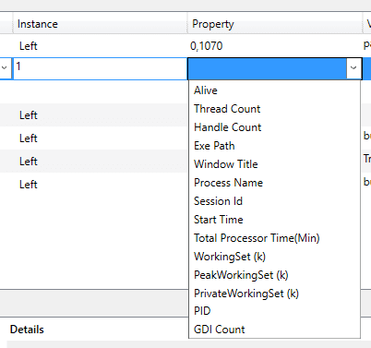



**Peak Working Set (K):** To get the information regarding the process having property peak working set select peak working set.



**Private Working set (K):** To get the information regarding the process having property private working set select private working set.



**PID:** To get the information regarding the process having property PID select PID.



**GDI Count:** To get the information regarding the process having property GDI count select GDI count.



These information can be stored in variables, which can later be used for other purposes.

The Red error mark shows that the step is Invalid. The tooltip shows what needs to be selected to make it a valid step as shown in below figure:

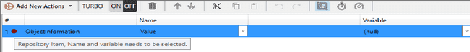

#### Set Value Operations

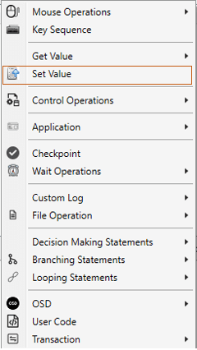

This method can be used for setting values to attributes of repository items. Depending on the assigned repository item, the available attributes can be different. The value obtained using Get Value in a variable can be used to set another repository item.

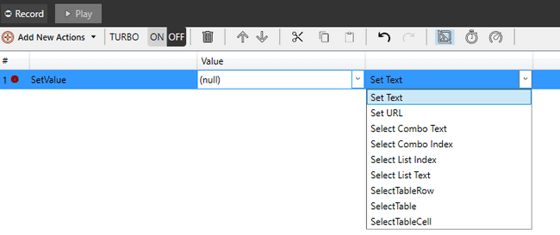

User can set the following values.

**Set Text**: Sets values in text box. This item is applicable only for INPUT control.

**Set URL:** Setsvalue in chrome/edge browser whichever is open and navigates to the given URL during execution. URL is given in the value column either directly or using variable. No repository items are associated with this.If both chrome and edge browsers are open, set url execution will fail and the following error message will be displayed on report.

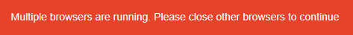

**Set Combo Text:** Sets text values in combo box.

**Select Combo Index**: Sets index value for combo box.

Set Combo Text and Set Combo Index are applicable for SELECT control only.

**Select List Index**: Sets index value for list box.

**Select List Text:** Sets text value for list box.

Both Select List Index and Select List Text are applicable for LI or UL controls.

**SelectTableRow**: Selects single row of a table.

**SelectTable**: Selects entire table.

**SelectTableCell:** Selects single cell of a table. The value of table cell should be given in the value column

SelectTableRow, SelectTable and SelectTableCell are applicable only for TABLE control.

#### Control Operations

##### **Check Box**

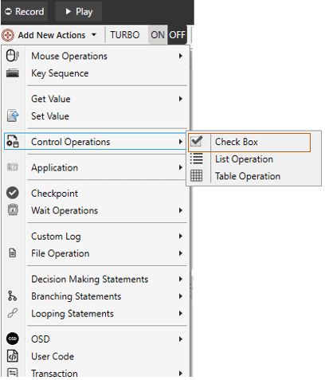

Using this operation, user can simulate the check and uncheck operation of checkbox control in AUT. This action is used to check or uncheck the check box control on a selected repository item of chromium application. The selected repository item attribute type should be "checkbox".

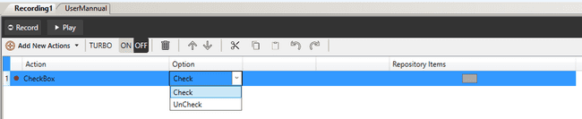

##### **List Operation**

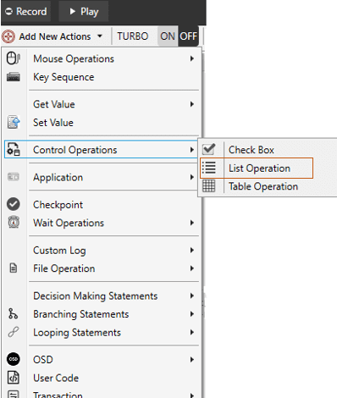

Using this step user can simulate the selection of list box item by specifying the index of the item to be selected in the list box. This action is used to select item in list control on a selected repository item of chromium application. The repository item of the list operation should be parent element of the “li[]” element.

For example:

If the “li[]” elements xpath is “//html[1]/body[1]/div[1]/div[1]/div[1]/ul[1]/li[2]”. The repository item that has to be provided for the list operation is till the “ul[]” for the above given example, so the elements xpath of the parent of “li[]” will be like “//html[1]/body[1]/div[1]/div[1]/div[1]/ul[1]”.



##### **Table Operation**

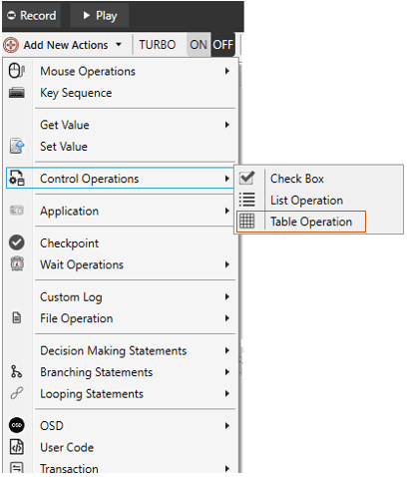

Using this step user can simulate the selection of a single row or a table control. This action is used to select item in table control on a selected repository item of chromium application.



**SelectRow:** This operation is used to select any table row in the given repository item which is a table. The index of the row that has to be selected in the table has to be mentioned in the “Value” column. It can be value or variable.

The repository item of the Table operation “SelectRow” should be table element.

For example:

If the “tr[]” elements xpath is “//html[1]/body[1]/div[1]/div[1]/div[1]/table[1]/tbody[1]/tr[2]”. The repository item that has to be provided for the table operation is till the “table[]” for the above given example.

So the elements xpath of the parent of “tr[]” will be like “//html[1]/body[1]/div[1]/div[1]/div[1]/table[1]”

**SelectTable**: This operation is used to select a table which is the child of the given repository item. The index of the table that has to be selected from the repository item can be mentioned in the “Value” column.

The repository item of the Table operation “SelectTable” should be table element.

For example:

If the “table[]” elements xpath is “//html[1]/body[1]/div[1]/div[1]/div[1]/table[1]”. The repository item that has to be provided for the table operation is till the “div[]” for the above given example.

So the elements xpath of the parent of “table[]” will be like “//html[1]/body[1]/div[1]/div[1]/div[1]”

#### Application Operations

##### **Start Application**

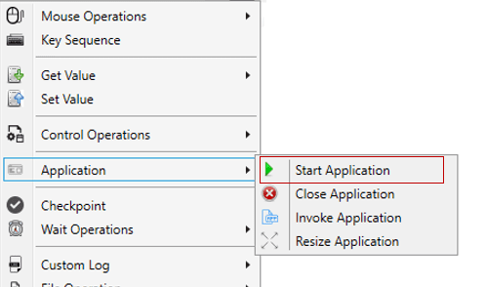

Start application step is used to invoke any application in the given path. The start application step will be displayed in step view as shown below.



##### **Close Application**

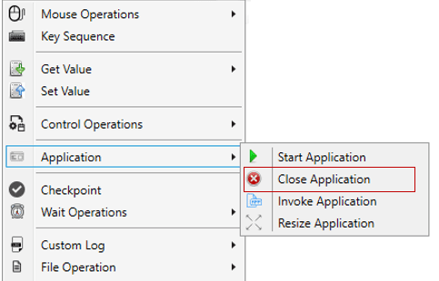

Close application step is used to close any running application. Close application have three options as shown below.

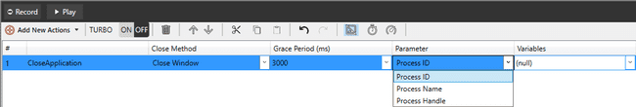

If Process ID/Process Name is selected, then user will see variable list other than Start application variables. User can close process with selected variable’s default value having process name/id (if it is open).

##### **Invoke Application**

Invoke application will simply invoke the app to the front whose PID is provided.

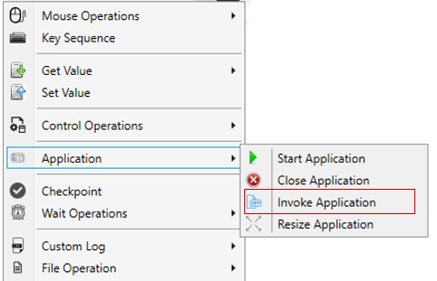

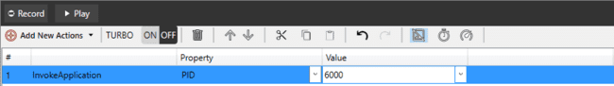

##### **Resize Application**

With process ID as input, user can maximize or minimize the given process( for dialog applications).

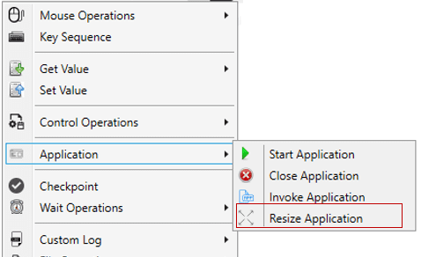

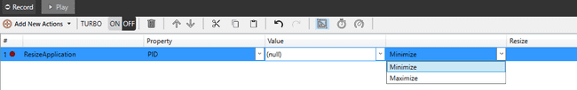

#### Checkpoint Operations

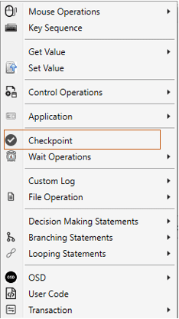

Checkpoint opens the Expression Generator window. Expressions can be created in “Expression Generator” window. User can create the Expressions using various actions like Exists, Not Exists, Property, Compare Image and Variable Compare. Expression Generator window also provides options for creating AND/OR expressions based on action’s values.

Click on Checkpoint in ‘Add New Actions’ to open Expression Generator window as shown.

The Expression Generator window:

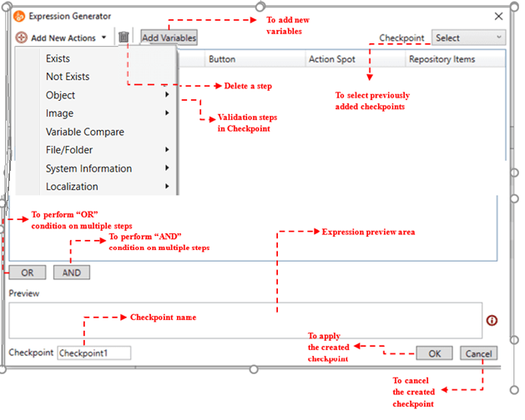

In this Expression Generator dialog, ‘Add new action’ menu contains Sub action using which user can create expressions.

User can see already created checkpoints in Available checkpoints combo box which is top-right side. User can check and also re-write checkpoint label which is bottom-left. User can create expressions using [OR] and [AND] button. It will work as per their truth table. Using this user can create conditions of multiple expressions.



After creating condition Expression generator will be shown as below:

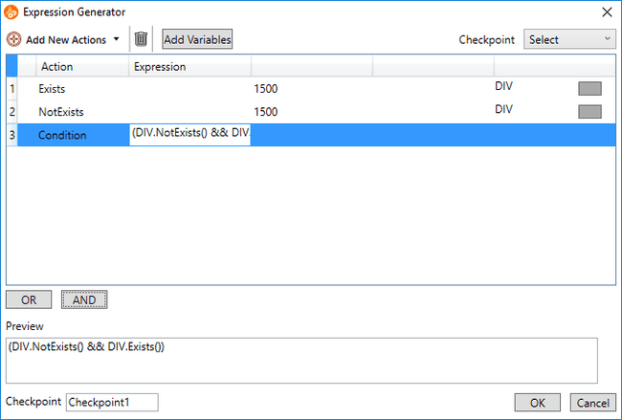

Final condition user can use for checkpoint in Main IDE. After clicking [OK] button user can see Checkpoint label in main IDE column. If user wants to change expression then he can modify again by clicking same button which is used to open Expression Generation window.

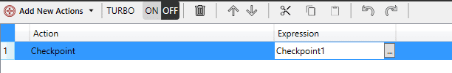

##### **General Checkpoints**

###### **Exists**

The sub action checks for the existence of the repository item and expects an existing item.

Example:

A user can validate whether a button exists with a resulting success if the button actually exists.

Time out field decides the time out for searching the item. If the selected repository item is not found in the time allotted in this field, the step fails. If the item is found, based on the condition/action in the step, the step may pass.

Repository Item is compulsory filed for Exists. After selecting item window will be shown as follows

E.g. Exists Object

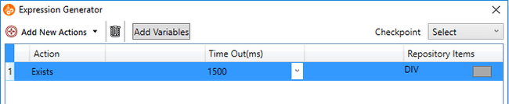

###### **Not Exists**

The validation checks for the existence of the repository item and expects the item not to exist.

Example:

A user can validate whether an error dialog does not exist with a resulting success if the dialog does not exist.

Time out field decides the time out for searching the item. If the selected repository item is found in the time allotted in this field, the step fails. If the item is not found, based on the condition/action in the step, the step may pass.

Repository Item is compulsory filed for not-Exists. After selecting item window will be shown as follows

E.g. Not Exists Object



###### **Object Checkpoint**

###### **Property**

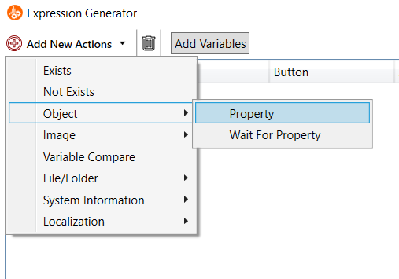

User can find property under object Action. This validation checks whether a specified repository item is equal to a specific property value. Property will be displayed according to item selected in repository. It is depends on item’s Control Type.

Example:

A user can validate a button name by selecting its property “caption”.

On selecting Property following row will be added

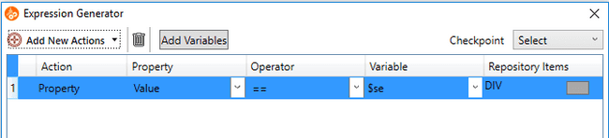

Repository items, Property, operator, variable these all fields are compulsory for property validation.

The following property values are available.



If the user selects ”SelectedIndexByClassname” or “SelectedTextByClassName” and the button in the “Property” field is clicked , following popup will appear in the steps that allows the user to input value.

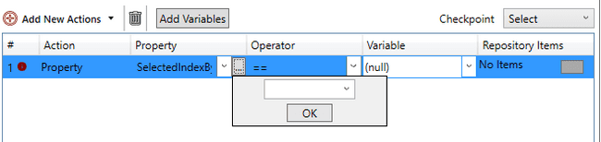

All the available variables will be displayed on clicking on the dropdown in the popup.

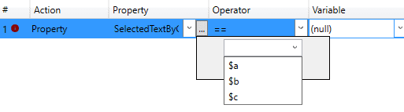

If “GetTableCell” is selected and the user clicks on the button in the “Property” field, following popup will appear.

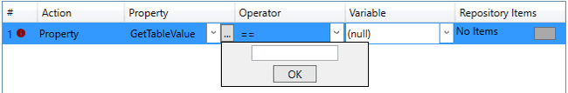

Operator used for compare property and variable values. Operator fields contains following operators.

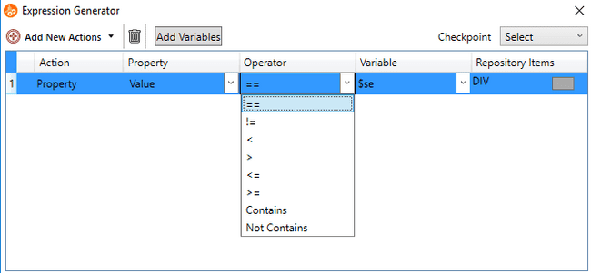

Variable field contains Available variables, default values of selected property and also user can add variable using “As new variable” option.

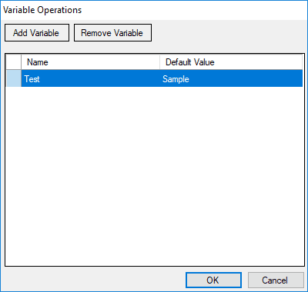

###### **Wait For Property**

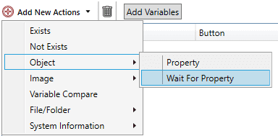

This validation will wait till the allotted time for an object to get the specified property.

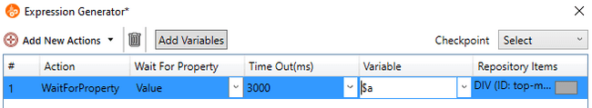

The following property values are available.

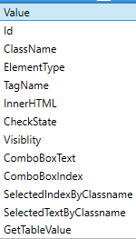

If the user selects SelectedIndexByClassname, SelectedTextByClassName, or GetTableValue, following popup will appear in the steps that allows the user to input value.



Time out field decides the time out for searching the item property value and matching with variable value. If the selected repository item’s property value is not found in the time allotted in this field, the step fails. If the item’s property value is found, based on the condition/action in the step, the step may pass.

Repository items, Property, time out and variable fields are compulsory for Wait for property validation. Property field will populate after selecting repository items. Variable field contains available variables, default values of selected property and also user can add variable using “As new variable” option.

See the figure shown below.

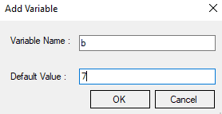

###### **Image Checkpoint**

Image checkpoint provides log of the similarity as well as the difference in two compared images. It also has contain Image option. Mostly image checkpoint is useful to compare the image obtained from the object with the reference/parent image. Two types of comparison can be carried out using Image Validation: Compare.

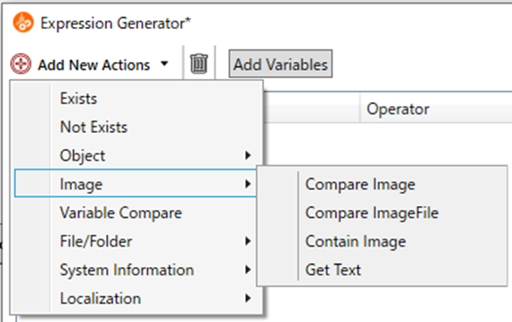

**Compare Image**



This validation checks whether a specified repository image is equal to a specific screenshot. The image comparison will fail even if there is a small difference in the size of the image.

**How to perform Compare validations:**

* + Choose action Compare. This will add new row into the Expression Generator window. Please note the default values for current row’s cells would be as same as shown below in the image.

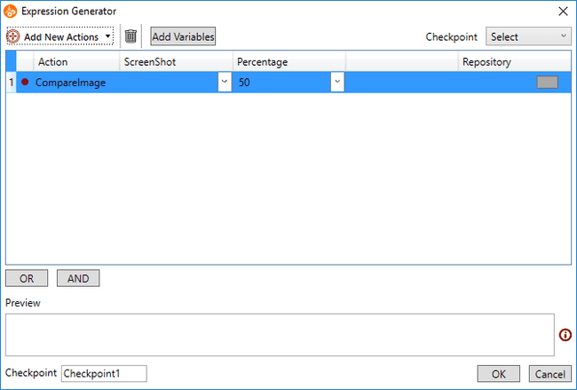

* + Click on the button present in the Repository Items cell. This will open up the Validation dialog box. This dialog let’s user choose between ‘Select Repository’.

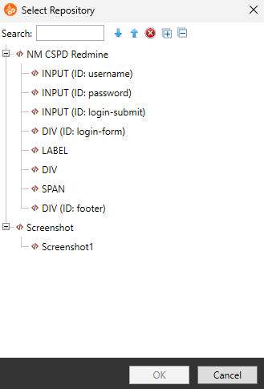

**Select Repository**: This will open up another dialog to select any one available repository out of available repositories list.

**Add Image**: This will open up the screen capture mode. User can crop a co-ordinates using mouse. This will generate a co-ordinate’s value.

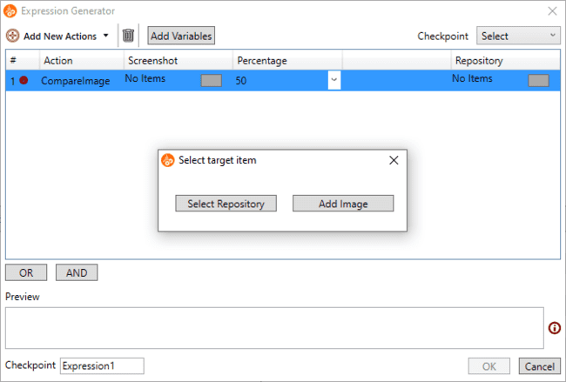

* + Once user is done with adding the actions using proper valid values. User can create AND/OR options as shown below. Making such expressions, will add new row as a condition number. If user has created proper valid actions.

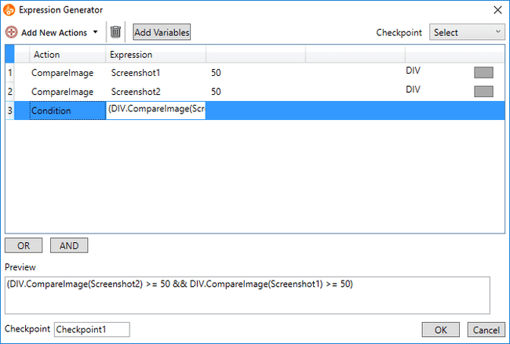

* + When comparing images with Pixel by Pixel in Compare Image , you can specify the area to exclude the comparison. The exclusion area is set in Excluded area . The Excluded area is only visible when comparing on Pixel by Pixel.



The exclusion area specifies the x, y coordinates in the comparison image and the width and height from those coordinates in the following format.

The specified exclusion area is displayed as a translucent red rectangle in the image.

**Contain Image**

This validation checks whether the repository item’s image contains a specified screenshot. This can be useful for tweaking the similarity of the corresponding image validation action.

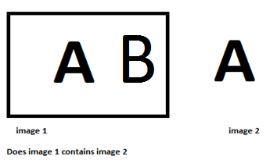

For this select the Contain Image option from Image in Add New Actions.

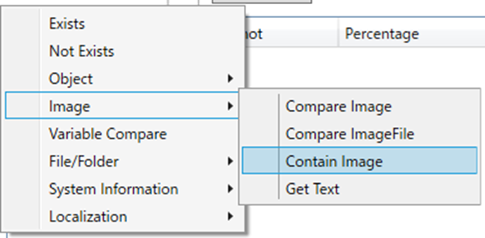

Example: It's possible to validate whether the user-defined list of icons contains a specific icon. This can be done using image-based validation. The repository item would therefore hold the list of icons and the screenshot would be a picture of the specified icon. The validation would lead to a result if the list contains the specified icon.

For both Compare Image and Contain Image operations, user can update screenshot image without unlinking from steps. The edit click location dialog box will be displayed when clicking on the button present in screenshot item cell.

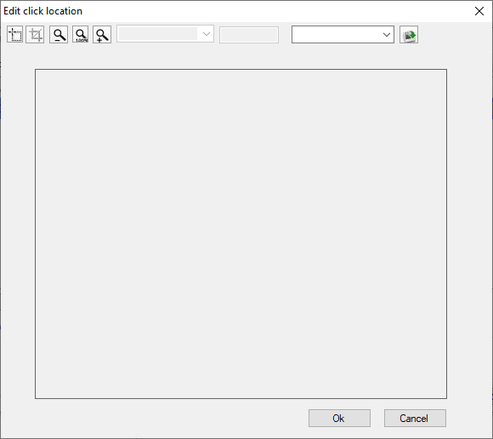

User can crop, zoom in or zoom out the existing image. User can also select any other . from the repository or import another image from disk. User can also change the Compare/Contain validation percentage.

**Note:** While updating image, if new image is a single color image then user will get a following warning message. As single color image may give wrong result.



**Compare ImageFile**

This validation checks whether the specified repository image is equal to the image displayed during the test run. The image displayed during test execution is the image captured by the Capture Screenshot action described later, and is used for comparison using a variable whose value is the image file path. This function has the following features.

**How to perform Compare ImageFile validations:**

* + Select the action “CompareImageFile”. This will add a new line to the Expression Generator window. Note that the default values for cells in the current row are the same as the values shown in the image below.

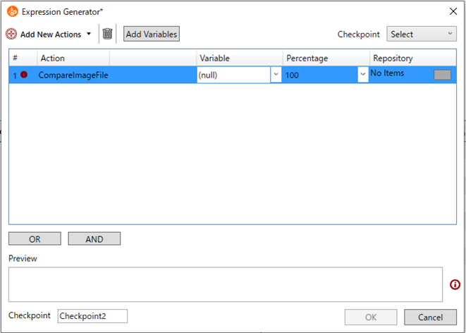

* + Click the button in the repository item cell. This will open the Select target item dialog box. This dialog allows the user to choose from ‘Select Repository’.



**Select Repository**: Another dialog will open allowing you to select one repository from the list of available repositories.

**Coordinate**: Another dialog will open where you can set the region values. You can also crop coordinates using the mouse on the screen to generate coordinate values.

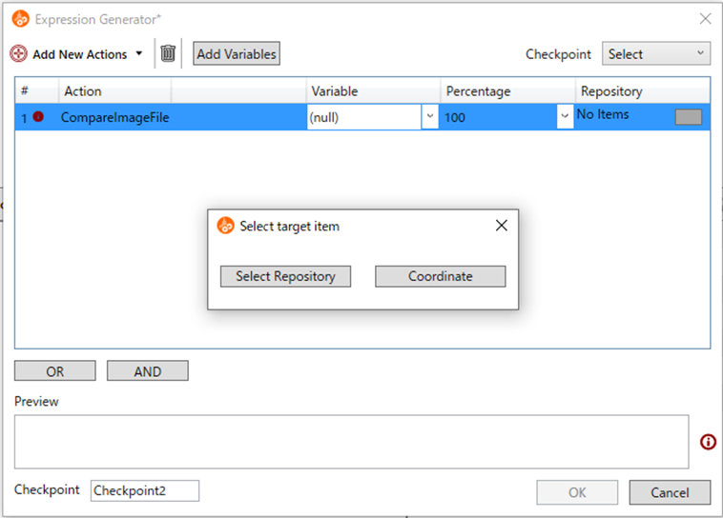

* + Users add actions with appropriate valid values. User can create AND/OR options as shown below. Creating such a conditional expression adds a new row as the condition number, provided the user creates an appropriate valid action.

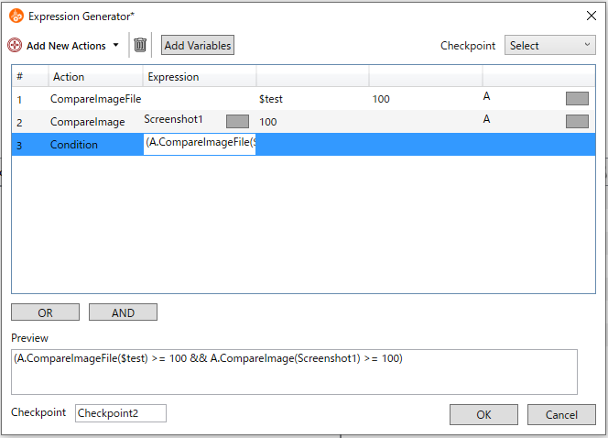

* + You can specify areas to exclude from comparison. Exclude areas are set in the Exclude dialog. After selecting a repository or area, open the repository selection dialog again and a new option "Exclude Areas" will appear.

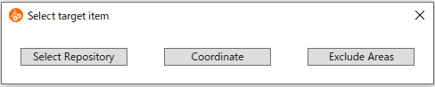

**Exclude Areas**: The xclude dialog allows you to exclude multiple unwanted areas of an image and save the corresponding excluded image. This is useful for filtering out dynamically changing text like dates and times.



###### **Variable Compare**

User can create expressions using Variables (String, Integer, and Decimal)/Constants or User Variables (Which is already saved in “Variable Operations” Window).  
User can create expression by two way

* **Using Variable/Constants** – User can directly enter string, integer or decimal values.

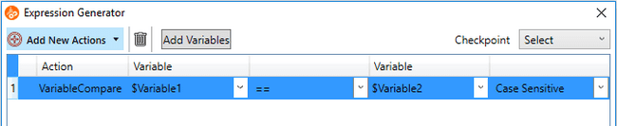

* **Using User Variables** – User can select variables from Saved variables.

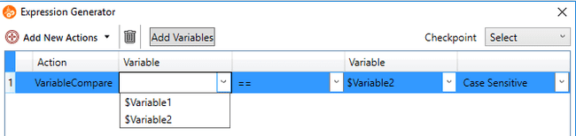

###### **File/Folder**

###### Property

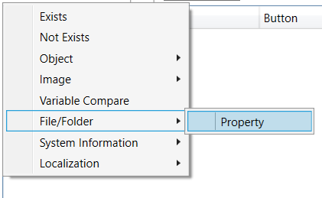

File/Folder property is used to check the size of selected file/ folder or existence of selected file/folder. User will provide one value for comparison in variable column to check size and existence of file/folder and one value will get runtime (actual value of file/folder).



There are two ways to select file/folder we can have file/folder path in relative path or in full path.

* One way is by clicking on the button shown in the figure below



* Another way is by saving the path in the variable as shown in the below figure.

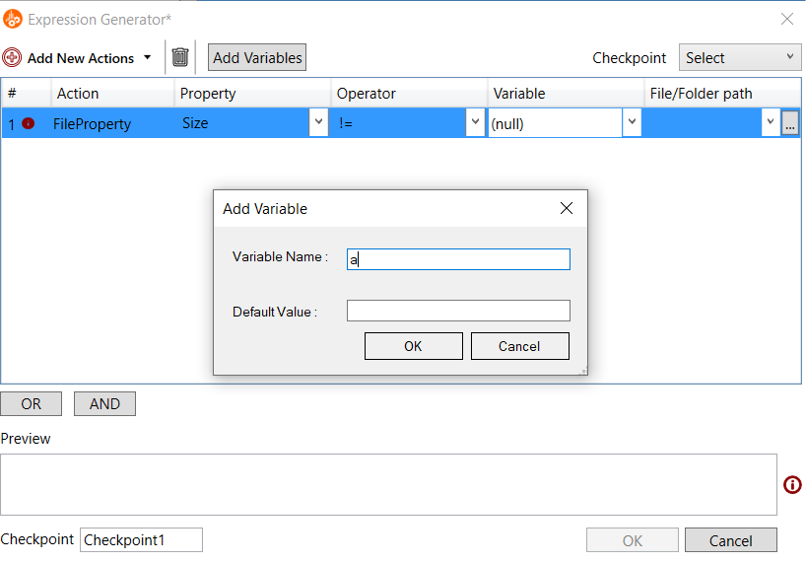

There are the two properties applicable for File/Folder.

* **Size :**

Size will have “==”,”!=”,”<”,”<=”,”>”,”>=” operators and can accept integer as a variable and also can be add by “Add New Variable” by giving only integer value in Default value other that integer is selected then it will empty the variable column.



* **Exists:**

Exists will accept only “==”,”!=” operators if other that these two are selected then it will empty the operator column and can accept Boolean value as a variable and also can be add by “Add New Variable” by giving only Boolean value in Default Value other than Boolean values are selected then it will empty the variable column.



###### **System Information**

**Mouse Cursor**Mouse cursor provides us to check run time cursor type. It is useful to know the type of the cursor. We need to select the operator and Cursor Value to validate the step.

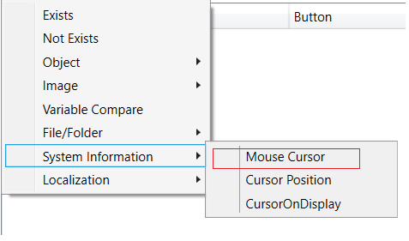

1. User can do following step :

We can do the comparison in mouse cursor step by comparing one value from drop down and it will take one value from the screen whichever cursor is present after playing. It will compare the cursor value one from the dropdown and one from the screen present during the execution.

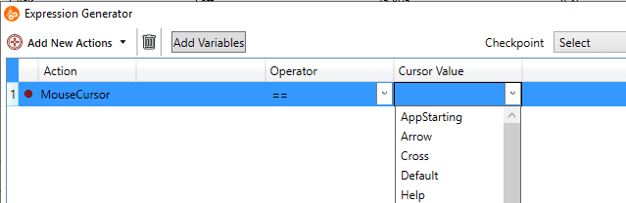

1. Step Added in the checkpoint dialog

In the below mouse cursor step we have selected the cursor value as “Arrow”, Now it will check whether same cursor is present on screen during execution or not. If the cursor matches then report will show “Pass” otherwise the report will show fail.

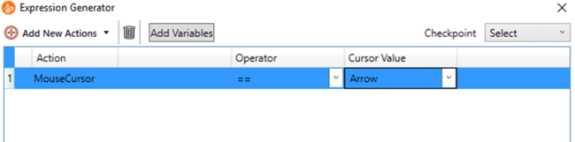

**Cursor Position**Cursor position will allow the user to check whether the cursor is present in a particular region of the screen.

a. Configuration Step

To check whether cursor is present in the particular region user can do the following. To select the region on screen user can do by using below Select Area dialog by putting coordinates and width and height manually, or user can also select cursor on screen it will provide the provision to select the region and coordinates and width and height will fill according to the captured area.

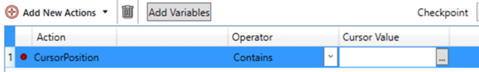

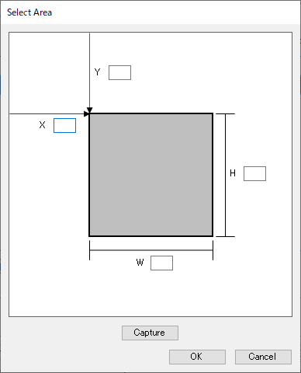

b. Step Added in the checkpoint dialog

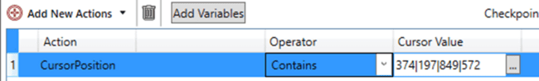

If the cursor is present in the mentioned region the report will show Passed.

**CursorOnDisplay**

This can be used to check if the cursor on display contains the given display number.

a. Configuration Step

Select CursorOnDisplay option from the Add New Actions. Then provide the operator and Display number.



b. Step added in the checkpoint Dialog

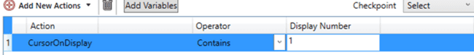

###### **Localization**

Localization is the**process of adapting software for a specific region or country** by translating text and adding locale-specific components. Checkpoints in this action aids used to do localization testing. Two types of comparison can be carried out in localization: GUI Text compare and GUI Image compare.

#### GUI Text Compare

GUI Text Compare checkpoint is used to verify the text in a GUI interface.When there is a change in the GUI due to a new requirement change like changing a string or adding a new component etc, there is a chance that the strings will get cut in the components.

In order to address this issue while testing, it is possible to use AI models to recognise the text from the GUI. By comparing with the strings that are stored previously in a configuration file, text can be verified in a GUI. In Text compare, user can add corresponding items like language,config file path and repository. GUI Text compare recognizes and verifies the texts in GUI.



On clicking the localization option, GUI Text compare opens and the below step is generated which consists of language,config file path and repository items.



* Language: Target language can be selected. Variable support is added for language.   
  Following 16 languages are supported.



* Config file: The strings available in the UI that selected in repository in each language can be stored as a json file. The path of json file can be browsed.Variable support is also added.

If UI labes are available in excel files (i18 excel files ), then configuration files for Concord can be created using ’GUI Text Config Creator’. This utility is available in Concord installation path %concordhome%\Utilities\GUITextConfigCreator



‘GUI Text Config Creator’ converts xls and xlsx files to json. User can select which all columns needed be converted as json. Each column will be converted as separate json files. The format of converted json file is shown below.



**How to perform Text compare validations**

Step 1: Choose action GUI Text Compare. This will add new row into the Expression Generator window.

Step 2: Click on the button present in the Repository Items cell. This dialog let’s user choose between “Select Repository” and “Add Image”.



**Select Repository**: User can select controls from repository. This option is same as ‘Compare Image’ action.

**Add Image**: This option allow user to capture a screen area. This option is same as ‘Compare Image’ action.

During execution of step, concord will capture the current screen based on above slection.

Once repository is selected and open repository selection dialog again, a new option will be displayed “Exclude Areas”.



**Exclude Areas**: In exclude area dialog, user can exclude the unwanted multiple region of an image and can save the corresponding excluded image This will help user to exclude text that dynamically change like date and time.



Once execution is completed, the following report will be generated which shows that the result is either pass or fail. Text which correctly mached will be displayed in green bounding box and not matched texts will be displayed in red bounding box.

In failed report, a ‘Review’ button also displayed. In which user can view the image and statistics by selecting “Show image” and “Show statistics” option respectively. Some times, the fail might be expected as the text change is as part of new requirement or it wrongly considered as fail (as AI can not promise 100% accuracy). This such cases, user can review the result and change the result of failed steps to pass by selecting ‘Consider as Pass’ option.

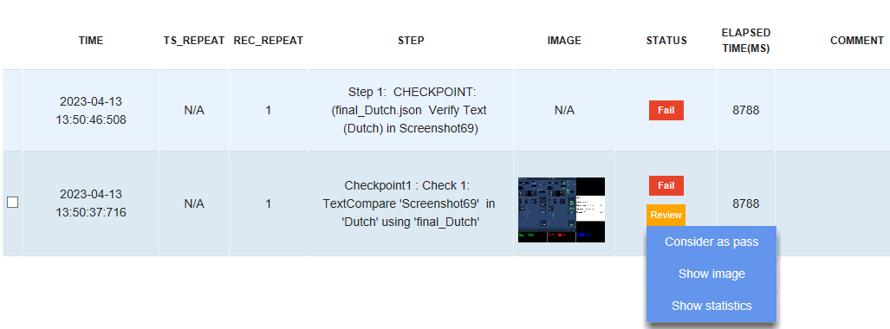

* **Configurations and Global settings**

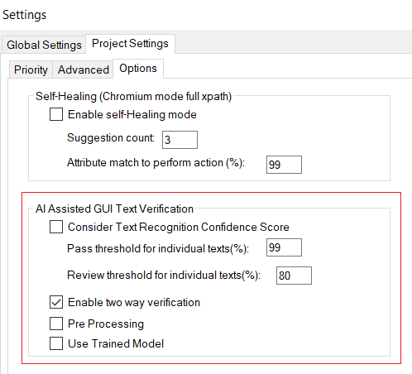

A new setting is added in Project Settings to run solution with GUI Text Verification (in Project Settings-> Options tab of Global project settings).

* **Text Recognition Confidence score**

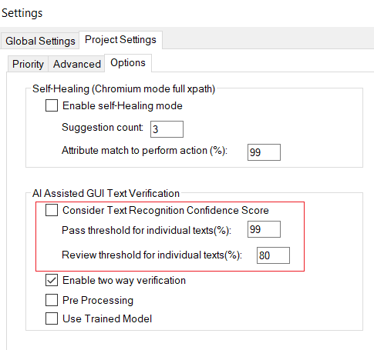

If the string obtained from the image is not exactly matched with the string in configuration file, user can decide whether the confidence score retured by the AI need to be used or not. It can be used as along with ‘text matching’ for deciding the pass or fail of a test case.

* + There is a checkbox option for Consider Text Recognition Confidence Score to determine whether we can include/not include the Confidence score.
  + If the above option is selected, we can choose the pass threshold and review threshold via edit boxes. These values are considered for individual texts. For example, if pass threshold is set as 99, all the texts with match percentage greater than or equal to 99 will be considered as pass. That is, it will be marked with green rectangle. Similarly, if review threshold is set as 80, all texts with match percentage between 80 and 99 will be considered for review and marked with orange rectangle.
  + All the text values below review threshold can be considered as ‘Fail’.

If the Text Recognition Confidence Score is not considered, all the texts that are not matched with the contents of the json file will be considered as ‘Fail’.

* **Pre-processing**

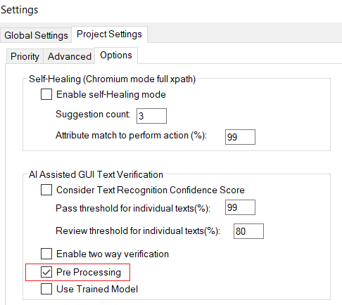

If pre-processing is enabled, accuracy of text recognition will be increased by sharpening the image. So, some strings that are not recognized earlier may be recognized after enabling pre-processing option.

* **Two-way verification**

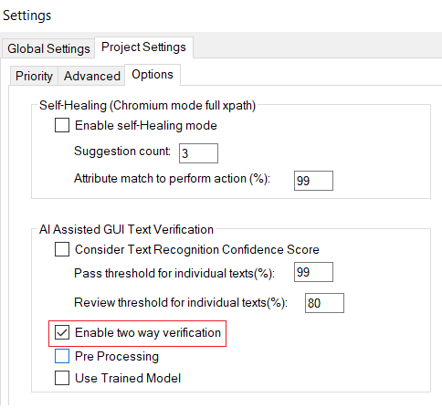

The purpose of two way verification is to check whether if strings are present in both json and image.

Enable two way verification OFF : Texts extracted from UI image will check whether it is available in the configuration file.

Enable two way verification ON : First, texts extracted from UI image will check whether it is available in the configuration file. Then it check all texts avalibable in the config file exist in UI image. When this operation is enabled, report will display the texts that not matched.

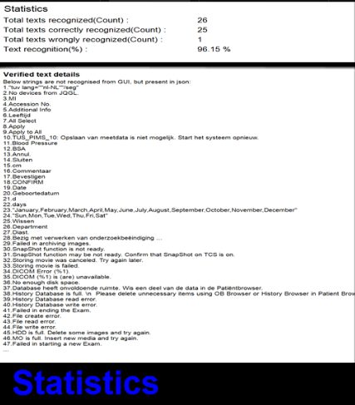

* Use trained model

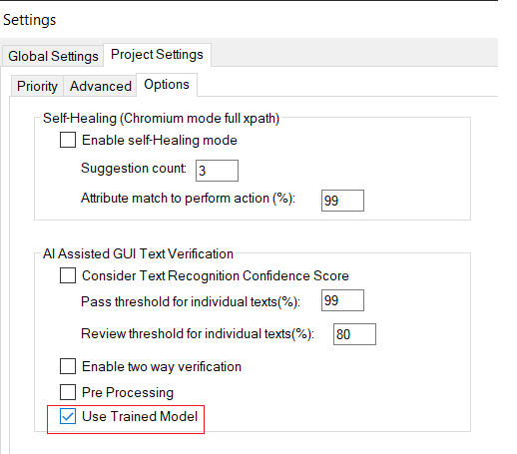

The main purpose of use trained model option is to load all the latest trained models also which will improve/enhance the accuracy if the current accuracy is not upto the desired expectations First of all, train the model by making use of text recognition training utility tool. Copy the trained model to the EasyOCR folder [\Concord\lib\ GUIVerificationexe\EasyOCRmodels].Once completed, check the “Use trained model” option and click on apply button. It will load the latest model along with the pre-trained models. This will ensure that the latest trained model will be considered along with other pre-trained models.

#### GUI Image Compare

When there is a change in the GUI due to a new requirement change like changing a string or adding a new component etc, there is a chance that the strings will get cut or the strings will be absent in certain components. There may be font change issues also. To address this issue while testing, it is possible to use AI models to detect label areas from the GUI screen shots so that it can be compared with a reference GUI screenthat is already captured. By comparing with this reference image, it is possible to mark the GUI areas in which the strings are changed.

On clicking the GUI Image compare property, the below dialog opens which consists of screenshot name and repository items.



**How to perform image compare validations**

Step 1: Choose action GUI image Compare. This will add new row into the Expression Generator window.

Step 2: Click on the button present in the Repository Items cell. This will open up the Exclude dialog box. This dialog let’s user choose between “Select Repository” and “Add Image”. User can choose anyone option provided on the ValidationDialogBox window. On the selection of Select Repository, Repository Selection Window will open as shown in the below figure. User gets option to search any repository, Expand/Collapse the tree view and Move Up/Move Down the selections.

**Select Repository**: This will open up another dialog to select any one available repository out of available repositories list.

**Add Image**: This will open up the screen capture mode.

Once saved the image to repository, another dialog opens when clicking on repository item cell. This dialog lets user can choose between “Select Repository”, ”Select Screen Area” and “Exclude Areas”.



**Exclude Areas**: In exclude area dialog, user can exclude the unwanted multiple region of an image and can save the corresponding excluded image.

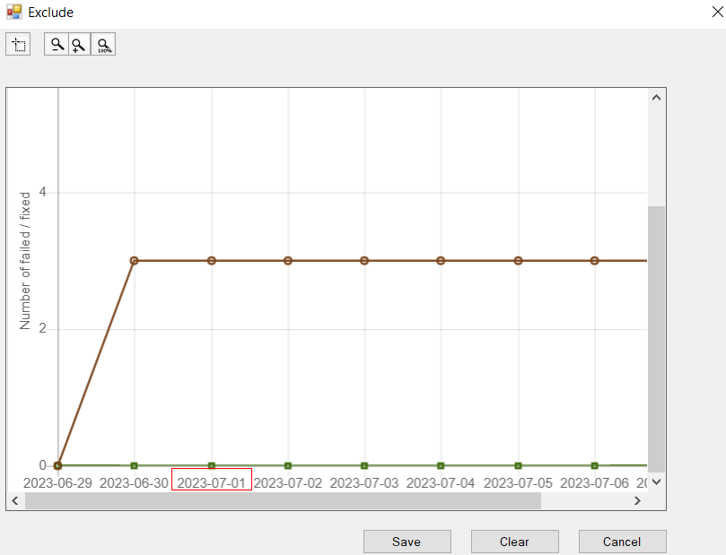

Report will contain the output image.



On clicking on the image, user can see the input image, output image and the statistics. Text which correctly matched will be displayed in green bounding box and not matched texts will be displayed in red bounding box.

In failed report, a ‘Review’ button also displayed in which user can view the image and statistics by selecting “Show image” and “Show statistics” option respectively.



#### Wait Operations

##### **Delay**

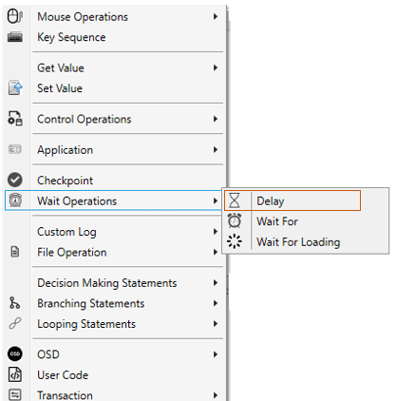

A delay action can be used to pause test automation execution for a specific time (column ‘Time (ms)’).

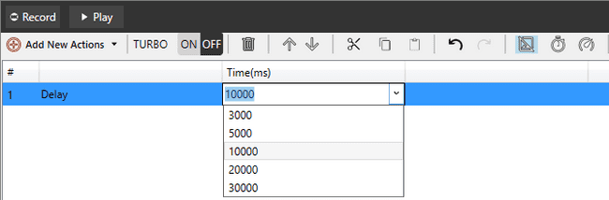

##### **Wait For**

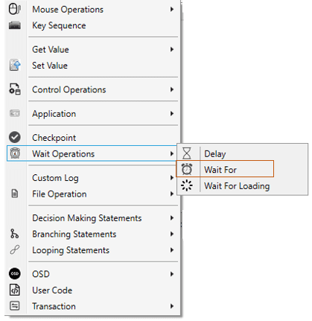

There are 2 options – Exists and Not Exists.

If ‘Exists’ is selected, the execution waits until the assigned repository item exists and if ‘Not Exists’ is selected, the execution waits until the item does not exists. Optionally, Timeout can also be specified. If timeout is specified, the execution waits until the assigned item exists/not exists within the specified time.  
It supports object and image both repository items.

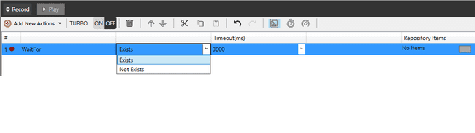

##### **Wait For Loading**

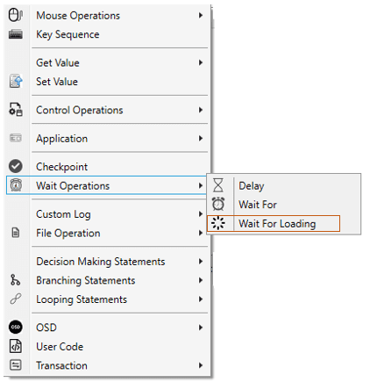

Wait for Loading is used if there is loading scenario as repository item. This waits for the given repository item to disappear.

The repository item to be used in the step should be the loading element or its parent that contains the “display” style property.

For example:

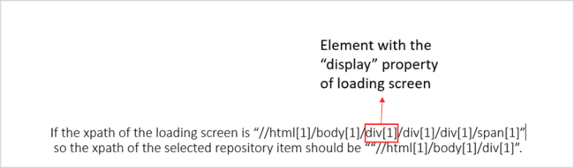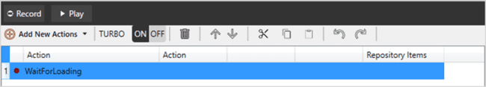

#### Custom log

##### **User Message**

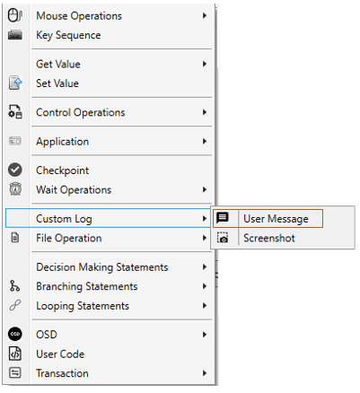

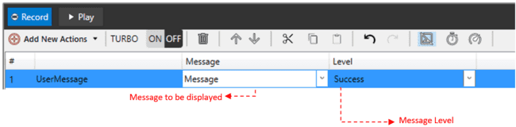

This action is used to show user provided message in the report. It also shows the level of the step. Within concord, user is able to use different levels of reporting information importance, from a debug message to failure information. Report Levels describe the importance of a message that is delivered to the report. Using different kinds of report levels can help in keeping the reports short and better readable.

The different levels of Report/Custom Log available are shown in below figure:

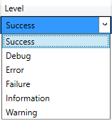

On executing the Custom Log action with User Message option below Report is created:

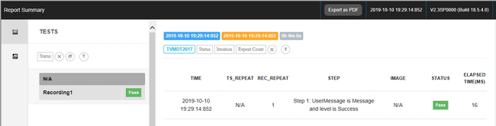

##### **Screenshot**

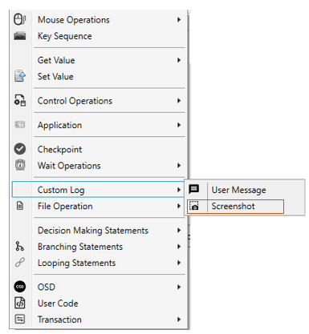

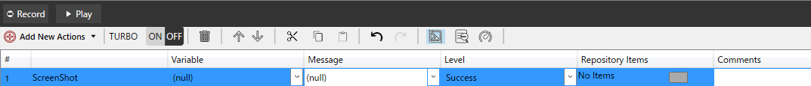

This action allows you to take a screenshot of the portion of the screen you wish to review. In this case, a screenshot of the desktop is taken, so Repository Items are not used.

The capture target will vary depending on the Repository Items setting.

[To take a screenshot of a specified repository item]

1. Click the rectangular button in the Repository Items cell to display the Select target item dialog.

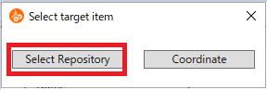

2. Select the repository item you wish to capture and press the "OK" button.

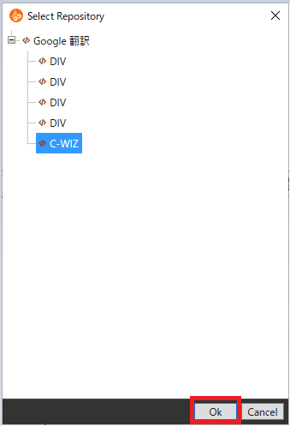

3. The selected item will be registered in the step.

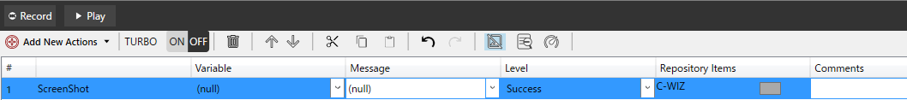

[To take a screenshot of a specified area]

1. Click the rectangular button in the Repository Items cell to display the Select target item dialog box, and press the "Coordinate" button.

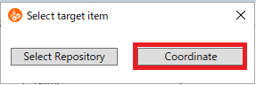

2. The Select Area dialog appears.

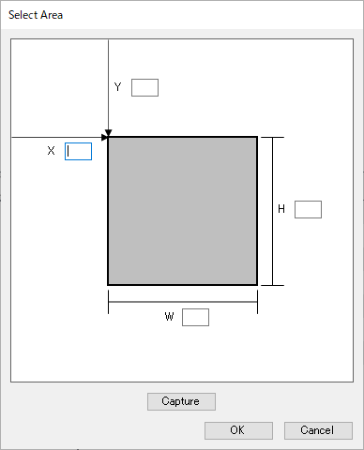

3. Enter values in the X, Y, W, and H fields or click the Capture button and drag & drop to specify the range.



4. When the OK button is pressed, the specified range (X|Y|W|H) is registered in the step.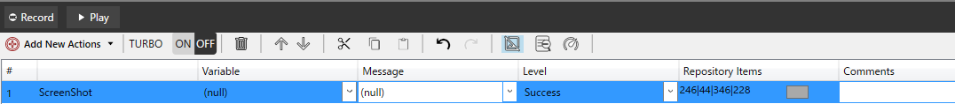

This also contains different levels of report as shown in below figure:

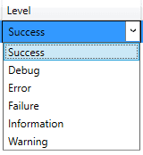

This step allows you to capture a screenshot of the portion of the screen you wish to review and store it in a designated folder. For details on specifying a folder, see Folder for saving report images.

The file path of the captured image can also be stored in a variable.

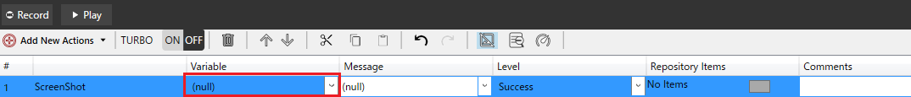

On execution following Report will be generated see the figure shown below:

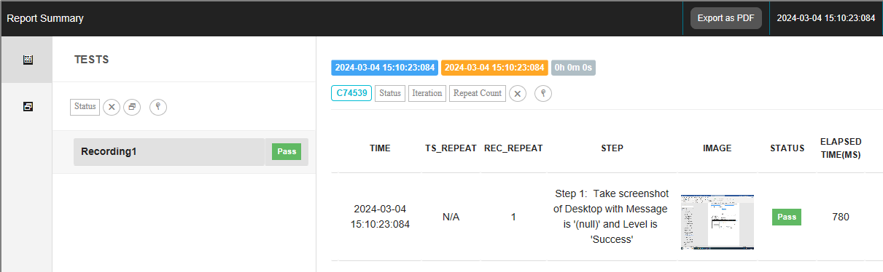

#### File Operations

##### **File Read**

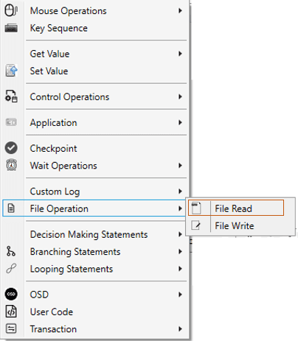

This operation is used to read value from selected file and save in selected variable. Following are the steps for file reading operation. Selected file size should be less than 2 GB. This is Maximum limit for file reading.

Browse the file path to be read by clicking the button show below.

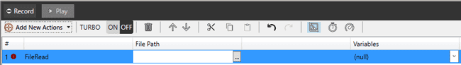

Select Variable in which file data is to be saved.

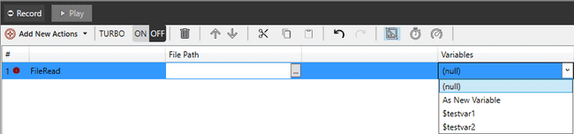

##### **File Write**

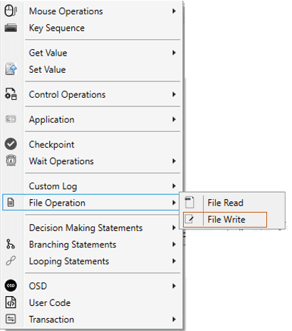

This action is used to write value in to selected file. Value to be written can be set by using variable or directly entering a string value. Below steps should be followed for file writing operation:

Browse the file path in which changes are to be made by clicking the button show below.

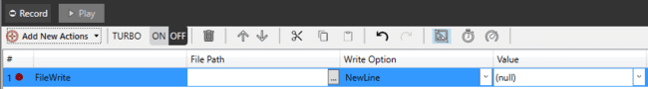

Select write option. In the option to write value in newline or append in same line or create new file are available. Select any one.

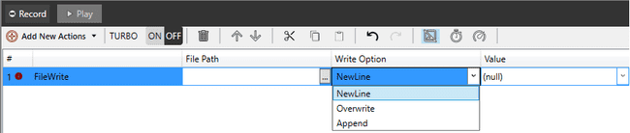

Select Variable or add directly string value or both for write.

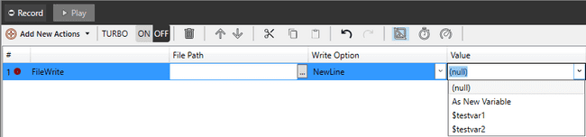

#### Decision Making Operations

##### **IF Statement**

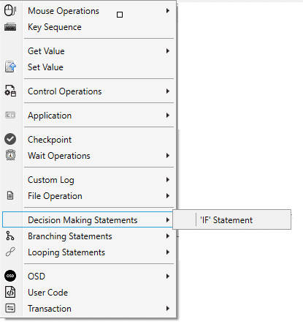

This operation is used to validate the expression generated by expression generator. User will have option to give condition checking block with the help of IF ENDIF.



IF expression is valid then it executes the inner statement.  
On right clicking EndIf statement, the context menu shows “Else” Option.

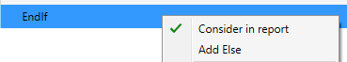

User can add Else statement by clicking the ‘Add Else” option.



#### Branching Operations

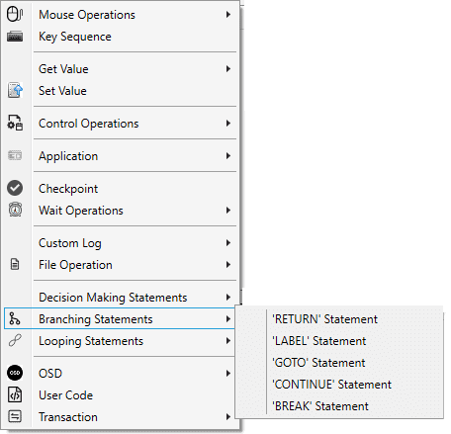

• **RETURN Statement:** Return statement user will stop execution of current recording.

• **LABEL Statement:** User can create label at anywhere in steps then can pass the execution control via the goto statements.

**• GOTO Statement:** The goto statement is a jump statement that controls the execution of the program to another segment of the same program via label.

• **CONTINUE Statement:** This statement alters control flow. It is used in loop bodies. It allows to skip the execution of the rest of the iteration.

• **BREAK Statement:** When the break statement is encountered inside a loop, the loop is immediately terminated and program control resumes at the next statement following the loop.

#### Looping Operations

##### **For Loop**

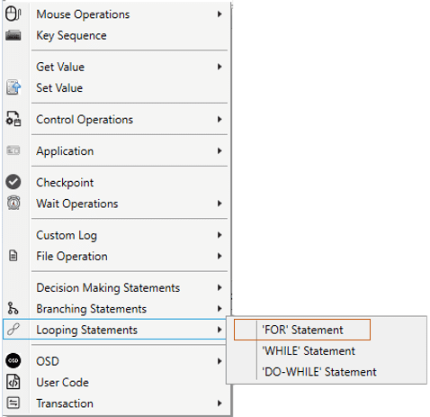

For loop is used to run the same statement or set of statements for a number of times. Enter a variable in Variables and use it to set the number of times the statement has to be done. The expression for ‘For loop’ can be set in For Block Expression Generator which pops up on adding a For Loop.



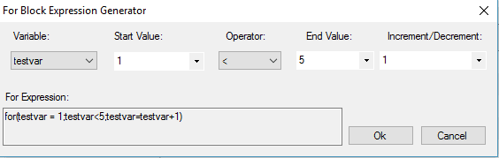

##### **While Loop**

While loop is used to run the same statement or set of statements till a particular condition is met. The condition can be set in Expression Generator which pops up on adding a While loop.

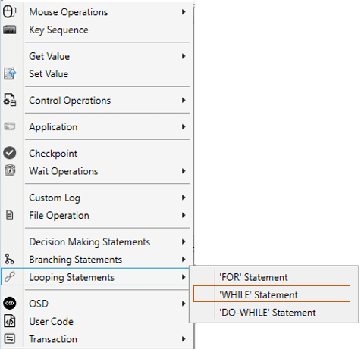



##### **Do-While Loop**

Do-While loop is used to run the same statement or set of statements till a particular condition is met. The only difference between Do-While and While loop is that the statements are run at least for one time. The condition can be set in Expression Generator which pops up on adding a Do-While loop.

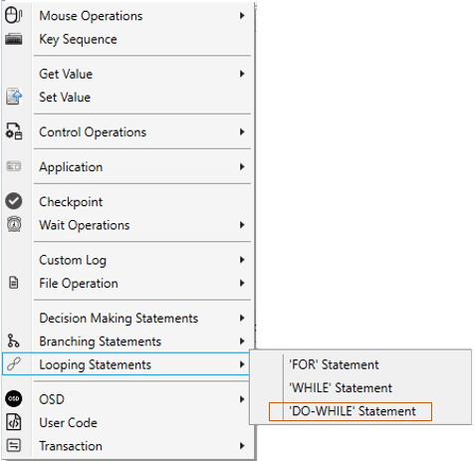



#### OSD

OSD step is used to display the on- screen message any time while executing test suite. If user wants an information message or any other type of message to be displayed on the screen to user between any steps of execution, user can use OSD step.

In Concord, user can add the OSD step from IDE similar to all other actions.

##### **Run OSD**

The Run OSD step can be added as given in the fig below:

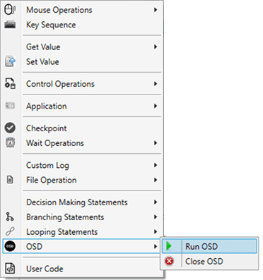

The Run OSD step addition will open a dialog to set the properties of the OSD Text to be displayed.

The OSD dialog will open as shown in below figure:

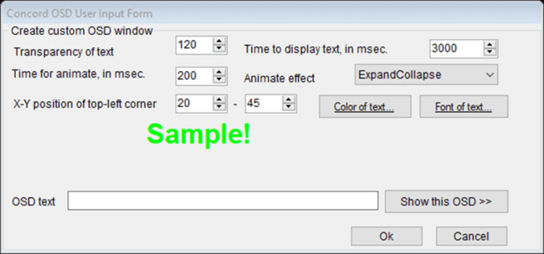

The dialog contains following setting options:

**Transparency of text –** indicates the transparency of text when shown on the screen.

**Time to display text, in ms –** indicates the time for which the OSD text will be displayed on the screen for showing demo.

**Time for animate, in ms –** indicates the time for which the OSD text will undergo animation effect.

**Animate effect –** indicates the animation effect which would be applied to the OSD text.

**X-Y position of top-left corner –** indicates the x, y position of the screen where the OSD text will be displayed.

**Color of text –** color to be applied on the OSD text. The color selector window is shown in below fig:

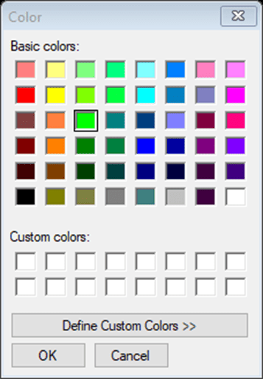

Font of text – indicates the font style which would be applied on OSD text as shown below:

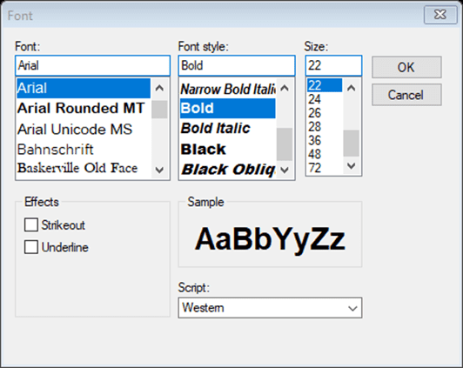

OSD text – user can type the message that needs to be displayed on screen.

Show this OSD>> - this button will show the demo for OSD message being displayed.

Once the configuration is done, user can click on OK button to add the Run OSD step in concord IDE. On cancel the step will not be added in IDE.

##### **Close OSD**

The Close OSD step will be added in IDE and user cannot edit the close OSD step, as shown in below fig:

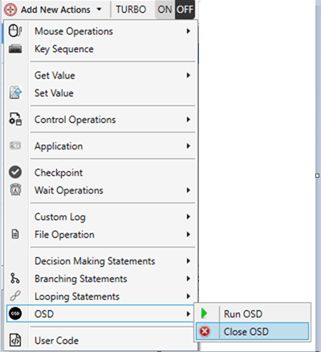

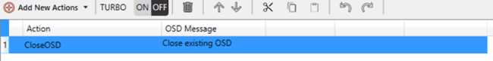

Run OSD will show the OSD text on screen once the script is played and Close OSD will close all the currently running OSD i.e. it will close the displayed OSD text.

#### User code

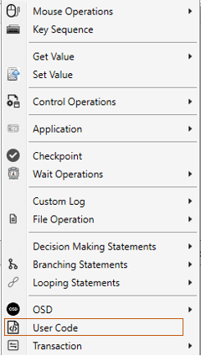

The user code step can be used to write user’s own custom functionality and use the same to give extended support to automation script. As user code is a partial class of recording, variable defined at class level or in a function in recording class can be accessible in user code. It is not advisable to change anything directly from background. Please use IDE for all operations.

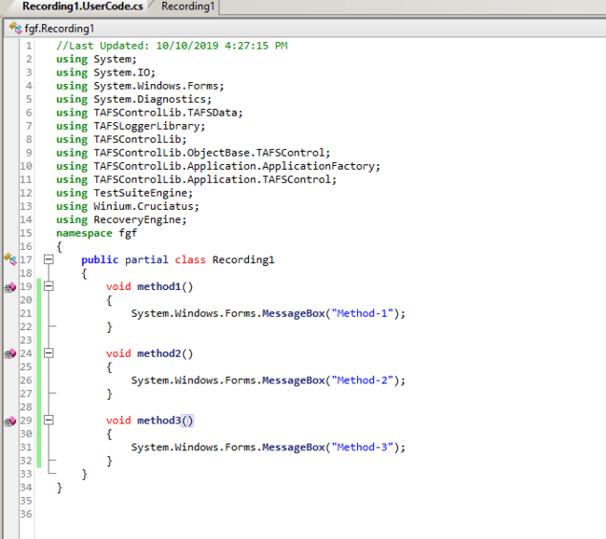

Method column will show all methods which are written in user code file of current recording.

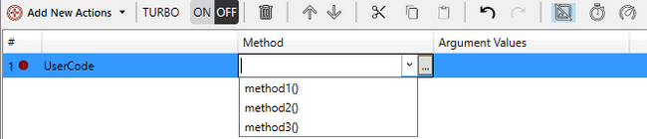

While working with repository or external reference, user can use these objects in user code file by importing namespace. User can also add parameters to the method using argument editor window as follows

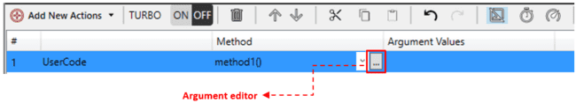

By clicking the above button near the method column, the argument editor window shown below will be invoked.

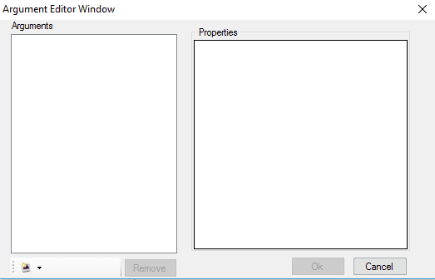

User can add multiple arguments with different data type as follows.

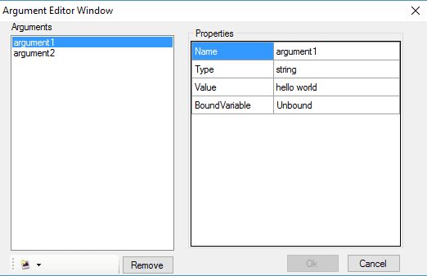

User can add the values of the arguments in Argument value field. On click of [OK] button, values will be displayed in the argument field of IDE.

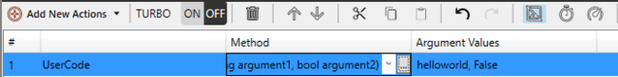

Same arguments will also get updated in usercode.cs file and vice versa i.e. if any changes are made in user code.cs file, changes will be displayed in the IDE as well.

#### Transaction

The transaction action module can be used to find the transaction time between two execution steps.

Transaction should be start by “Start” and end by “Stop” action, Transaction may include “Pause” and “Resume” actions to pause and resume the transaction in between the “Start” and “Stop” actions only.

Transaction steps include the two sub steps Configure Transaction and Summarize Transaction

##### **Configure Transaction**

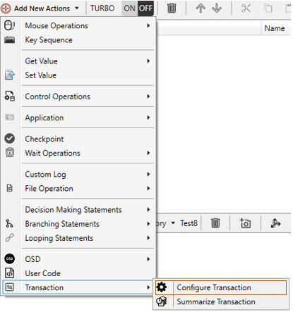

Configure transaction include the steps Start, Stop, Pause and Resume steps. Start will be the default action and user can change it accordingly.

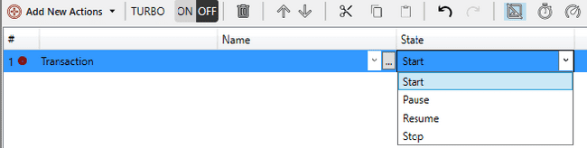

User need to add transaction name in “Name” column to recognize the transaction individually.

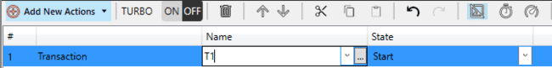

To edit or delete the name user need to click on the edit button near to the name which will open a new window.

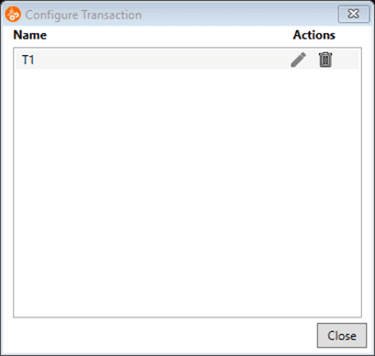

Using this window user can edit or delete the name.

On “Stop” transaction state, checkpoint setting window is provided to the user with logical operation, using the applied setting, the result is displayed in the execution report.



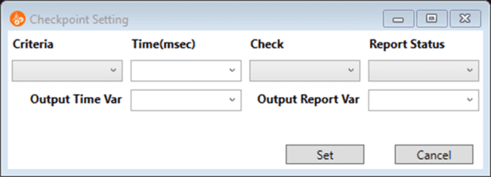

**Criteria**: Logical Operation on the result to be performed**.**

**Time:** Match value to be entered. (E.g. If user wants to check the time taken from Start to stop is less than or equal to 2000 ms then user need to select <= operation in criteria and enter 2000 in Time field).

**Check:** To check the condition is true or false.

True: User wants to check time taken is <= 2000 as true condition, then user need to set true for check field.

False: User wants to check time taken is <= 2000 as false condition, then user need to set false for Check field.

**Report Status:** As per the above expression user can set the report status as PASS/FAIL

Example: Scenario1 -> if [(time taken<=2000) == true] then report PASS

Scenario2 -> if [(time taken<=2000) == true] then report FAIL

Similarly false can also be used, this is based of user’s logic to validate the output of transaction time.

##### **Summarize Transaction**

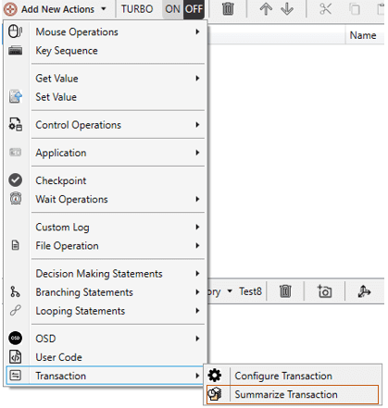



User can select multiple transaction/All for summary. By clicking on the Checkpoint button transaction summary window will open.

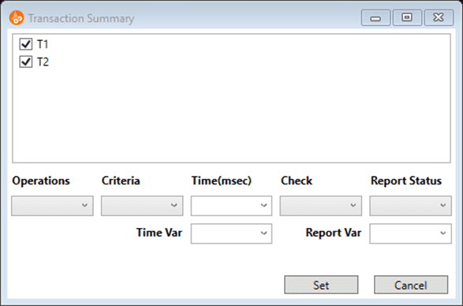

Transaction summary dialog details as below:

**Operation:** Basic mathematical operations like sum, product etc. (These operations will be done to the output of the transactions selected. E.g. Sum (T1, T2)).

**Criteria:** Logical Operation on the result to be performed.

**Time:** Match value to be entered. (E.g. If user wants to check the outcome of operation performed on two transaction is less than or equal to 2000 ms then user need to select <= operation in criteria and enter 2000 in Time field).

**Check:** To check the condition is true or false.

True: User wants to check outcome of operation performed on two transaction is <= 2000 as true condition, then user need to set true for Check field.

False: User wants to check outcome of operation performed on two transaction is <= 2000 as false condition, then user need to set false for Check field.

**Report Status:** As per the above expression user can set the report status as PASS/FAIL

Example: Scenario1 -> if [(Sum (T1, T2) <=2000) == true] then report PASS

Scenario2 -> if [(Sum (T1, T2) <=2000) == true] then report FAIL

### Commenting feature in IDE

The Logger comments for each step are added in the Comments column in IDE. User can add their desired comments for each step.

Also user can edit the comments for the corresponding step added as shown below,



The given comment will be displayed in the report as shown below,

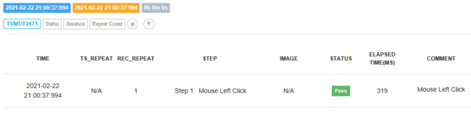

Comments (Description) for TestCase and Recording will be automatically generated while creating it,

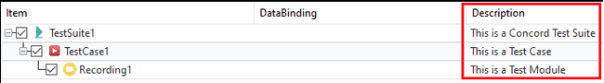

These comments (Description) will be displayed in the Details View of Report.

For TestCase, comments will be displayed while hover on the info icon in TestCase row,

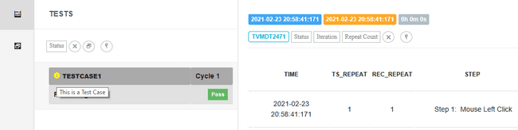

For Recording, comments will be displayed while hover on the Recording row,

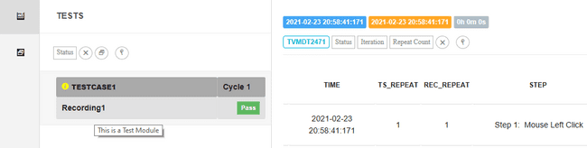

### Mouse Image Action (Force Threshold to pass)

User can capture coordinate and check linked image is exist in given coordinate. On failed steps user can pass action by applying Force Threshold to Pass.

1) On adding new mouse action click on Repository Item column two options will display Add Image and Select Repository, see the figure shown below.

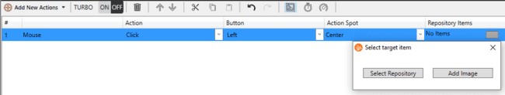

1. Select Repository => User can select existing repository and link to mouse action
2. Add Image => On click of Add Image button Screen Capture mode open user can select required area to capture, After capturing, the area is saved as an image in repository as Screenshot and "then, Edit click location, window with editable Image percentage and Captured coordinates, opens as shown in below figure.

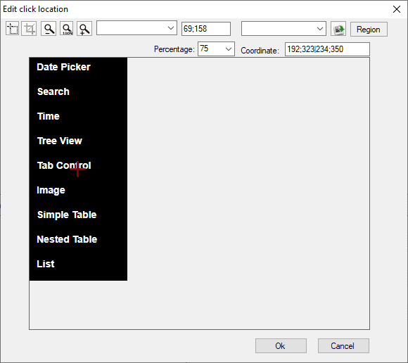

On click of OK button captured screenshot get added in selected step, on cancel operation screenshot will not add in step.

Runtime it will check screenshot exist in captured coordinate, user can update screenshot.

When an external image is added to the given step, the coordinates will be removed.

1. Default percentage will show to all image based actions where user can update matching percentage.
2. After linking screenshot to given step and after Play/Run action is performed; if image is not matched with user given percentage, the step fails. User can pass same step by applying “Force Threshold to Pass” as shown in below dialog.
3. Right click on failed step, “Force Threshold to Pass” option appears in context menu, on click of Force threshold to pass User percentage value will swap with actual threshold. So that step will passed. See the figure shown below.

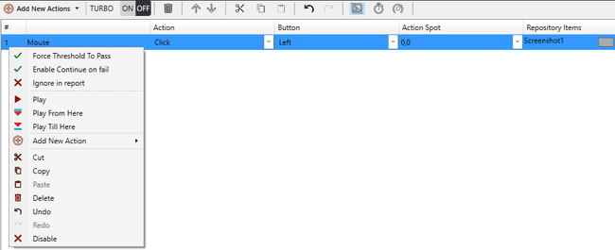

### Enable/Disable steps

Test steps can be enabled/disabled using the Enable/Disable option that appears on the right click of the test steps. See the figure shown below. By default step is enabled. When enabled, only disable option appears in the context menu on right click. If step is disabled, only enable option appears in the context menu on right click.

Right click on the enabled step in order to get the option to disable the step

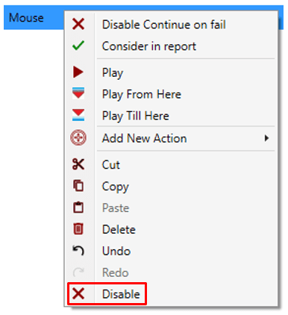

When disabled, Step changes the font to italics and gets greyed out as shown below.



Right click on the disabled step in order to get the option to enable the step as shown below:

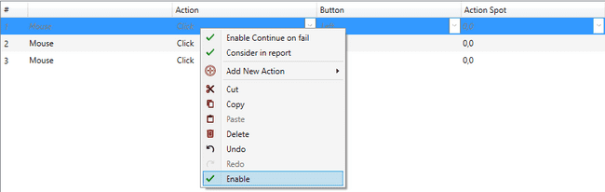

On clicking on the enable action the step becomes enabled and changes its font to normal.

When a mix of Enabled/Disabled steps is selected, user gets the option to Enable /Disable in the context menu on right click. Enable will enable the disabled steps and Disable will disable the enabled steps.

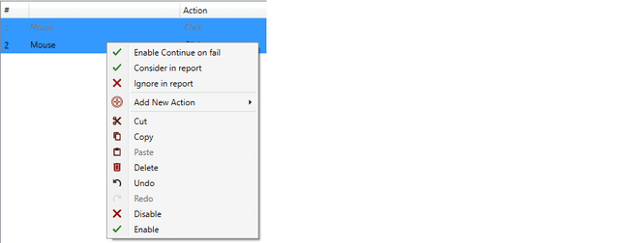

### Changing repository item

User can change the linked repository item of a step by clicking on repository selector button in “Repository Item” field. The following dialog will appear on clicking the repository selector button.

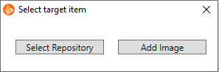

All repository items will be listed on clicking “Select Repository” button. User can either select a repository item from the list or capture new image by clicking “Add Image” button. After capturing a screenshot, the following window opens with multiple options for image editing like Crop, Zoom in, Zoom Out, and to select the point of click, by moving the “+” icon.

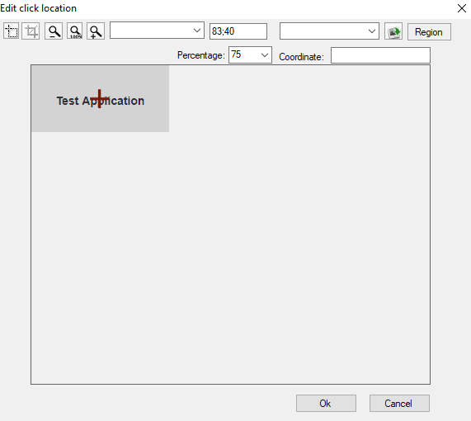

Also presets for the click location are available through a dropdown selection. See the figure shown below.

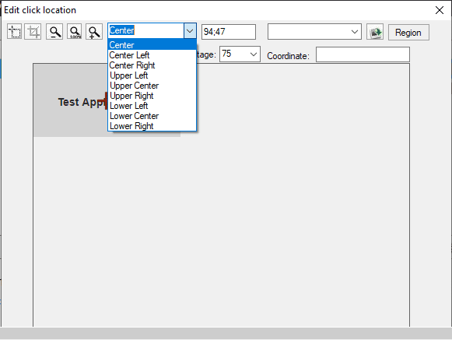

In addition, image from any other location can also be selected see the figure shown below.

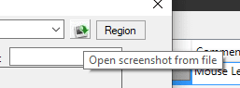

If the linked repository item of selected step is a screenshot, the following dialog will appear on clicking the repository selector button.

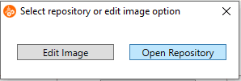

User can either edit the screenshot or select another repository item

## Settings

The Global and Local Settings related to the Test Project Solution can be done through the buttons see the figure shown below:

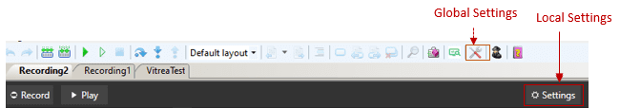

There are 3 types of settings.

1. Project Settings
2. Local Settings.
3. Global Settings

### Project Settings

#### Priority

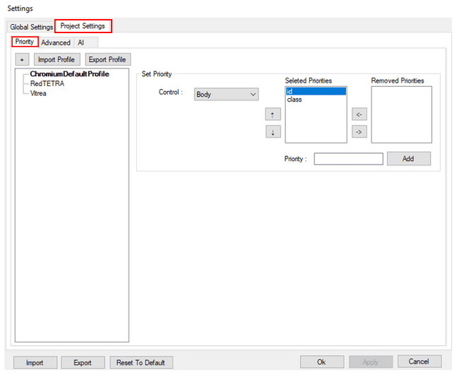

Priority settings is same as that of Desktop. Inaddition, here, for each control, user can add new priorities

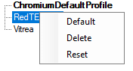

#### 34.7.1.2 Path Style

Specifies whether path should be converted to relative or full path. This setting will be applicable to current solution.

Path style can be access see the figure shown below:

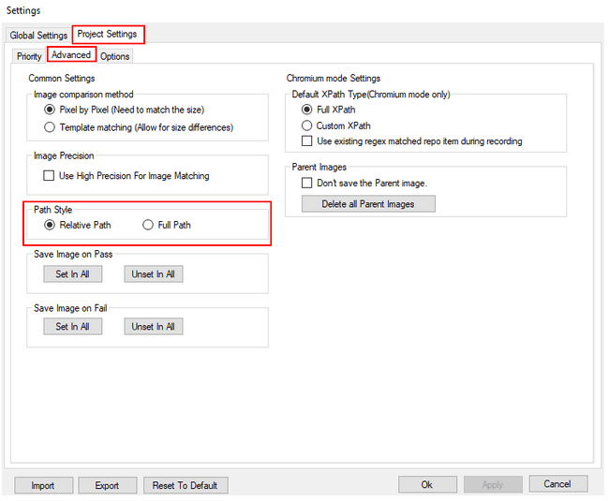

When user change path style and click “Apply”/”OK” below message will be shown once path is converted successfully. On Click of “OK” concord will restart and latest setting will be applied see the figure shown below.

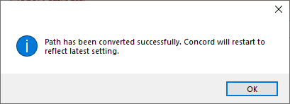

If user click on “Cancel” without modifying path settings, setting form will close and no changes will be done. If user click on “Cancel” after changing path style below confirmation dialog will be displayed. See the figure shown below.

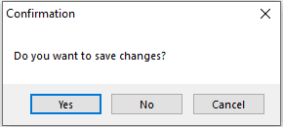

On click on “Yes” latest changes will be applied. On Click of “No” no changes will be applied in setting. On click of “Cancel” this dialog box will be closed.

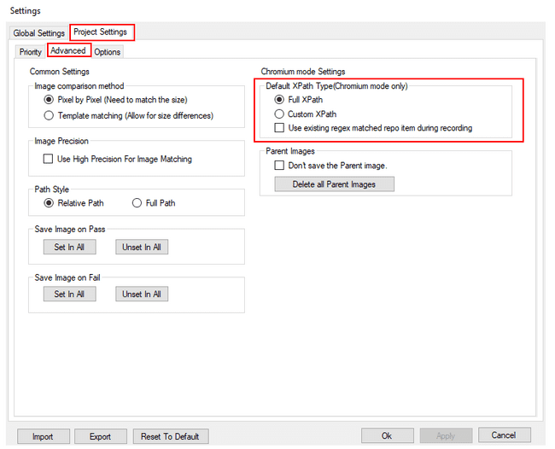

By default XPath type will be “Custom XPath”. User can select either “Full XPath” or “Custom XPath” as default XPath type

The default XPath type of elements of subsequent recordings will be set based on this selection. Upon hovering each xpath type, examples of that xpath type will be displayed as shown below.

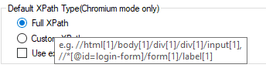

If “Use existing regex matched repo item during recording” checkbox is checked, in addition to XPath checking, regexis also matched. This option is disabled by default. If there is a match, the element will not be added to the repository. If the user is adding repository from Spy or using shortcuts (e.g.: F2/F3) to add elements to repository, “Item exists” message will be displayed if there the regex is matched. By default, this checkbox is disabled.

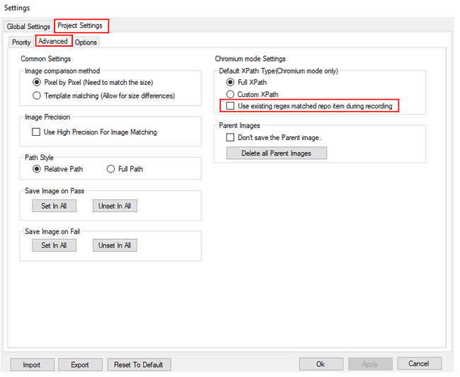

#### Image comparison method

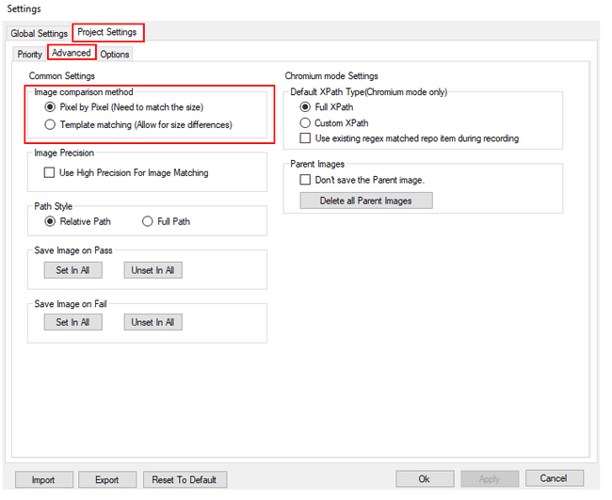

If Template matching（Allow for size differences） is on, use Template matching to perform an image comparison. When Pixel by Pixel（Need to match the size） is on, Pixel by Pixel is used for image comparison. Pixel by Pixel is on by default.

#### Image Precision

When image precision settings is ON, Concord will check all image based steps precisely. For eg. If any minute difference is there in image then it will show matching percentage like 99.57%.

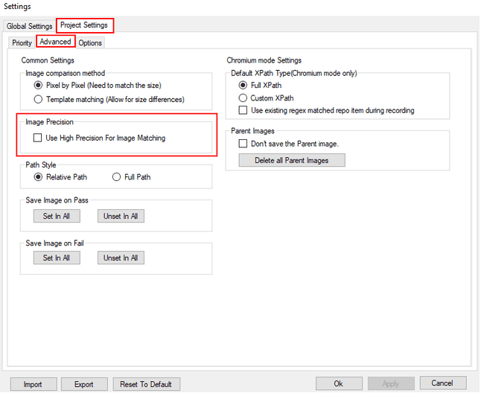

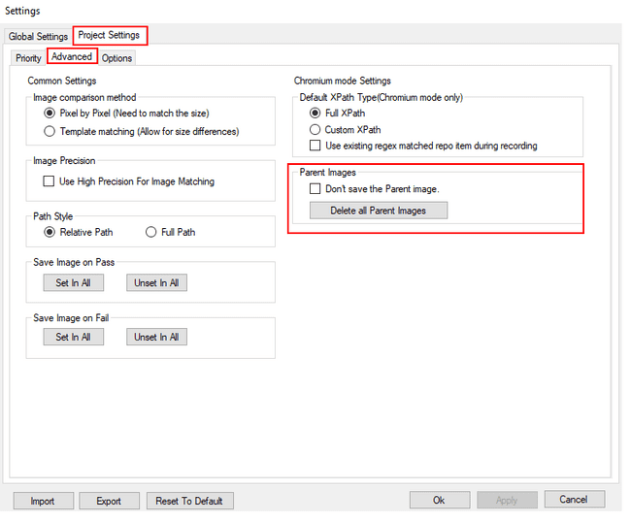

#### Parent Image



If Don’t save the Parent image. is checked, the Parent image will not be saved when saving the Repository.

Select Delete all Parent Image Button to delete all saved Parent images.

#### Input method of KeySequence

If Unicode is on, the input method for KeySequence is Unicode. If Virtual-Key Codes is on, the input method for KeySequence is Virtual-Key Codes. By default, Virtual-Key Codes is on. If Virtual-Key Codes is on, "$" will be represented as "{LShiftKey down}4{LShiftKey up}".

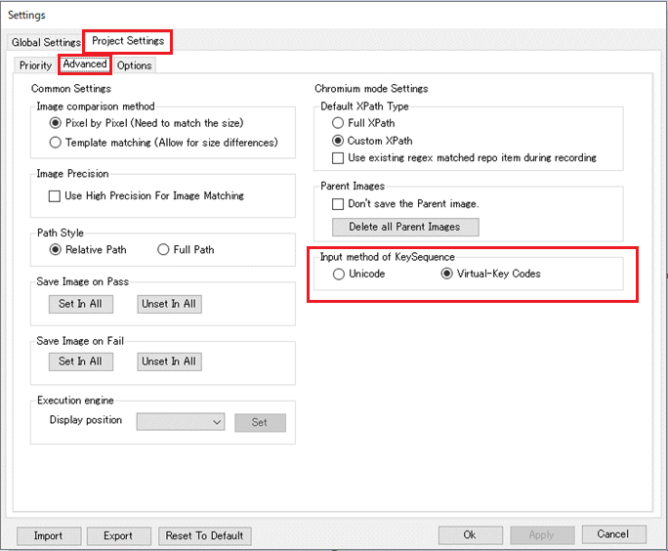

#### Folder for saving report images

You can save result images (success or failure images recorded according to each action's Save Image setting) and images captured by the Screenshot action to a specified folder after a test run.

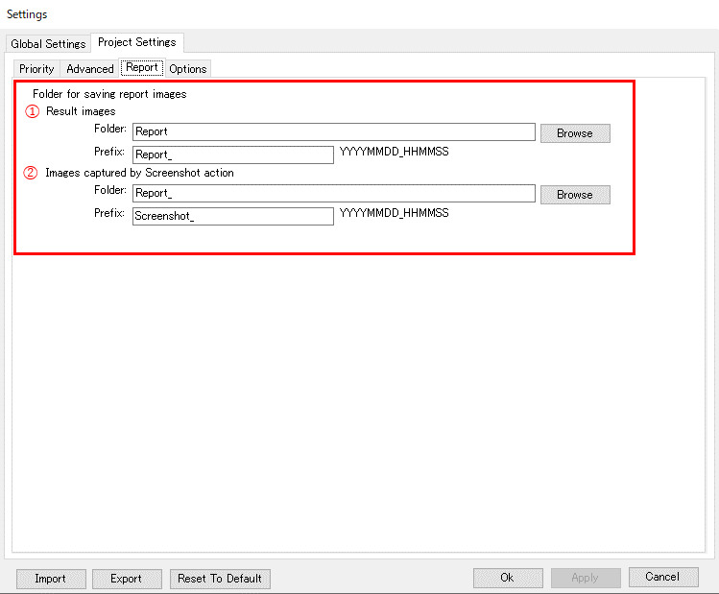

1. Result Images

You can set the path and prefix of the folder where result images (success or failure images recorded depending on each action's Save Image setting) are saved.

* + Folder:

Creates a folder in the format “[character string specified in Prefix]YYYYMMDD_HHMMSS” under the specified folder every time a test is executed, and saves the result image. (Default: Report)

If the specified folder does not exist when running the test, the folder set in Prefix will be created under the Report folder in the script. However, if there are no result images after the test run, the folder will not be generated.

*For setting values, we recommend character strings that can be set in an English environment.

* + Prefix:

Creates a folder name by adding the string “YYYYMMDD_HHMMSS” to the specified prefix for each test run. (Default: Report_) If this field is left blank, it will be output as “YYYYMMDD_HHMMSS” without a prefix.

*For setting values, we recommend character strings that can be set in an English environment.

|  |
| --- |
| example)  Report\Report_20230831100000 (1st test run)  Report_20230831101500 (2nd test run)  Report_20230831103000 (3rd test run) |

1. Images captured by Screenshot action

You can set the path and prefix of the folder where images captured by the Screenshot action will be saved.

* + Folder:

Creates a folder in the format “[character string specified in Prefix]YYYYMMDD_HHMMSS” under the specified folder every time a test is executed, and saves the result image. (Default: Report)

If the specified folder does not exist when running the test, the folder set in Prefix will be created under the Report folder in the script. However, if there are no images captured by the Screenshot action after the test run, the folder will not be generated.

*For setting values, we recommend character strings that can be set in an English environment.

* + Prefix:

Creates a folder name by adding the string “YYYYMMDD_HHMMSS” to the specified prefix for each test run. (Default: Screenshot _) If this field is left blank, it will be output as “YYYYMMDD_HHMMSS” without a prefix.

*For setting values, we recommend character strings that can be set in an English environment.

#### Self healing support

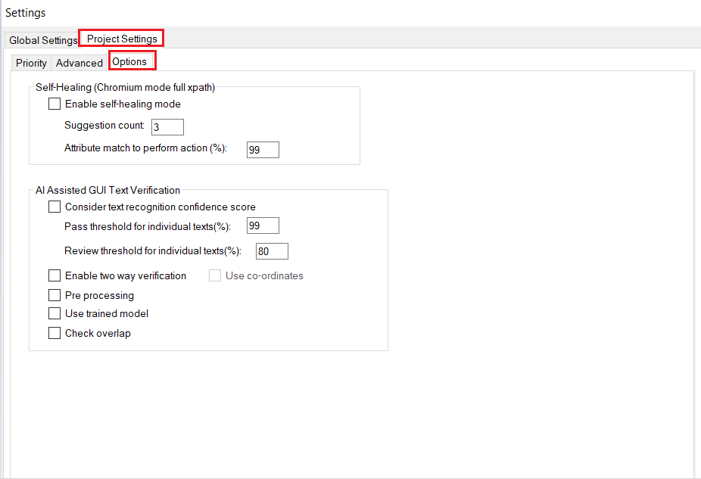

Options tab contains the settings for self healing which aids in auto script execution. When self healing mode is enabled, if element is not found during execution, self healing will be invoked.

Suggestions count is the number of suggested xpaths for each element that will be displayed in the self healing summary dialog after performing a self healing enabled action. Action will be performed if the match is greater than the match provided in the attribute match textbox and suggestions data will be updated in the VitreaElements.xml.

AI assisted GUI Text verification is a new setting that is added in Project Settings, which is present under the options tab, that helps to recognise the text from the GUI.

Text Recognition Confidence score: This can be used for deciding the color of the bounding boxes and for checking the review conditions that can either be selected or not selected as per the user requirements .If this option is selected, we can choose the pass threshold and review threshold via edit boxes. These values are considered for individual texts. For example, if pass threshold is set as 99, all the texts with match percentage greater than or equal to 99 will be considered as pass. That is, it will be marked with green rectangle. Similarly, if review threshold is set as 80, all texts with match percentage between 80 and 99 will be considered for review and marked with orange rectangle. All the text values below review threshold can be considered as ‘Fail’.

The purpose of two way verification is to check whether if strings are present in both json and image and vice versa. In addition to this,texts that are found in json and not found in GUI will also been displayed.When this operation is enabled, report will display the texts that is not matched.

By default, Concord and Localization test application will load only pre-trained model.In order to load trained model file in Concord and text recognition test application, “use trained model” is being used. First of all, train the model by making use of text recognition training utility tool. Copy the trained model to the EasyOCR folder [\Concord\lib\ GUIVerificationexe\EasyOCRmodels].Once completed, check the “Use trained model” option and click on apply button. It will load the latest model along with the pre-trained models. This will ensure that the latest trained model will be considered along with other pre-trained models. The main purpose of this option is to load all the latest trained models which will improve/enhance the accuracy if the current accuracy is not upto the desired expectations.

If “Check Overlap” is enabled, overlap checking can be done between the controls and texts in the GUI.

Use co-ordinates option can be used to confirm that the text is displayed on the correct control. By enabling this setting any newly added or misplaced text on the input image can be detected.



### 

### 

### 

### 

### Global Settings

#### Recorder Shortcuts (This is disabled currently)

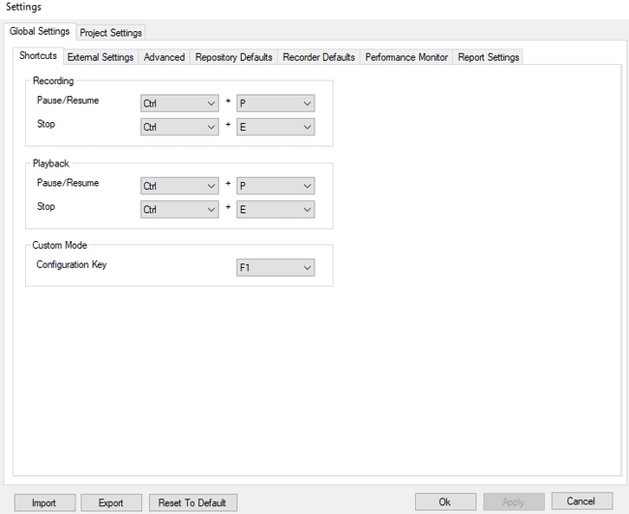

It is used to set the shortcuts for the recorder operations as shown in the figure.

As per the above configuration, the short cut keys will be displayed on mouse hover on the respective button.

#### External Settings (UWSC/MOTT)

This tab allows the user to set the path for external files and their executable see the figure shown below.

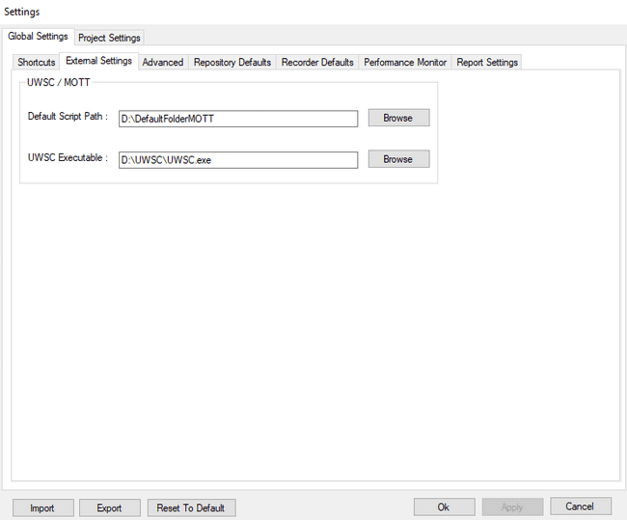

#### Advanced Settings (UWSC/MOTT)

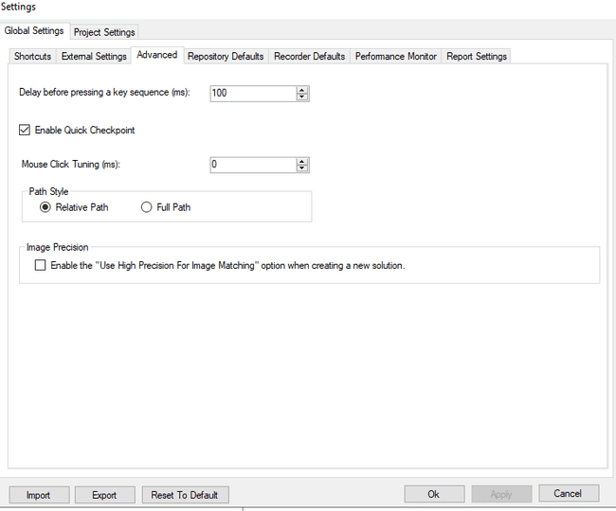

**Delay before pressing a key sequence (ms**) Specifies the time to wait in milliseconds before performing a key sequence simulation.

**Enable Quick Checkpoint:** Specifies quick checkpoint should be enabled or not at project level.

**Mouse Click Tuning:** Specifies length of time between setting/placing/putting the cursor on the object and clicking it.

**Path Style:** Specifies whether path should be converted to relative or full path. This setting will be applicable to next solution created by user and not for current solution.

#### Repository Defaults

This tab allows setting search time-out and other general settings related to the repository see the figure shown below.

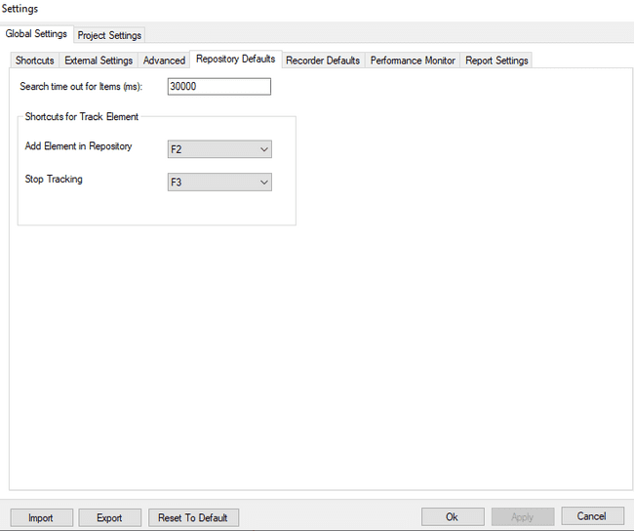

**Search time out:** When an item in repository is set as repository item in a step in IDE, on trying to execute that step, this field decides the time out for searching the item. If the selected repository item is not found in the time allotted in this field, the step fails. If the item is found, based on the condition/action in the step, the step may pass.

**Add Element to Repository:** This field is used to set the key for adding the focused element to repository when the Tracking mode is ON. The key can be changed from the options provided in the dropdown.

**Stop Tracking:** This field is used to set the key for exiting the tracking mode. Once this key is pressed, the tracking mode is set to OFF and no more elements are added to the repository on press of the key set in Add Element to Repository. Also the green border that appears on setting the tracking mode to ON will stop appearing on this key press. The key can be changed from the options provided in the dropdown.

Please refer Track Element section for more details related to tracking elements and adding them to repository.

Note: User has to take care that the allotted key does not perform any other function in the application. E.g. it is advised not to use the F1 key for adding the elements or stopping the tracking as F1 is usually used to open the help file. However this key has been provided as this behavior may differ from application to application.

#### Recorder Defaults

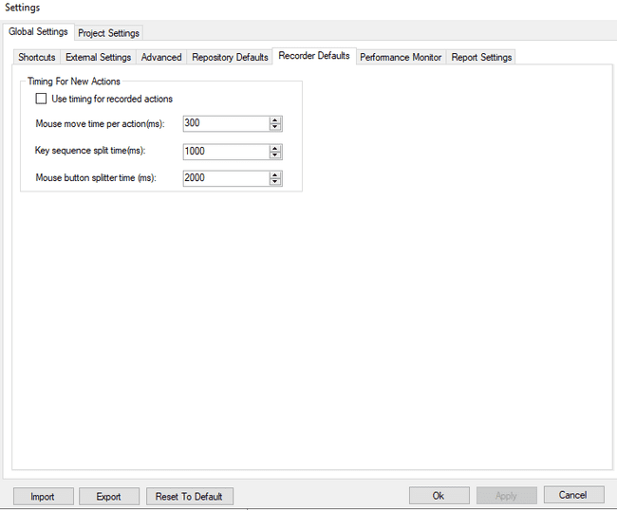

**Use timing for recorded actions:** When enabled, the specified timings will be taken instead of the recorded durations.

##### **Delay Settings**

It is used to add delay in milliseconds between two steps. It can either be real time delay that is recorded in steps or it can be predefined delay depending on the project setting see the figure shown below:



**Use timing for recorded actions** is used to record delay time between two steps at the time of recording. If it is checked it will take predefined delay time between steps. Else it will take real delay time between steps see the figure shown below.

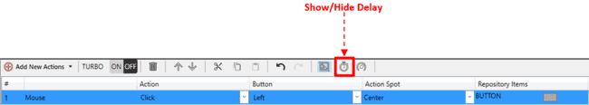

**Detail**

When actions are added manually or using recording there is a column for delay time for every action which can be show and hidden using a button named “Show Detail” see the figure shown below:

Initially Delay column and SaveImage column are not visible. If click on “Show Detail” button then “Delay (ms)” column and “SaveImage” column shows and delay time and save Image setting for every action can be seen in this column. “Delay (ms)” column is editable and its value can be changed. In the "Save Image" column, User can change the setting of whether to save the image by pulling down.See the figure shown below:

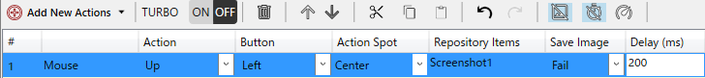

##### **Recording Action**

If actions are added in recording mode and **Use timing for recorded actions field** is enabled, then Delay (ms) column will display predefined delay.



If the field is unchecked, Delay (ms) column will display real time delay.



Value of “Delay (ms)” column can be changed by double click on cell.

User can change the setting value of image saving from the pull-down displayed after selecting the cell.

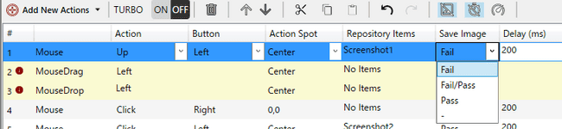

The meaning of each setting value is as follows. The initial value is Fail and the image is saved when the test execution fails.

|  |  |
| --- | --- |
| 設定値 | 設定値の表す意味 |
| 0 | - |
| 1 | Pass(Save image only when the test is successful) |
| 2 | Fail (Save image only when the test is failed) |
| 3 | Fail/Pass（Save image in both success / failure） |

##### **Manual Action**

If actions are added manually, regardless of whether the **timing for recorded actions** field is enabled or disabled, the Delay (ms) column will display predefined delay by default.



**Mouse move time per action (ms):** Sets the time (in milliseconds) used to move the mouse to the UI object related to the action.

**Key sequence split time (ms):** Sets the maximum time between key presses in a key sequence during recording. If this time is exceeded, the sequence is split into multiple key sequences

**Mouse button splitter time (ms):** Sets the minimum time taken to split actions for Mouse. It decides whether to add a single step for “Click” action or to add separate steps for mouse “Up” and “Down”.

#### Report Settings

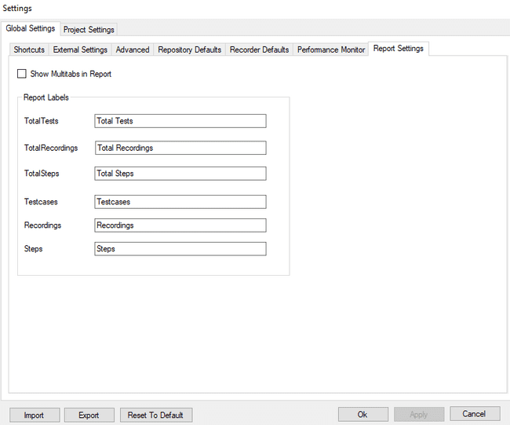

If **Show Multitabs in Report is enabled,** reports will be displayed in multiple tabs. Otherwise, only one report will be displayed at a time.

User can also change labels for report.

#### Image Precision:

**Sets the precision settings to all image based steps in project**.

* + If setting is checked then image precision is applicable to all newly created projects.
  + If setting is unchecked then it will take default settings to all newly created projects.

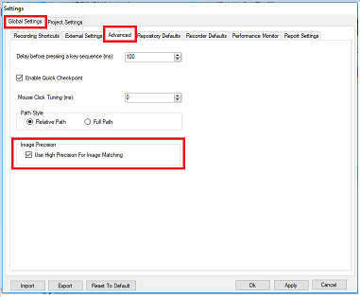

### Local Settings

#### Current Recording

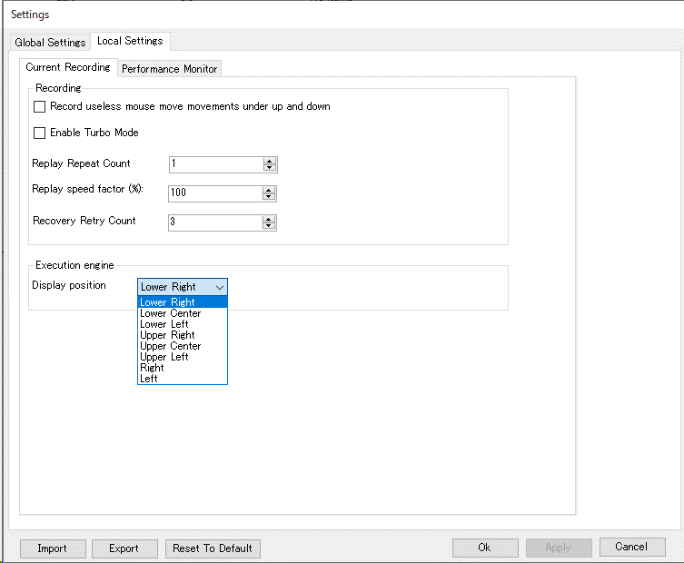

**Record useless mouse move movements under up and down:** This is used to record all the move movements between mouse up and mouse down and add those as steps.

**Enable Turbo mode:** This is used to specify whether recorded delays between actions should be part of the generated code. When selected, the delays between the actions are ignored.

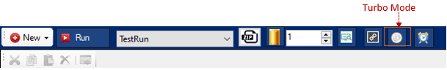

**Replay Repeat Count:** This is used to run the current recording multiple times. Different repeat count can be set for different recording i.e. replay repeat count is recording specific. Minimum limit of replay repeat count is 1 and maximum limit is 99999.

**Replay Speed Factor:** The speed factor is used to increase or decrease the replay overall speed by a specific factor value.

**Display position:** This is used to change the position of the Execution engine.

Following is the functionality of other buttons on the Settings window:

 Button in Settings window is used to import the global settings as well as local setting from an xml file.

Button in Settings window is used to export the global settings as well as local settings in form of zip file which can be stored in user specified location.

 Button resets the values of all the global and local settings to their initial default values.

### Import/Export of settings

If only global settings is open then global settings would be imported /exported, and if invoked from Local Settings window, then local settings would be.

 Button in global settings is used to import the global settings from an xml file.

Button in global settings is used to export the global settings in form of zip file and can be stored in user specified position.

 Button reset to default resets the value of current tab settings to its initial default settings.

 Button saves the changed settings.

 Button exits the global settings with saved changes.

 Button exits the global settings without saving the changes made after clicking the Apply button.

## Save/Save All

For any modification in Test Suite/Recording/Project Settings (Local)/Data Connector It will show below asterisk (*) symbol. If asterisk is present and the tab/Concord is closed, then for the unsaved changes it will show save dialog.

Click on ‘Yes’ to save the changes. If ‘No’ is clicked then changes will revert back to its previous state.

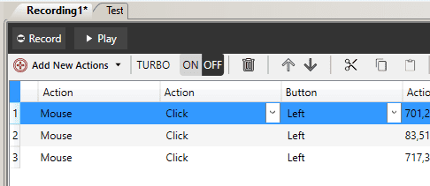

## Data Binding

Refer Data binding for more details

## Regular Expression

Concord uses XPath for finding the elements during automation. In normal cases it uses strict XPath mapping for finding an element. But in some situations, this will not be useful. Say for example; the ID of table elements may vary based on the user input. In such situations it will not be efficient to find the element by using strict XPath mapping.

*XPath is used for selecting nodes from an HTML document. XPath can be used to navigate through elements and attributes in an HTML DOM document.*

*Example*

*//*[@id="highlighter_210395"]/table/tbody/tr/td/div/div[16]*

Regular expression comes handy in such scenarios and helps to overcome this limitation of XPath. They help to create flexible XPath to find the elements. A full-fledged regular expression support is available in Concord.

Example: //*[@id="highlighter_210395"]/table/tbody/tr/td/div/div[16] is a sample Xpath where the numbers in id may change at runtime. Here we can use following regular expression to find the exact element.

^\/\S+highlighter\S+\[16]$

What is XPath?

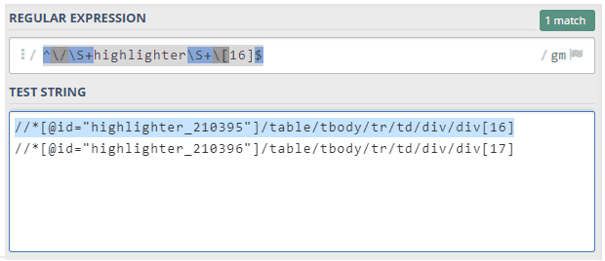

### How to set regular expression in Concord Chromium?

There are two Regex editors.

* + - * Normal Regex editor
      * Global Regex editor

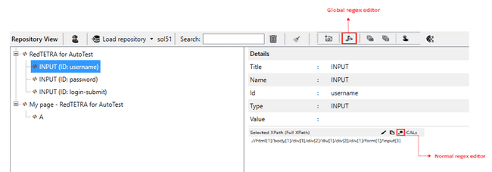

#### Normal Regex editor

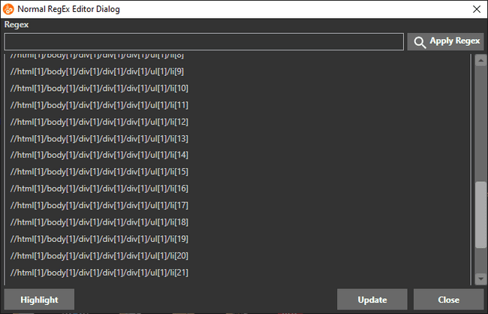

Normal regex editor dialog will display XPaths of all elements from the selected elements title.

If an element is selected and Highlight button is clicked, the selected element will be highlighted on screen using red border.

If the selected element exists in multiple browsers with the same session,the element will not be highlighted and the following message will be displayed



On adding any regular expression and clicking on Apply Regex, all matching portions in the XPaths will be highlighted as shown below.

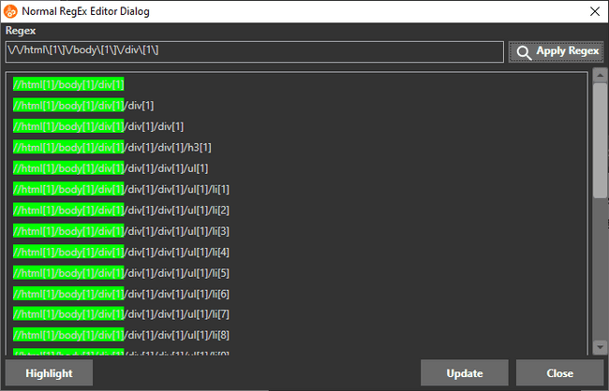

On clicking update button, the following dialog will be displayed.

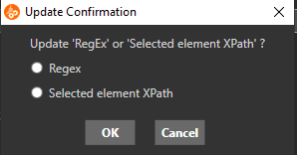

User can update the elements XPath using either Regex or selected element XPath. The following dialog will be displayed on clicking on OK button.

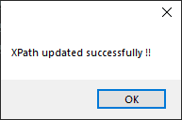

#### Global Regex editor

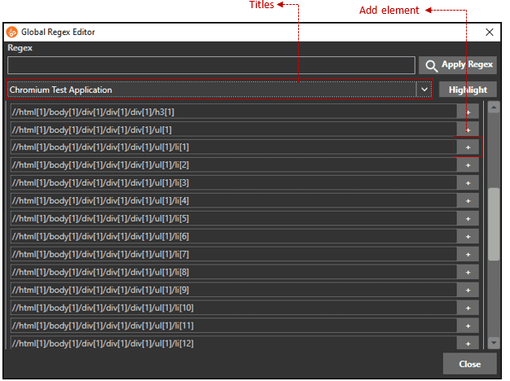

In Global regex editor, the available Vitrea application titles will be displayed and the user can select it from the combo box. All XPATH from selected title will be displayed.

Clicking on the add element button, the selected xpath’s element will be added to the repository.

#### Session Name Regex editor

When the user clicks on any repository item title, RegEx editor button will appear on the Title field in repository details section.

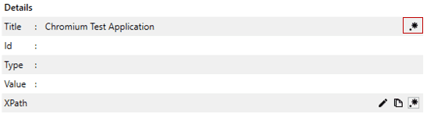

On clicking the button, Session Name Regex editor dialog will appear and displays titles of all webpages in Vitrea Application.

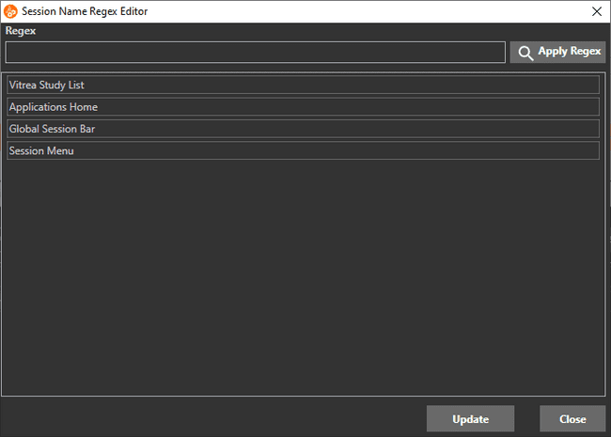

On adding any regular expression and clicking on Apply Regex, only those titles that matches the regular expression will be displayed and all matching portions in the titles will be highlighted as shown below.

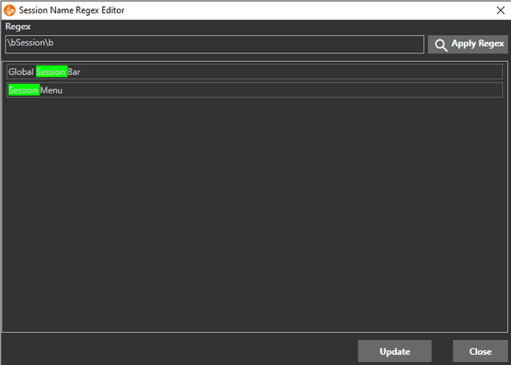

User can update the session name of selected title by clicking on the Update button. The following dialog will be displayed on clicking Update button.

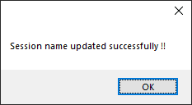

#### CALs Compatible Regex

In some Vitrea applications, normal application of regex is not possible. This happens when the application has multiple views and IDs of elements contains common prefix followed by numbers. In this case, XPATH is converted to CALS compatible Regex for View related elements.

Here, user can easily apply regex using CALs Compatible Regex

For example:

Suppose an input element has an id of OPENRIB111345376304967453090 with the OPENRIB fixed followed by a 21 digits UID number. The Xpath of all the given elements follows the same format.

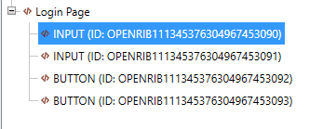

The Xpath of selected input element is shown below.

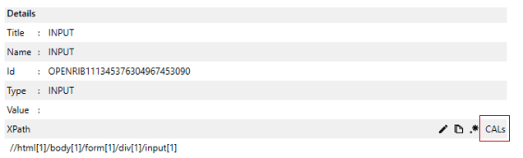

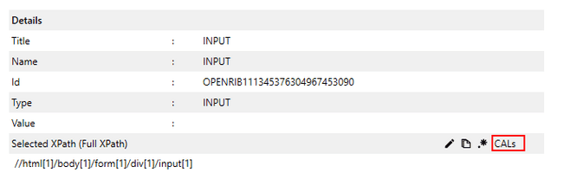

On applying CALS, the Xpath of selected element changes as shown below.

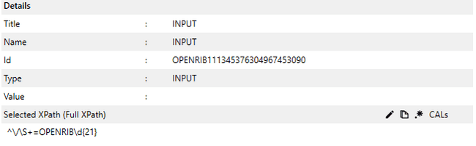

## Google Chrome and Microsoft Edge Support

Google Chrome and Microsoft Edge automation also can be supported in ‘Chromium’ mode, they are started using following parameters.

* Target url
* --remote-debugging-port=port_number
* --user-data-dir=path (Any temporary directory path)
* --remote-allow-origins

### Steps to create shortcut

1. Create a shortcut of Google Chrome or Microsoft Edge.
2. Take "Properties" of the created shortcut and add the url and parameters in the "Target" field of "Shortcut" tab in below format.

**For chrome:**

<<Chrome exe path>><<SPACE>><<Target url>><< SPACE >>--remote-debugging-port=<<Port number>><<SPACE >>--user-data-dir=<<Folderpath>> --remote-allow-origins=*

**For edge:**

<<Edge exe path>><<SPACE>><<Target url>><< SPACE >>--remote-debugging-port=<<Port number>><<SPACE >>--user-data-dir=<<Folderpath>> --remote-allow-origins=*

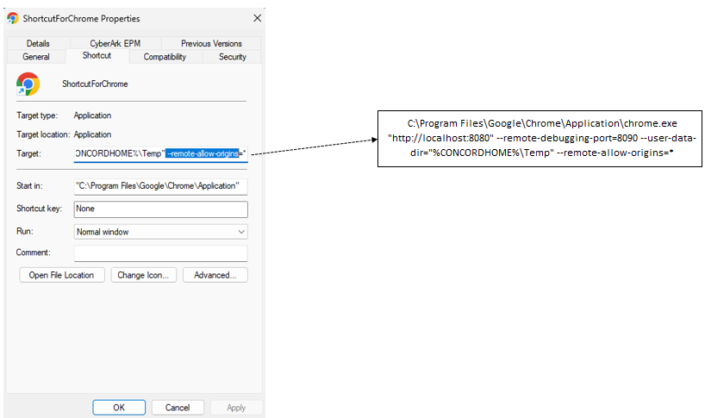

Similarly, shortcut for edge can also be created.

### Browser shortcut creation utility

For creating the shortcut for browser, a “Browser shortcut creation utility” is there and it is available in the below path,

“%CONCORDHOME%\Utilities\CreateBrowserShortcut”

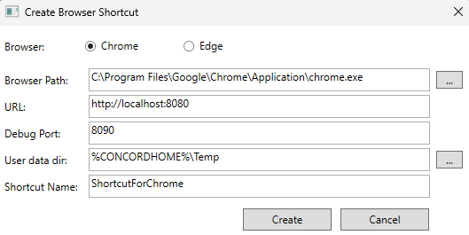

* “Path” : Exe path of selected browser
* “URL” : target url
* “Debug Port” : remote-debugging-port
* “User data dir” : a temporary folder path
* “Shortcut Name” : name of the shortcut that we want to create

When clicking on the “Create” button the shortcut for the selected browser will be created on the “Desktop”.

### Limitations

* Currently given only support for Google Chrome and Microsoft Edge via Chromium mode.
* During recording elements in multiple tabs can be recorded. But during playback only one tab is supported.
* During recording and playback, only one instance of Google Chrome/Microsoft Edge should be running and that too with the debug parameters like --remote-debugging-port and --user-data-dir mentioned above.
* User could not track some items that are created as JavaScript objects, instead of elements. An example of such an item is calendar control.

# Good practices while creating or maintaining the Concord Suites

Following are some of the good practices while creating or maintaining the concord suites,

**Recommended :**

1. Always test with Turbo mode also during creation of a suite.
2. Always use implicit delays rather than explicit delays.

* Implicit delays: Wait for, Wait for property. User can also use conditional statements and loops to wait for particular condition to meet before the start of next execution. User can also use user code module to wait for particular condition to meet (Basic C# knowledge is required).
* Explicit delays: Delay action, User delays during recording (This will be ignored during turbo mode execution).

1. Rename the repository object to a specific name for easy use of linking of objects.
2. Delete the unused repository objects.
3. Clear the execution reports of the suites once in a while (Only in case if it is not needed for future reference).
4. When using the Data Connector, please copy the Excel/CSV file inside the solution folder.
5. Create a common recording for frequently used flow, this will help reusing the recording and save time.
6. While Renaming any elements in concord (Solution name, Recording, Test case, Repository Objects etc), please follow the good practices of naming convention.
7. While pasting any solution which contains relative path, always maintain destination folder structure same as source folder.
8. In File/Folder Size property it is recommended to use <, <=, >, >= operator for special scenario. For detailed information please refer 5.8.6 (**Size**)
9. If element is not searchable or Concord is not performing desired user action then it is recommended user to check search path using Spy or Inline Path Editor.
10. We support upto 260 for any longest path in solution after which user will get warning and current operation will get cancelled.
11. In case of Copy/paste, Import and Load/Merge repository, if destination repository contain same element without any Duplicate tag and source has Duplicate tag then user will have option to merge duplicate element. If user selects No then existing element will be used. For other cases where both source/desitnation elements have tag, don’t have tag and reverse case of above, Concord will show warning message with OK button. After these operations, the report will be displayed to the user containing details of affected steps from each Reording/Scenarios.
12. Target Image selection:

Concord usually search for the target image in the present desktop if User didn't give any ROI.

This may result in failure if user selects very small image for comparison/click operation.

So it is advisable to select a region of interest. Please refer the following example.

e.g: If user want to click OK button on confirmation dialog (any dialog can be considered). Then,

->For Mouse action user can select approximate coordinate so that concord will search for the OK button only inside the coordinate.

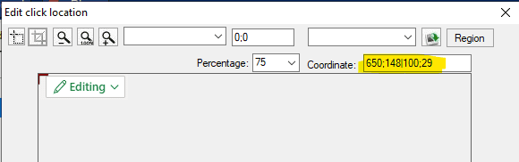

->For Compare/contain image, user can either select the coordinates or object of the dialog.

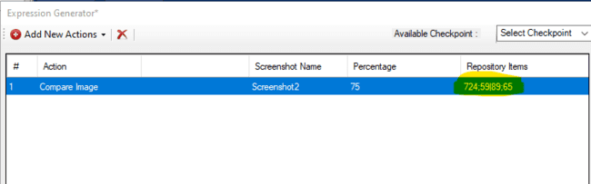

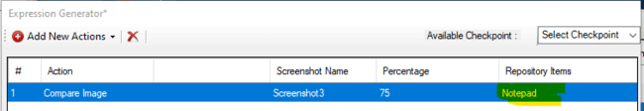

**Not Recommended :**

1. While renaming or creating any elements in concord (Solution name, Recording, Test case, Repository Objects etc) user should not use C# keywords.

It is not a good practice to use “Ctrl+Alt+Delete” in key sequence action during script creation as it will take precedence of windows “Ctrl+Alt+Delete” behavior and there is a chances of affecting the creation flow.

1. User cannot give path of project which folder size is exceeding the count of 240, Use path with the less limit and maximum count is 240, as shown in figure below.

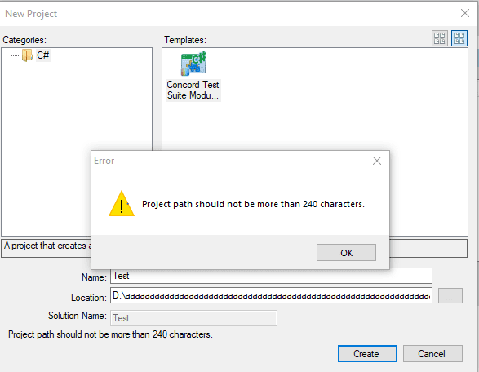

1. If you are moving a folder to another location from created path then please make sure you are not exceeding path limit and keeps buffer length. In case a user doesn’t follow this point then there are chances that he\she will face unexpected errors.
2. Whenever user wants to clear reports, always clear from Concord. It is not recommended to clear from physical location directly.

**Limitations :**

1. As per many form it is not allowed to simulate “Ctrl+Alt+Delete” programmatically in windows because of security reason .It can only be simulate by hardware calls.We may not use a script created in one culture to another culture.
2. Say if a user has created a script in the English version of OS\Concord and s\he trying to use the same script in Japanese culture, then there are possibilities that script will fail runtime. Apart from it, if a user tries to modify script, then there are chances of script corruption.

The following could be some reasons for failure.

1. Objects which are identifying with name properties will fail as the text will be different in both cases, also if some properties which are support localization will also not work in this case.

2. Images in English OS will have English text, and the Japanese OS will have the Japanese version of the text, so there is no possibility that it will work.

User will get warning message for following scenario.

1. So when the user tries to open script in mismatch culture s\he will get warning message for same.
2. While loading of repository.
3. While importing a script.
4. Execution of script in case of mismatch culture.
5. There may be possibility that if same solution of concord is opened from two different path , then after click on Play/Run button concord may not minimized while execution.
6. Recorder shortcuts are currently disabled while Recording operation due to limitation with Key Sequence.
7. It is recommended that not to repeat keys (Ex : Ctrl, shift, Alt , etc.) for mouse wheel in a single recording.
8. The characters ‘[‘ and ‘]’ may missed from the report. Since these characters are used in Concord for log packet parsing i.e. the output file which is generated after execution, it contains all the information about the steps, information, error and warnings.
9. While conversion of old solutions, if user not selected backup option then in case of solution corruption due to any failed case, solution will be in unstable state.
10. User will get warning messages in case if long path situation occurs across operations.
11. There is one limitation in desktop mode self healing. If the parent hierarchy changes after version upgrade, the changed attributes will not be displayed in path editor after replacing xpath.

# Appendix

1. “For open issue and fixed list please refer %ConcordHome%doc\concord\Notes”
2. Recorder shortcuts are disabled (Ref section 17.2.1)

# History

|  |  |  |  |
| --- | --- | --- | --- |
|  | Ver. | Section | Details |
|  | V2.2SP0000 Build 17.5.4.0 | Baselined Version | |
|  | V2.3SP0000 Build 18.5.4.0 | 3.6 | Added Highlighter Info |
| 5.5.3  5.5.2  5.8.5.2 | Added a new screenshot |
| 5.8.5.2 | Cursor Position |
| 5.8.5.3 | Cursor On Display |
| 9.2.1 | Custom image drag drop |
| 11 | Pause Script Execution |
| 13.16 | Rename solution |
| 37 | Point 9 added to Good Practice |
|  | V2.4SP0001 Build 19.4.17.2 | 2.1, 2.2, 2.3, 2.4,2.2.3 | New Installation process, Added Installer for Path Style settings. |
| 5.6 | Set Value – Tree View Control and Menu |
| 5.8.6 | File/Folder checkpoint support |
| 5.13.1 | Updated for OSD variable support |
| 5.13.2 | Close OSD. Added a note at the end |
| 9.2 | Added one more point (e) |
| 13.16 | Rename solution updated |
| 17.1, 17.2.3 | Updated for Path Style setting added |
| 21.2 | Console Application. |
| 29.2.2 | Inline Path Editor |
| 30.2, 30.3 | Added Note in the end. |
| 35.135.2 | Updated Import/Export for sequence order |
|  |  | 36 | Concord Chromium |
|  |  | 2 | Added point “Report structure when image NotFound”. |
|  | V2.4SP0002 Build 19.5.5.0 | 5.2 | Limitations |
|  | 5.9.3 | Limitations |
|  | 28.8 | Replace Image |
| 33 | Link functionality repository disabled |
| 37 | Added point 12, 13 |
|  | V2.4SP0003 Build 19.5.10.0 | 30030.1 | Export recording/recovery change |
| 37 | Added point 14 for key sequence |
| 3 | Updated Images which contain Load |
| 3.4 | Added note. |
|  | V2.4SP0004 Build 19.6.2.25 | 1.2 | Note added |
| 4.5 | Note added |
| 5.1 | Note added |
| 9.1 | Note added |
| 37 | Note added, Limitation added.Limitation updated (Point 16). |
|  | V2.4SP1000 Build 19.7.2.0 | 5.2 | Key Sequence - Merge Selected Keyboard Items details |
| 5.6 | Limitation added |
| 5.8.1 | Added note at bottom of the section. |
| 5.19 | Added note.User code-Note added for limitations at the end of 5.19 section. |
| 13.16 | Added one point regarding rename solution at last. |
| 24.2 , 29 | Details Updated in 24.2(Global Settings) and Image updated in 29. |
| 35 | Limitation added for Recording shortcuts. Limitation added for MouseWheel action while recording.  Limitation added for characters ‘[‘ and ‘]’. |
|  | V3.0SP0000 Build 21.0.0.0 | 13.16 2 | SoftwareDetails Updated. |
| 2.2.2 , 2.5 , 19 ,  21.1 , 21.2 | Install path Updated. |
|  | V3.1SP0000 | 3.2, 3.3 | Explanation about highlight (blue text) of the added repository items. Highlight will turn back to black after the repository having saved.s |
|  | V3.1SP0000 | 4.2, 4.3 | Added Explanation about display link information in dialog when deleting repository items / nodes. Added explanation of batch deletion of unlinked repository. |
|  | V3.1SP0000 | 26.3 | Added explanation about naming rules of step execution result screenshot. |
|  | V3.1SP0000 | 26.7 | Change the explanation about save the passing image by adding the function of project settings. |
|  | V3.1SP0000 | 17.2.5.3 | Reflect the update of Show Delay → Show Detail in the manual action |
|  | V3.1SP0000 Build 23.0.0.0 | 34.6.6.13 | Added Explanation about display link information in dialog when deleting repository items / nodes.Added explanation of batch deletion of unlinked repository. |
|  | V3.1SP0000 Build 23.0.0.0 | 34.7.2.5 | Addition about step unit setting of image saving at the time of step execution |
|  | V3.1SP0000 Build 23.0.0.0 | 34.6.6.3 | Explanation about highlight (blue text) of the added repository items. Highlight will turn back to black after the repository having saved. |
|  | V3.2SP0000 Build 24.0.0.0 | 13.13 | Added description about renaming recordings from the Test Suite context menu |
|  | V3.2SP0000 Build 24.0.0.0 | 3.3 | Added section [3.3] |
|  | V3.2SP0000 Build 24.0.0.0 | 17.2.1 | The section title and the image are updated. |
|  | V3.4SP0000 Build 25.0.0.0 | 31  17.1  26.5.1  26.5.2  33.7  33.6.8.7 | Link Repository →Delete, Project Settings Added explanation and Replaced the image.Added description of excluded area |
|  | V3.5SP0000 Build 26.0.0.0 | 26 | Version change, table of contents change Add macro function |
|  | V3.6SP0000 Build 27.0.0.0 | 13.20  30  30.1.  30.2.  35  36.6.6  36.6.7.17 | Added Exclusive feature for user mouse controland Import/Export Macro and UserGroup. |
|  | V3.7SP0000 Build 28.0.0.0 | 4.5  28.3 | Addes UserGroup(Desktop Mode)And Using smart path variables. |
|  | V3.8SP0000 Build 29.0.0.0 | 13.21  17.1  17.3.1  25.4  36.6.7  36.7.1.5  36.7.3 | Added Display positionAnd Input method of KeySequenceAnd Requirement ticket number and test IDAnd XPath value when Reset button is pressedAnd Recovery Configuration Manager |
|  | V3.9SP0000 Build 30.0.0.0 | 1.2  2  3.1  5.14.2  36.6.9.9 | Update description And Precautions for installation  And add Control with IsControlElement=False  And Capture Screenshot  And Screenshot |
|  | V3.10SP0000 Build 31.0.0.0 | 3.2.  3.3  3.4.  3.5.  36.7.1.6.  36.6.7.5. | Update description And Added about repository item registration function using timer in SPY  And Folder for saving report images |
|  | V3.11SP0000 Build 32.0.0.0 | 5.8.3.  37.6.9.7.  5.14.2.  37.6.9.9. | Added Compare ImageFileAdded Capture Screenshot |
|  | V3.12SP0000 Build33.0.0.0 | 4.7.  9.2.1.  5.1.  37.6.9.1.  29.4. | Update Edit click location screen image And Added about variable specification of click coordinates in Mouse actionAnd Added about propagate smart path changes to descendant controls |

**This is the last page.**